Module 15 — Design Patterns II (Behavioral)
  - OOP with Python Mastery: FAANG Interviews / GATE / SEBI-RBI IT / Backend — In-Depth Notes (with visuals)
Prepared for nidhi.sharma@forensiccybertech.com
2026
Table of Contents

Module 15 — Design Patterns II (Behavioral)
Why this module matters. Behavioral patterns are about how objects talk to each other and divide responsibility — and they’re the ones that show up most in real design interviews. Strategy (swap algorithms) is the single most useful pattern for replacing if/elif ladders and deep inheritance; Observer underpins every event/notification system; Command powers undo/redo and job queues. As always, Python’s first-class functions often let you implement these with far less ceremony than the textbook UML.
Importance ratings (out of 5):
Exam / Use | FAANG Interview | GATE CS | SEBI/RBI IT | Backend Dev | LLD Rounds
This module | ★★★★★ | ★★ | ★★ | ★★★★ | ★★★★★
Most-asked concepts: Strategy (and its Pythonic function form); Observer (pub/sub); Command (undo/redo); State (state machine); Template Method; Chain of Responsibility; Strategy vs State; how these replace conditionals/inheritance.
What you must be able to do after this module: implement Strategy, Observer, Command, State, and Template Method in Python; recognise which pattern a problem calls for; and give the Pythonic (function-based) form of Strategy.

15.1 Behavioral Patterns Overview
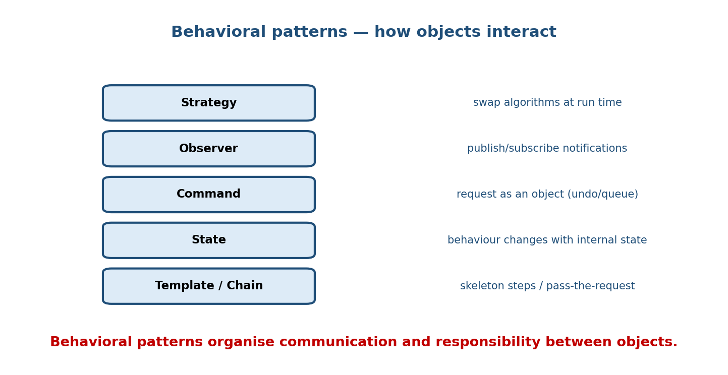
Behavioral patterns: Strategy (swap algorithms), Observer (publish/subscribe), Command (request as object with undo/queue), State (behaviour changes with internal state), Template/Chain (skeleton steps / pass the request).
Behavioral patterns coordinate communication and responsibility among objects. We focus on the six you’ll actually use and be asked about.

15.2 Strategy — swap interchangeable algorithms
Intent: define a family of algorithms, encapsulate each, and make them interchangeable at run time. The context delegates to a chosen strategy.
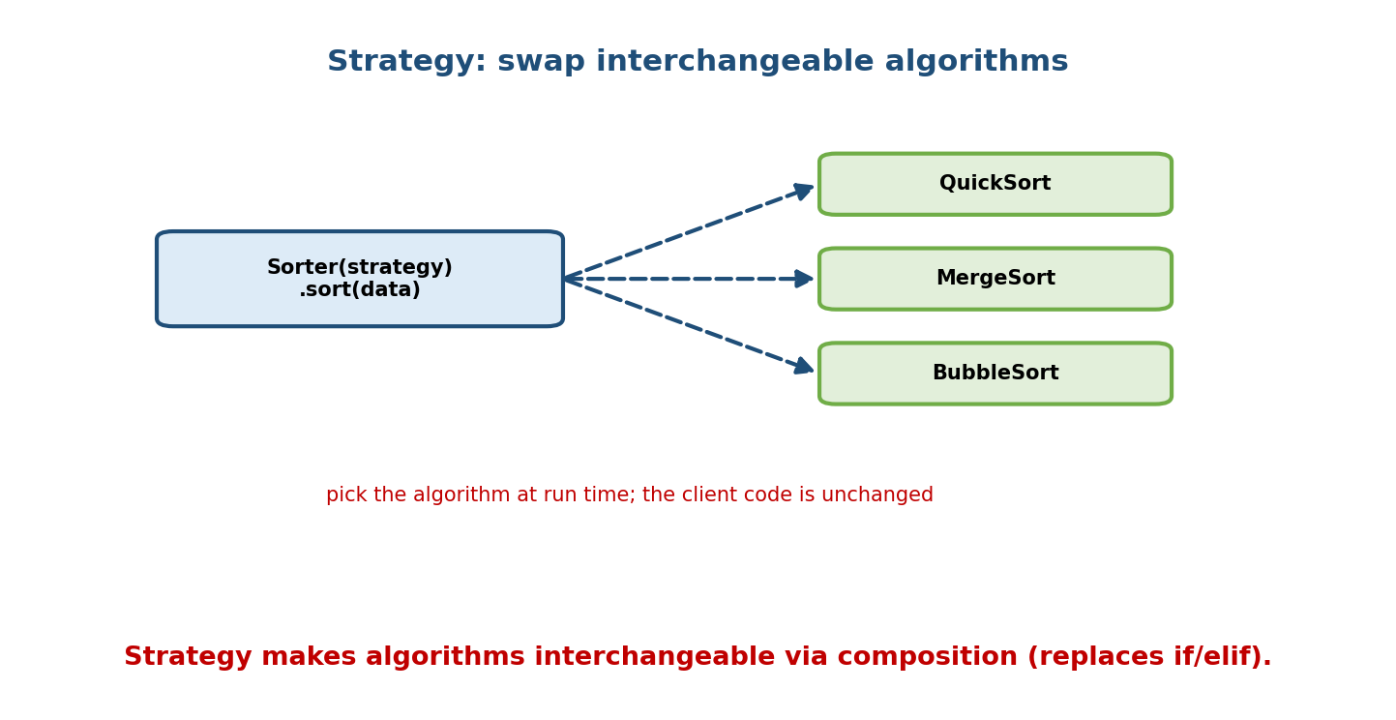
A Sorter holds a strategy and calls .sort(data); the strategy can be QuickSort, MergeSort, or BubbleSort, chosen at run time without changing the client.
from abc import ABC, abstractmethod
class SortStrategy(ABC):
@abstractmethod
def sort(self, data): ...
class QuickSort(SortStrategy):
def sort(self, data): return sorted(data) # (stand-in)
class ReverseSort(SortStrategy):
def sort(self, data): return sorted(data, reverse=True)
class Sorter:
def __init__(self, strategy: SortStrategy):
self.strategy = strategy
def run(self, data):
return self.strategy.sort(data) # delegate
print(Sorter(ReverseSort()).run([3, 1, 2])) # [3, 2, 1]
Why it’s the “big one”: Strategy is composition instead of inheritance and the direct answer to OCP — it replaces if algo == "x" ladders and subclass explosions. It’s how you make behaviour pluggable.

15.3 Observer — publish/subscribe
Intent: define a one-to-many dependency so that when one object (the subject) changes state, all its observers are notified automatically.
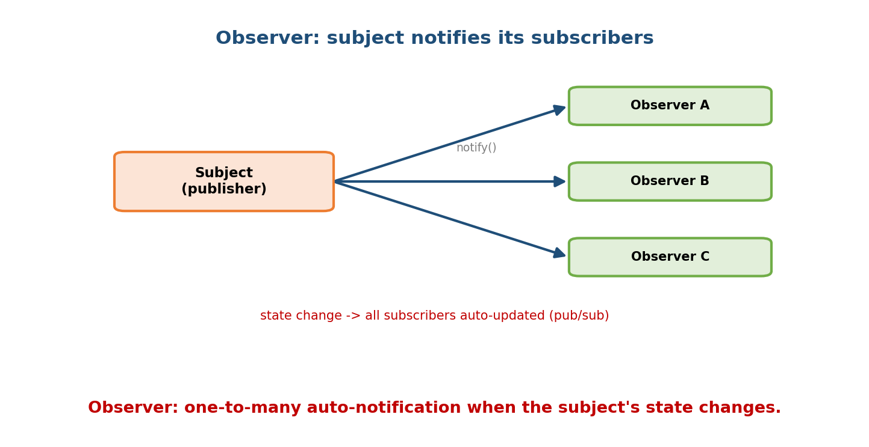
A Subject (publisher) calls notify() to update Observer A, B, and C automatically whenever its state changes — one-to-many pub/sub.
class Subject:
def __init__(self):
self._observers = []
def subscribe(self, obs): self._observers.append(obs)
def notify(self, event):
for obs in self._observers:
obs.update(event) # push to all subscribers
class EmailObserver:
def update(self, event): print(f"email: {event}")
class LogObserver:
def update(self, event): print(f"log: {event}")
s = Subject()
s.subscribe(EmailObserver()); s.subscribe(LogObserver())
s.notify("order placed") # both observers react
Powers event systems, GUI callbacks, model↔view sync, and message buses. Tip: use weakref (Module 12) for observers so the subject doesn’t keep dead observers alive.

15.4 Command — request as an object
Intent: encapsulate a request as an object, letting you parameterise, queue, log, and undo/redo operations.
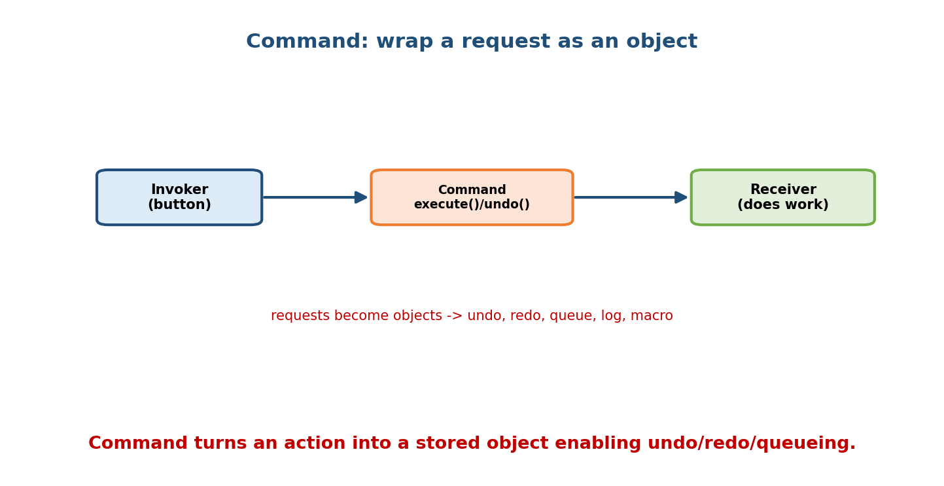
An Invoker (e.g. a button) holds a Command with execute()/undo(); the Command calls the Receiver that does the work — turning requests into objects for undo/redo/queue/log.
from abc import ABC, abstractmethod
class Command(ABC):
@abstractmethod
def execute(self): ...
@abstractmethod
def undo(self): ...
class AddText(Command):
def __init__(self, doc, text): self.doc, self.text = doc, text
def execute(self): self.doc.append(self.text)
def undo(self): self.doc.pop()
doc, history = [], []
cmd = AddText(doc, "hello"); cmd.execute(); history.append(cmd)
history.pop().undo() # undo the last command
Why: decouples the invoker (button/menu) from the receiver (who does the work); enables undo stacks, macro recording, and task queues.

15.5 State — behaviour changes with state
Intent: let an object alter its behaviour when its internal state changes — it appears to change class. A clean state machine without giant if blocks.
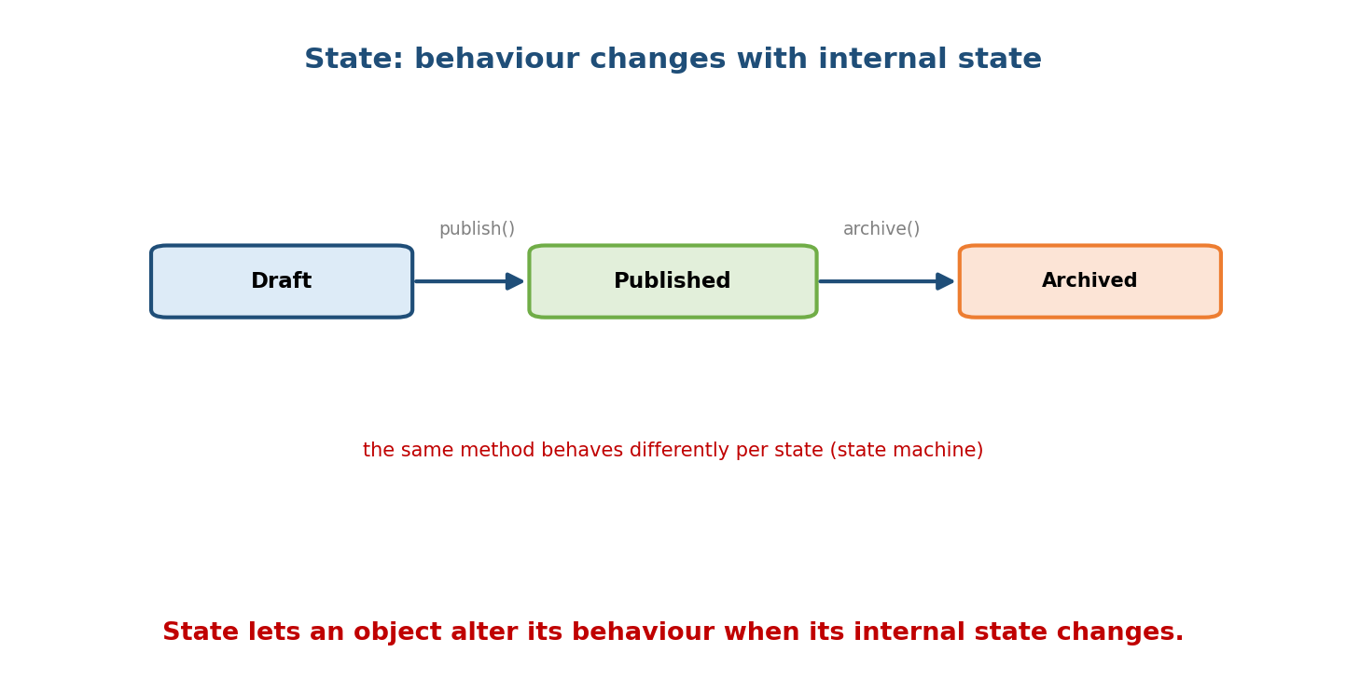
A document moves Draft -> Published -> Archived via publish() and archive(); the same method behaves differently depending on the current state.
class State(ABC):
@abstractmethod
def publish(self, doc): ...
class Draft(State):
def publish(self, doc): doc.state = Published() # transition
class Published(State):
def publish(self, doc): print("already published") # different behaviour
class Document:
def __init__(self): self.state = Draft()
def publish(self): self.state.publish(self) # delegate to state
Strategy vs State (classic interview distinction): structurally similar (both delegate to a swappable object), but Strategy varies an algorithm chosen by the client, while State varies behaviour driven by the object’s own state transitions.

15.6 Template Method — fixed skeleton, variable steps
Intent: define the skeleton of an algorithm in a base method, deferring some steps to subclasses — the order is fixed; specifics vary.
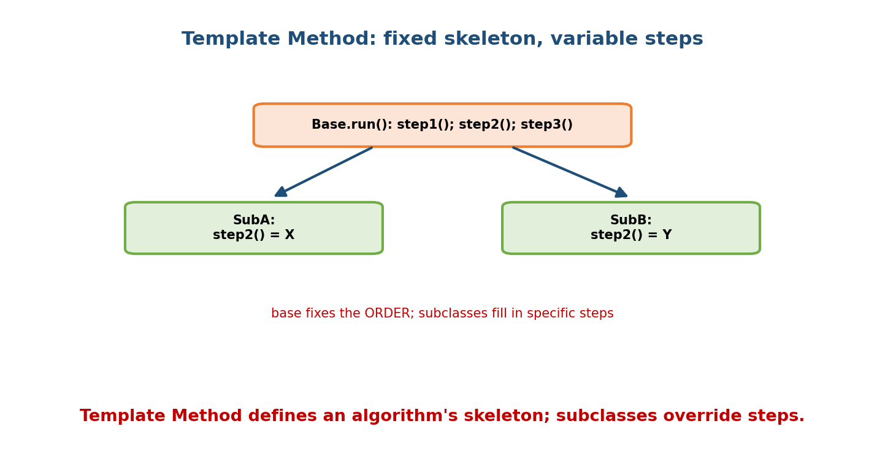
Base.run() calls step1(); step2(); step3() in a fixed order; SubA and SubB each override step2() with their own behaviour, keeping the skeleton constant.
class DataPipeline(ABC):
def run(self): # the template (fixed order)
data = self.extract()
data = self.transform(data)
self.load(data)
@abstractmethod
def extract(self): ...
@abstractmethod
def transform(self, data): ...
def load(self, data): print("saving", data) # default step
class CsvPipeline(DataPipeline):
def extract(self): return "csv-rows"
def transform(self, d): return d.upper()
Uses inheritance (the one place it’s clearly right): the base owns the invariant sequence; subclasses fill the hooks. Contrast with Strategy, which uses composition to vary the whole algorithm.

15.7 Chain of Responsibility
Intent: pass a request along a chain of handlers until one handles it — decoupling sender from receiver.
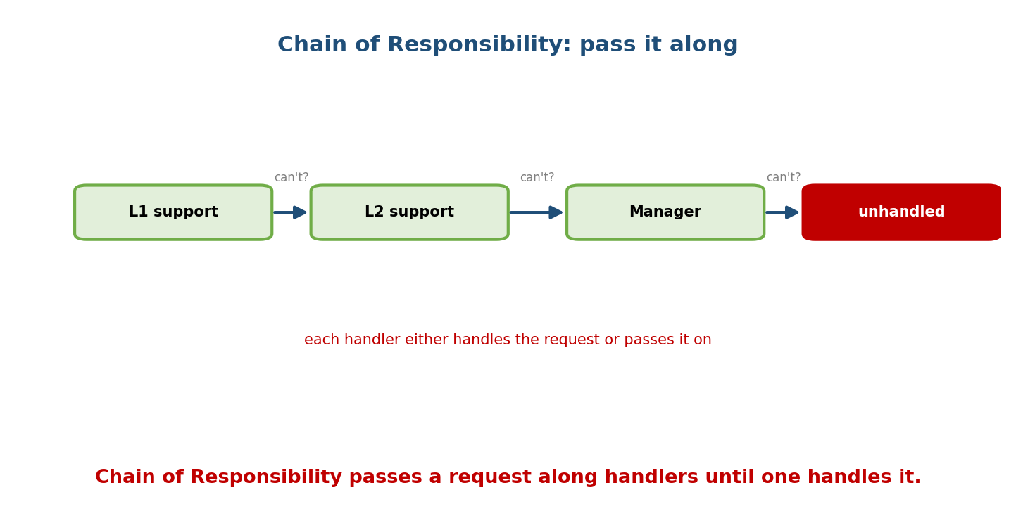
A request goes L1 support -> L2 support -> Manager, each either handling it or passing it on; if none can, it ends up unhandled.
class Handler:
def __init__(self, successor=None): self.successor = successor
def handle(self, level):
if self.can_handle(level):
return self.process(level)
if self.successor:
return self.successor.handle(level) # pass it along
return "unhandled"
# L1 -> L2 -> Manager chain; each Handler subclass defines can_handle/process
Uses: middleware pipelines (web frameworks), event bubbling, logging levels, approval workflows. (Also behavioral: Mediator centralises complex interactions; Memento captures/restores state; Visitor adds operations to a class hierarchy; Iterator — Module 7 — traverses a collection.)

15.8 The Pythonic Shortcut: functions as strategies
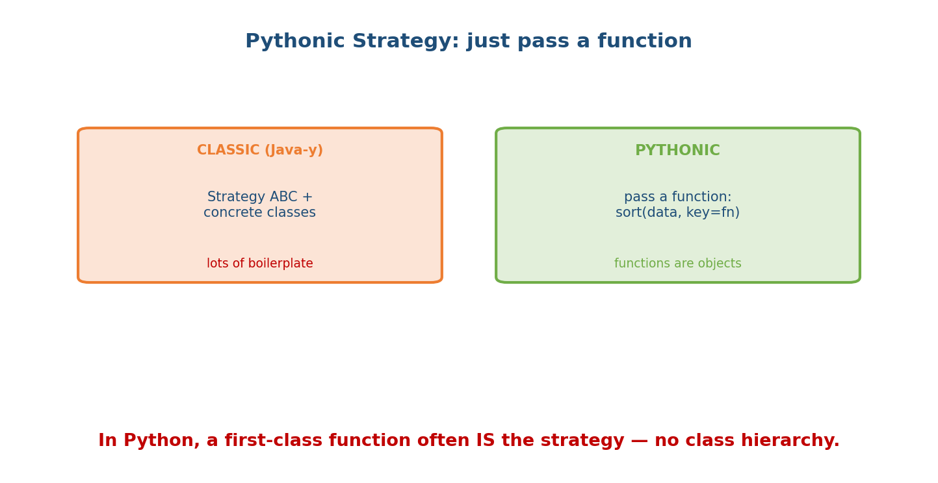
Classic Strategy needs a Strategy ABC plus concrete classes (boilerplate); the Pythonic form just passes a function, e.g. sort(data, key=fn), because functions are first-class objects.
Because functions are first-class objects, many behavioral patterns collapse in Python:
# Strategy as a plain function — no class hierarchy needed
def process(data, strategy):
return strategy(data)
process([3, 1, 2], sorted) # strategy = a function
process([3, 1, 2], lambda d: sorted(d, reverse=True))
# The stdlib already does this: sorted(data, key=...) IS Strategy.
# Observer -> a list of callbacks. Command -> a function/partial. State -> a dict of funcs.
Senior takeaway: know the classic OO form (for interviews and Java-shaped codebases), but in Python prefer the lighter function-based version when it’s clearer — that judgment is exactly what distinguishes idiomatic Python.

Module 15 — Interview Mapping
Question | Junior answer | Senior answer
“Strategy pattern?” | “Swap algorithms.” | “Encapsulate interchangeable algorithms; context delegates; composition over inheritance; replaces if/elif. In Python often just a passed function (sorted(key=...)).”
“Observer?” | “One notifies many.” | “Subject keeps subscribers and pushes updates on state change; use weakrefs to avoid leaks; basis of event systems.”
“Strategy vs State?” | (blurs) | “Same structure; Strategy = algorithm chosen by client; State = behaviour driven by the object’s own state transitions.”
“Command — why?” | “Encapsulate a request.” | “Decouples invoker from receiver; enables undo/redo, queues, macros, logging.”

Module 15 — Exam Mapping
- GATE CS: occasionally definitional / pattern-category matching.
- SEBI / RBI IT: rarely.
- FAANG / LLD rounds: Strategy, Observer, State, Command appear constantly in design questions (e.g. “design a notification system” → Observer; “design an undo feature” → Command; “pluggable pricing” → Strategy).

Module 15 — Common Mistakes & Misconceptions
- Confusing Strategy and State — algorithm-choice vs state-driven behaviour.
- Over-engineering Strategy with classes where a function is clearer.
- Observer memory leaks — subject holds strong refs to dead observers (use weakref).
- Template Method with too many abstract steps — fragile base class; consider Strategy/composition.
- Command without a receiver — losing the decoupling benefit.
- Chain with no terminal handler — requests silently lost.

Module 15 — MCQs (with answers & explanations)
Q1. Swapping interchangeable algorithms at run time is: a) State b) Strategy c) Observer d) Command
Answer
b. Strategy encapsulates interchangeable algorithms.
Q2. A one-to-many auto-notification on state change is: a) Command b) Observer c) Chain d) Template Method
Answer
b. Observer (pub/sub).
Q3. Encapsulating a request to support undo/redo is: a) Strategy b) State c) Command d) Facade
Answer
c. Command turns actions into objects.
Q4. The difference between Strategy and State is: a) none b) algorithm chosen by client vs behaviour driven by internal state c) speed d) memory
Answer
b. Same structure, different intent/driver.
Q5. A base method fixing the step order while subclasses fill steps is: a) Strategy b) Template Method c) Observer d) Proxy
Answer
b. Template Method defines the skeleton; subclasses override steps.
Q6. Passing a request through handlers until one handles it is: a) Chain of Responsibility b) Command c) Mediator d) State
Answer
a. Chain of Responsibility.
Q7. The Pythonic Strategy is often: a) a metaclass b) a first-class function passed in (e.g. key=) c) a Singleton d) a mixin
Answer
b. Functions are objects; sorted(key=...) is Strategy.
Q8. sorted(data, key=fn) is an example of which pattern? a) Observer b) Strategy c) Command d) State
Answer
b. key is a pluggable strategy function.

Module 15 — Design/Practice Exercises (easy → hard)
- (easy) Implement a PaymentContext with CardStrategy/UpiStrategy; swap at run time.
- (easy) Rewrite that Strategy using plain functions.
- (medium) Build an Observer Stock that notifies Display and Alert observers on price change.
- (medium) Implement Command with execute/undo for a text editor and an undo stack.
- (hard) Model a traffic light as a State machine (Red→Green→Yellow) where next() behaves per state.
- (hard, interview) Design a support-ticket escalation with Chain of Responsibility, then discuss when Strategy would fit better.

Module 15 — Concept Review (one page)
Behavioral patterns coordinate object interaction and responsibility. Strategy encapsulates interchangeable algorithms and delegates to a chosen one — composition over inheritance, the antidote to if/elif ladders (and often just a passed function in Python). Observer defines one-to-many auto- notification from a subject to its subscribers (event systems; use weakref to avoid leaks). Command turns a request into an object, enabling undo/redo, queues, and macros by decoupling invoker from receiver. State lets an object change behaviour with its internal state (a clean state machine) — structurally like Strategy but driven by state transitions, not client choice. Template Method fixes an algorithm’s skeleton in a base class while subclasses fill steps (the right use of inheritance). Chain of Responsibility passes a request through handlers until one handles it. Know the classic OO forms, but prefer Python’s lighter, function-based versions when clearer.

Module 15 — Flash Cards (Q → A)
Front | Back
Strategy | interchangeable algorithms, chosen at run time (composition)
Pythonic Strategy | pass a function (sorted(key=...))
Observer | one-to-many auto-notification (pub/sub)
Command | request as an object → undo/redo/queue
State | behaviour changes with internal state (state machine)
Strategy vs State | client-chosen algorithm vs state-driven behaviour
Template Method | base fixes step order; subclasses fill steps
Chain of Responsibility | pass request along handlers until handled
Observer leak fix | hold observers via weakref
sorted(key=fn) is | Strategy
Template Method uses | inheritance (skeleton + hooks)
Command decouples | invoker from receiver

Module 15 — Pattern Recognition
- See “pluggable algorithm / behaviour” → Strategy (or a function).
- See “notify many parts when something changes” → Observer.
- See “undo/redo, queue, or log actions” → Command.
- See “object behaves differently in different modes” → State.
- See “same overall steps, differing details per type” → Template Method.
- See “try handlers in order until one accepts” → Chain of Responsibility.
- See a big if algo == ... block → replace with Strategy.

Module 15 — Revision Notes / Mini Cheat Sheet
BEHAVIORAL = how objects interact / share responsibility.
Strategy interchangeable algorithms; context delegates; composition; replaces if/elif.
Pythonic: pass a function (sorted(key=...)).
Observer subject notifies many subscribers on change (pub/sub). Use weakref -> no leaks.
Command request -> object with execute()/undo(); decouple invoker/receiver; undo/redo/queue.
State behaviour varies with internal state (state machine); delegate to state object.
Strategy vs State: client-chosen ALGO vs state-driven BEHAVIOUR (same structure).
Template base method fixes step ORDER; subclasses override steps (inheritance).
Chain pass request along handlers until one handles it (middleware, escalation).
(Also: Mediator, Memento, Visitor, Iterator[M7].)
PYTHON: functions are objects -> Strategy=fn, Observer=list of callbacks, Command=partial.
Next module: Module 16 — Exception Hierarchies & OOP Error Handling. Errors are objects too. We’ll design custom exception hierarchies, use inheritance to catch families of errors, cover try/except/else/finally, exception chaining (raise ... from), and the EAFP vs LBYL philosophy that pairs with duck typing.

Module 15 — Summary
Behavioral patterns structure how objects communicate. Strategy makes algorithms interchangeable via composition (often just a function in Python) and is the go-to replacement for conditionals and subclass explosions. Observer implements one-to-many notification behind event systems; Command reifies requests to enable undo/redo and queues; State models state-machine behaviour and contrasts with Strategy by being state-driven rather than client-chosen. Template Method rightly uses inheritance to fix an algorithm’s skeleton while varying steps, and Chain of Responsibility routes a request through handlers until one handles it. Mastering these — and knowing Python’s leaner function-based forms — equips you for the interaction-design questions that dominate LLD interviews.
You have mastered this module when you can: implement Strategy (class and function forms), Observer, Command, State, and Template Method in Python; pick the right pattern for a scenario; and articulate Strategy vs State.

