Module 16 — Exception Hierarchies & OOP Error Handling
  - OOP with Python Mastery: FAANG Interviews / GATE / SEBI-RBI IT / Backend — In-Depth Notes (with visuals)
Prepared for nidhi.sharma@forensiccybertech.com
2026
Table of Contents

Module 16 — Exception Hierarchies & OOP Error Handling
Why this module matters. Errors are objects — instances of exception classes arranged in an inheritance hierarchy. That single fact makes error handling an OOP topic: you catch by class (and its subclasses), and you design your own exception hierarchies so callers can catch a whole family or one specific error. Add try/except/else/finally, exception chaining (raise ... from), and the EAFP philosophy that pairs with duck typing, and you have robust, debuggable code — a real differentiator in backend interviews and code reviews.
Importance ratings (out of 5):
Exam / Use | FAANG Interview | GATE CS | SEBI/RBI IT | Backend Dev | LLD Rounds
This module | ★★★★ | ★★ | ★★ | ★★★★★ | ★★★
Most-asked concepts: the exception class hierarchy (BaseException → Exception); catching a base catches subclasses; try/except/else/finally; custom exception hierarchies; raise ... from (chaining, __cause__); EAFP vs LBYL; why not to catch bare Exception/except: pass.
What you must be able to do after this module: design a custom exception hierarchy; use try/except/else/finally correctly; chain exceptions; choose specific over broad catches; and explain EAFP vs LBYL.

16.1 Exceptions Are Objects
Raising an exception creates and throws an object — an instance of an exception class. except catches based on that object’s class (respecting inheritance).
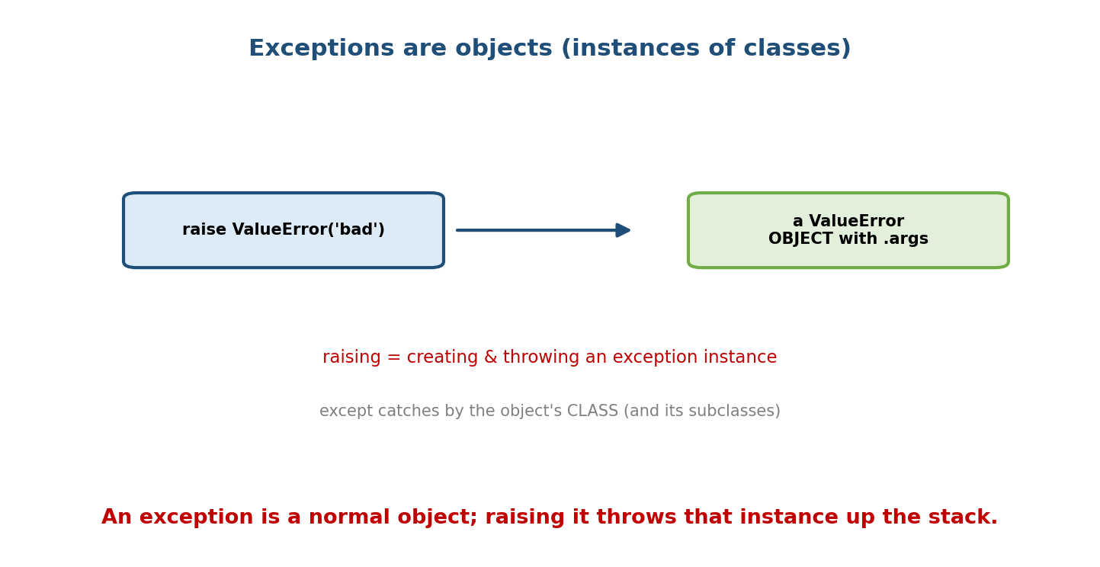
raise ValueError(‘bad’) creates a ValueError object (with .args) and throws it; except catches by the object’s class and its subclasses.
try:
raise ValueError("bad input")
except ValueError as e: # 'e' is the exception OBJECT
print(type(e), e.args) # <class 'ValueError'> ('bad input',)
Because they’re objects, you can give them attributes, methods, and — crucially — subclass them to build meaningful hierarchies.

16.2 The Built-in Exception Hierarchy
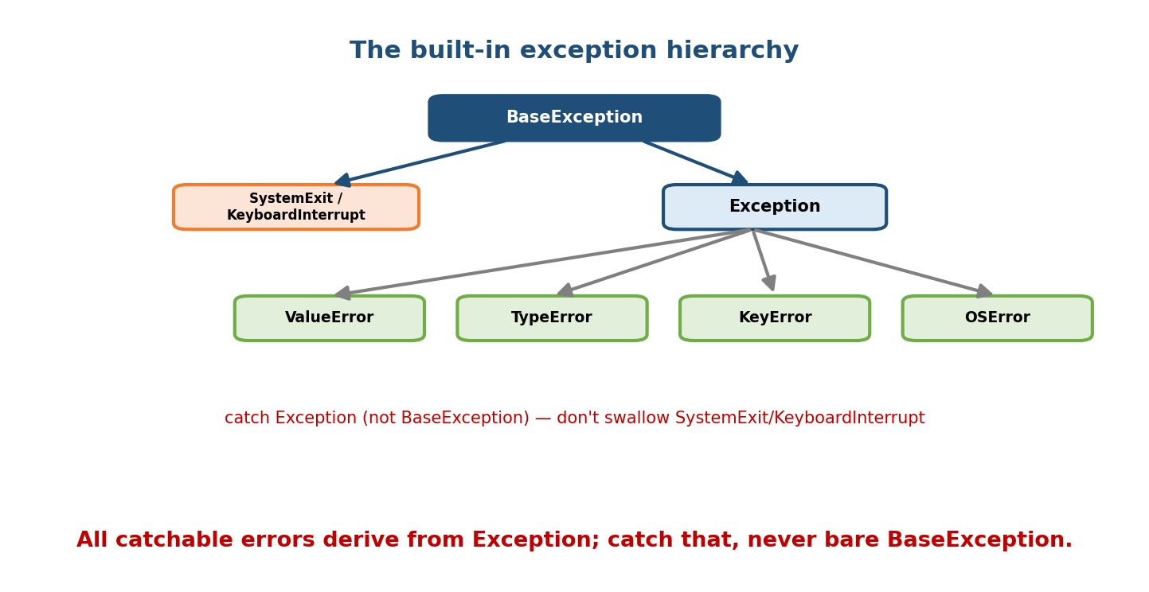
The hierarchy: BaseException at the top; under it SystemExit/KeyboardInterrupt (system-level) and Exception; under Exception the everyday errors ValueError, TypeError, KeyError, OSError.
BaseException
├── SystemExit (sys.exit) \ system-level — usually DON'T catch
├── KeyboardInterrupt (Ctrl-C) /
└── Exception <- catch THIS family for normal errors
├── ArithmeticError -> ZeroDivisionError
├── LookupError -> KeyError, IndexError
├── ValueError, TypeError, OSError, RuntimeError, ...
Key rule: catch Exception, never bare BaseException (or bare except:), because the latter also swallows SystemExit/KeyboardInterrupt — making your program impossible to exit or Ctrl-C.

16.3 try / except / else / finally
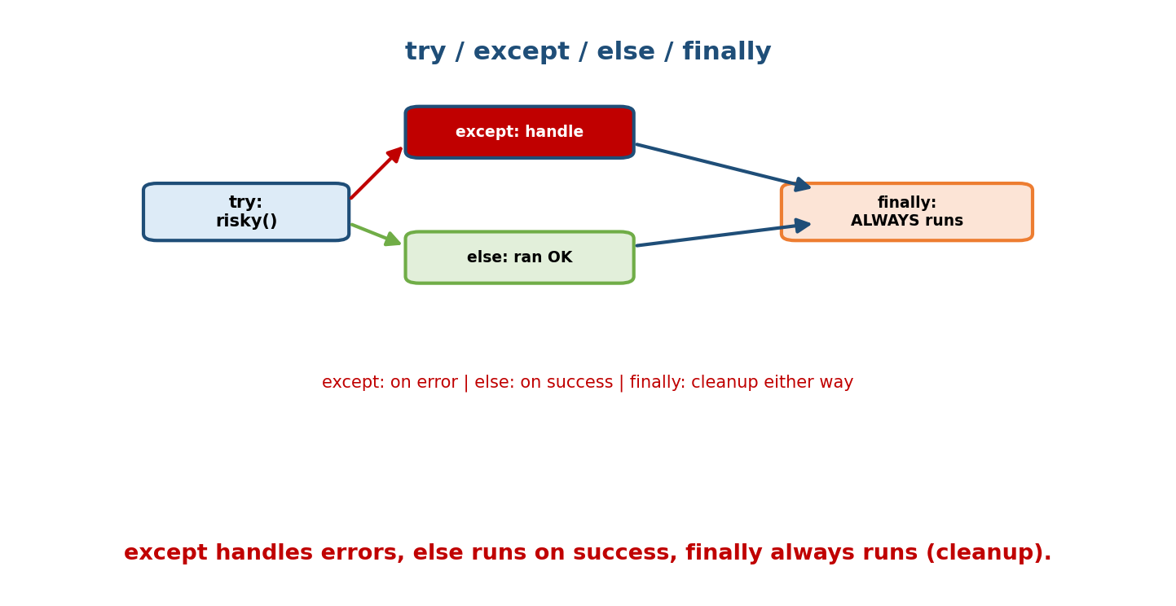
Control flow: try runs risky code; except handles an error; else runs only if no error occurred; finally always runs (cleanup), error or not.
try:
result = risky() # code that might fail
except ValueError as e:
handle(e) # runs only on ValueError
else:
use(result) # runs only if NO exception
finally:
cleanup() # ALWAYS runs (success or failure)
- except — runs on a matching error.
- else — runs only if the try block succeeded (keeps the “success path” out of try, so you don’t accidentally catch errors from use(result)).
- finally — always runs; for releasing resources (though a with block is usually cleaner — Module 7/12).

16.4 Catching a Base Catches Its Subclasses
Because except respects inheritance, catching a base class catches all its subclasses. This is polymorphism applied to error handling.
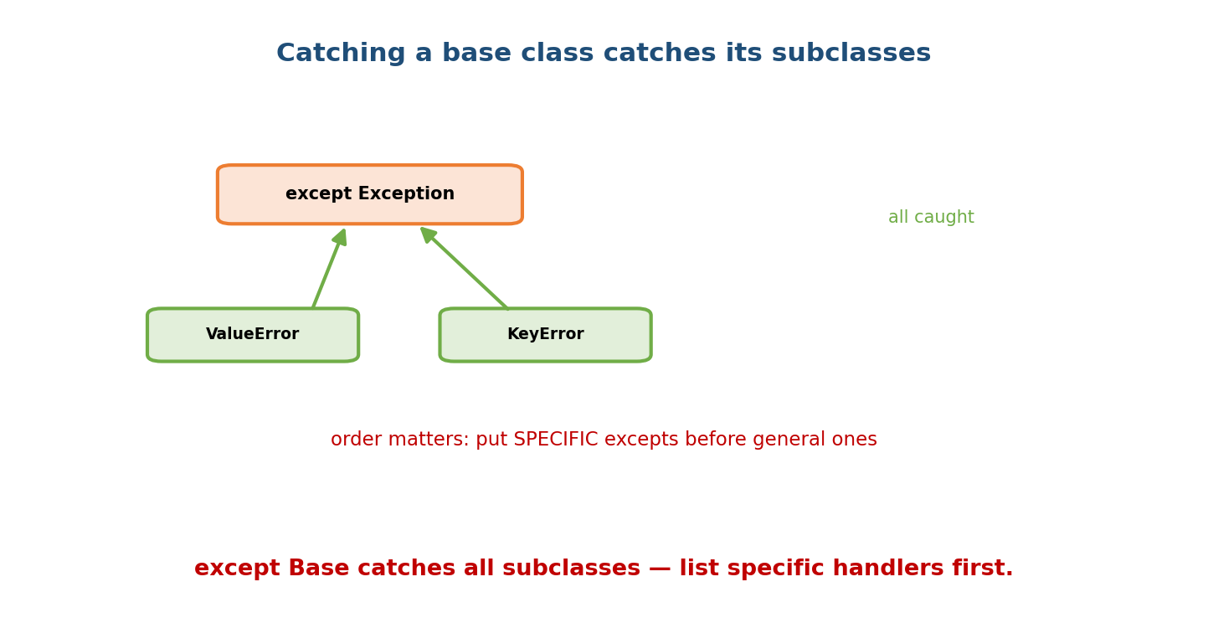
except Exception catches ValueError and KeyError (both subclasses); specific handlers must come before general ones.
try:
...
except FileNotFoundError: # SPECIFIC first
...
except OSError: # broader (FileNotFoundError is an OSError)
...
except Exception: # broadest last
...
Order matters: put specific exceptions before general ones. If except Exception came first, it would catch everything and the specific handlers would be dead code (Python evaluates except clauses top to bottom).

16.5 Designing Custom Exception Hierarchies
For an application/library, define one base exception and specific subclasses. Callers can then catch the whole family or a specific error.
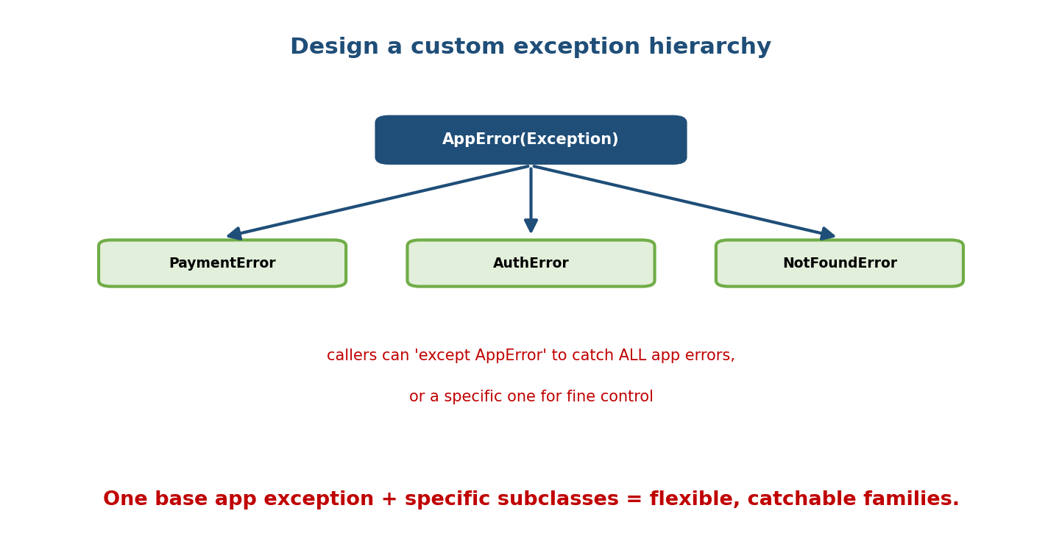
An AppError base (subclass of Exception) with specific subclasses PaymentError, AuthError, NotFoundError; callers can catch AppError for all app errors or a specific one.
class AppError(Exception):
"""Base for all application errors."""
class PaymentError(AppError): ...
class InsufficientFunds(PaymentError):
def __init__(self, needed, available):
super().__init__(f"need {needed}, have {available}")
self.needed, self.available = needed, available
# Caller choices:
try:
charge()
except InsufficientFunds as e: # very specific
retry_with(e.available)
except AppError: # catch ANY application error
log_and_alert()
Benefits: callers aren’t forced to know every leaf type; a single except AppError is a stable contract; and rich attributes (e.needed) carry structured context. This is the OOP payoff for error handling.

16.6 Exception Chaining — raise ... from
When you catch a low-level error and raise a more meaningful one, chain them so the original cause isn’t lost.
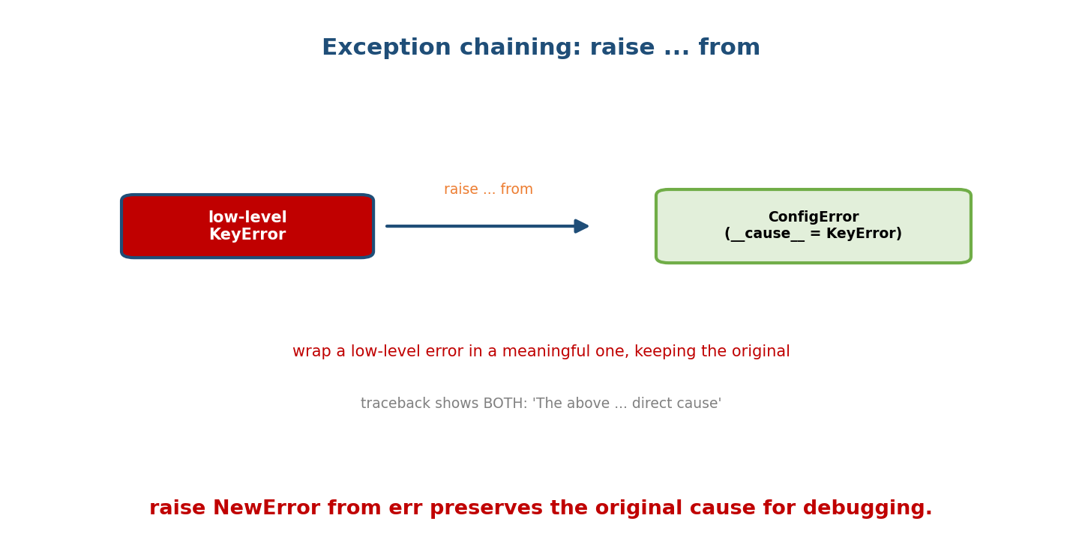
A low-level KeyError is wrapped via raise ConfigError(…) from err, producing a ConfigError whose cause is the KeyError; the traceback shows both.
def load_config(d):
try:
return d["host"]
except KeyError as e:
raise ConfigError("missing 'host'") from e # preserves the cause
# Traceback shows:
# KeyError: 'host'
# The above exception was the direct cause of the following exception:
# ConfigError: missing 'host'
- raise New from original sets __cause__ and prints “direct cause”.
- An exception raised inside an except without from still records __context__ (“During handling of the above exception…”).
- raise ... from None suppresses the chain when the original is noise.

16.7 EAFP vs LBYL
Python culturally prefers EAFP — “Easier to Ask Forgiveness than Permission”: just attempt the operation and catch the failure, rather than LBYL — “Look Before You Leap” (check conditions first).
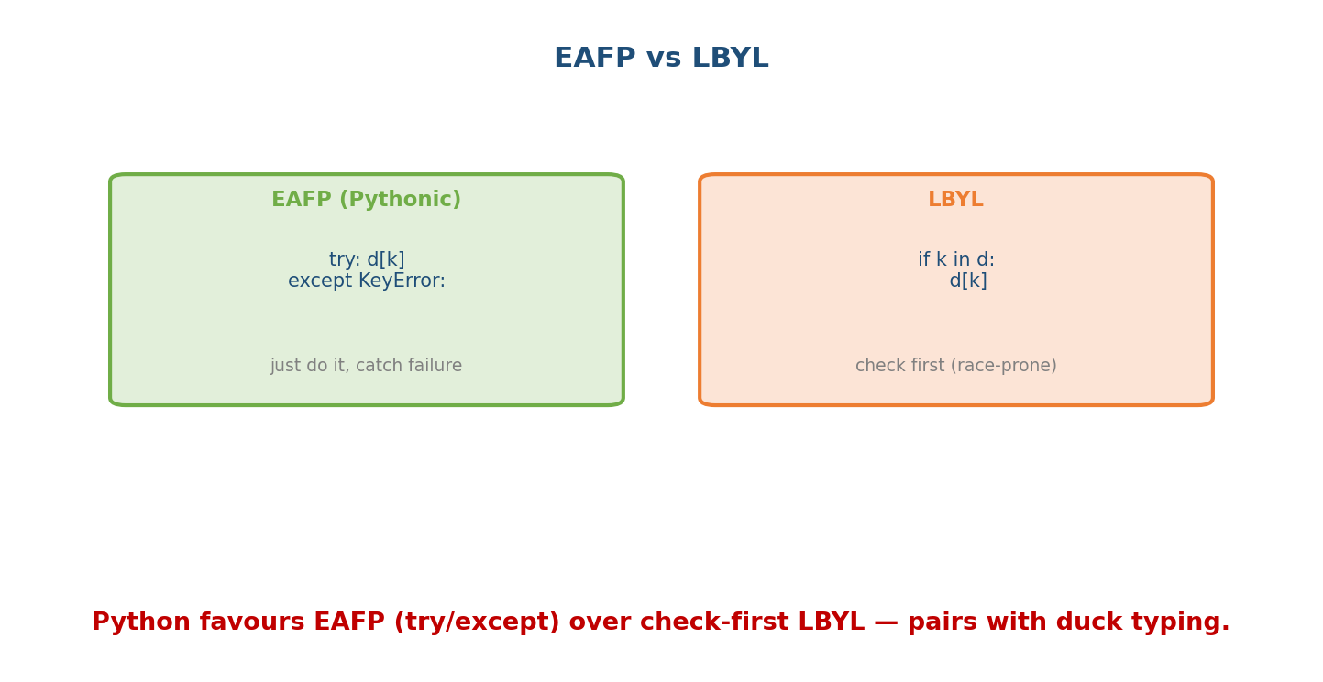
EAFP (Pythonic): try d[k] / except KeyError — just do it and catch failure. LBYL: if k in d: d[k] — check first, which is race-prone.
# EAFP (Pythonic)
try:
value = data[key]
except KeyError:
value = default
# LBYL (check first) — verbose and racy in concurrent code
if key in data:
value = data[key]
else:
value = default
EAFP pairs with duck typing (Module 6): try to use the object, handle it if it can’t. It’s also race-safe — LBYL’s check-then-act can break if state changes between the check and the use (e.g. a file deleted after os.path.exists).

16.8 Best Practices
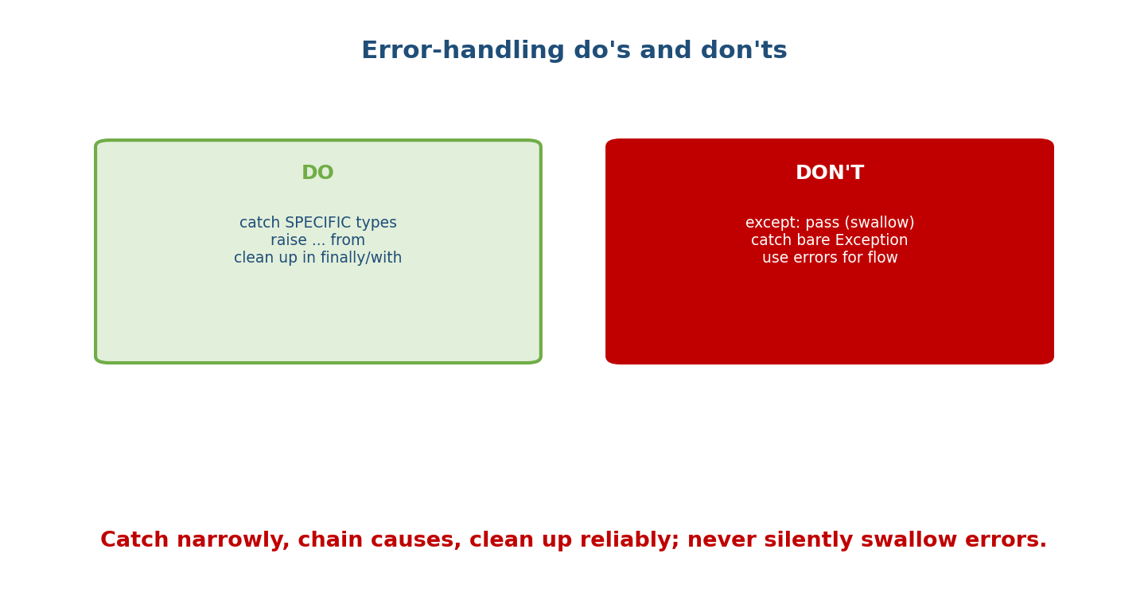
Do: catch specific types, use raise … from, clean up in finally/with. Don’t: except: pass (swallow errors), catch bare Exception, use exceptions for normal control flow.
Do | Don’t
Catch specific exception types | except: / except Exception: pass (silent swallow)
Chain with raise ... from | lose the original cause
Clean up with with / finally | rely on __del__
Define a custom hierarchy | raise bare Exception("...") everywhere
Let unexpected errors propagate | catch-and-ignore
Use EAFP for expected failures | overuse exceptions for normal control flow
Golden rule: never silently swallow an exception. If you catch it, handle it, log it, or re-raise it — but don’t make failures invisible.

Module 16 — Interview Mapping
Question | Junior answer | Senior answer
“Why custom exceptions?” | “Nicer errors.” | “A base app exception + specific subclasses lets callers catch a family or one case; carries structured context; a stable API contract.”
“except Exception vs except:?” | (unsure) | “Bare except/BaseException also catches SystemExit/KeyboardInterrupt — never do it; catch Exception and be specific.”
“EAFP vs LBYL?” | “Try vs check.” | “Python prefers EAFP (try/except) — cleaner, race-safe, pairs with duck typing; LBYL’s check-then-act can race.”
“raise ... from?” | (unaware) | “Chains exceptions, setting __cause__; wraps a low-level error in a meaningful one while preserving the original in the traceback.”

Module 16 — Exam Mapping
- GATE CS: exception-handling flow (try/except/else/finally), hierarchy basics.
- SEBI / RBI IT: basic exception syntax and terms.
- FAANG / backend: custom hierarchies, chaining, EAFP, and error-handling hygiene in code.

Module 16 — Common Mistakes & Misconceptions
- except: pass — swallows everything (including KeyboardInterrupt); hides bugs.
- Catching Exception too broadly when a specific type is meant.
- Wrong except order — general before specific makes specific unreachable.
- Losing the cause — re-raising without from (though __context__ still records it).
- Using exceptions for normal control flow everywhere (overuse).
- Relying on finally for resource cleanup where a with block is clearer.
- Raising bare Exception instead of a specific/custom type.

Module 16 — MCQs (with answers & explanations)
Q1. Which should you generally catch? a) BaseException b) Exception c) bare except: d) object
Answer
b. Exception excludes SystemExit/KeyboardInterrupt.
Q2. finally runs: a) only on error b) only on success c) always d) never
Answer
c. It always executes, for cleanup.
Q3. except OSError will also catch: a) nothing else b) FileNotFoundError (a subclass) c) ValueError d) SystemExit
Answer
b. Catching a base catches its subclasses.
Q4. Handlers should be ordered: a) general first b) specific first, general last c) alphabetical d) any order
Answer
b. Otherwise the general clause shadows specific ones.
Q5. raise NewError from original sets: a) __context__ b) __cause__ c) args d) nothing
Answer
b. Explicit chaining sets __cause__ (“direct cause”).
Q6. EAFP stands for: a) check first b) Easier to Ask Forgiveness than Permission c) an exception type d) a decorator
Answer
b. Try the operation, handle failure — the Pythonic style.
Q7. except: pass is bad because it: a) is slow b) silently swallows all errors, including Ctrl-C c) is a syntax error d) is required
Answer
b. It hides bugs and catches KeyboardInterrupt/SystemExit.
Q8. The else clause of try runs: a) on error b) always c) only if no exception occurred d) before try
Answer
c. It runs on the success path.

Module 16 — Design/Practice Exercises (easy → hard)
- (easy) Write try/except/else/finally around a division and show which clauses run for 4/2 and 4/0.
- (easy) Show that except OSError catches a FileNotFoundError.
- (medium) Design an AppError hierarchy with ValidationError and DatabaseError; catch the family in one handler.
- (medium) Wrap a low-level KeyError in a ConfigError using raise ... from and print the chained traceback.
- (hard) Rewrite an LBYL file-existence check as EAFP and explain the race it avoids.
- (hard, interview) Critique a snippet with except Exception: pass, then fix it with specific catches, chaining, and proper cleanup.

Module 16 — Concept Review (one page)
Exceptions are objects — instances of classes in an inheritance hierarchy rooted at BaseException, with Exception as the base for normal errors (catch Exception, never bare BaseException/except:, which swallow SystemExit/KeyboardInterrupt). try/except/else/finally: except handles matching errors, else runs on success, finally always runs (cleanup). Catching a base catches its subclasses, so order handlers specific-first. Design a custom hierarchy — one base app exception plus specific subclasses carrying structured attributes — so callers can catch a family or a single case. Chain wrapped errors with raise New from original (sets __cause__) to preserve the root cause. Python favours EAFP (try/except) over LBYL (check-first) — cleaner, race-safe, and aligned with duck typing. Above all: never silently swallow exceptions.

Module 16 — Flash Cards (Q → A)
Front | Back
Exceptions are | objects (instances of exception classes)
Root of hierarchy | BaseException; catch Exception
Catch a base → | catches all its subclasses
Handler order | specific first, general last
else clause | runs only if no exception
finally | always runs (cleanup)
Custom hierarchy | base app exception + specific subclasses
raise New from e | chains; sets __cause__
Implicit chain | __context__ (raised during handling)
EAFP | try, then handle failure (Pythonic)
LBYL | check conditions first (race-prone)
Never do | except: pass (silent swallow)

Module 16 — Pattern Recognition
- See “callers need to catch all my library’s errors” → custom base exception.
- See a low-level error leaking to users → wrap + raise ... from.
- See if os.path.exists(...) then open → EAFP (try open except).
- See except Exception: pass → catch specific, handle/log/re-raise.
- See resource that must always close → with (or finally).
- See general except before specific → reorder (specific first).

Module 16 — Revision Notes / Mini Cheat Sheet
EXCEPTIONS = objects; classes in a hierarchy (BaseException -> Exception -> ...).
CATCH Exception (normal errors). NEVER bare except / BaseException (eats SystemExit, Ctrl-C).
try: risky()
except Specific as e: handle # specific FIRST
except Broad: ... # broad LAST
else: on-success # only if no error
finally: cleanup # ALWAYS (prefer 'with')
catch BASE => catches SUBCLASSES. Custom hierarchy: class AppError(Exception); subclasses.
-> callers 'except AppError' (family) or a specific type; attach context attributes.
CHAINING: raise New from original -> __cause__ ("direct cause"); ... from None suppresses.
EAFP (try/except, Pythonic, race-safe) > LBYL (check-first, race-prone). Pairs with duck typing.
DON'T: except: pass (swallow), overuse exceptions for control flow, lose the cause.
Next module: Module 17 — UML & Object-Oriented Design (OOAD). We step back to modelling: reading and drawing UML class diagrams, notating association, aggregation, composition, inheritance, and dependency, plus value objects, multiplicity, and how to go from a problem statement to a class model — the bridge into the LLD interview module.

Module 16 — Summary
Error handling is an OOP topic because exceptions are objects in a class hierarchy. Catch Exception (never bare BaseException/except:), use try/except/else/finally correctly, and remember that catching a base catches its subclasses — so order handlers specific-first. Design a custom exception hierarchy (one base plus specific subclasses with structured context) so callers can catch a family or a single case; chain wrapped errors with raise ... from to keep the root cause; and prefer EAFP over check-first LBYL for cleaner, race-safe code. The overriding discipline: never silently swallow errors — handle, log, or re-raise. Done well, this makes OOP systems robust and debuggable.
You have mastered this module when you can: design a custom exception hierarchy; use try/except/else/finally and correct handler ordering; chain exceptions with raise ... from; and explain EAFP vs LBYL with an example.

