Module 17 — UML & Object-Oriented Analysis and Design (OOAD)
  - OOP with Python Mastery: FAANG Interviews / GATE / SEBI-RBI IT / Backend — In-Depth Notes (with visuals)
Prepared for nidhi.sharma@forensiccybertech.com
2026
Table of Contents

Module 17 — UML & Object-Oriented Analysis and Design (OOAD)
Why this module matters. Before you write classes, you model them — and the shared language for that is UML class diagrams. In an LLD interview you’ll sketch classes and their relationships on a whiteboard; getting the relationship arrows right (inheritance vs composition vs association vs dependency) signals design maturity. This module teaches you to read and draw UML, notate every relationship, use multiplicity, and go from a problem statement to a class model — the direct bridge into Module 18’s full LLD problems.
Importance ratings (out of 5):
Exam / Use | FAANG Interview | GATE CS | SEBI/RBI IT | Backend Dev | LLD Rounds
This module | ★★★★ | ★★★ | ★★ | ★★★ | ★★★★★
Most-asked concepts: UML class box (visibility +/-/#); the six relationships (association, aggregation, composition, generalization/inheritance, realization, dependency) + their arrows; aggregation vs composition notation; multiplicity; deriving classes from requirements (nouns/verbs).
What you must be able to do after this module: read/draw a UML class diagram; pick and notate the correct relationship; label multiplicity; and turn a short requirements paragraph into a class model.

17.1 The UML Class Box
A class is drawn as a three-compartment box: name, attributes, methods. Visibility is marked with symbols.
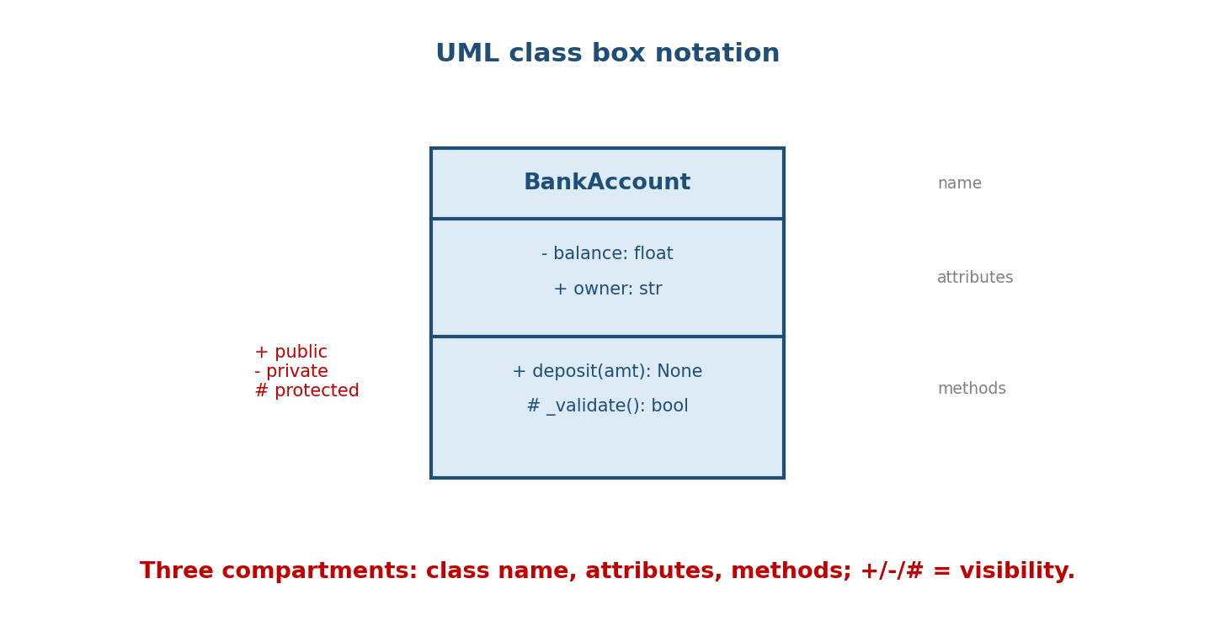
A UML class box for BankAccount with three compartments: name (BankAccount), attributes (- balance: float, + owner: str), methods (+ deposit(amt): None, # _validate(): bool); + public, - private, # protected.
Symbol | Visibility
+ | public
- | private
# | protected
~ | package
Attributes: visibility name: Type. Methods: visibility name(params): ReturnType. (In Python, “private/protected” are conventions — Module 4 — but UML still uses the symbols to express intent.)

17.2 The Six Relationships
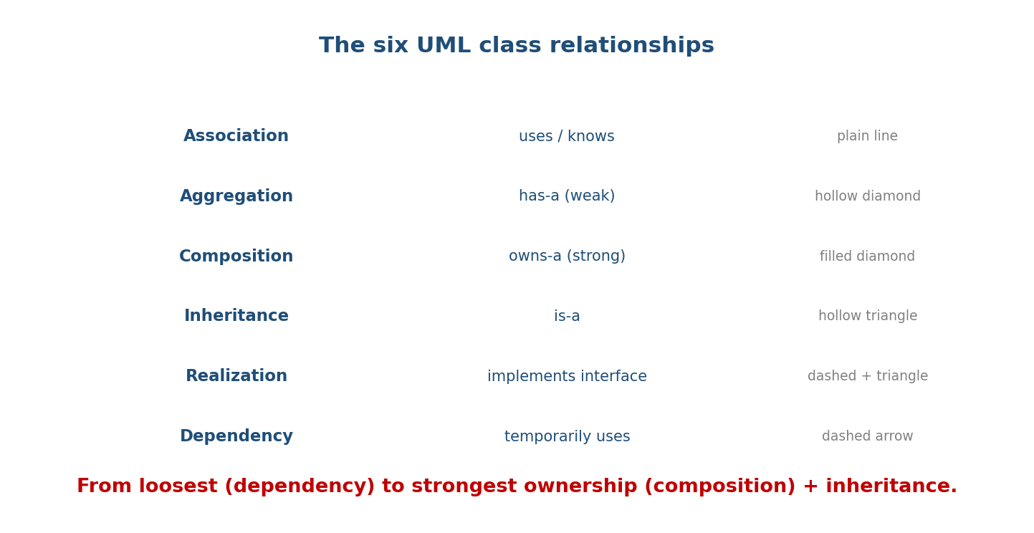
The six UML relationships from loosest to strongest: Association (uses/knows, plain line), Aggregation (has-a weak, hollow diamond), Composition (owns-a strong, filled diamond), Inheritance (is-a, hollow triangle), Realization (implements interface, dashed+triangle), Dependency (temporarily uses, dashed arrow).
Relationship | Meaning | Notation
Dependency | temporarily uses (e.g. a parameter) | dashed arrow - - ->
Association | a lasting link (a stored reference) | solid line
Aggregation | has-a, weak ownership | hollow diamond ◇
Composition | owns-a, strong ownership | filled diamond ◆
Generalization | is-a (inheritance) | solid line + hollow triangle ▷
Realization | implements an interface | dashed line + hollow triangle

17.3 Generalization vs Realization
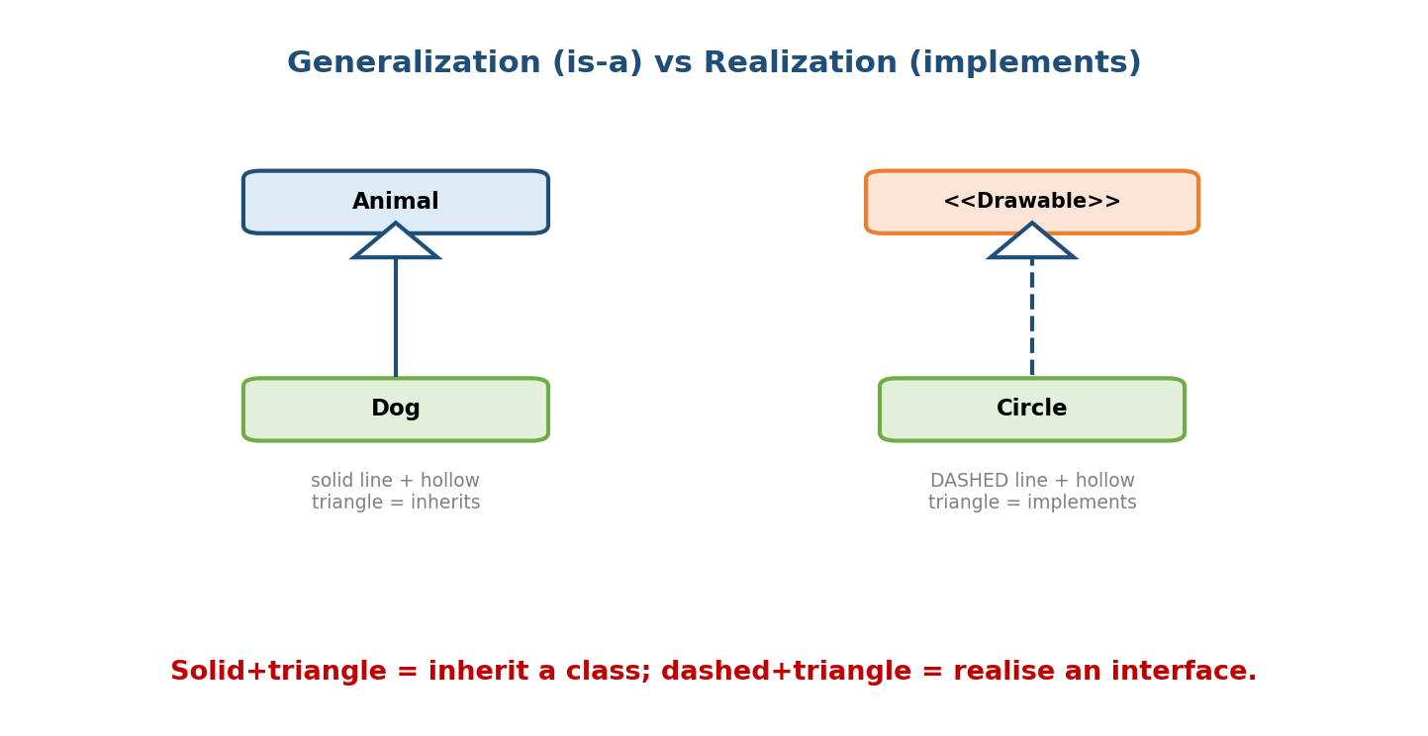
Generalization: Dog inherits Animal via a solid line + hollow triangle (is-a). Realization: Circle implements the <> interface via a dashed line + hollow triangle (implements).
- Generalization (inheritance) — a subclass is-a superclass. Solid line, hollow triangle pointing at the parent. (Python: class Dog(Animal).)
- Realization — a class implements an interface/ABC. Dashed line, hollow triangle pointing at the interface. (Python: implementing a Protocol/ABC.)
The triangle always points to the more abstract end (the parent/interface).

17.4 Aggregation vs Composition (the arrow that trips people)
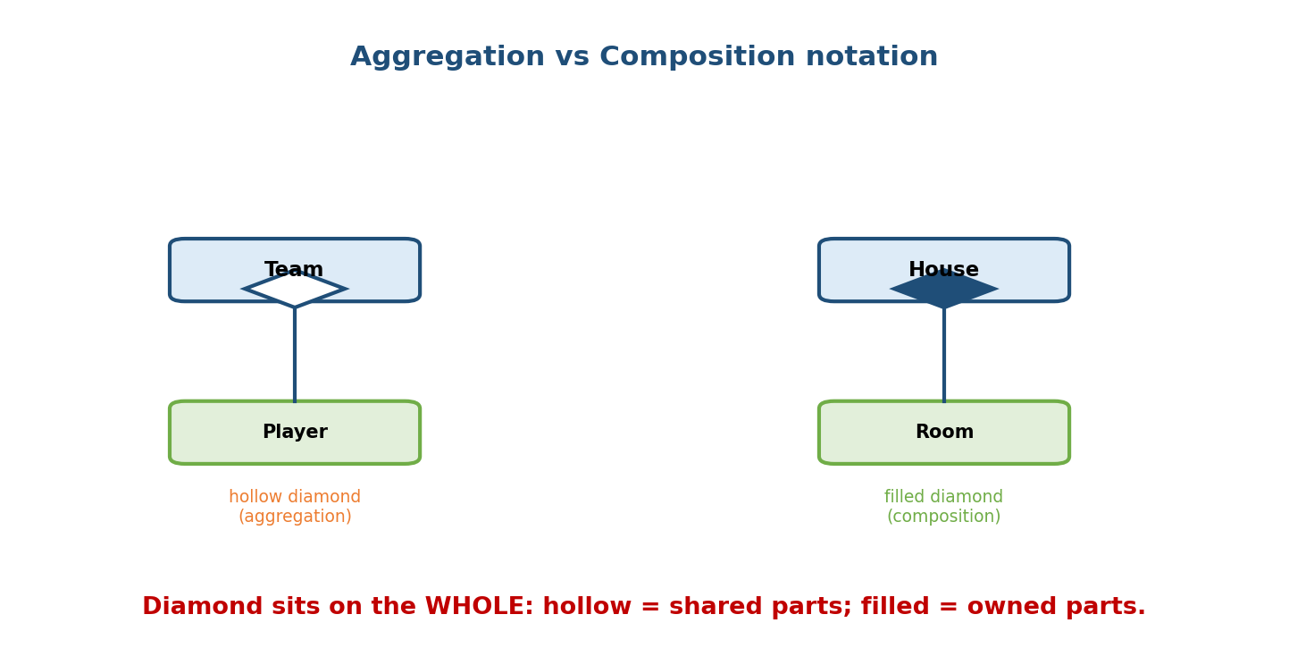
Aggregation: Team has Players via a hollow diamond on the Team end (shared, independent parts). Composition: House has Rooms via a filled diamond on the House end (owned parts that die with the whole).
- Aggregation (◇ hollow) — the whole has parts that can exist independently and be shared. Team ◇— Player (players outlive teams).
- Composition (◆ filled) — the whole owns parts whose lifecycle it controls; parts die with the whole. House ◆— Room.
The diamond sits on the WHOLE (the container), pointing to the part. (Recall Module 5’s Python examples — passing parts in = aggregation; creating/owning them = composition.)

17.5 Multiplicity
Each association end can carry a multiplicity — how many objects participate.
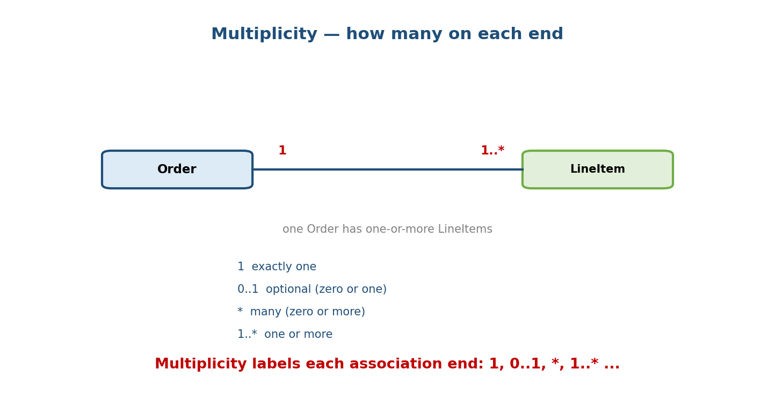
An Order—LineItem association labelled 1 on the Order end and 1..* on the LineItem end: one Order has one-or-more LineItems. Legend: 1 (exactly one), 0..1 (optional), * (many), 1..* (one or more).
Notation | Meaning
1 | exactly one
0..1 | optional (zero or one)
* or 0..* | many (zero or more)
1..* | one or more
2..5 | a specific range
Example: Order (1) —— (1..*) LineItem means “an order has at least one line item; each line item belongs to exactly one order.”

17.6 Dependency vs Association
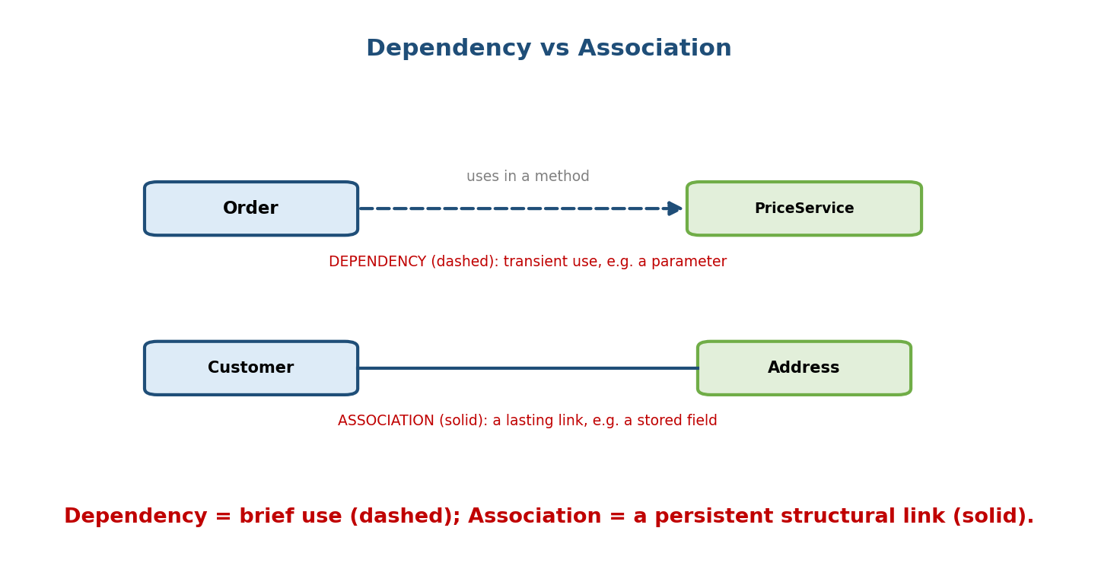
Dependency (dashed arrow): Order uses PriceService transiently, e.g. as a method parameter. Association (solid line): Customer has a lasting link to Address, e.g. a stored field.
- Dependency (dashed) — a transient use: the class uses another inside a method (as a parameter, local, or return) but doesn’t keep a reference.
- Association (solid) — a structural, lasting link: the class stores a reference (an attribute) to the other.
class Order:
def total(self, price_service): # DEPENDENCY: uses it, doesn't store it
return price_service.calc(self)
class Customer:
def __init__(self, address):
self.address = address # ASSOCIATION: stores the reference

17.7 From Requirements to a Class Model (OOAD)
Object-Oriented Analysis and Design turns a problem statement into classes. The starting heuristic (Module 1): nouns → classes/attributes; verbs → methods/ associations.
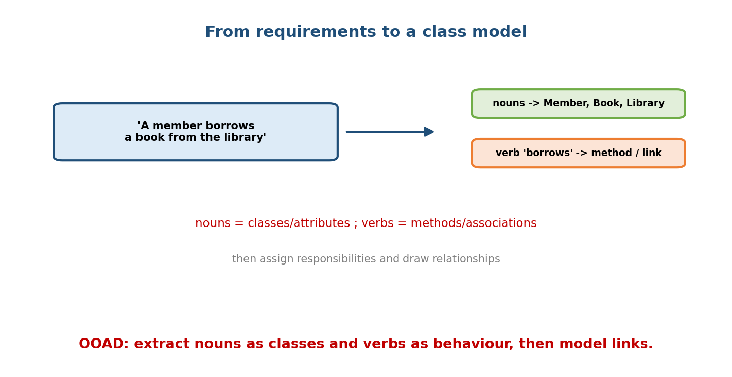
The sentence ‘A member borrows a book from the library’ yields nouns Member/Book/Library (classes) and the verb ‘borrows’ (a method or association); then assign responsibilities and draw relationships.
Process:
- Find candidate classes — the important nouns (Member, Book, Library).
- Find attributes — nouns describing a thing (a book’s title, isbn).
- Find behaviour — the verbs (borrow, return) → methods.
- Find relationships — who owns/uses/knows whom → association/aggregation/ composition.
- Assign responsibilities — each class owns the data and behaviour it’s best placed to handle (high cohesion, low coupling).
- Add multiplicity and refine (apply SOLID, Module 13).
Entities vs value objects: an entity has identity that persists (a User with an id); a value object is defined by its values and is usually immutable (a Money, a Point) — model value objects as frozen dataclasses (Module 10).

17.8 A Worked Class Diagram
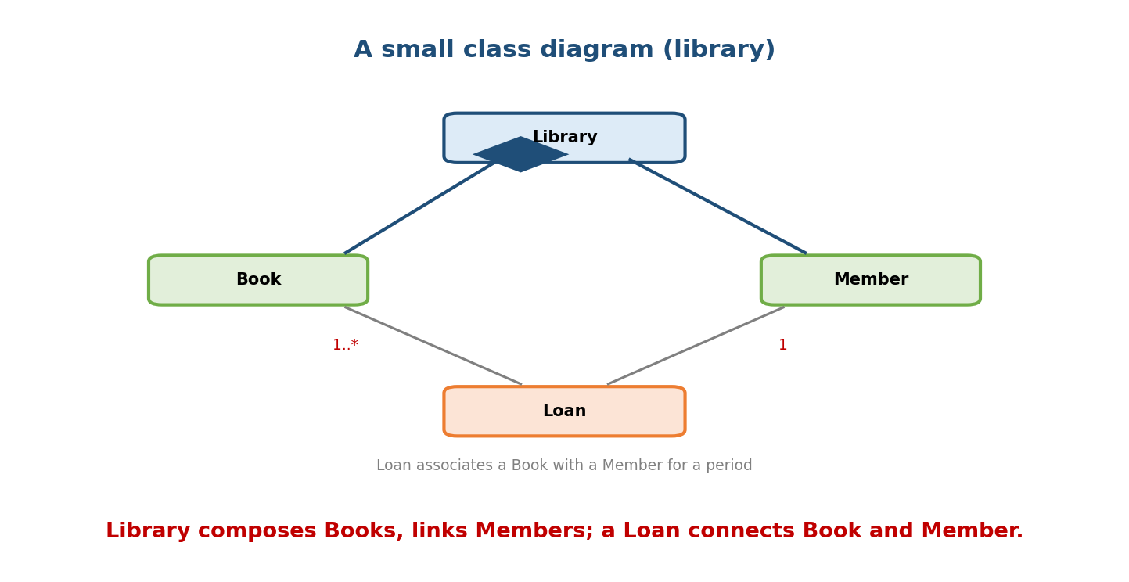
A small library class diagram: Library composes Books (filled diamond) and is associated with Members; a Loan connects a Book (1..*) with a Member (1) for a period.
Reading the diagram:
- Library ◆— Book — composition: the library owns its book copies.
- Library —— Member — association: members are linked to, not owned by, the library.
- Loan — an association class connecting a Book and a Member with loan data (dates). Loans have a 1..* / 1 multiplicity to books/members.
from dataclasses import dataclass, field
from datetime import date
@dataclass
class Book: title: str; isbn: str
@dataclass
class Member: name: str; member_id: str
@dataclass
class Loan: book: Book; member: Member; due: date
@dataclass
class Library:
books: list[Book] = field(default_factory=list) # composition
loans: list[Loan] = field(default_factory=list)
(Other UML diagrams exist — use-case (actors vs features), sequence (message order over time), state (Module 15’s State pattern) — but the class diagram is the one you draw most in OOP/LLD interviews.)

Module 17 — Interview Mapping
Question | Junior answer | Senior answer
“Aggregation vs composition in UML?” | “Diamonds.” | “Hollow diamond = aggregation (parts independent/shared); filled = composition (parts owned, die with the whole); diamond sits on the whole.”
“Association vs dependency?” | (blurs) | “Association = stored, lasting link (attribute); dependency = transient use (parameter/local); solid vs dashed.”
“How do you model X?” | (jumps to code) | Extracts nouns→classes, verbs→methods, identifies relationships + multiplicity, assigns responsibilities (cohesion/coupling), then codes.
“Entity vs value object?” | (unaware) | “Entity has persistent identity (id); value object is defined by value and usually immutable (frozen dataclass).”

Module 17 — Exam Mapping
- GATE CS: UML relationship notation; class diagram reading; multiplicity.
- SEBI / RBI IT: basic UML terms.
- FAANG / LLD rounds: you’ll draw class diagrams and be judged on correct relationships and responsibility assignment.

Module 17 — Common Mistakes & Misconceptions
- Confusing aggregation and composition diamonds (hollow vs filled; lifecycle).
- Putting the diamond on the part instead of the whole.
- Using inheritance where composition fits (Module 5) — modelled as a triangle when it should be a diamond/line.
- Association vs dependency — storing a reference (association) vs using in a method (dependency).
- Over-modelling — a diagram with every getter/setter; show what matters.
- Triangle pointing the wrong way — it points to the parent/interface.

Module 17 — MCQs (with answers & explanations)
Q1. A filled diamond denotes: a) aggregation b) composition c) dependency d) inheritance
Answer
b. Filled diamond = composition (owned parts).
Q2. Inheritance is shown by: a) dashed arrow b) solid line + hollow triangle c) filled diamond d) plain line
Answer
b. Generalization: solid line, hollow triangle to the parent.
Q3. 1..* means: a) exactly one b) zero or one c) one or more d) zero or more
Answer
c. At least one.
Q4. A dashed line with a hollow triangle means: a) dependency b) association c) realization (implements interface) d) aggregation
Answer
c. Realization — implementing an interface/ABC.
Q5. Storing another object as an attribute is best shown as: a) dependency b) association c) realization d) nothing
Answer
b. A lasting structural link = association.
Q6. In OOAD, nouns typically map to: a) methods b) classes/attributes c) loops d) exceptions
Answer
b. Nouns → classes/attributes; verbs → methods.
Q7. The diamond in aggregation/composition sits on: a) the part b) the whole (container) c) both ends d) neither
Answer
b. On the whole, pointing to the part.
Q8. A value object is best characterised as: a) has a persistent id b) defined by its values, usually immutable c) always mutable d) a metaclass
Answer
b. E.g. a Money/Point modelled as a frozen dataclass.

Module 17 — Design/Practice Exercises (easy → hard)
- (easy) Draw a UML class box for a Car with brand, speed, drive(), and correct visibility symbols.
- (easy) Name the notation for each: is-a, owns-a, has-a (weak), implements, transient use.
- (medium) Model “A playlist contains many songs; a song can be in many playlists” — pick the relationship and multiplicity.
- (medium) From “A customer places orders; each order has line items and one shipping address,” draw the class diagram.
- (hard) Model a parking lot at class-diagram level (Vehicle, Spot, Ticket, Lot) with correct relationships and multiplicity.
- (hard, interview) Given a two-paragraph spec, produce a class diagram and justify each aggregation/composition/association choice.

Module 17 — Concept Review (one page)
UML class diagrams are the shared language for modelling OOP. A class is a three-compartment box (name, attributes, methods) with visibility markers (+/-/#). Six relationships, from loosest to strongest: dependency (dashed arrow — transient use), association (solid line — a stored, lasting link), aggregation (hollow diamond — weak, shared ownership), composition (filled diamond — strong ownership; parts die with the whole; diamond on the whole), generalization/inheritance (solid line + hollow triangle — is-a), and realization (dashed line + triangle — implements an interface). Multiplicity (1, 0..1, *, 1..*) labels each end. OOAD turns requirements into a model: nouns → classes/attributes, verbs → methods/associations, then assign responsibilities (high cohesion, low coupling), add multiplicity, and refine with SOLID. Distinguish entities (persistent identity) from value objects (defined by value, immutable).

Module 17 — Flash Cards (Q → A)
Front | Back
Class box compartments | name / attributes / methods
Visibility symbols | + public, - private, # protected
Dependency notation | dashed arrow (transient use)
Association notation | solid line (stored link)
Aggregation notation | hollow diamond ◇ (weak, shared)
Composition notation | filled diamond ◆ (owned, dies with whole)
Inheritance notation | solid line + hollow triangle (is-a)
Realization notation | dashed line + hollow triangle (implements)
Diamond sits on | the whole (container)
Multiplicity examples | 1, 0..1, , 1..
OOAD heuristic | nouns → classes/attrs; verbs → methods
Entity vs value object | persistent id vs value-defined/immutable

Module 17 — Pattern Recognition
- See “X owns Y; Y dies with X” → composition (filled diamond).
- See “X has Y; Y lives independently” → aggregation (hollow diamond).
- See “X is a kind of Y” → generalization (triangle).
- See “X implements interface I” → realization (dashed + triangle).
- See “X uses Y only inside a method” → dependency (dashed arrow).
- See a requirements paragraph → extract nouns/verbs → classes/methods.

Module 17 — Revision Notes / Mini Cheat Sheet
CLASS BOX: [Name | attributes | methods]; visibility + public / - private / # protected.
attr: vis name: Type method: vis name(params): ReturnType
RELATIONSHIPS (loose -> strong):
Dependency dashed arrow transient use (parameter/local)
Association solid line stored, lasting link (attribute)
Aggregation hollow diamond ◇ has-a, weak, parts independent/shared
Composition filled diamond ◆ owns-a, parts die with whole (diamond on WHOLE)
Generalization solid + hollow triangle ▷ is-a (inheritance)
Realization dashed + hollow triangle implements interface/ABC
(triangle/diamond point to the MORE ABSTRACT / WHOLE end)
MULTIPLICITY: 1 | 0..1 | * (0..*) | 1..* | 2..5.
OOAD: nouns->classes/attrs, verbs->methods/associations; assign responsibilities
(high cohesion, low coupling); add multiplicity; refine with SOLID.
Entity (persistent id) vs Value object (value-defined, immutable -> frozen dataclass).
Next module: Module 18 — Low-Level Design (LLD): FAANG Systems. We put it all together on the interview’s marquee question type: designing real systems (parking lot, elevator, deck of cards, rate limiter) from requirements to a class model to Python code — applying pillars, SOLID, patterns, and UML end to end.

Module 17 — Summary
UML class diagrams are how you model and communicate OOP designs. Classes are three-compartment boxes with visibility markers; their relationships — dependency (dashed, transient), association (solid, stored link), aggregation (hollow diamond, weak ownership), composition (filled diamond, strong ownership), generalization (triangle, is-a), and realization (dashed + triangle, implements) — capture how objects connect, refined with multiplicity. OOAD derives a model from requirements by turning nouns into classes and verbs into methods, assigning responsibilities for cohesion and low coupling, and distinguishing entities from value objects. This modelling fluency is exactly what you’ll deploy — on a whiteboard — in the low-level-design interview.
You have mastered this module when you can: draw a correct UML class box; choose and notate the right relationship (and put diamonds/triangles the right way round); label multiplicity; and convert a requirements paragraph into a class model.

