Module 18 — Low-Level Design (LLD): FAANG Systems
  - OOP with Python Mastery: FAANG Interviews / GATE / SEBI-RBI IT / Backend — In-Depth Notes (with visuals)
Prepared for nidhi.sharma@forensiccybertech.com
2026
Table of Contents

Module 18 — Low-Level Design (LLD): FAANG Systems
Why this module matters. This is the interview’s marquee OOP question: “Design a parking lot / elevator / deck of cards / rate limiter.” It’s where everything from Modules 1–17 comes together — pillars, SOLID, patterns, UML — under time pressure, on a whiteboard. The good news: LLD is a repeatable process, not raw talent. This module gives you that process and three fully worked designs in Python so you can pattern-match any new prompt.
Importance ratings (out of 5):
Exam / Use | FAANG Interview | GATE CS | SEBI/RBI IT | Backend Dev | LLD Rounds
This module | ★★★★★ | ★ | ★ | ★★★★ | ★★★★★
Most-asked concepts: the LLD approach (clarify → entities → relationships → patterns → code); classic problems (parking lot, elevator, deck of cards, rate limiter, vending machine, BookMyShow, splitwise); which pattern fits which sub-problem; designing for extensibility.
What you must be able to do after this module: run the LLD process on a fresh prompt; identify entities and relationships; choose the right patterns; write clean, extensible Python classes; and articulate trade-offs and extensions.

18.1 The LLD Process (do this every time)
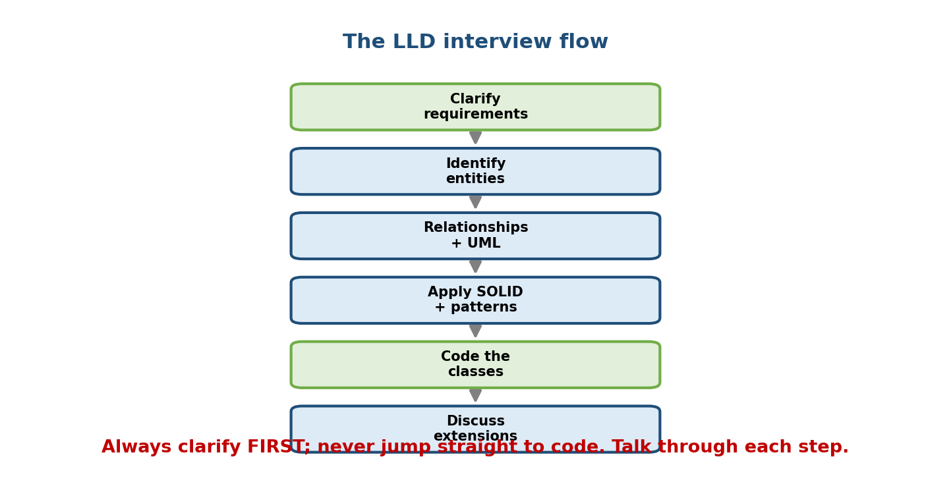
The LLD flow: clarify requirements, identify entities, define relationships + UML, apply SOLID + patterns, code the classes, discuss extensions — in order, top to bottom.
- Clarify requirements — ask about scope, scale, features. Never jump to code. (e.g. “Multiple floors? Payment? Vehicle types?”)
- Identify entities — nouns → classes (Module 17). List core objects.
- Define relationships & responsibilities — who owns/uses whom; draw a quick UML class sketch; assign each class one job (SRP).
- Apply SOLID + patterns — spot where Strategy/State/Factory/Observer fit.
- Code the classes — interfaces first, then implementations; use enums/ dataclasses.
- Discuss extensions & trade-offs — “how would you add X?”, concurrency, persistence.
Interviewers score communication as much as code. Think out loud, state assumptions, and evolve the design.

18.2 Worked Example 1 — Parking Lot
Clarified requirements: multiple levels; spots sized for bike/car/truck; issue a ticket on entry; pluggable spot-allocation policy; compute fee on exit.
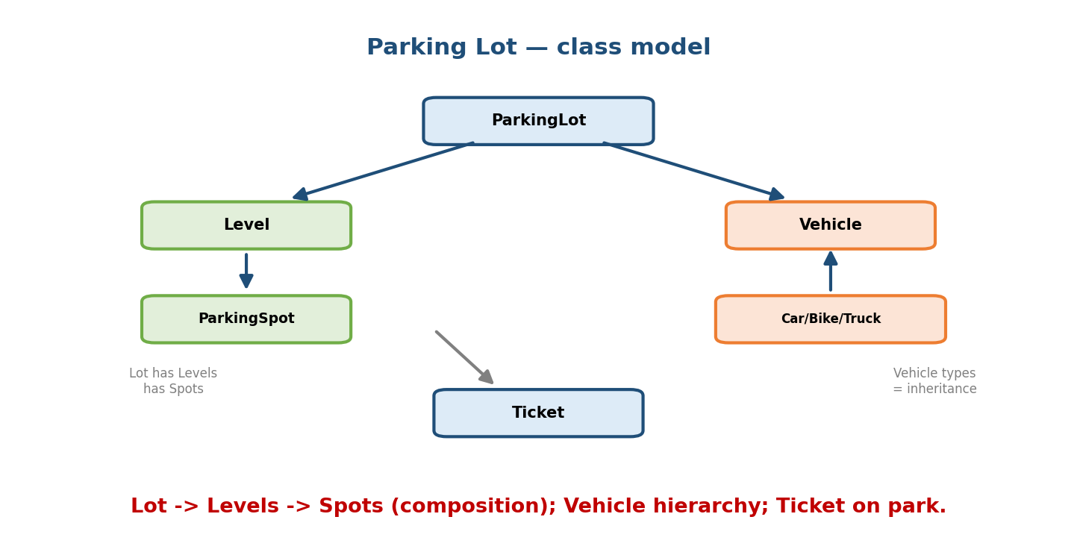
Parking Lot class model: ParkingLot composes Levels which compose ParkingSpots; a Vehicle hierarchy (Car/Bike/Truck) via inheritance; a Ticket issued on park.
from abc import ABC, abstractmethod
from dataclasses import dataclass, field
from enum import Enum, auto
class VehicleSize(Enum):
BIKE = auto(); CAR = auto(); TRUCK = auto()
class Vehicle(ABC): # inheritance: vehicle hierarchy
def __init__(self, plate): self.plate = plate
@property
@abstractmethod
def size(self) -> VehicleSize: ...
class Car(Vehicle):
size = VehicleSize.CAR
class Bike(Vehicle):
size = VehicleSize.BIKE
@dataclass
class ParkingSpot:
id: str
size: VehicleSize
occupied_by: Vehicle | None = None
def is_free(self, v): return self.occupied_by is None and self.size == v.size
@dataclass
class Ticket:
vehicle: Vehicle
spot: ParkingSpot
entry_time: float
Spot allocation as a Strategy (so the policy is pluggable — OCP):
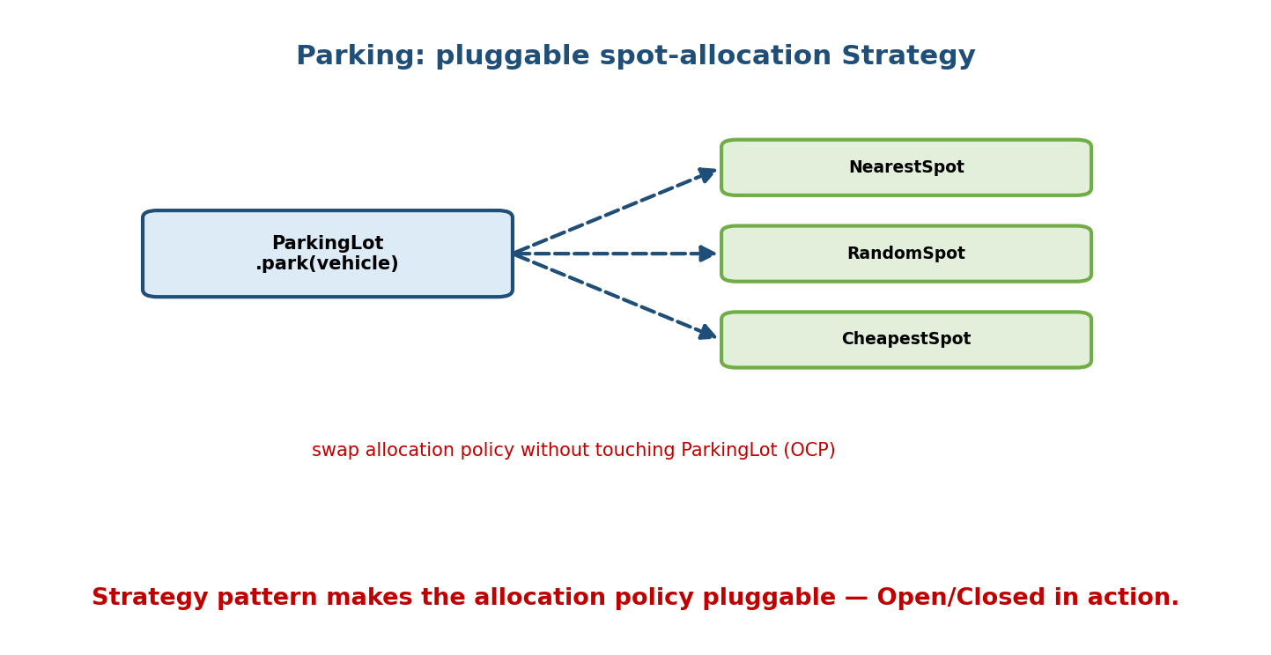
Parking uses a Strategy: ParkingLot.park(vehicle) delegates to an allocation strategy (NearestSpot / RandomSpot / CheapestSpot) chosen without modifying the lot.
class AllocationStrategy(ABC):
@abstractmethod
def find_spot(self, spots, vehicle) -> ParkingSpot | None: ...
class NearestFirst(AllocationStrategy):
def find_spot(self, spots, vehicle):
return next((s for s in spots if s.is_free(vehicle)), None)
class ParkingLot:
def __init__(self, spots, strategy: AllocationStrategy):
self.spots = spots
self.strategy = strategy # Dependency Injection (DIP)
def park(self, vehicle) -> Ticket:
spot = self.strategy.find_spot(self.spots, vehicle)
if spot is None:
raise NoSpotAvailable(vehicle)
spot.occupied_by = vehicle
return Ticket(vehicle, spot, entry_time=0.0)
Patterns used: inheritance (Vehicle), composition (Lot→Level→Spot), Strategy (allocation), DIP/DI (strategy injected). Extensions to mention: payment (Strategy again), multiple levels, concurrency (locks per spot).

18.3 Worked Example 2 — Elevator System
Clarified requirements: N floors; internal + external requests; a scheduling policy; the elevator has modes (idle/up/down).
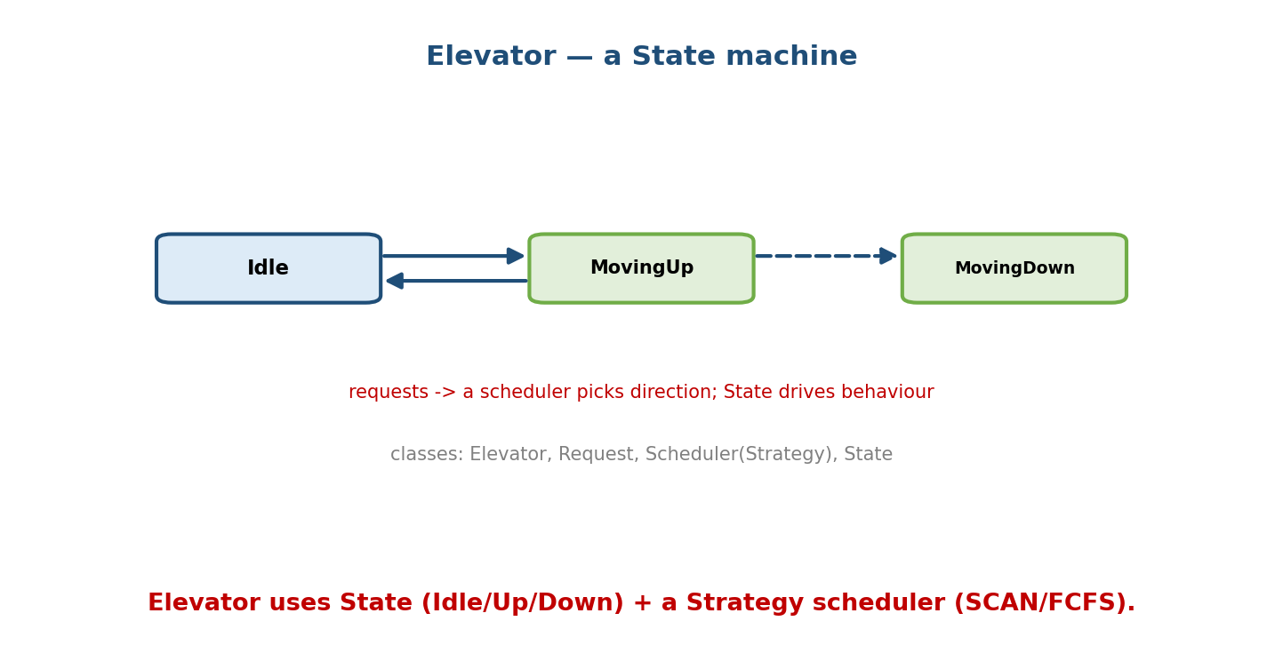
Elevator as a State machine: Idle transitions to MovingUp/MovingDown and back; a scheduler picks direction while State drives behaviour.
from enum import Enum, auto
import heapq
class Direction(Enum):
UP = auto(); DOWN = auto(); IDLE = auto()
class Elevator:
def __init__(self):
self.floor = 0
self.direction = Direction.IDLE
self._up = [] # min-heap of up requests
self._down = [] # max-heap (negated) of down requests
def request(self, floor):
if floor > self.floor: heapq.heappush(self._up, floor)
elif floor < self.floor: heapq.heappush(self._down, -floor)
def step(self): # SCAN-like scheduling (Strategy-able)
if self.direction == Direction.UP and self._up:
self.floor = heapq.heappop(self._up)
elif self._down:
self.direction = Direction.DOWN
self.floor = -heapq.heappop(self._down)
else:
self.direction = Direction.IDLE
Patterns used: State (direction drives behaviour), Strategy (scheduling algorithm: FCFS vs SCAN), Observer (floor displays subscribe to position). Extensions: multiple elevators + a dispatcher, capacity limits, priority requests.

18.4 Worked Example 3 — Deck of Cards
Clarified requirements: standard 52-card deck; shuffle; deal N; cards are immutable/comparable.
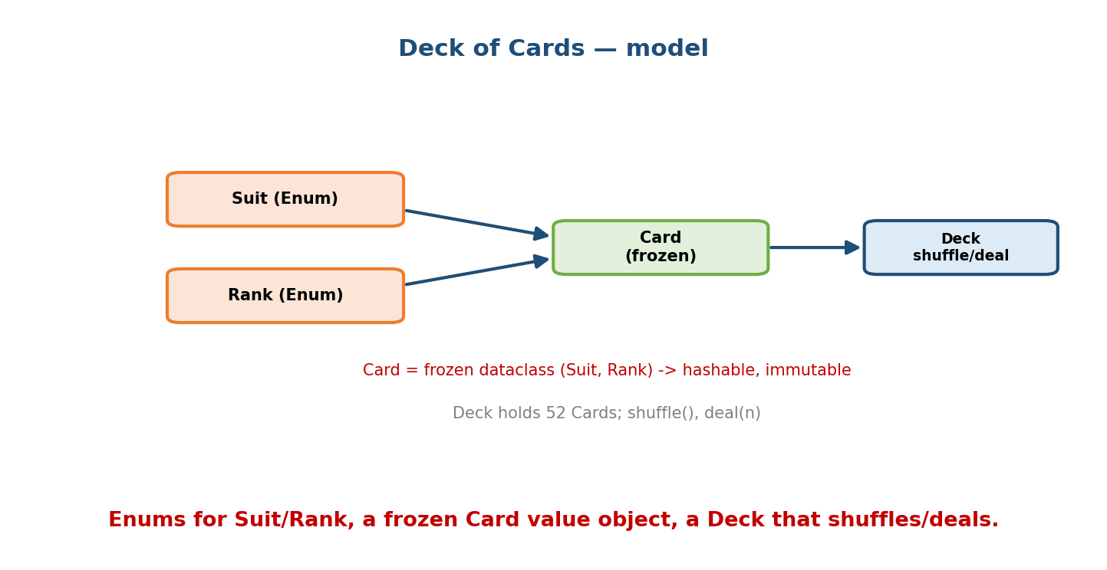
Deck of Cards model: Suit and Rank are Enums; Card is a frozen (immutable, hashable) dataclass of (Suit, Rank); Deck holds 52 Cards with shuffle() and deal(n).
from dataclasses import dataclass
from enum import Enum
import random
class Suit(Enum):
HEARTS = "H"; DIAMONDS = "D"; CLUBS = "C"; SPADES = "S"
class Rank(Enum):
TWO = 2; THREE = 3; # ...
JACK = 11; QUEEN = 12; KING = 13; ACE = 14
@dataclass(frozen=True, order=True) # immutable, hashable, sortable
class Card:
rank: Rank
suit: Suit
class Deck:
def __init__(self):
self.cards = [Card(r, s) for s in Suit for r in Rank] # 52 cards
def shuffle(self): random.shuffle(self.cards)
def deal(self, n):
dealt, self.cards = self.cards[:n], self.cards[n:]
return dealt
Patterns/tools used: Enum (Suit/Rank), frozen dataclass value object (Card), composition (Deck has Cards). Extensions: multiple decks, a Hand class, a Game (Template Method for turn structure).

18.5 Worked Example 4 — Rate Limiter (Token Bucket)
Clarified requirements: allow up to R requests/sec per user; smooth bursts.
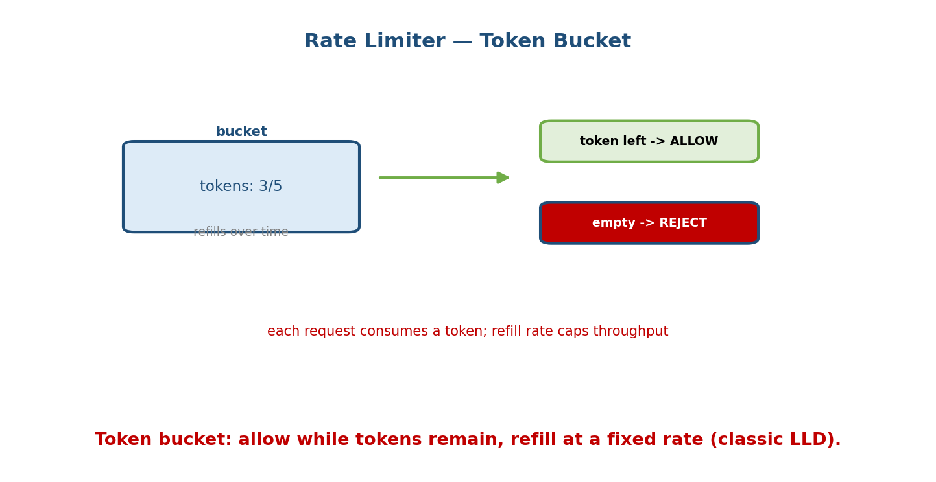
Token bucket rate limiter: a bucket holds tokens (3/5) that refill over time; each request consumes a token — allow if one remains, reject if empty.
class TokenBucket:
def __init__(self, capacity: int, refill_rate: float):
self.capacity = capacity
self.tokens = capacity
self.refill_rate = refill_rate # tokens per second
self.last = 0.0 # last refill timestamp (injected clock)
def allow(self, now: float) -> bool:
self.tokens = min(self.capacity,
self.tokens + (now - self.last) * self.refill_rate)
self.last = now
if self.tokens >= 1:
self.tokens -= 1
return True # request allowed
return False # rate limited
Design notes: inject the clock (now) for testability (DIP); one bucket per user (a dict/Factory). Alternatives to discuss: fixed/sliding window, leaky bucket; distributed limiting (Redis). This connects OOP to system design.

18.6 Which Pattern for Which Sub-Problem
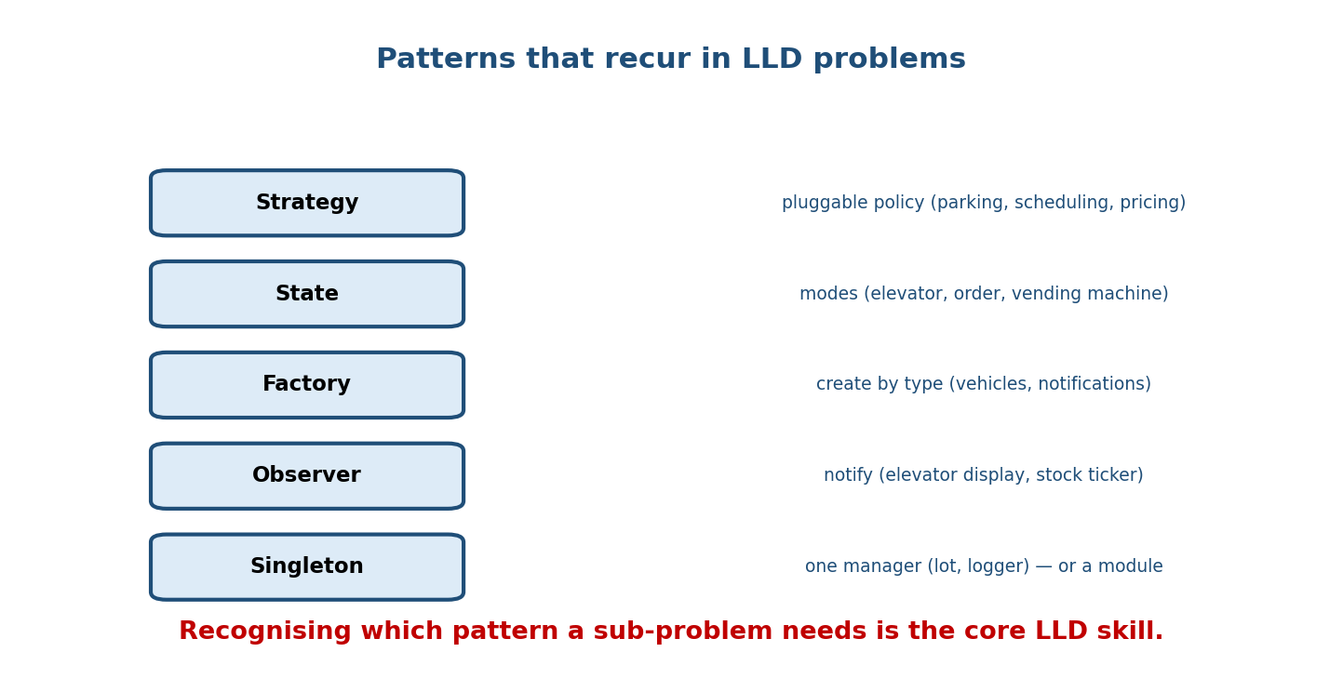
Patterns recurring in LLD: Strategy (pluggable policy — parking, scheduling, pricing), State (modes — elevator, order, vending), Factory (create by type — vehicles, notifications), Observer (notify — displays, tickers), Singleton (one manager — lot, logger, or a module).
Sub-problem | Pattern
Pluggable policy (allocation, pricing, scheduling) | Strategy
Object behaves differently by mode/status | State
Create objects by type/config | Factory
Notify many parts of a change | Observer
One shared manager/registry | Singleton (or a module)
Undo/redo, command queue | Command
Build a complex object stepwise | Builder
Recognising these mappings fast is the core LLD skill — most designs are 2–4 of these composed.

18.7 What Interviewers Score
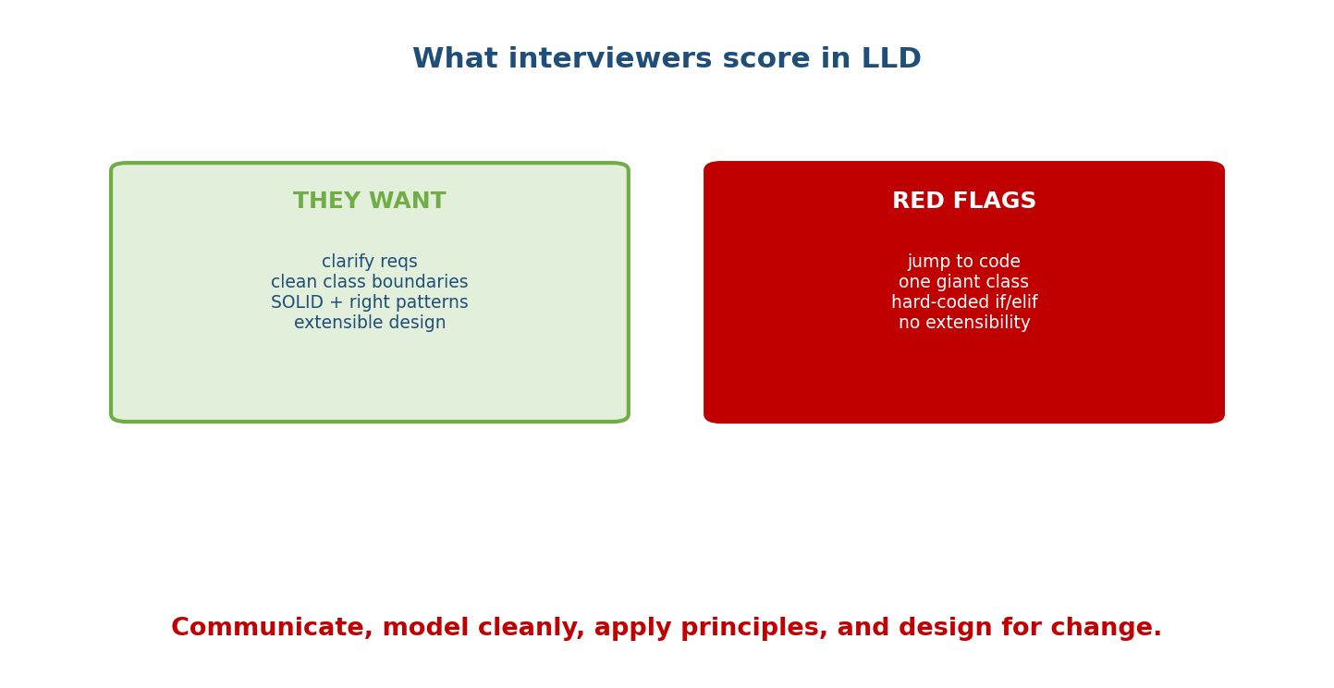
LLD scoring: they want clarified requirements, clean class boundaries, SOLID + right patterns, extensible design; red flags are jumping to code, one giant class, hard-coded if/elif, and no extensibility.
- Green: you clarify first, define clean class boundaries (SRP), apply SOLID and the right patterns, and design for extension.
- Red flags: jumping straight to code, one god class, hard-coded if/elif ladders (should be Strategy/polymorphism), and a design that can’t absorb the “now add X” follow-up.

18.8 A Bank of Classic LLD Prompts
Practice these (each maps to patterns you now know):
Prompt | Key patterns
Parking Lot | Strategy, composition, Factory
Elevator / Lift system | State, Strategy, Observer
Deck of Cards / Card game | Enum, value object, Template Method
Rate Limiter | Strategy (algorithm), Factory (per-user)
Vending Machine | State (idle/paid/dispensing)
BookMyShow / movie booking | Strategy (seat pricing), Observer, locking
Splitwise | composition, Strategy (split types)
Logger | Singleton/module, Chain of Responsibility (levels)
Notification service | Observer, Strategy (channel), Factory
Chess / Tic-Tac-Toe | State, Strategy (rules), composition

Module 18 — Interview Mapping
Question | Junior answer | Senior answer
“Design a parking lot.” | Jumps to classes. | Clarifies (levels, sizes, payment), sketches entities + UML, uses Strategy for allocation, DI for policy, discusses extensions & concurrency.
“Where’s a pattern here?” | (misses) | Maps sub-problems to Strategy/State/Factory/Observer explicitly.
“How would you add feature X?” | (rewrites) | Shows the design already supports it via a new subclass/strategy (OCP).
“How do you avoid a god class?” | (unsure) | SRP: split responsibilities; composition; each class one job.

Module 18 — Exam Mapping
- GATE / PSU: not directly (this is interview-focused).
- FAANG / product LLD rounds: the core round — process, class design, patterns, and extensibility under time pressure.

Module 18 — Common Mistakes & Misconceptions
- Skipping clarification — designing the wrong thing.
- God class — one class doing everything (violates SRP).
- Hard-coded if/elif for policies — use Strategy/polymorphism.
- Over-engineering — 15 patterns for a toy; match complexity to requirements.
- Ignoring extensibility — can’t answer “now add trucks / a new pricing rule”.
- No enums/dataclasses — verbose, error-prone models.
- Forgetting concurrency in shared-resource designs (mention locks).

Module 18 — MCQs (with answers & explanations)
Q1. The first step in an LLD interview is: a) write classes b) clarify requirements c) pick patterns d) code the DB
Answer
b. Clarify scope/features before designing.
Q2. Pluggable spot-allocation in a parking lot is best modelled with: a) State b) Strategy c) Singleton d) Observer
Answer
b. Interchangeable allocation policies = Strategy.
Q3. An elevator’s idle/up/down behaviour fits: a) Factory b) State c) Builder d) Adapter
Answer
b. Behaviour changes with internal state.
Q4. A Card should be modelled as: a) mutable class b) frozen dataclass (immutable, hashable value object) c) dict d) tuple of strings
Answer
b. Cards are value objects — immutable and hashable.
Q5. A token-bucket rate limiter’s clock should be: a) hard-coded b) injected (for testability) c) global d) random
Answer
b. Inject the clock (DIP) so you can test without real time.
Q6. Hard-coded if kind == 'car'...elif... for vehicle behaviour should become: a) a Singleton b) polymorphism / Strategy c) a metaclass d) a global
Answer
b. Replace conditionals with polymorphic types.
Q7. A single shared ParkingLot manager is often: a) a Factory b) a Singleton or a module c) an Observer d) a mixin
Answer
b. One instance — Singleton (or just a module).
Q8. The biggest LLD red flag is: a) using enums b) one giant god class c) drawing UML d) asking questions
Answer
b. A god class violates SRP and signals poor decomposition.

Module 18 — Design/Practice Exercises (easy → hard)
- (easy) Design a Deck/Card with Enums + frozen dataclass; deal a poker hand.
- (easy) Add a PricingStrategy to the parking lot (flat vs hourly).
- (medium) Design a Vending Machine as a State machine (Idle→HasMoney→Dispensing).
- (medium) Design a Logger with levels using Chain of Responsibility.
- (hard) Design an elevator bank (multiple elevators + dispatcher) with a pluggable scheduling Strategy.
- (hard, interview) Full parking-lot design: clarify, UML, code core classes, then extend to payments and multiple levels — narrate your choices.

Module 18 — Concept Review (one page)
Low-Level Design applies all prior modules to real systems via a repeatable process: clarify requirements → identify entities (nouns) → define relationships & responsibilities (UML, SRP) → apply SOLID + patterns → code clean classes → discuss extensions. Recurring patterns map to recurring sub-problems: Strategy for pluggable policies (parking allocation, pricing, scheduling), State for modes (elevator, vending machine), Factory for type-based creation, Observer for notifications, and Singleton/module for shared managers. Model data with enums and dataclasses (frozen value objects like Card), inject dependencies for testability (DIP/DI), and replace if/elif policy ladders with polymorphism/Strategy. Interviewers reward clarification, clean boundaries, principled use of patterns, and extensibility — and penalise god classes, hard-coded conditionals, and jumping straight to code.

Module 18 — Flash Cards (Q → A)
Front | Back
First LLD step | clarify requirements
Entities from | nouns; behaviour from verbs
Pluggable policy | Strategy
Mode-driven behaviour | State
Create by type | Factory
Notify many | Observer
One shared manager | Singleton / module
Model a Card | frozen dataclass + Enums
Rate limiter clock | inject it (DIP, testable)
Replace if/elif policy | polymorphism / Strategy
Biggest red flag | god class
Score driver | clarify + clean classes + patterns + extensibility

Module 18 — Pattern Recognition
- See “different policies/algorithms” → Strategy.
- See “behaves differently in states/modes” → State.
- See “create objects based on input type” → Factory.
- See “many parts react to a change” → Observer.
- See “one global manager/registry” → Singleton/module.
- See a growing if/elif on a type → polymorphism.
- See “immutable record with equality” → frozen dataclass value object.

Module 18 — Revision Notes / Mini Cheat Sheet
LLD PROCESS: clarify -> entities(nouns) -> relationships+UML(SRP) ->
SOLID+patterns -> code classes -> extensions/trade-offs. (talk out loud!)
MODEL WITH: Enum (fixed sets), dataclass (records), frozen dataclass (value objects),
ABC/Protocol (interfaces), composition over inheritance.
PATTERN MAP:
pluggable policy -> Strategy modes/status -> State
create by type -> Factory notify many -> Observer
one manager -> Singleton/module undo/queue -> Command stepwise build -> Builder
INJECT dependencies (DIP) for testability (clock, db, strategy).
REPLACE if/elif policy ladders with polymorphism/Strategy (OCP).
CLASSIC PROMPTS: parking lot, elevator, deck of cards, rate limiter, vending machine,
BookMyShow, splitwise, logger, notification service, chess/tic-tac-toe.
RED FLAGS: jump to code | god class | hard-coded if/elif | no extensibility.
Next module: Module 19 — Anti-patterns, Code Smells & Refactoring. The flip side of good design: recognising god objects, spaghetti inheritance, and other smells — and the refactoring moves (extract class, replace conditional with polymorphism, composition over inheritance) that fix them.

Module 18 — Summary
Low-Level Design is where OOP mastery is proven. It’s a repeatable process — clarify, identify entities, model relationships, apply SOLID and patterns, code clean classes, and discuss extensions — not a test of cleverness. The recurring pattern-to-problem mappings (Strategy for policies, State for modes, Factory for creation, Observer for notification, Singleton/module for managers) let you decompose almost any prompt, while enums, dataclasses, and dependency injection keep the code clean and testable. Interviewers reward clarification, clean class boundaries, principled patterns, and extensibility — so practise the classic prompts (parking lot, elevator, deck of cards, rate limiter) until the process is second nature.
You have mastered this module when you can: run the full LLD process on an unseen prompt; map sub-problems to the right patterns; code clean, enum/dataclass- based, extensible classes; and confidently handle the “now add X” follow-up.

