Module 19 — Anti-patterns, Code Smells & Refactoring
  - OOP with Python Mastery: FAANG Interviews / GATE / SEBI-RBI IT / Backend — In-Depth Notes (with visuals)
Prepared for nidhi.sharma@forensiccybertech.com
2026
Table of Contents

Module 19 — Anti-patterns, Code Smells & Refactoring
Why this module matters. Knowing good design (pillars, SOLID, patterns) is half the job; the other half is recognising bad design and fixing it safely. Code reviews and interviews often ask you to critique code: spot the god object, the if/elif type ladder, the deep inheritance chain — and name the refactoring that cures each. This module gives you a vocabulary of anti-patterns and code smells plus the standard refactoring moves, all with Python examples. It’s the practical capstone that ties Modules 13–18 together.
Importance ratings (out of 5):
Exam / Use | FAANG Interview | GATE CS | SEBI/RBI IT | Backend Dev | LLD Rounds
This module | ★★★★ | ★ | ★ | ★★★★★ | ★★★★
Most-asked concepts: god object; spaghetti/deep inheritance (yo-yo); replace conditional with polymorphism; common code smells + their cures; extract method/class; composition over inheritance as a refactor; Python-specific smells (mutable defaults, __del__, not using dataclasses); safe (test-backed) refactoring.
What you must be able to do after this module: name and recognise the major anti-patterns/smells; apply the matching refactoring; explain “replace conditional with polymorphism”; and describe how to refactor safely with tests.

19.1 Anti-patterns vs Code Smells
- Anti-pattern — a commonly-used but counterproductive design (a “solution” that causes more problems). Examples: God Object, Spaghetti Code, Golden Hammer, Singleton abuse, Copy-paste programming, Lava Flow (dead code nobody dares remove).
- Code smell — a surface symptom hinting at a deeper design problem. Not a bug, but a signal to look closer (Kent Beck / Martin Fowler).
- Refactoring — changing a program’s internal structure without changing its external behaviour, to remove smells and improve design.

19.2 The God Object (the #1 anti-pattern)
A God Object knows too much and does too much — it violates SRP and becomes a bottleneck for every change.
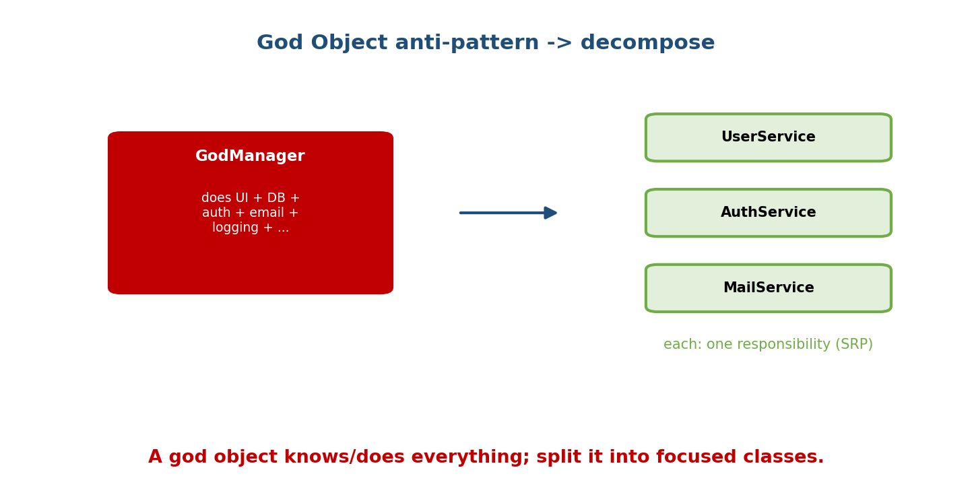
A GodManager class doing UI + DB + auth + email + logging is decomposed into focused UserService, AuthService, and MailService — each with one responsibility.
# ANTI-PATTERN: one class does everything
class AppManager:
def parse_request(self): ...
def query_db(self): ...
def authenticate(self): ...
def send_email(self): ...
def render_html(self): ... # any change touches this monster
# FIX: Extract Class — one responsibility each (SRP)
class RequestParser: ...
class UserRepository: ...
class Authenticator: ...
class Mailer: ...
Cure: Extract Class — split by responsibility; compose the pieces.

19.3 A Catalogue of Common Code Smells
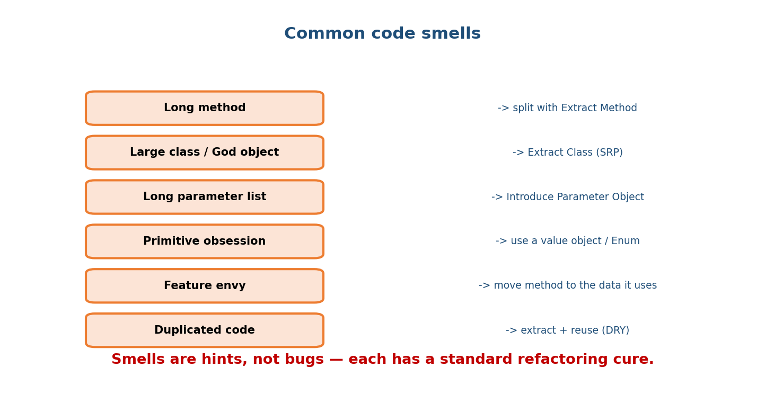
Common smells and cures: Long method -> Extract Method; Large class/God object -> Extract Class (SRP); Long parameter list -> Introduce Parameter Object; Primitive obsession -> value object/Enum; Feature envy -> move method to the data it uses; Duplicated code -> extract + reuse (DRY).
Smell | What it looks like | Cure
Long method | a function doing 5 things over 80 lines | Extract Method
Large class / God object | dozens of methods, many concerns | Extract Class (SRP)
Long parameter list | f(a, b, c, d, e, f) | Introduce Parameter Object / dataclass
Primitive obsession | passing (amount, currency) everywhere | a value object / Enum
Feature envy | a method mostly uses another object’s data | Move Method to that object
Data clumps | the same group of fields travels together | bundle into a class
Duplicated code | copy-paste logic | Extract + reuse (DRY)
Shotgun surgery | one change forces edits in many places | consolidate responsibility
Refused bequest | subclass ignores/overrides most of the base | favour composition
Message chains | a.b().c().d().e() | Hide Delegate (Law of Demeter)

19.4 Replace Conditional with Polymorphism (the key move)
A growing if/elif ladder on a type is a smell — it violates OCP (every new type edits the ladder). Replace it with subclasses overriding a method.
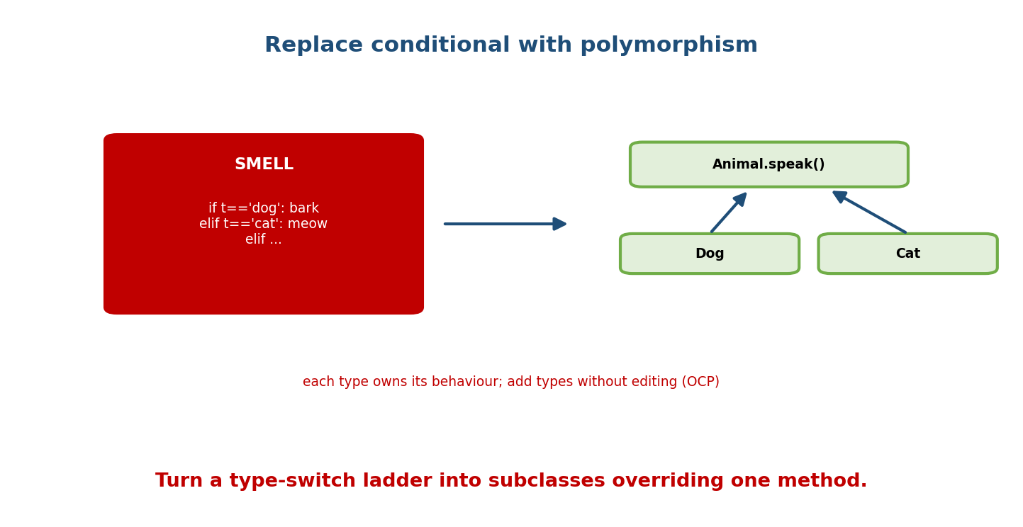
A smell — if t==‘dog’: bark / elif t==‘cat’: meow / elif … — becomes Animal.speak() with Dog and Cat subclasses overriding it, so new types are added without editing existing code.
# SMELL: type-switch ladder (edit it for every new animal)
def speak(animal):
if animal.type == "dog": return "Woof"
elif animal.type == "cat": return "Meow"
# elif ... forever
# REFACTORED: polymorphism (add a subclass, touch nothing)
class Animal:
def speak(self): raise NotImplementedError
class Dog(Animal):
def speak(self): return "Woof"
class Cat(Animal):
def speak(self): return "Meow"
This single refactor recurs constantly — in LLD it turns brittle policy ladders into clean Strategy/subclass designs.

19.5 Deep Inheritance (Yo-Yo) → Composition
Tall inheritance chains (D(C(B(A)))) are fragile: a change high up ripples down, and you “yo-yo” up and down the hierarchy to understand behaviour. This is the smell composition over inheritance (Module 5) exists to fix.
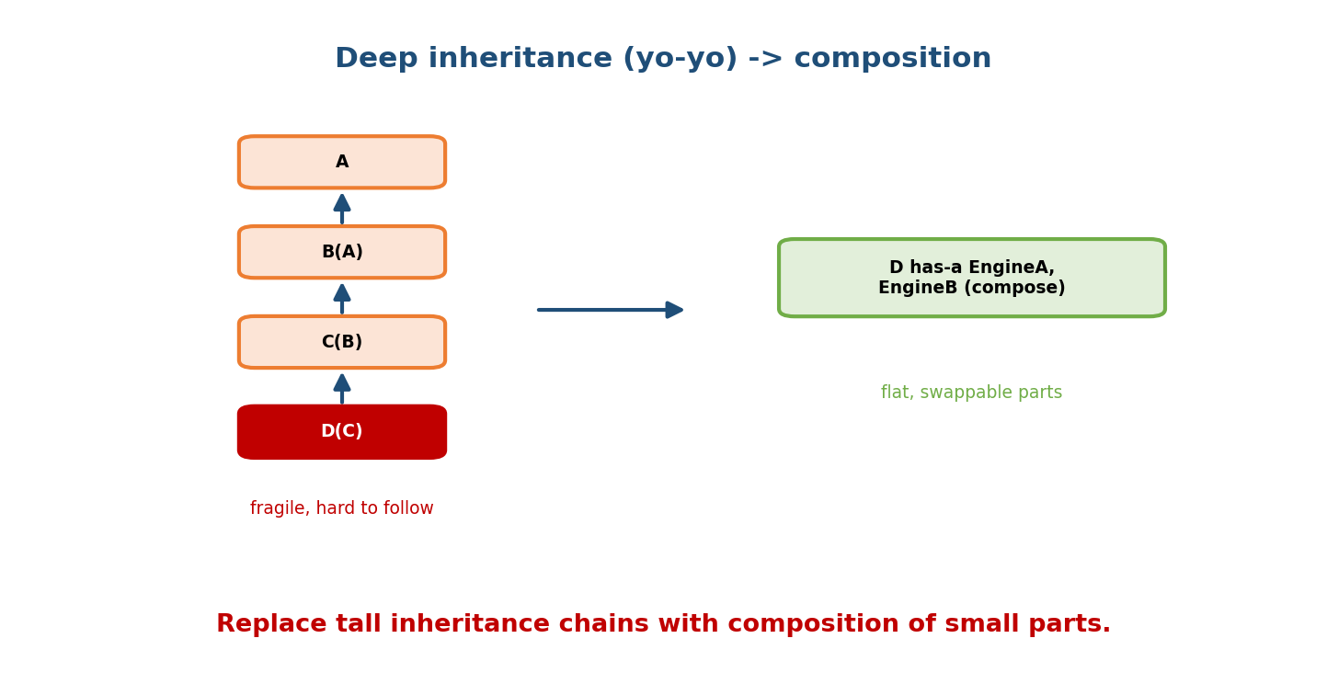
A deep chain A -> B(A) -> C(B) -> D(C) (fragile, hard to follow) is replaced by D composing swappable parts EngineA/EngineB (flat, swappable).
# SMELL: deep, rigid hierarchy
class Vehicle: ...
class LandVehicle(Vehicle): ...
class Car(LandVehicle): ...
class ElectricCar(Car): ... # behaviour scattered up 4 levels
# FIX: compose behaviours (Strategy-like)
class Car:
def __init__(self, engine, transmission):
self.engine = engine # swap ElectricEngine / PetrolEngine at runtime
self.transmission = transmission
Also called refused bequest when a subclass overrides away most of the parent — a sign it shouldn’t inherit at all.

19.6 Extract Class & Introduce Parameter Object
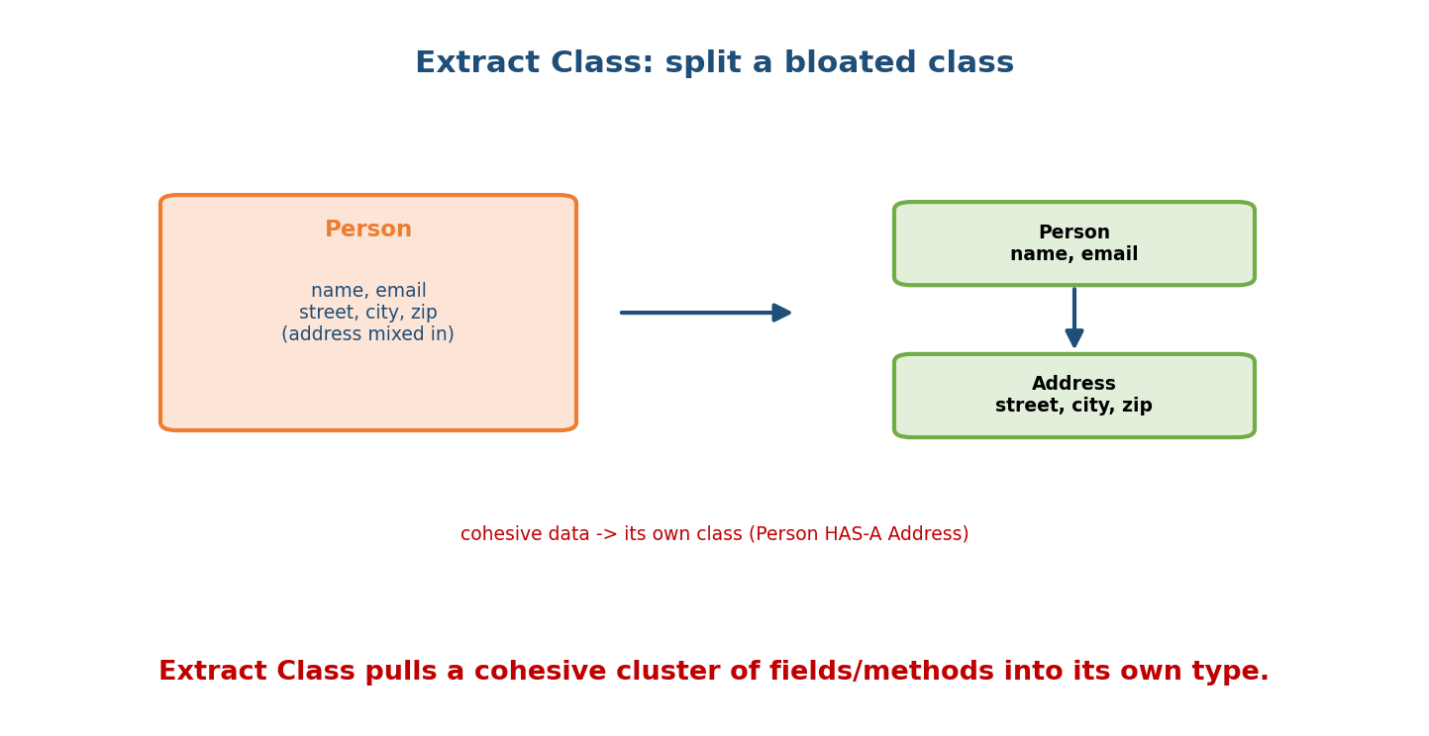
Extract Class: a Person class holding name/email AND street/city/zip is split so Person has-a separate Address class holding the address fields.
Extract Class — when a class has a cohesive cluster of fields/methods that form their own concept, pull them into a new class.
# BEFORE: address fields clutter Person
class Person:
def __init__(self, name, email, street, city, zip): ...
# AFTER: Address is its own value/class; Person HAS-A Address
@dataclass
class Address:
street: str; city: str; zip: str
@dataclass
class Person:
name: str; email: str; address: Address
Introduce Parameter Object — a long parameter list becomes a single object (often the same as Extract Class). create_user(name, email, street, city, zip) → create_user(user_data).

19.7 Primitive Obsession → Value Object
Passing bare primitives (float amount, str currency) everywhere scatters validation and meaning. Wrap them in a value object with rules and behaviour.
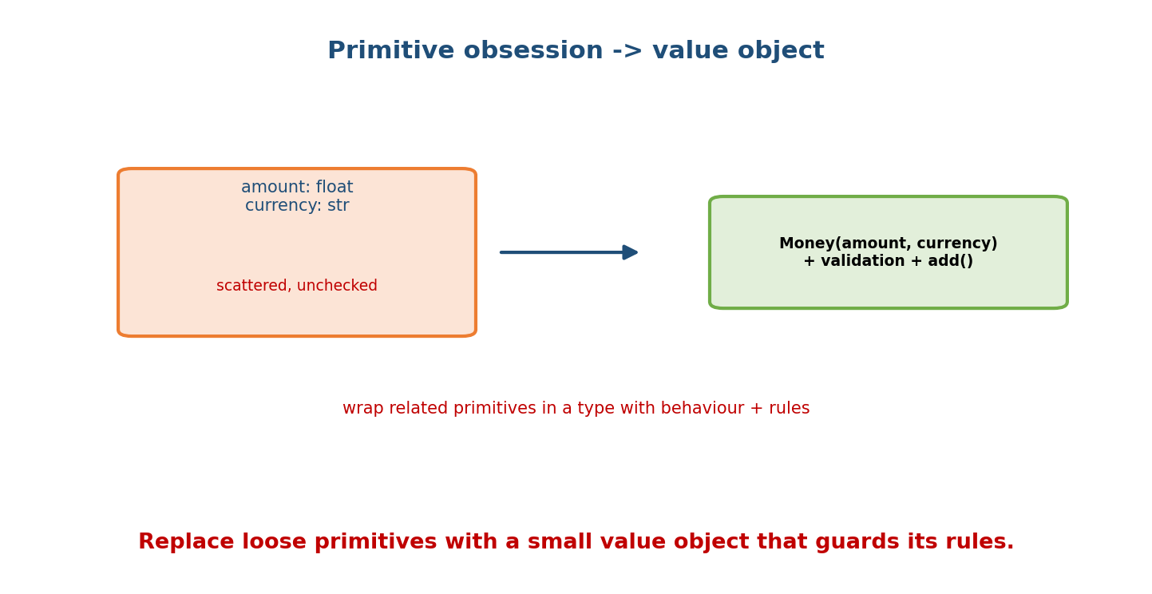
Primitive obsession — amount: float and currency: str scattered and unchecked — becomes a Money(amount, currency) value object with validation and an add() method.
# SMELL: primitives everywhere, no validation, easy to mix up
def transfer(amount: float, currency: str): ...
# FIX: a value object encapsulates the rules
@dataclass(frozen=True)
class Money:
amount: int
currency: str
def __post_init__(self):
if self.amount < 0: raise ValueError("negative")
def add(self, other):
if self.currency != other.currency: raise ValueError("currency mismatch")
return Money(self.amount + other.amount, self.currency)

19.8 Python-Specific Smells
Smell | Fix
Mutable default argument (def f(x=[])) | None sentinel (Module 2)
Mutable class attribute for per-object state | init in __init__ (Module 3)
__del__ for cleanup | context manager (Module 12)
Java-style getters/setters everywhere | public attrs → @property (Module 4)
Hand-written __init__/__repr__/__eq__ boilerplate | @dataclass (Module 10)
if/elif isinstance(...) ladders | polymorphism / singledispatch (Module 6)
except: pass | catch specific, handle/log (Module 16)
Deep inheritance / mixin soup | composition (Module 5)

19.9 Refactoring Safely
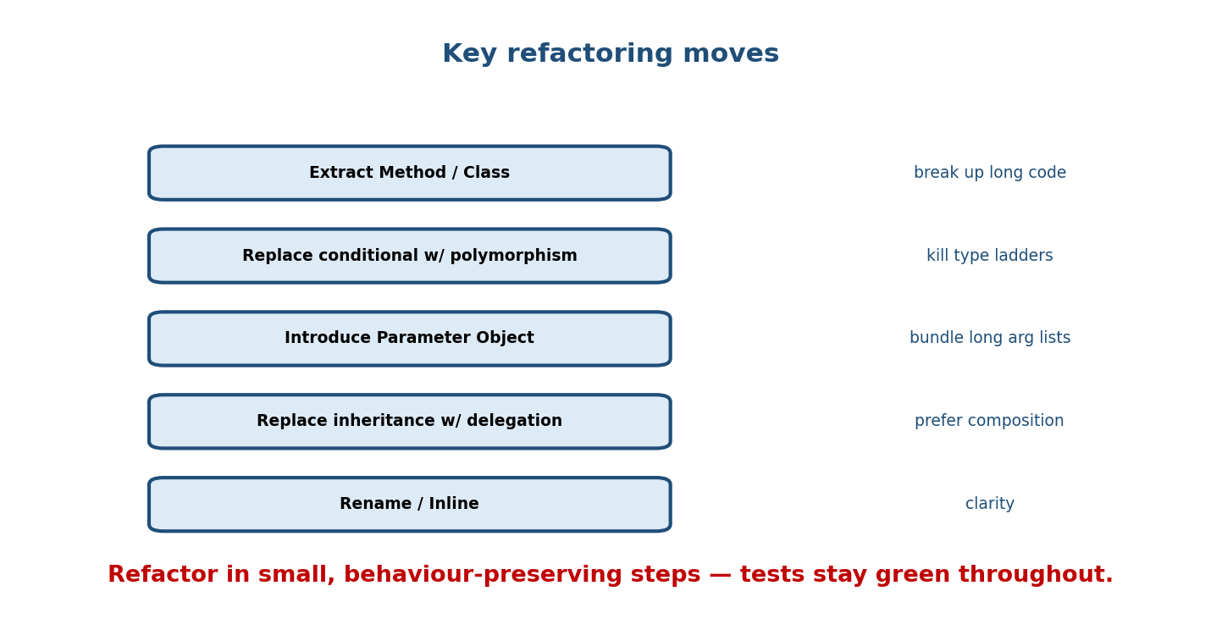
Key refactoring moves: Extract Method/Class (break up long code), Replace conditional with polymorphism (kill type ladders), Introduce Parameter Object (bundle long arg lists), Replace inheritance with delegation (prefer composition), Rename/Inline (clarity).
Refactoring changes structure, not behaviour — so you need a safety net:
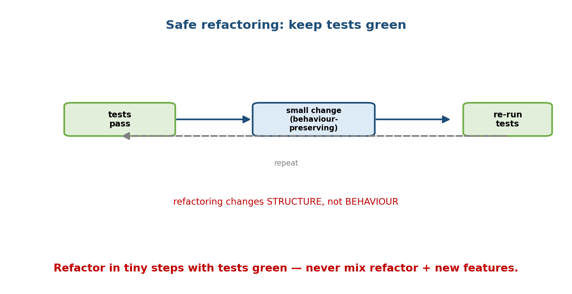
Safe refactoring cycle: with tests passing, make one small behaviour-preserving change, re-run tests (stay green), repeat; refactoring changes structure, not behaviour.
- Have tests that pin the current behaviour.
- Make one small, behaviour-preserving change.
- Re-run tests — they must stay green.
- Repeat.
Golden rule: never mix refactoring with new features in the same step. Get to green, refactor to green, then add the feature. Small steps keep you always a Ctrl-Z away from a working state.

Module 19 — Interview Mapping
Question | Junior answer | Senior answer
“Critique this class.” | “It’s long.” | Names the smell (god object / feature envy / primitive obsession) and the specific refactoring to fix it.
“This if/elif on type?” | “Add another branch.” | “Replace conditional with polymorphism — subclasses override a method; supports OCP.”
“Deep inheritance issues?” | (unsure) | “Fragile base class, yo-yo problem, refused bequest — refactor to composition.”
“How do you refactor safely?” | “Carefully.” | “Behaviour-preserving small steps backed by tests; never mix refactor with feature work.”

Module 19 — Exam Mapping
- GATE / PSU: minimal; occasionally “what is refactoring / a code smell”.
- FAANG / backend / code review: heavily practical — critique code, name smells, and propose refactorings live.

Module 19 — Common Mistakes & Misconceptions
- Thinking a smell is a bug — it’s a hint; judge in context (sometimes a long method is fine).
- Refactoring without tests — you can’t prove behaviour was preserved.
- Mixing refactoring with feature changes — hides regressions.
- Over-refactoring / pattern-itis — adding abstraction the problem doesn’t need.
- Keeping a god object because “it works” — it’s a change bottleneck.
- Chasing every smell — prioritise ones that hurt change/readability now.

Module 19 — MCQs (with answers & explanations)
Q1. A class that does far too much is a: a) value object b) god object c) mixin d) singleton
Answer
b. God object — violates SRP; cure with Extract Class.
Q2. A growing if/elif on an object’s type should be refactored to: a) a dict b) polymorphism (subclasses overriding a method) c) a metaclass d) a global
Answer
b. Replace conditional with polymorphism (supports OCP).
Q3. Passing (amount, currency) everywhere is: a) feature envy b) primitive obsession c) shotgun surgery d) lava flow
Answer
b. Wrap them in a value object (Money).
Q4. A method that mostly uses another object’s data has: a) primitive obsession b) feature envy c) refused bequest d) long method
Answer
b. Move the method to the class whose data it uses.
Q5. Refactoring is defined as changing: a) behaviour, not structure b) structure, not behaviour c) both d) neither
Answer
b. Internal structure changes; external behaviour is preserved.
Q6. A subclass that overrides away most of its parent’s behaviour shows: a) refused bequest b) feature envy c) god object d) data clump
Answer
a. Sign it shouldn’t inherit — prefer composition.
Q7. The cure for a long parameter list is: a) more globals b) Introduce Parameter Object c) a metaclass d) inheritance
Answer
b. Bundle the params into an object/dataclass.
Q8. The safe way to refactor is: a) big rewrite b) small behaviour-preserving steps with tests green c) without tests d) with new features
Answer
b. Tiny steps, tests green, no feature mixing.

Module 19 — Design/Practice Exercises (easy → hard)
- (easy) Identify three smells in a 50-line god class and name their cures.
- (easy) Refactor an if type == ... payment ladder into polymorphic PaymentMethod subclasses.
- (medium) Extract an Address class from a bloated Customer.
- (medium) Replace a 6-parameter create_order(...) with a parameter object.
- (hard) Turn a 4-level inheritance chain into a composition design and list what improved.
- (hard, interview) Given messy code with a mutable default, except: pass, and a type ladder, refactor all three and explain each move.

Module 19 — Concept Review (one page)
Anti-patterns are counterproductive designs (god object, spaghetti/deep inheritance, golden hammer, singleton abuse); code smells are surface symptoms (long method, large class, long parameter list, primitive obsession, feature envy, duplicated code, refused bequest, message chains); refactoring changes structure without changing behaviour to remove them. The signature moves: Extract Method/Class (break up bloat, restore SRP), Replace Conditional with Polymorphism (kill type ladders, honour OCP), Introduce Parameter Object (bundle long arg lists), Replace Inheritance with Delegation (composition over deep hierarchies), and wrapping loose primitives in value objects. Python adds its own smells — mutable defaults, __del__ cleanup, hand-rolled dunders, except: pass — each with a known cure. Refactor safely: tests green, one small behaviour- preserving change at a time, never mixing refactor with new features.

Module 19 — Flash Cards (Q → A)
Front | Back
Anti-pattern | common but counterproductive design
Code smell | surface symptom of a deeper design issue
Refactoring | change structure, not behaviour
God object cure | Extract Class (SRP)
if/elif type ladder cure | Replace Conditional with Polymorphism
Long parameter list cure | Introduce Parameter Object / dataclass
Primitive obsession cure | value object / Enum
Feature envy cure | Move Method to the data it uses
Deep inheritance cure | composition (delegation)
Refused bequest | subclass overrides away the base → don’t inherit
Python smell examples | mutable default, __del__ cleanup, except: pass
Safe refactoring | small steps, tests green, no feature mixing

Module 19 — Pattern Recognition
- See one class doing everything → god object → Extract Class.
- See if/elif on a type field → Replace Conditional with Polymorphism.
- See (amount, currency) passed around → value object.
- See a method using another object’s fields → Move Method (feature envy).
- See a 4-level class chain → composition.
- See copy-pasted logic → extract + reuse.
- See def f(x=[]) / except: pass → Python smell; apply the known cure.

Module 19 — Revision Notes / Mini Cheat Sheet
ANTI-PATTERN = counterproductive design (God Object, Spaghetti, Golden Hammer,
Singleton abuse, Copy-paste, Lava Flow).
CODE SMELL = symptom (long method, large class, long param list, primitive obsession,
feature envy, data clumps, duplicated code, shotgun surgery, refused bequest).
REFACTORING = change STRUCTURE, not BEHAVIOUR.
CURES:
god object / large class -> Extract Class (SRP)
long method -> Extract Method
if/elif on type -> Replace Conditional w/ Polymorphism (OCP)
long parameter list -> Introduce Parameter Object / dataclass
primitive obsession -> value object / Enum
feature envy -> Move Method
deep inheritance / refused bequest -> composition (delegation)
message chains -> Hide Delegate (Law of Demeter)
PYTHON SMELLS: mutable default (=None), __del__ cleanup (use with), hand dunders (dataclass),
Java getters (@property), isinstance ladders (polymorphism/singledispatch), except: pass.
SAFE REFACTOR: tests green -> ONE small behaviour-preserving change -> re-run -> repeat.
NEVER mix refactoring with new features.
Next module: Module 20 — Exam & Interview Mapping + Master Question Bank. We consolidate the whole course into an exam/interview map and a large, graded question bank (conceptual, output-prediction, code, and design) with answers — your primary revision-and-drill resource.

Module 19 — Summary
Great OOP means not only building good designs but spotting and fixing bad ones. Anti-patterns (god object, deep inheritance, singleton abuse) and code smells (long method/class, long parameter list, primitive obsession, feature envy, refused bequest) are the recognisable failure modes, and each has a standard refactoring: Extract Method/Class, Replace Conditional with Polymorphism, Introduce Parameter Object, composition over inheritance, and value objects. Python contributes its own smells (mutable defaults, __del__ cleanup, hand-rolled dunders, except: pass) with known cures. Above all, refactor safely — behaviour-preserving small steps backed by tests, never mixed with feature work. This is the skill that turns code that works into code that lasts.
You have mastered this module when you can: name the major anti-patterns/smells on sight; apply the correct refactoring to each; explain “replace conditional with polymorphism”; and describe a safe, test-backed refactoring workflow.

