Module 20 — Exam & Interview Mapping + Master Question Bank
  - OOP with Python Mastery: FAANG Interviews / GATE / SEBI-RBI IT / Backend — In-Depth Notes (with visuals)
Prepared for nidhi.sharma@forensiccybertech.com
2026
Table of Contents

Module 20 — Exam & Interview Mapping + Master Question Bank
Why this module matters. This is your drill-and-revise hub. Every prior module ends with its own MCQs; here we consolidate the whole subject into an exam/interview map, an answer framework, and a large, graded question bank — conceptual, output-prediction, coding, and design — with answers. Work through this before any interview or exam; it converts understanding into fast, confident answers.
Importance ratings (out of 5):
Exam / Use | FAANG Interview | GATE CS | SEBI/RBI IT | Backend Dev | LLD Rounds
This module | ★★★★★ | ★★★★ | ★★★★ | ★★★★ | ★★★★★

20.1 Topic Priority
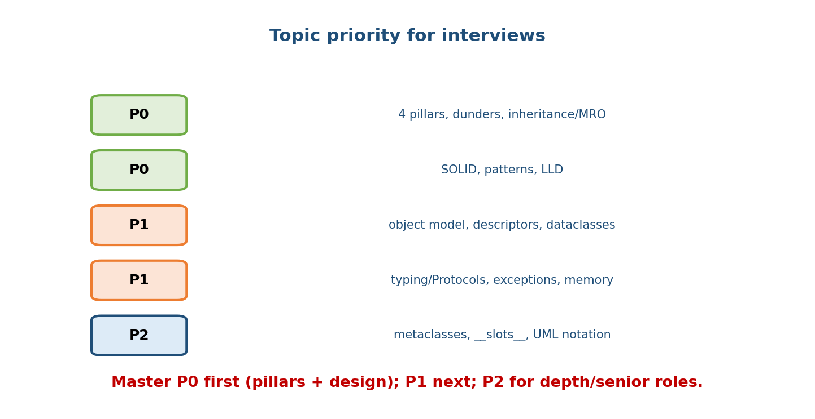
Topic priority: P0 = four pillars, dunders, inheritance/MRO, SOLID, patterns, LLD; P1 = object model, descriptors, dataclasses, typing/Protocols, exceptions, memory; P2 = metaclasses, slots, UML notation.
- P0 (must nail): four pillars; class/object mechanics; inheritance + MRO; polymorphism/dunders; SOLID; core patterns; LLD process.
- P1 (strong): object model (is/==, mutability); descriptors/@property; dataclasses/enums; typing/Protocols; exceptions; memory.
- P2 (depth / senior): metaclasses; __slots__; UML notation; advanced typing.

20.2 How Questions Escalate
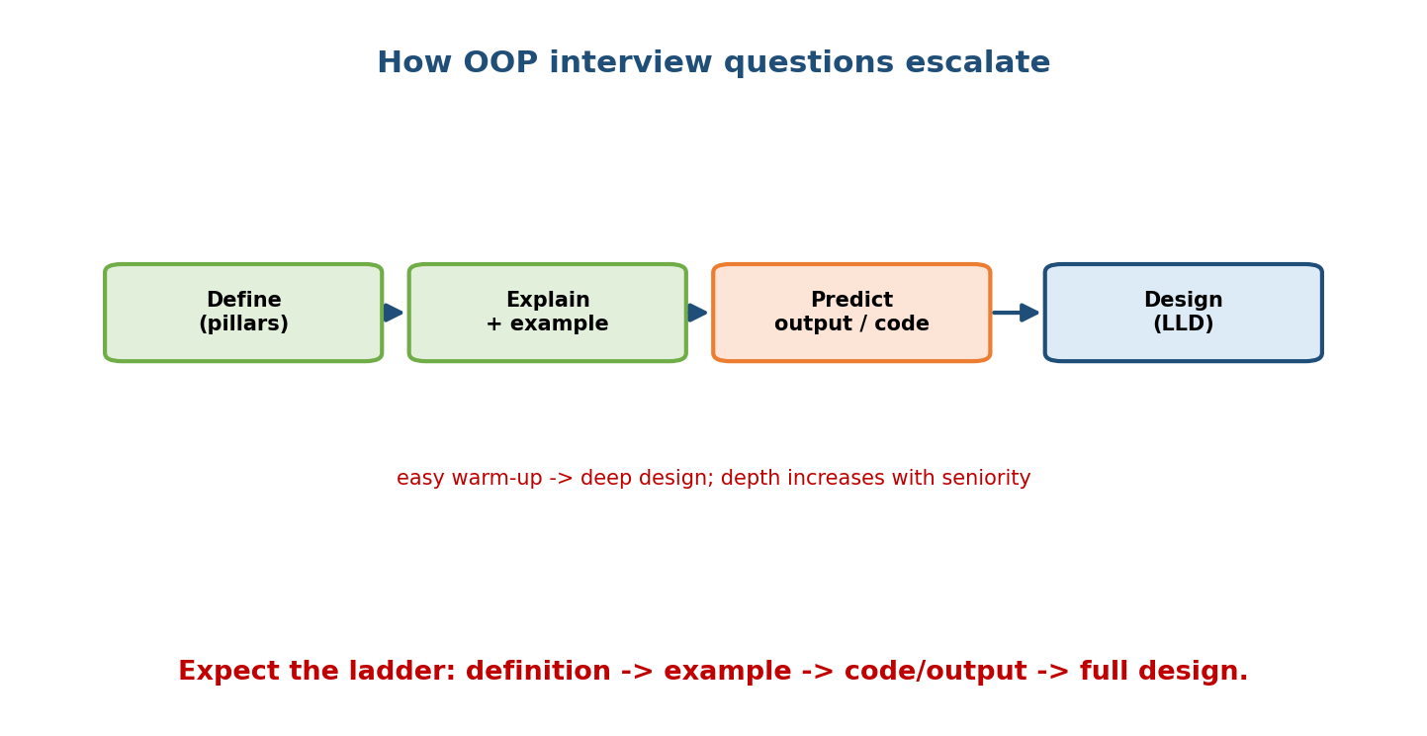
Interview escalation: Define (pillars) -> Explain + example -> Predict output / code -> Design (LLD); depth rises with seniority.
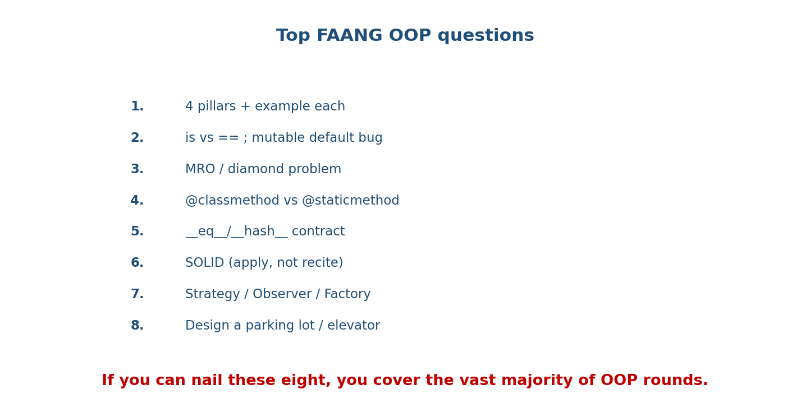
Top FAANG OOP questions: 4 pillars + example; is vs == and mutable default bug; MRO/diamond; classmethod vs staticmethod; eq/hash contract; SOLID applied; Strategy/Observer/Factory; design a parking lot/elevator.
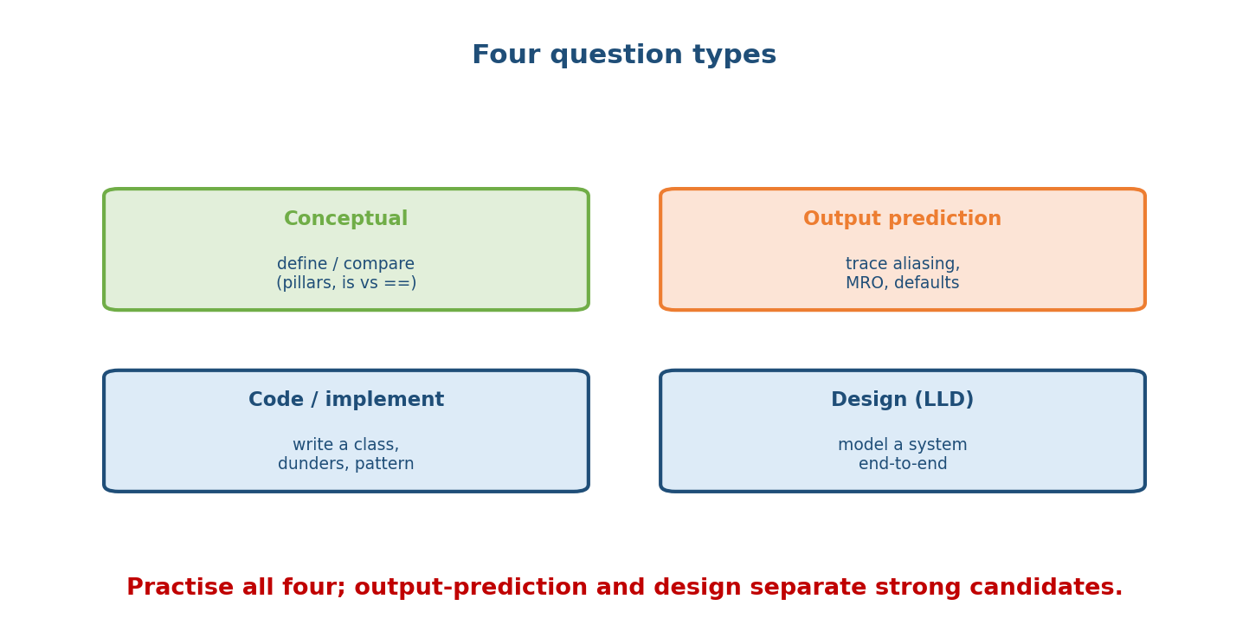
Four question types: Conceptual (define/compare), Output prediction (trace aliasing/MRO/defaults), Code/implement (write a class/dunders/pattern), Design/LLD (model a system end-to-end).

20.3 The Answer Framework
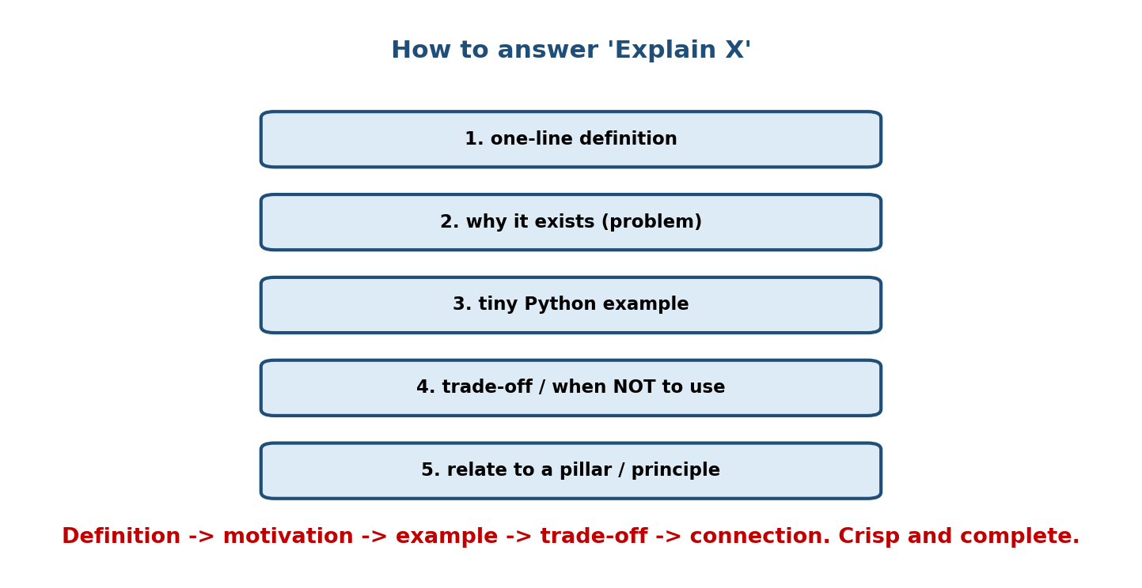
Answer framework for ‘Explain X’: 1) one-line definition, 2) why it exists (problem), 3) tiny Python example, 4) trade-off / when NOT to use, 5) relate to a pillar/principle.
Use this five-beat structure for any “explain/compare” question: definition → motivation → example → trade-off → connection. It reads as senior and complete.

20.4 Conceptual Question Bank (with answers)
C1. Name the four pillars and define each in one line.
Answer
Encapsulation (bundle + hide), Abstraction (expose what, hide how), Inheritance (reuse via is-a), Polymorphism (one interface, many forms).
C2. Class vs object?
Answer
Class = blueprint/type; object = instance with its own state + identity + shared behaviour.
C3. is vs ==?
Answer
is = identity (same object, id); == = value (__eq__). Use is only for singletons like None.
C4. Explain the diamond problem and how Python solves it.
Answer
Two paths to a shared ancestor; Python uses a deterministic MRO via C3 linearisation, and super() follows it so each ancestor runs once.
C5. @classmethod vs @staticmethod vs instance method?
Answer
Instance → self (state); classmethod → cls (factories/subclass-aware); staticmethod → neither (namespaced helper).
C6. Does Python have private variables?
Answer
No true private. _x is convention; __x is name-mangled to _Class__x (avoids subclass clashes, still accessible).
C7. Encapsulation vs abstraction?
Answer
Encapsulation = data protection / access control (implementation); abstraction = simple interface hiding complexity (design).
C8. Composition vs inheritance — which to prefer and why?
Answer
Favour composition (has-a): loose coupling, runtime-swappable, avoids fragile base classes; use inheritance for genuine is-a.
C9. What is duck typing?
Answer
Compatibility depends on having the right methods, not the class (“if it quacks…”); pairs with EAFP.
C10. Why does defining __eq__ require __hash__?
Answer
Defining __eq__ sets __hash__=None → unhashable; add __hash__ over the same fields (value-immutable objects) to keep it usable in sets/dicts.
C11. ABC vs Protocol?
Answer
ABC = nominal (must inherit; explicit is-a; can hold concrete methods); Protocol = structural (matches by method shape; no inheritance; static duck typing).
C12. What is a metaclass?
Answer
The class of a class (type by default); it creates classes. class is sugar for type(name, bases, ns).
C13. EAFP vs LBYL?
Answer
EAFP (try/except, Pythonic, race-safe) vs LBYL (check-first, race-prone). Python prefers EAFP.
C14. State the five SOLID principles.
Answer
SRP (one reason to change), OCP (extend not modify), LSP (subtype substitutable), ISP (small interfaces), DIP (depend on abstractions).
C15. Strategy vs State pattern?
Answer
Same structure; Strategy = client-chosen algorithm; State = behaviour driven by internal state transitions.

20.5 Output-Prediction Bank (rehearse these!)
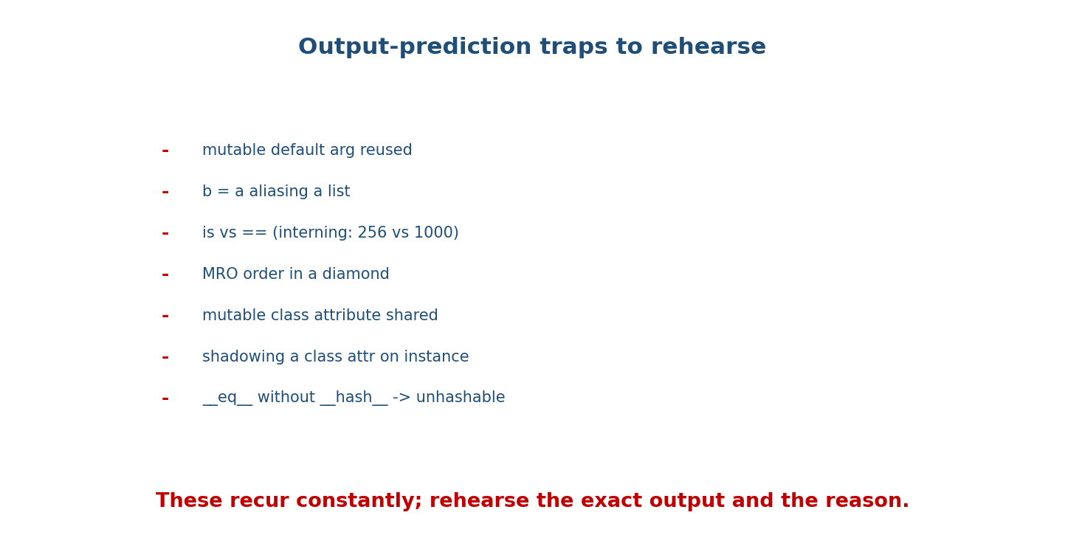
Output-prediction traps: mutable default reused; b = a aliasing; is vs == interning (256 vs 1000); MRO order; mutable class attribute shared; instance shadowing a class attr; eq without hash.
O1. def f(x=[]): x.append(1); return x — output of f(); f()?
Answer
[1] then [1, 1] — the default list is created once and shared.
O2. a=[1]; b=a; a.append(2); print(b)?
Answer
[1, 2] — b aliases the same list.
O3. print(256 is 256, 1000 is 1000) (CPython)?
Answer
True and (usually) False — small ints -5..256 are interned; 1000 may not be.
O4. Diamond D(B, C), B(A), C(A) — D.__mro__?
Answer
(D, B, C, A, object).
O5. class Dog: tricks=[] then two dogs each add_trick — do they share?
Answer
Yes — the mutable class attribute is shared; both dogs see all tricks.
O6. Class attr species="canine"; a.species="wolf"; does b.species change?
Answer
No — assignment created an instance attr on a shadowing the class attr; b still sees “canine”.
O7. s="hi"; id1=id(s); s+="!"; id2=id(s) — equal ids?
Answer
No — strings are immutable; += rebinds s to a new object.
O8. print("a"+"b", [1]+[2], 1+2) — one operator, three results?
Answer
'ab' [1, 2] 3 — operator overloading via __add__ per type.
O9. Define __eq__ only, then {obj} — result?
Answer
TypeError: unhashable type — need __hash__ too.
O10. grid=[[0]*3]*3; grid[0][0]=1; print(grid)?
Answer
[[1,0,0],[1,0,0],[1,0,0]] — all rows are the same list; use a comprehension.

20.6 Coding Question Bank
K1. Implement a Stack class with push, pop, peek, is_empty, __len__.
K2. Make a Money class supporting +, ==, <, __hash__, __repr__, rejecting mismatched currencies.
K3. Write a @classmethod from_string factory for a Date class.
K4. Implement an Observer-based Stock that notifies displays on price change.
K5. Build a validating @property (Temperature.celsius rejecting < -273.15).
K6. Implement a reusable Positive descriptor and use it on two fields.
K7. Write a context manager Timer using __enter__/__exit__.
K8. Implement Strategy for sorting (asc/desc) both as classes and as functions.
Sample answer — K2 (Money)
from functools import total_ordering
@total_ordering
class Money:
def __init__(self, amount, currency):
self.amount, self.currency = amount, currency
def _check(self, o):
if self.currency != o.currency: raise ValueError("currency mismatch")
def __add__(self, o): self._check(o); return Money(self.amount + o.amount, self.currency)
def __eq__(self, o): return (self.amount, self.currency) == (o.amount, o.currency)
def __lt__(self, o): self._check(o); return self.amount < o.amount
def __hash__(self): return hash((self.amount, self.currency))
def __repr__(self): return f"Money({self.amount}, {self.currency!r})"

20.7 Design (LLD) Question Bank
D1. Design a parking lot (levels, vehicle types, pluggable allocation, ticket). D2. Design an elevator system (requests, scheduling Strategy, State modes). D3. Design a deck of cards + a card game (Enums, frozen Card, Deck). D4. Design a rate limiter (token bucket; inject the clock). D5. Design a vending machine (State: idle/paid/dispensing). D6. Design a notification service (Observer + Strategy channels + Factory). D7. Design Splitwise (users, groups, split Strategies, balances). D8. Design a logging framework (levels via Chain of Responsibility, Singleton/module).
For each: clarify → entities → relationships (UML) → SOLID + patterns → code → extensions. (Full worked solutions in Module 18.)

20.8 Exam Mapping (written exams)
Exam | OOP focus
GATE CS | pillar definitions; class vs object; inheritance/overriding; access; output prediction
SEBI / RBI / NABARD IT | definitions; features of OOP; encapsulation; which language is OO
UGC-NET / PSU | pillars; UML relationship notation; patterns (definitional)
FAANG / product | apply pillars/SOLID/patterns; output prediction; LLD design

20.9 Revision & Prep Plan
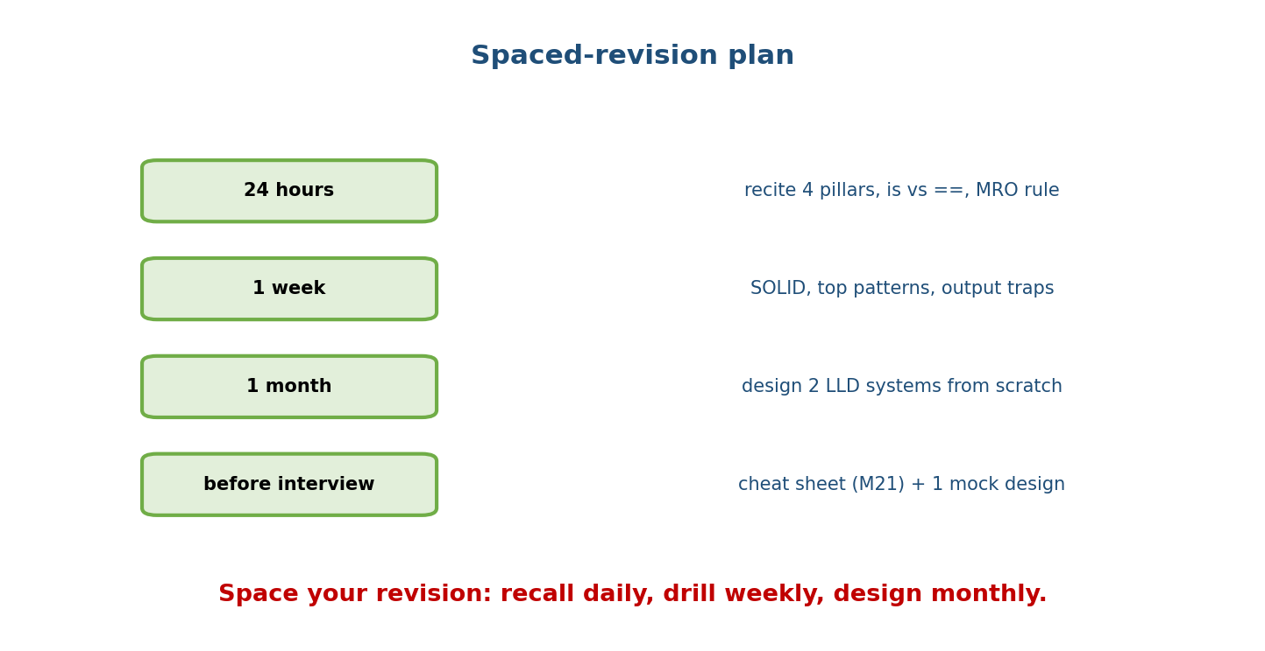
Spaced revision: 24 hours — recite pillars, is vs ==, MRO rule; 1 week — SOLID, top patterns, output traps; 1 month — design 2 LLD systems; before interview — cheat sheet + 1 mock design.
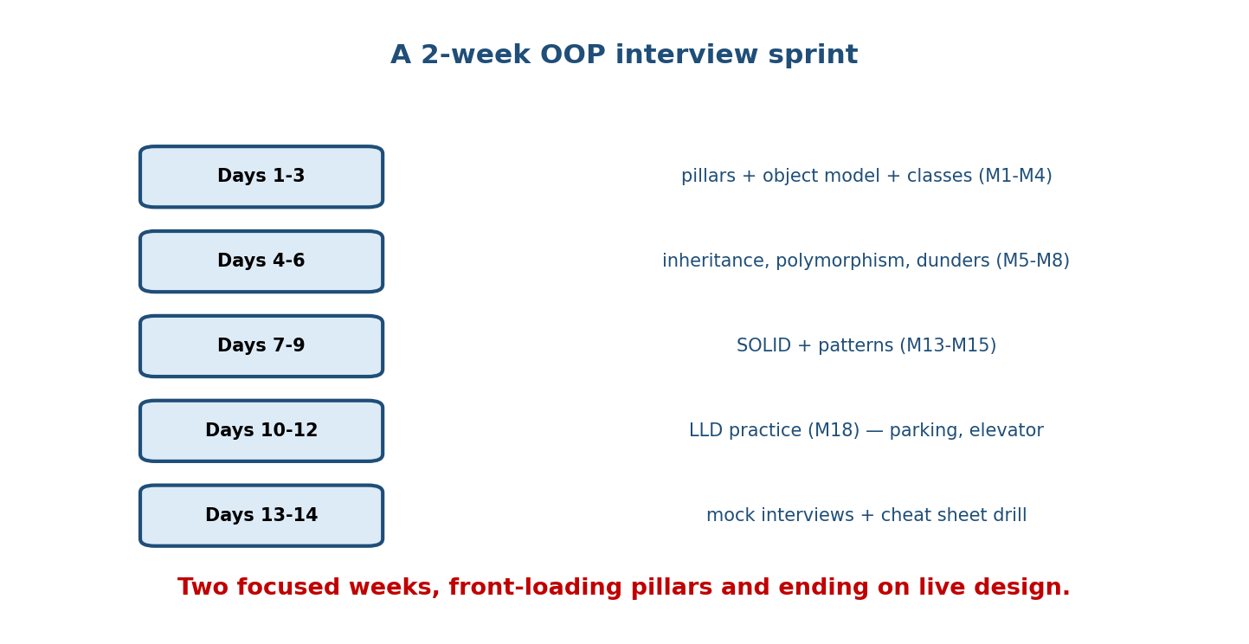
Two-week sprint: Days 1-3 pillars + object model + classes; Days 4-6 inheritance, polymorphism, dunders; Days 7-9 SOLID + patterns; Days 10-12 LLD practice; Days 13-14 mock interviews + cheat-sheet drill.

Module 20 — Concept Review (one page)
Interviews and exams test OOP in a predictable ladder: define (pillars), explain with an example, predict output / write code, then design (LLD). Prioritise P0 (four pillars, class mechanics, inheritance/MRO, polymorphism/ dunders, SOLID, patterns, LLD), then P1 (object model, descriptors, dataclasses, typing, exceptions, memory), then P2 (metaclasses, __slots__, UML). Answer “explain X” in five beats — definition → motivation → example → trade-off → connection. Rehearse the recurring output-prediction traps (mutable defaults, aliasing, is/== interning, MRO, shared class attributes, __eq__/__hash__) and practise the classic LLD prompts end-to-end. Revise on a spaced schedule and, for interviews, run a two-week sprint front-loading pillars and ending on live design.

Module 20 — Flash Cards (Q → A)
Front | Back
Four pillars | Encapsulation, Abstraction, Inheritance, Polymorphism
is vs == | identity vs value
Mutable default fix | None sentinel
MRO of D(B,C) | D, B, C, A, object
classmethod vs staticmethod | cls (factory) vs nothing (helper)
__eq__ implies | must define __hash__ too
SOLID | SRP, OCP, LSP, ISP, DIP
Strategy vs State | client algorithm vs state-driven behaviour
Favour | composition over inheritance
ABC vs Protocol | nominal (inherit) vs structural (shape)
Answer framework | define → motivate → example → trade-off → connect
LLD process | clarify → entities → UML → patterns → code → extend

Module 20 — Revision Notes / Mini Cheat Sheet
QUESTION LADDER: define -> explain+example -> output/code -> design(LLD).
PRIORITY: P0 pillars/classes/MRO/dunders/SOLID/patterns/LLD ; P1 object model/descriptors/
dataclasses/typing/exceptions/memory ; P2 metaclasses/__slots__/UML.
ANSWER 'EXPLAIN X': definition -> why (problem) -> tiny example -> trade-off -> connect to pillar.
OUTPUT TRAPS: mutable default (=[]), b=a aliasing, 256 is 256 / 1000 maybe not,
MRO order, mutable class attr shared, instance shadows class attr, __eq__ w/o __hash__,
[[0]*n]*m rows aliased.
DESIGN: clarify -> entities(nouns) -> relationships(UML) -> SOLID+patterns -> code -> extend.
parking lot | elevator | deck | rate limiter | vending | notifications | splitwise | logger.
PREP: daily recall (pillars/MRO), weekly drill (SOLID/patterns/traps), monthly design,
pre-interview: cheat sheet (M21) + a mock design.
Next module: Module 21 — Revision Kit & Master Cheat Sheets. The final module distils the entire course into dense one-page recall sheets — the four pillars, dunder table, MRO/super(), SOLID, patterns, and a full glossary — the single document to review the night before an interview or exam.

Module 20 — Summary
This module turns knowledge into interview performance. OOP questions follow a ladder — define, explain, predict/code, design — and you should prioritise P0 topics first. Use the five-beat answer framework for explanations, and rehearse the conceptual, output-prediction, coding, and design banks here until answers are automatic. The output-prediction traps (mutable defaults, aliasing, interning, MRO, shared class attributes, __eq__/__hash__) and the classic LLD prompts are the highest-yield drills. Combine with a spaced revision schedule and a focused two-week sprint and you’ll walk into any OOP round prepared.
You have mastered this module when you can: answer any P0 conceptual question in the five-beat framework; predict the output of every trap here and say why; code the listed classes cleanly; and run a full LLD design under time pressure.

