Module 4 — The MAC Sublayer & LANs (Access, Ethernet, ARP, Switching)
  - Computer Networks Mastery: SEBI IT / RBI / NABARD / GATE / C-DAC / Interview / Backend — In-Depth Notes (with visuals)
Prepared for nidhi.sharma@forensiccybertech.com
2026
Table of Contents

Module 4 — The MAC Sublayer & LANs (Access, Ethernet, ARP, Switching)
Where this module sits. Module 3 made a single link reliable. But a LAN is a shared medium — many hosts, one cable/air. If two send at once, their signals collide and both are lost. The MAC (Media Access Control) sublayer answers the question “who gets to talk, and when?” This module covers the access protocols (ALOHA, CSMA/CD, CSMA/CA), the LAN that won (Ethernet), how a host finds another’s MAC (ARP), and how switches, collision/broadcast domains, and VLANs structure real networks. ALOHA efficiency and the CSMA/CD minimum-frame-size numerical are exam favourites.
Importance ratings (out of 5):
Exam / Use | SEBI IT | RBI IT | GATE CS | Interview | Backend
This module | ★★★ | ★★★ | ★★★★ | ★★★ | ★★★
Most-asked PYQ concepts (SEBI / RBI / GATE / C-DAC): pure vs slotted ALOHA efficiency (18.4% / 36.8%); CSMA variants (1-persistent / non-persistent / p-persistent); CSMA/CD vs CSMA/CA (wired vs Wi-Fi); minimum Ethernet frame size and why (≥ 2·Tp·B); MAC address (48-bit); ARP (broadcast request / unicast reply); hub vs switch vs router and collision vs broadcast domains; VLAN.

4.1 The Multiple-Access Problem
On a shared medium, simultaneous transmissions collide. MAC protocols coordinate access. They fall into three families:
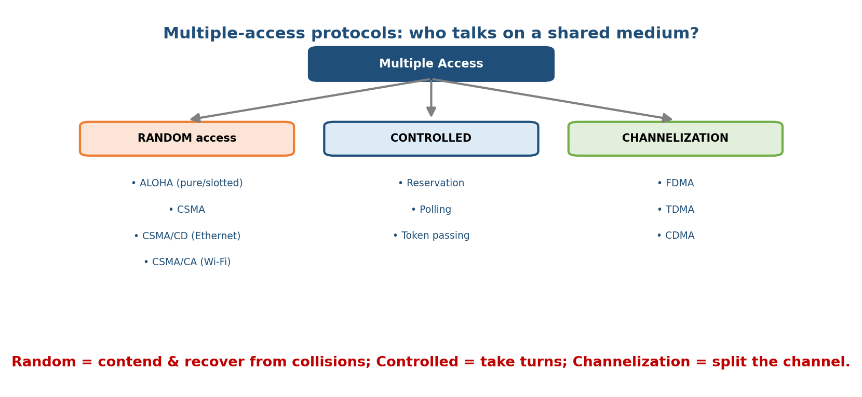
Multiple-access protocols split into random access (contend and recover), controlled access (take turns), and channelization (split the channel).
- Random access — hosts transmit whenever they have data, and recover from collisions (ALOHA, CSMA, CSMA/CD, CSMA/CA).
- Controlled access — hosts coordinate turns (reservation, polling, token passing) — no collisions, but overhead.
- Channelization — statically split the channel (FDMA/TDMA/CDMA — from M2).
Memory hook: Random = “just talk, apologise on collision”; Controlled = “raise your hand / pass the mic”; Channelization = “everyone gets a fixed lane.”

MCQs
- Three MAC families? → random, controlled, channelization.
- Token passing is which family? → controlled access.
- Ethernet (classic) is which family? → random access (CSMA/CD).

4.2 ALOHA (the ancestor) — Pure & Slotted
Pure ALOHA: transmit whenever you have data; if a collision occurs (no ACK), wait a random time and resend. Very simple, but collisions are frequent.
- Vulnerable period = 2 × frame time (a frame collides with any frame starting in the frame-time before or during it).
- Maximum efficiency = 1/(2e) ≈ 18.4% at load G = 0.5.
Slotted ALOHA: time is divided into slots equal to one frame time; hosts may only start at a slot boundary. This halves the vulnerable period.
- Vulnerable period = 1 × frame time.
- Maximum efficiency = 1/e ≈ 36.8% at G = 1.
Memory hook: slotting doubles ALOHA’s efficiency (18.4% → 36.8%) by making everyone start on the beat. S = G·e^(−2G) (pure), S = G·e^(−G) (slotted).

MCQs
- Pure vs slotted ALOHA max efficiency? → 18.4% (1/2e) vs 36.8% (1/e).
- Pure ALOHA vulnerable period? → 2 × frame time.
- Slotted ALOHA improves efficiency by? → aligning sends to time slots.

4.3 CSMA — Listen Before You Talk
Carrier Sense Multiple Access: sense the channel first; transmit only if idle. This cuts collisions but can’t eliminate them (propagation delay means two hosts can both sense “idle” and then collide). Variants differ in what you do when the channel is busy:
Variant | If channel busy | Behaviour
1-persistent | keep sensing; send immediately when idle | greedy; high collision if many wait
Non-persistent | wait a random time, then sense again | fewer collisions, more delay
p-persistent | (slotted) when idle, send with prob p, else defer | tunable middle ground

MCQs
- Why does CSMA still get collisions? → propagation delay (two see idle, both send).
- Which CSMA sends immediately when the channel frees? → 1-persistent.
- Which waits a random time when busy? → non-persistent.

4.4 CSMA/CD (classic Ethernet) & CSMA/CA (Wi-Fi)
CSMA/CD (Collision Detection): while transmitting, keep listening; if a collision is detected, stop, send a JAM signal, and back off a random time (binary exponential backoff: after the k-th collision, wait a random number of slots in [0, 2^k − 1], up to k = 10).
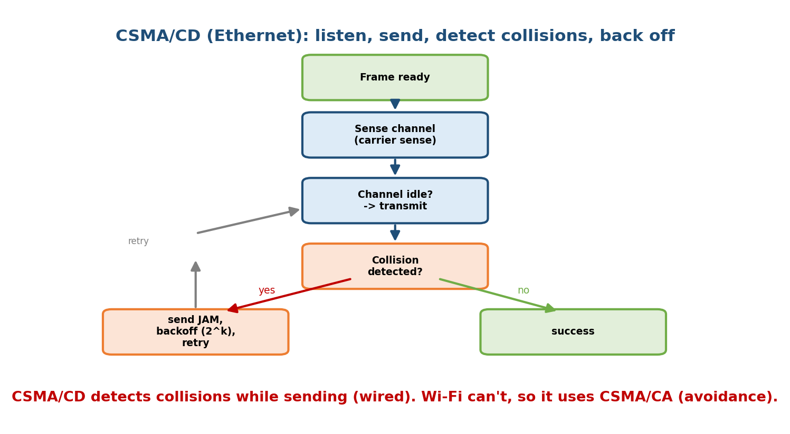
CSMA/CD: sense the channel, transmit, and if a collision is detected send a jam and back off before retrying.
The minimum-frame-size rule (key numerical): to detect a collision, a sender must still be transmitting when the collision signal returns — so the frame must take at least 2 × Tp (round-trip propagation) to send:
Frame transmission time Tt ≥ 2 · Tp
Minimum frame size L_min = 2 · Tp · B (B = bandwidth)
For classic 10 Mbps Ethernet this gives the famous 64-byte minimum frame.
CSMA/CA (Collision Avoidance): used by Wi-Fi (802.11), because a wireless node can’t detect collisions while transmitting (its own signal drowns others, and the hidden-terminal problem). Instead it avoids them: sense idle, wait a random backoff, use ACKs to confirm receipt, and optionally RTS/CTS handshake to reserve the medium.
Memory hook: CD = “Collision Detection” (wired, stop when you hear a crash); CA = “Collision Avoidance” (wireless, tiptoe with backoff + ACK because you can’t hear the crash).

MCQs
- Min frame size formula? → L_min = 2·Tp·B.
- Classic Ethernet min frame? → 64 bytes.
- Why Wi-Fi uses CA not CD? → a station can’t detect collisions while sending (hidden terminal).
- Backoff after k-th collision picks a slot in? → [0, 2^k − 1] (binary exponential backoff).

4.5 Ethernet & the MAC Address
Ethernet (IEEE 802.3) is the dominant wired LAN. Its frame:
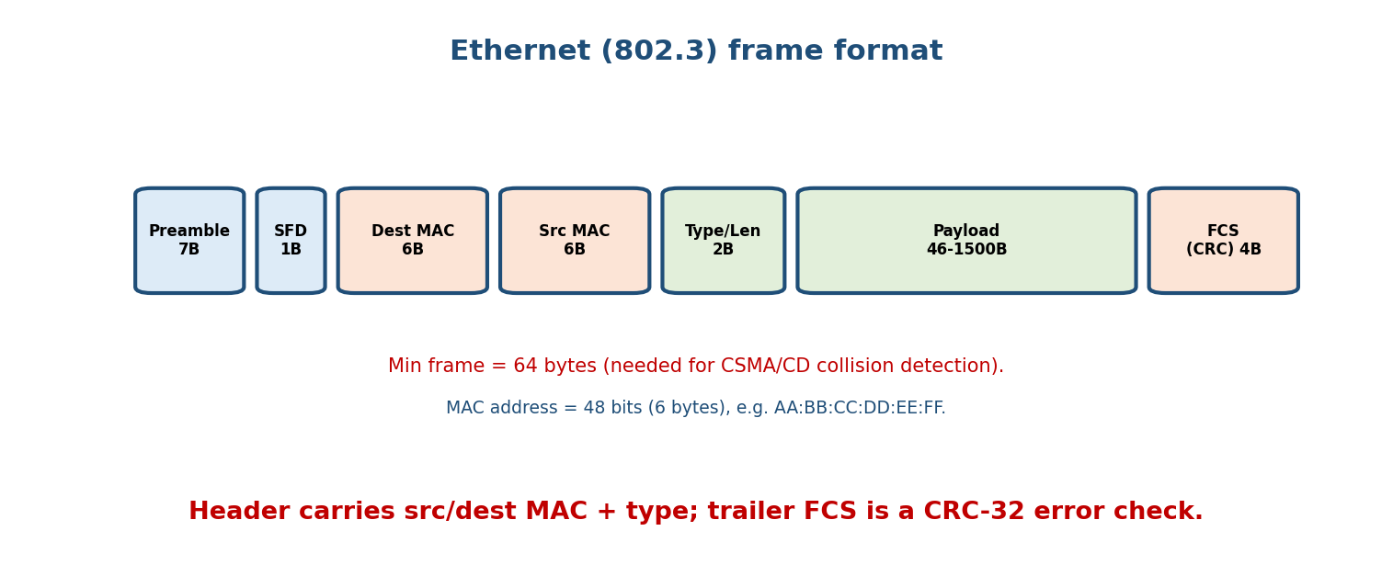
Ethernet frame: preamble + SFD, destination and source MAC, type/length, 46–1500-byte payload, and a CRC-32 FCS trailer.
- MAC address: 48 bits (6 bytes), written as AA:BB:CC:DD:EE:FF. First 3 bytes = OUI (vendor); globally unique per NIC. Broadcast = FF:FF:FF:FF:FF:FF.
- Payload: 46–1500 bytes (1500 = the standard MTU). Min frame 64 bytes (padding if needed); FCS = CRC-32 (from M3).
- Evolution: 10 Mbps → Fast (100M) → Gigabit → 10/40/100 GbE; modern Ethernet is switched full-duplex (no collisions at all — CSMA/CD is legacy for shared media).
Memory hook: MAC = 48-bit hardware address burned into the NIC (physical), vs IP = logical address (M5). MAC is local; IP is end-to-end.

MCQs
- MAC address length? → 48 bits (6 bytes).
- Ethernet MTU (max payload)? → 1500 bytes.
- Broadcast MAC address? → FF:FF:FF:FF:FF:FF.
- First 3 bytes of a MAC identify the? → vendor (OUI).

4.6 ARP — Mapping IP to MAC
To send a frame on the LAN you need the destination’s MAC, but apps use IP. ARP (Address Resolution Protocol) bridges L3 → L2.
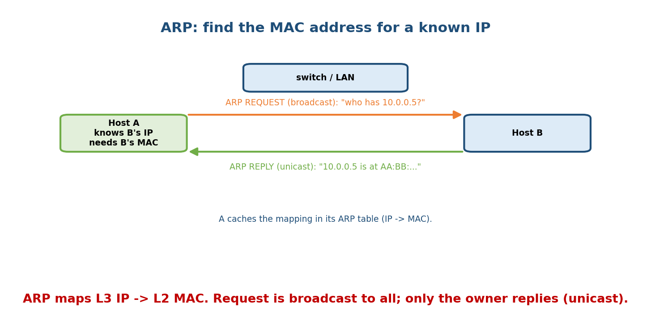
ARP broadcasts “who has this IP?” to the whole LAN; only the owner replies with its MAC, and the sender caches the mapping.
- ARP request: broadcast — “Who has 10.0.0.5? Tell 10.0.0.1.”
- ARP reply: unicast from the owner — “10.0.0.5 is at AA:BB:CC:DD:EE:FF.”
- The sender caches it in the ARP table (with a timeout).
- Cousins: RARP (MAC→IP, obsolete), DHCP (get your own IP — M9), ARP spoofing is a classic LAN attack (M10).
Memory hook: ARP asks the whole room “who owns this IP?”; only the owner answers with its MAC. IP is known, MAC is discovered.

MCQs
- ARP maps? → IP → MAC (L3 to L2).
- ARP request is sent how? → broadcast; the reply is unicast.
- Where is the resolved mapping stored? → the ARP cache/table.

4.7 LAN Devices — Collision vs Broadcast Domains
Device | Layer | Collision domains | Broadcast domains
Hub | 1 | 1 (all ports share) | 1
Switch/bridge | 2 | 1 per port (each port isolated) | 1 (floods broadcasts)
Router | 3 | 1 per port | 1 per port (blocks broadcasts)
- A switch learns which MAC is on which port (MAC learning) and forwards a frame only to the right port (unicast) — unlike a hub which repeats to all. It breaks up collision domains but still forwards broadcasts to the whole LAN.
- A router separates broadcast domains (each interface = a different network).
- Spanning Tree Protocol (STP) prevents switching loops (which would cause broadcast storms) by disabling redundant links.
Memory hook: Hub = 1 collision domain (dumb); Switch = collision domain per port (smart by MAC); Router = broadcast domain per port (smart by IP).

MCQs
- How many collision domains does an 8-port switch have? → 8 (one per port).
- Which device separates broadcast domains? → router.
- What prevents switching loops? → Spanning Tree Protocol (STP).

4.8 VLANs (Virtual LANs)
A VLAN logically splits one physical switch into multiple broadcast domains — hosts in different VLANs can’t talk directly (need a router / L3 switch), even on the same switch. Benefits: segmentation, security, and less broadcast traffic. VLAN tags use the 802.1Q header (a 4-byte tag inserted in the Ethernet frame with a 12-bit VLAN ID → up to 4094 VLANs).
Memory hook: VLAN = software walls inside one switch — same hardware, many separate LANs; crossing walls needs a router.

MCQs
- A VLAN creates multiple? → broadcast domains on one switch.
- VLAN tagging standard? → 802.1Q.
- To route between VLANs you need? → a router / L3 switch.

4.9 Real-World & Backend Perspectives
- Modern data-center LANs are fully switched and full-duplex — collisions are gone; CSMA/CD survives only as exam history and legacy shared media. Throughput and microbursts (buffer overflow at switches) are the real concerns.
- ARP + MAC learning are why “it works on the LAN”: arp -a shows the cache; stale ARP or ARP spoofing causes classic connectivity/security incidents.
- VLANs + 802.1Q are how cloud VPCs and office networks isolate tenants/teams on shared switching hardware.

4.10 Tradeoffs, Common Mistakes, Edge Cases
- Mistake: swapping ALOHA numbers — pure 18.4%, slotted 36.8% (slotted is higher).
- Mistake: thinking a switch breaks broadcast domains — it breaks collision domains; only a router breaks broadcast domains.
- Trap: forgetting the min-frame-size reason — it exists so a sender is still transmitting when a collision returns (Tt ≥ 2Tp).
- Edge case: on a full-duplex switched link there are no collisions, so CSMA/CD is disabled.

4.11 Exam, Interview & Coding Perspectives
- SEBI / RBI / NABARD: ALOHA/CSMA definitions, CD vs CA, MAC-address facts, hub/switch/router domain table, what a VLAN is.
- GATE / C-DAC: ALOHA efficiency, min-frame-size, backoff, collision-domain counting — numericals and precise definitions.
- Interview: “what happens (at L2) when two hosts talk to each other on a LAN?” → ARP to resolve MAC, switch forwards by MAC; “hub vs switch?” → collision domains.

4.12 Concept Checks & MCQs (test yourself)
- Pure vs slotted ALOHA efficiency? → 18.4% vs 36.8%.
- Three CSMA persistence methods? → 1-persistent, non-persistent, p-persistent.
- CD vs CA — wired or wireless? → CD wired (Ethernet), CA wireless (Wi-Fi).
- Min-frame-size formula & classic value? → 2·Tp·B; 64 bytes.
- MAC address size and broadcast value? → 48 bits; FF:FF:FF:FF:FF:FF.
- ARP resolves what, and how is the request sent? → IP→MAC, broadcast.
- Collision domains of an N-port switch? → N.
- Which device breaks broadcast domains? → router.
- VLAN tagging standard? → 802.1Q.
- What stops switching loops? → STP.

4.13 One-Page Revision Sheet
MAC SUBLAYER: who talks on a SHARED medium. Families:
RANDOM (ALOHA, CSMA, CSMA/CD, CSMA/CA) | CONTROLLED (polling, token) | CHANNELIZATION (FDMA/TDMA/CDMA).
ALOHA: pure S=G e^-2G, max 1/2e = 18.4% (vuln = 2 frame times)
slot S=G e^-G, max 1/e = 36.8% (vuln = 1 frame time)
CSMA (listen before talk; collisions remain due to PROPAGATION DELAY):
1-persistent(send immediately when idle) | non-persistent(random wait) | p-persistent(prob p).
CSMA/CD (Ethernet, WIRED): sense->send->detect collision->JAM->binary exp backoff [0,2^k-1].
MIN FRAME: Tt >= 2Tp => Lmin = 2*Tp*B => 64 bytes (10M Ethernet).
CSMA/CA (Wi-Fi, WIRELESS): can't detect collisions -> avoid: backoff + ACK + optional RTS/CTS.
ETHERNET 802.3: Preamble|SFD|DstMAC(6)|SrcMAC(6)|Type/Len(2)|Payload 46-1500|FCS(CRC32).
MAC = 48-bit (OUI vendor + NIC). Broadcast=FF:FF:FF:FF:FF:FF. MTU=1500. Modern=switched full-duplex(no collisions).
ARP: IP->MAC. REQUEST=broadcast "who has IP?"; REPLY=unicast MAC. cached in ARP table.
DOMAINS: Hub(L1)=1 collision domain | Switch(L2)=1 collision/port, floods broadcast |
Router(L3)=1 broadcast domain/port. Switch learns MAC->port. STP stops loops.
VLAN: split 1 switch into many BROADCAST domains (802.1Q, 12-bit ID <=4094). inter-VLAN needs router.

Flash cards
Front | Back
Pure / slotted ALOHA efficiency | 18.4% / 36.8%
Min Ethernet frame + rule | 64 bytes; Tt ≥ 2Tp
CD vs CA | wired detection vs wireless avoidance
Binary exponential backoff range | [0, 2^k − 1]
MAC address size | 48 bits (6 bytes)
Ethernet MTU | 1500 bytes
ARP maps / request type | IP→MAC / broadcast
Switch breaks which domain | collision (per port)
Router breaks which domain | broadcast
VLAN standard | 802.1Q

Spaced repetition
- 24-hour: recite ALOHA efficiencies + the min-frame-size derivation.
- 7-day: CSMA variants; CD vs CA; hub/switch/router domain table.
- 30-day: given B and Tp, find L_min; count collision/broadcast domains in a mixed topology — without notes.

4.14 Summary
The MAC sublayer decides who transmits on a shared medium. Random-access protocols evolved from ALOHA (pure 18.4%, slotted 36.8%) to CSMA (listen first; 1-/non-/p-persistent) to CSMA/CD (Ethernet — detect collisions, jam, binary exponential backoff, and a 64-byte minimum frame so Tt ≥ 2Tp) and CSMA/CA (Wi-Fi — avoid collisions since it can’t detect them). Ethernet frames carry 48-bit MAC addresses and a CRC FCS; ARP resolves IP → MAC by broadcast request / unicast reply. In LANs, hubs share one collision domain, switches give a collision domain per port and learn MACs, routers separate broadcast domains, STP prevents loops, and VLANs (802.1Q) carve one switch into many broadcast domains.
Next, Module 5 — The Network Layer & IP Addressing moves to Layer 3: IPv4/IPv6 addresses, subnetting, CIDR, and how packets are addressed for the whole journey — with the subnetting numericals that dominate exams.
You have mastered this module when you can: name the three MAC families and place each protocol; state pure/slotted ALOHA efficiency; derive the minimum frame size and explain CD vs CA; read an Ethernet frame and a MAC address; walk through ARP; and count collision vs broadcast domains for hubs/switches/routers and VLANs — all without notes.

