***For meta-analysis of “Physical Impairments”***

The estimated population proportion is 0.52.

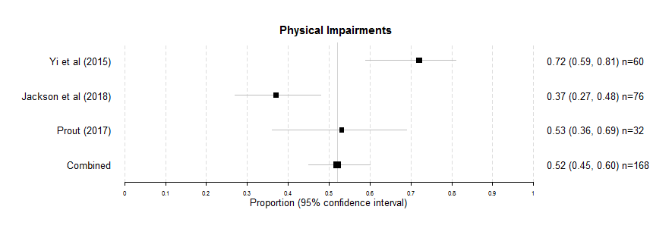

***For meta-analysis of “Lack of facilities or awareness of facilities”***

The estimated population proportion is 0.47.

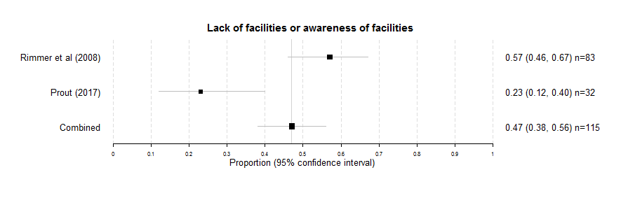

***For meta-analysis of “Fear of Falling”***

The estimated population proportion is 0.47.

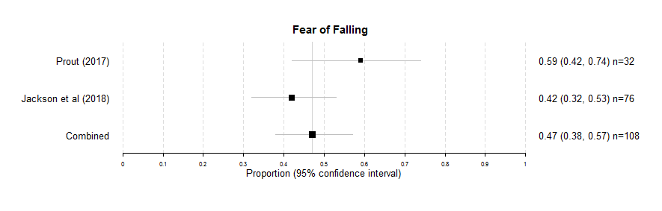

***For meta-analysis of “Transport”***

The estimated population proportion is 0.44.

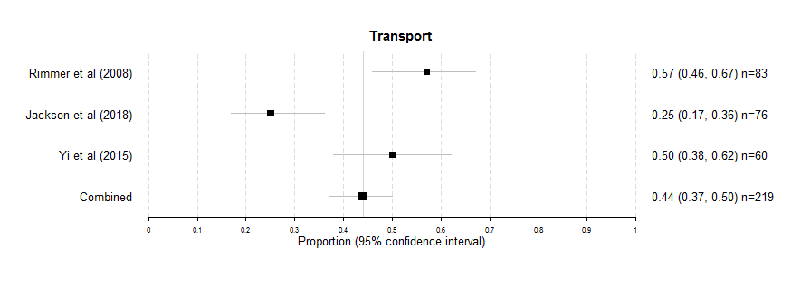

***For meta-analysis of “Lack of motivation”***

The estimated population proportion is 0.38.

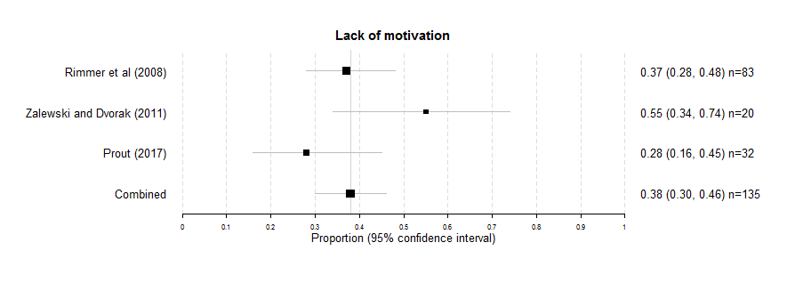

***For meta-analysis of “Knowledge of how to exercise”***

The estimated population proportion is 0.37.

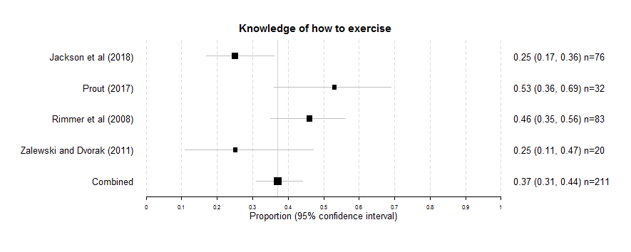

***For meta-analysis of “Not comfortable exercising in a facility”***

The estimated population proportion is 0.34.

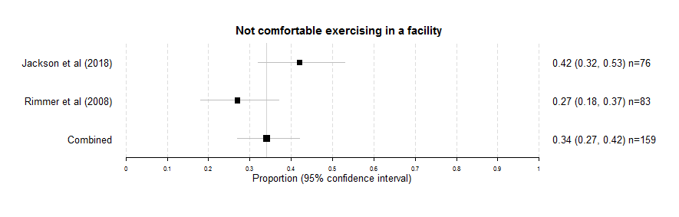

***For meta-analysis of “Poor health”***

The estimated population proportion is 0.37.

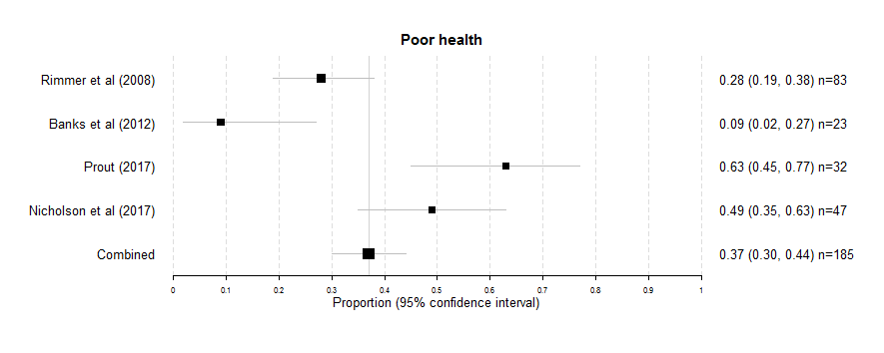

***For meta-analysis of “Pain”***

The estimated population proportion is 0.30.

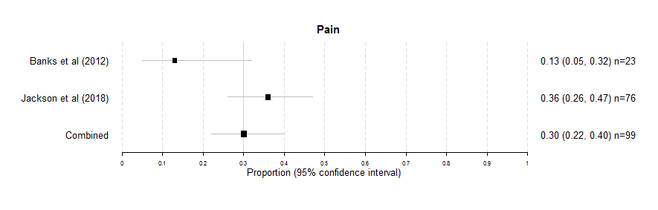

***For meta-analysis of “Weather”***

The estimated population proportion is 0.29.

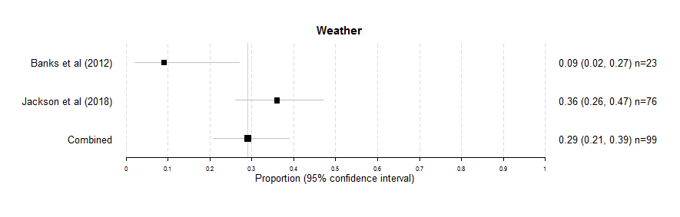

***For meta-analysis of “Fatigue”***

The estimated population proportion is 0.26.

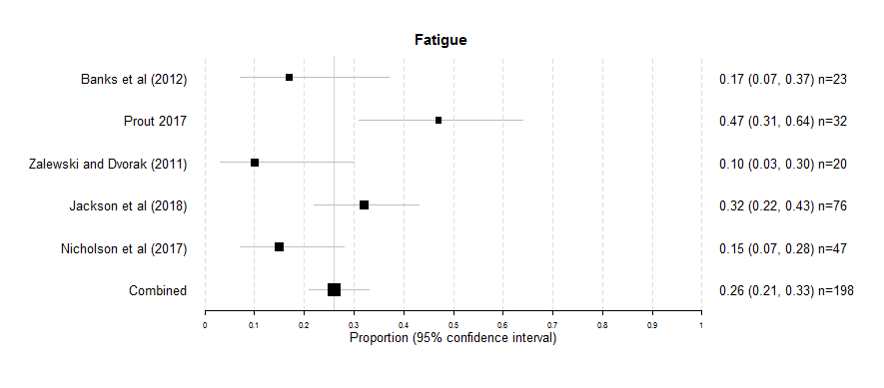

***For meta-analysis of “Family Support”***

The estimated population proportion is 0.29.

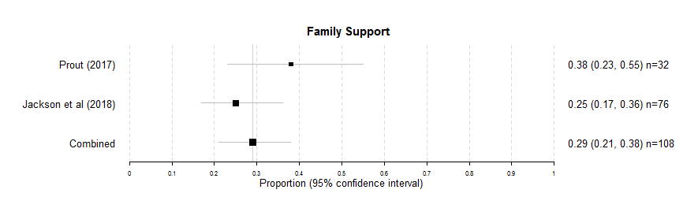

***For meta-analysis of “Too Lazy”***

The estimated population proportion is 0.28.

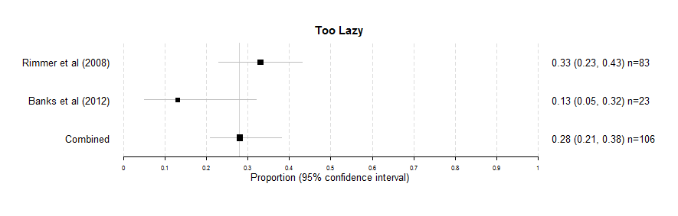

***For meta-analysis of “Lack of support from HP”***

The estimated population proportion is 0.27.

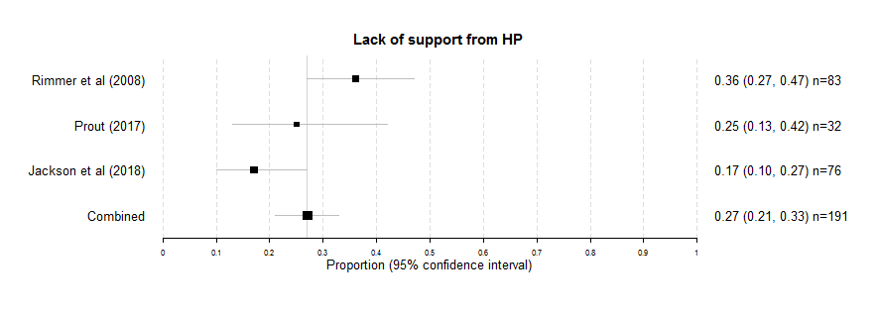

***For meta-analysis of “Lack of equipment”***

The estimated population proportion is 0.26.

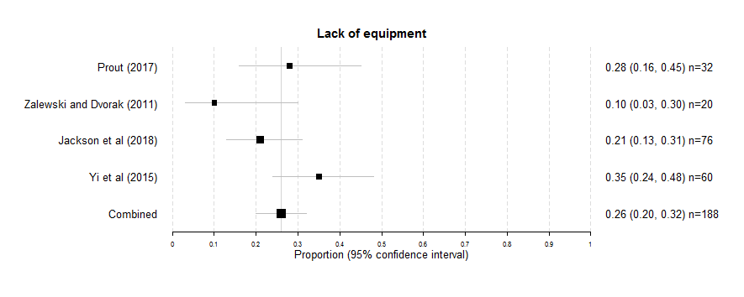

***For meta-analysis of “Lack of classes”***

The estimated population proportion is 0.19.

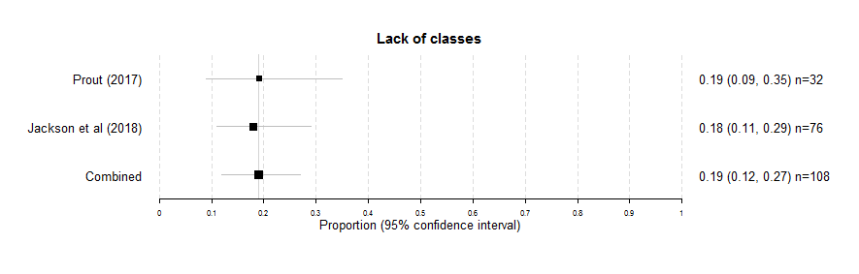

***For meta-analysis of “Fear of Injury”***

The estimated population proportion is 0.19.

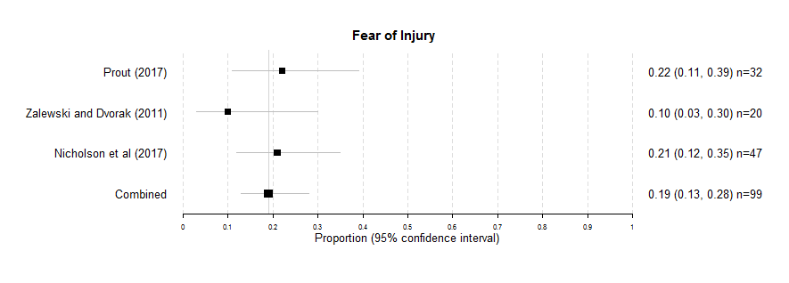

***For meta-analysis of “Lack of time”***

The estimated population proportion is 0.10.

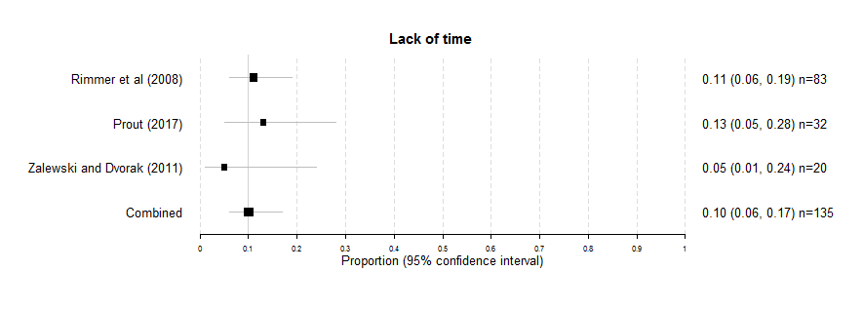

***For meta-analysis of “Belief exercise will make condition worse”***

The estimated population proportion is 0.06.

