***For meta-analysis of “Good for health”***

The estimated population proportion is 0.54.

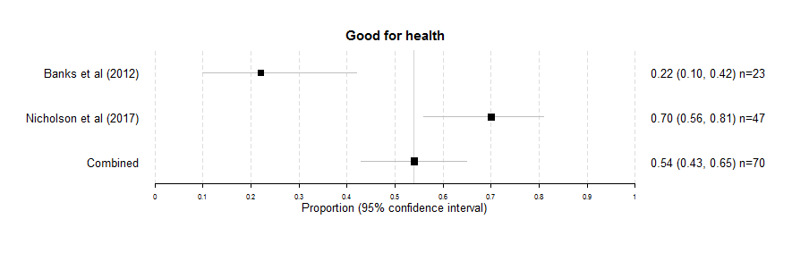

***For meta-analysis of “Improves fitness”***

The estimated population proportion is 0.50.

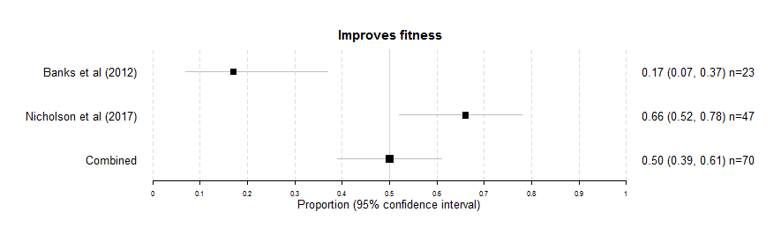

***For meta-analysis of “Makes you feel better”***

The estimated population proportion is 0.44.

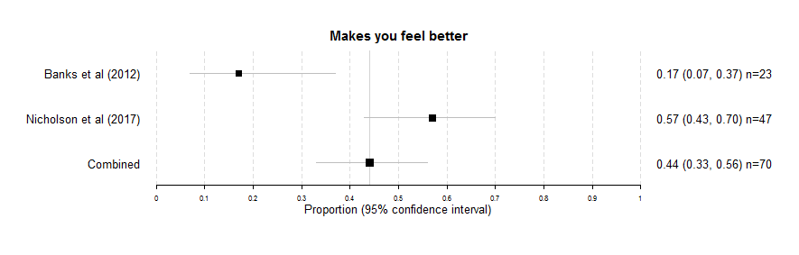

***For meta-analysis of “Helps mobility”***

The estimated population proportion is 0.44.

