# MY Bell Environment Setting

# Step 1: Software required for creating development environment-:

## Software Manifest

You will require the following software to complete the installation.

1. Windows 7 Enterprise Edition (64 bit)
2. Visual Studio 2010 Ultimate
3. MVC 3
4. Soap UI
5. Fiddler
6. SOSS setup
7. DistributedCacheListenerServiceSetup
8. Communicator
9. Live Meeting
10. VPN Client
11. Firefox Browser
12. rewrite_2.0_rtw_x64.
13. MicrosoftFixit50848 display drivers

**Step 2: Configuring IIS**

The following roles and feature need to be installed:

Go to Control Panel 🡪 Select programs 🡪Turn Windows Features on or off.

Make sure check the following Options:

1. Select & Expand Internet Information Service
2. Check Web Management Tools (Check All the options under this section)
3. World Wide Web services (Check All the options under this section)

And click ok. Finish the installation.

**Step 3: Installation of software**

### Install Visual Studio 2010 Ultimate Edition

### You can find the setup at \\10.5.18.185\f$.

### Install MVC 3 framework

### You should download and install MVC 3.

### Download and install MVC 3 from <http://www.asp.net/mvc/mvc3> on presentation server. Or

You can find the setup at \\10.5.18.185\f$.

Run

1. AspNetMVC3Setup.exe and then
2. AspNetMVC3ToolsUpdateSetup.exe
3. **Install URL Rewrite Module**

Run rewrite_2.0_rtw_x64.msi

1. **Others**
2. Soap UI (run soapUI-x32-3_6_1.exe)
3. Fiddler (run Fiddler2Setup.exe)
4. Nortel VPN Client (run NVC64-10.01.052.exe)
5. Install Office Communicator
6. Install Firefox

Install the latest version of **Firefox** and install two add-ons to it.

1. **Firebug**
2. **HttpFox**

**VPN Settings**

**For Contractor**

**Group ID**: generalaccess

**Password**: 1qaz2wSx3edc4rfv

**Destination**: vpncontractor.bell.ca or 206.47.249.94

**For VPNOR**

**Group ID**: bellicn

**Password:** ncIlleb!

**Destination**: vpnor.bell.ca

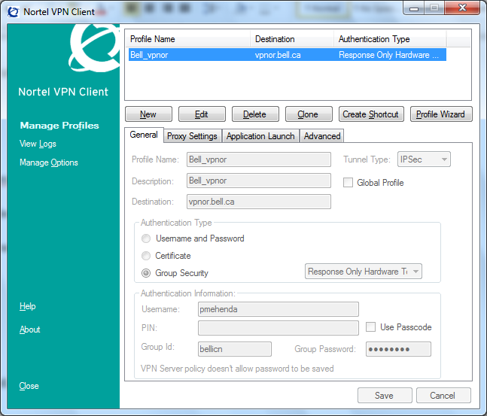

**Bell** **Username**

**Vpnor.bell.ca/ vpncontractor.bell.ca**

**Response only hardware and software token (No Passcode)**

**Select IPSec**

**bellicn**/**generalaccess**

**ncIlleb!** / **1qaz2wSx3edc4rfv**

**Communicator Settings**

1. Select Change In sign Address under connect option

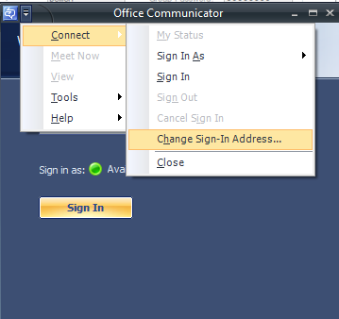

1. Click on Advanced Button. And configure as follows:

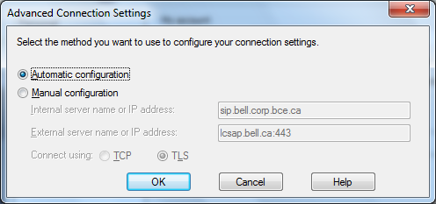

1. **Install SOSS**

Connect to VPN first.

**Install Scale Out State Server**. **Run soss_setup64.msi**.



Then configure it giving unique **Management Port** and **Server Port**.

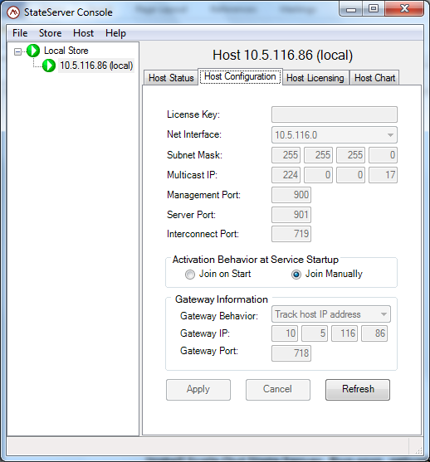

Provide these two ports a unique number. Keep rest settings same.

Click **Apply.**

1. **Troubleshooting:**

After all proper settings sometimes you still won’t be able to browse the site, in such scenario please check for below changes:

1. Your host file must be properly updated.

Location: C:\Windows\System32\drivers\etc

Entry required: 127.0.0.1 local-mybell-b.ids.int.bell.ca

(IP Address) local-mybell-b.ids.int.bell.ca

1. Check for LAN settings in IE that goes with your VPN type:

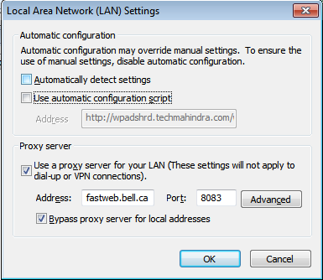

1. Add proper exceptions as required by the project in IE

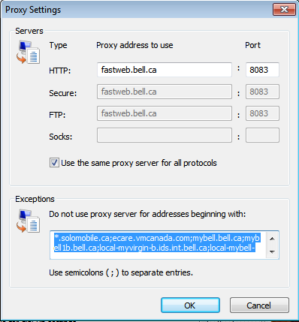

1. Now everything should work fine, but in case still you are not able to browse locally, then all issues are with IIS.

Check for below common issues:

1. Same Application pool is used to host all the projects in the site.
2. Sometimes you locally need to add version to be used in ISAPI filters. In MyBell case the framework version used is v4.0.30319 and the path for the same is C:\Windows\Microsoft.NET\Framework64\v4.0.30319\aspnet_filter.dll

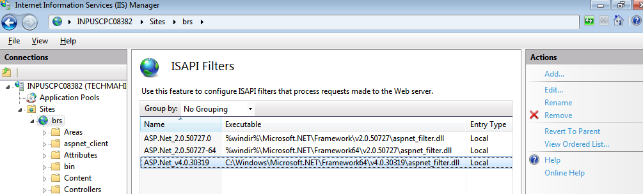

1. And the last for IIS please check

