Ideation Phase
Empathize & Discover

Date | 29 September 2026
Team ID | 6ab22a37f32d8c9d8b22620c
Project Name | AI FAQ Assistant
Maximum Marks | 4 Marks

Empathy Map Canvas:
An empathy map is a simple, easy-to-digest visual that captures knowledge about a user’s behaviours and attitudes.

It is a useful tool to helps teams better understand their users.
Creating an effective solution requires understanding the true problem and the person who is experiencing it. The exercise of creating the map helps participants consider things from the user’s perspective along with his or her goals and challenges.
Example:


Reference: https://www.mural.co/templates/empathy-map-canvas

Example: Food Ordering & Delivery Application

AI FAQ Assistant
Team ID: 6ab22a37f32d8c9d8b22620c
Target User
Primary persona: a student or support user who needs a reliable answer to a frequently asked question with minimal search effort. Secondary persona: an administrator/content maintainer.
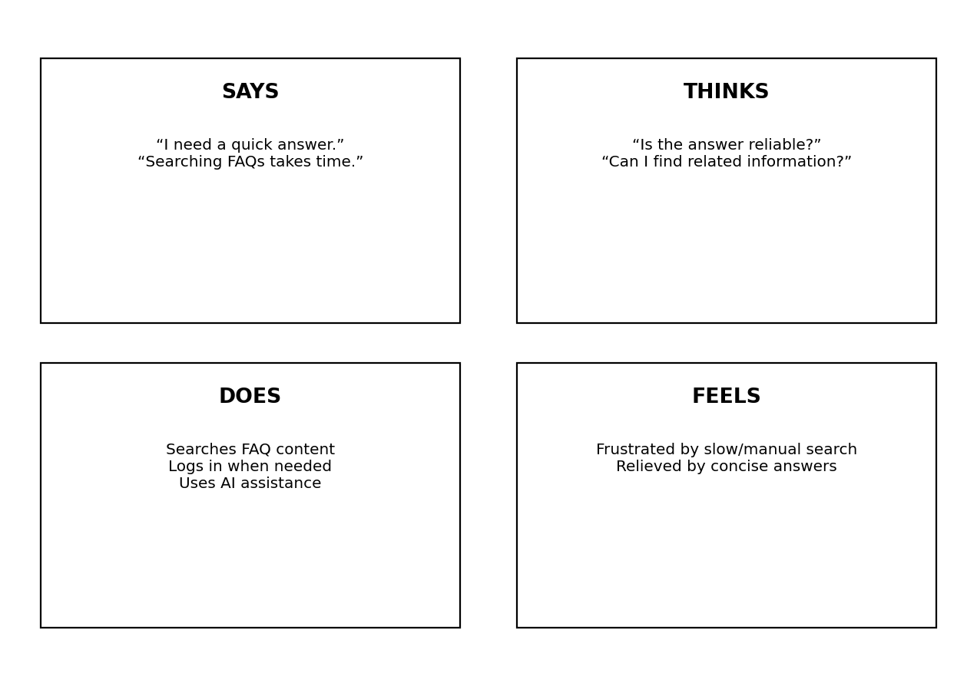
Pains
• Manual searching through many FAQ entries
• Difficulty finding concise answers
• Repeated effort creating similar FAQ content
• Need for secure protected operations
Gains
• Fast keyword search
• Centralized FAQ knowledge base
• AI-assisted FAQ generation
• Authenticated and validated API access

Team Members
Mitthun.D — Team Leader
Mohanavel.S.R
Muralidharan.K
Nithesh.J

