Project Design Phase-II
Data Flow Diagram & User Stories

Date | 29 September 2026
Team ID | 6ab22a37f32d8c9d8b22620c
Project Name | AI FAQ Assistant
Maximum Marks | 4 Marks

Data Flow Diagrams:
A Data Flow Diagram (DFD) is a traditional visual representation of the information flows within a system. A neat and clear DFD can depict the right amount of the system requirement graphically. It shows how data enters and leaves the system, what changes the information, and where data is stored.
Example: DFD Level 0 (Industry Standard)
Example: (Simplified)



User Stories
Use the below template to list all the user stories for the product.
User Type | Functional Requirement (Epic) | User Story Number | User Story / Task | Acceptance criteria | Priority | Release
Customer / Student | Registration | USN-1 | As a user, I can register with name, email and password. | User record is created and success response returned. | High | Sprint-1
Customer / Student | Login | USN-2 | As a user, I can log in with valid credentials. | JWT token is returned. | High | Sprint-1
Customer / Student | FAQ Management | USN-3 | As an authenticated user, I can create an FAQ. | Valid FAQ is stored and returned. | High | Sprint-2
Customer / Student | FAQ Search | USN-4 | As a user, I can search FAQs using a keyword. | Matching records are returned. | High | Sprint-2
Customer / Student | FAQ CRUD | USN-5 | As an authorized user, I can update/delete an allowed FAQ. | Record is updated/deleted. | Medium | Sprint-3
Customer / Student | AI Assistance | USN-6 | As a user, I can generate an FAQ from a topic. | Question, answer, category and timestamp are returned. | High | Sprint-3
Administrator | Validation & Security | USN-7 | As an administrator, I need protected and validated operations. | Invalid input is rejected and JWT is required. | High | Sprint-4
Customer Care Executive
Administrator

AI FAQ Assistant
Team ID: 6ab22a37f32d8c9d8b22620c
Data Flow Diagram
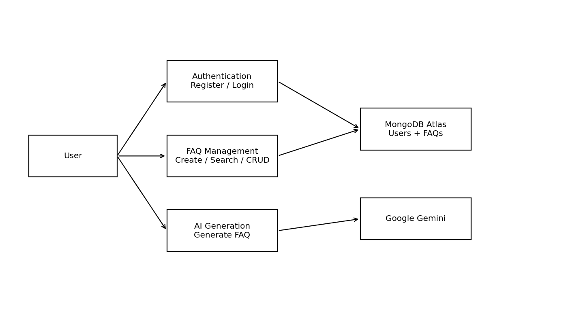

Team Members
Mitthun.D — Team Leader
Mohanavel.S.R
Muralidharan.K
Nithesh.J

