Project Design Phase
Solution Architecture

Date | 29 September 2026
Team ID | 6ab22a37f32d8c9d8b22620c
Project Name | AI FAQ Assistant
Maximum Marks | 4 Marks

Solution Architecture:
Solution architecture is a complex process – with many sub-processes – that bridges the gap between business problems and technology solutions. Its goals are to:
- Find the best tech solution to solve existing business problems.
- Describe the structure, characteristics, behavior, and other aspects of the software to project stakeholders.
- Define features, development phases, and solution requirements.
- Provide specifications according to which the solution is defined, managed, and delivered.

Example - Solution Architecture Diagram:


Figure 1: Architecture and data flow of the voice patient diary sample application
Reference: https://aws.amazon.com/blogs/industries/voice-applications-in-clinical-research-powered-by-ai-on-aws-part-1-architecture-and-design-considerations/

AI FAQ Assistant
Team ID: 6ab22a37f32d8c9d8b22620c
AI FAQ Assistant – Solution Architecture
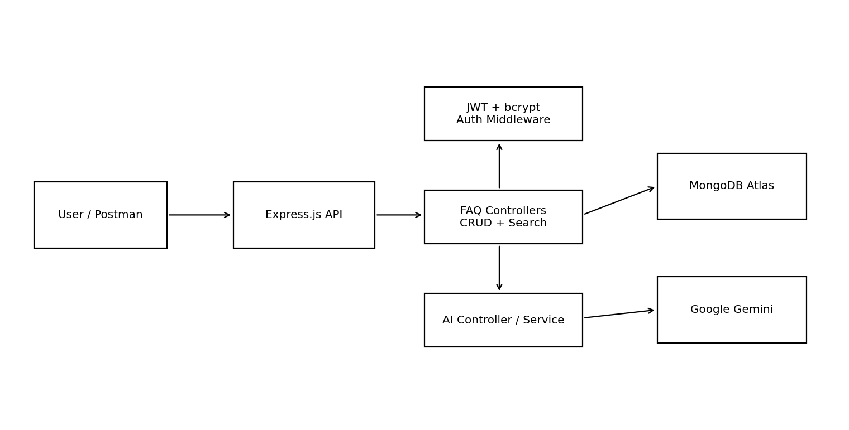
Architecture Components
• Client/API layer: Postman or future frontend.
• Express.js gateway: receives and routes HTTP requests.
• Middleware: validation, authentication and centralized errors.
• Controllers: authentication, FAQ and AI endpoints.
• Services: Gemini API integration.
• Models: Mongoose User and FAQ schemas.
• MongoDB Atlas: persistent user/FAQ storage.
• Google Gemini: generative AI service.
Data Flow
Request → Express.js → validation/authentication → controller/service → MongoDB or Gemini → structured JSON response.

Team Members
Mitthun.D — Team Leader
Mohanavel.S.R
Muralidharan.K
Nithesh.J

