Project Planning Phase
Project Planning Template (Product Backlog, Sprint Planning, Stories, Story points)

Date | 29 September 2026
Team ID | 6ab22a37f32d8c9d8b22620c
Project Name | AI FAQ Assistant
Maximum Marks | 5 Marks

Product Backlog, Sprint Schedule, and Estimation (4 Marks)
Use the below template to create product backlog and sprint schedule
Sprint | Functional Requirement (Epic) | User Story Number | User Story / Task | Story Points | Priority | Team Members
Sprint-1 | Authentication | USN-1 | Implement registration with validation and bcrypt hashing. | 3 | High | Project Team
Sprint-1 | Authentication | USN-2 | Implement login and JWT token generation. | 3 | High | Project Team
Sprint-2 | FAQ Management | USN-3 | Implement FAQ create/read/update/delete. | 5 | High | Project Team
Sprint-2 | FAQ Search | USN-4 | Implement keyword search across FAQ fields. | 3 | High | Project Team
Sprint-3 | AI Assistance | USN-5 | Integrate Gemini API for generated FAQ content. | 5 | High | Project Team
Sprint-3 | Validation & Errors | USN-6 | Add validation and centralized error handling. | 3 | Medium | Project Team
Sprint-4 | Testing | USN-7 | Test major API flows and fix integration issues. | 4 | High | Project Team

Project Tracker, Velocity & Burndown Chart: (4 Marks)
Sprint | Total Story Points | Duration | Sprint Start Date | Sprint End Date (Planned) | Story Points Completed | Sprint Release Date (Actual)
Sprint-1 | 6 | 6 Days | To be recorded | To be recorded | Completed | Completed
Sprint-2 | 8 | 6 Days | To be recorded | To be recorded | Completed | Completed
Sprint-3 | 8 | 6 Days | To be recorded | To be recorded | Completed | Completed
Sprint-4 | 4 | 6 Days | To be recorded | To be recorded | Completed | Completed

Velocity:
Imagine we have a 10-day sprint duration, and the velocity of the team is 20 (points per sprint). Let’s calculate the team’s average velocity (AV) per iteration unit (story points per day)


Burndown Chart:
A burn down chart is a graphical representation of work left to do versus time. It is often used in agile software development methodologies such as Scrum. However, burn down charts can be applied to any project containing measurable progress over time.

https://www.visual-paradigm.com/scrum/scrum-burndown-chart/
https://www.atlassian.com/agile/tutorials/burndown-charts

Reference:
https://www.atlassian.com/agile/project-management
https://www.atlassian.com/agile/tutorials/how-to-do-scrum-with-jira-software
https://www.atlassian.com/agile/tutorials/epics
https://www.atlassian.com/agile/tutorials/sprints
https://www.atlassian.com/agile/project-management/estimation
https://www.atlassian.com/agile/tutorials/burndown-charts

AI FAQ Assistant
Team ID: 6ab22a37f32d8c9d8b22620c
Project Tracker / Velocity
Planned backlog: 26 story points in this document. Core authentication, FAQ, search, AI generation and testing flows are implemented. Exact calendar sprint dates should be filled from the team's actual work log.
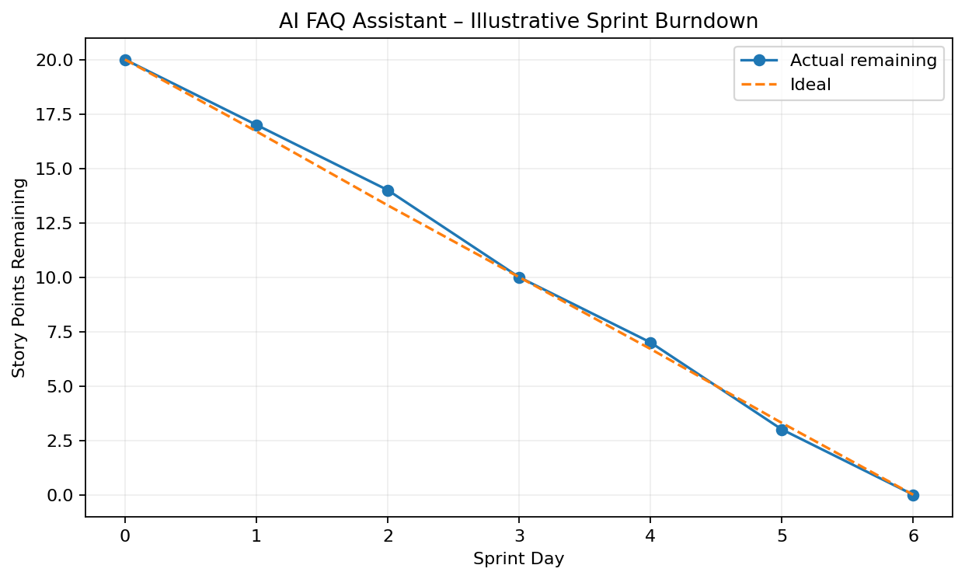
Burndown Note
The chart is illustrative and should not be treated as a measured historical team metric.

Team Members
Mitthun.D — Team Leader
Mohanavel.S.R
Muralidharan.K
Nithesh.J

