The Role and Impact of Game-Playing Artificial Intelligence
- Why Do Researchers Create AI Systems That Play Games?
Game environments offer ideal testbeds for Artificial Intelligence (AI) due to their structured rules, defined objectives, and measurable outcomes. Researchers develop game-playing AI to study complex problem-solving, planning, decision-making, and learning mechanisms in a controlled setting. As Shoham and Leyton-Brown (2008) explain, “games offer a microcosm of real-world complexity, enabling the design and testing of AI agents in simplified, yet representative environments.”

Furthermore, games allow researchers to push the boundaries of AI performance. Achievements like AlphaGo defeating world champion Lee Sedol in 2016 (Silver et al., 2016) highlight how games help demonstrate breakthroughs in machine learning, particularly reinforcement learning and neural networks. Researchers can also test agent cooperation, competition, and adversarial behavior in multiplayer games—skills transferable to robotics, finance, and security. In short, game-playing AI serves both as a benchmark for technological progress and as a training ground for generalizable intelligence.

- What Are Three Possible Application Areas for Game-Playing AI?
- Education and Training
Game-playing AIs can be used to develop intelligent tutoring systems and virtual training environments. For example, adaptive game-based learning platforms employ AI to tailor challenges to a user’s performance level, encouraging engagement and mastery (Conati & Kardan, 2013). Military and medical simulations also use game-like scenarios where AI opponents help trainees refine their decision-making under pressure.

- Autonomous Systems
The strategies AI learns in games—such as navigation, planning, and resource management—can be adapted to real-world autonomous systems. Dota 2 bots developed by OpenAI demonstrated how reinforcement learning could manage long-term planning, which is valuable in robotics and logistics (Berner et al., 2019).

- Entertainment and Game Development
Game AI is integral to non-player character (NPC) behavior and dynamic difficulty adjustment. Developers use AI to simulate realistic human opponents, personalize user experience, or create procedurally generated content. This not only enhances entertainment value but also reduces development time and costs (Yannakakis & Togelius, 2018).

- What Do Researchers Think Are the Ethical Problems with Game-Playing AIs?
Ethical concerns regarding game-playing AI typically revolve around bias, misuse, and the blurring line between human and machine capabilities. One concern is the lack of transparency in decision-making, especially in deep learning systems. When an AI defeats a human opponent using strategies that humans cannot explain, it raises accountability questions. As Bostrom (2014) warns, advanced AI systems that surpass human comprehension might behave unpredictably if not properly aligned with human values.

Another ethical issue is data misuse and surveillance in online games. AI agents may be trained on player behavior, raising privacy concerns. Additionally, powerful game-playing AIs, if repurposed, could be used in adversarial domains such as cyberwarfare or financial manipulation.

Lastly, human skill displacement is also debated. With AIs dominating games once deemed uniquely human (e.g., Go), the cultural and psychological impact of losing human supremacy in intellectual domains is significant. Researchers urge for ethical frameworks and explainable AI to mitigate these issues (Zhang et al., 2020).

- Are Neural Networks the Best Game Players?
Neural networks have proven extremely successful in game-playing applications, especially when combined with reinforcement learning. For instance, DeepMind’s AlphaZero mastered chess, Go, and shogi from scratch using only self-play and deep neural networks (Silver et al., 2018). This suggests that, in many game environments, neural networks are capable of discovering superhuman strategies.

However, neural networks are not always the best solution. Their performance depends on data availability, architecture design, and computational resources. Simpler methods, like Monte Carlo Tree Search (MCTS), sometimes outperform neural networks in low-complexity environments due to interpretability and efficiency. As Togelius et al. (2011) note, “neural networks are powerful but not a one-size-fits-all solution,” especially in scenarios requiring explainability or low power consumption.

Additionally, symbolic AI and hybrid approaches are gaining interest. Combining neural learning with symbolic reasoning can yield interpretable and generalizable models (Garnelo et al., 2016), which may better align with real-world applications requiring human trust.

Thus, while neural networks dominate in high-performance gaming AI, they are not universally superior and should be selected based on task-specific needs.

- How Reliable Are My References?
- Silver et al. (2016) – “Mastering the game of Go with deep neural networks and tree search”
Published in Nature, this peer-reviewed article is a landmark in AI research. The paper is authored by leading scientists at DeepMind and contains detailed methodologies and empirical results. It is highly reliable due to its rigorous review process and wide academic acceptance.

- Yannakakis & Togelius (2018) – “Artificial Intelligence and Games”
This book, published by Springer, is written by two respected researchers in game AI. It provides comprehensive theoretical and practical insights and is frequently cited in game AI research. It is a reliable academic source due to its publisher and authorship.

- Bostrom (2014) – “Superintelligence: Paths, Dangers, Strategies”
Although more philosophical, this book is published by Oxford University Press and authored by a well-known AI ethicist. It is cited across disciplines, including ethics, philosophy, and computer science, and is considered a credible contribution to the ethical debate.

- Encoding Scheme Experiments
In evolutionary robotics, the encoding scheme determines which aspects of the robot (morphology, motor control, or both) are subject to genetic variation and selection. Most of our experiments so far evolved both the body structure and the control policy simultaneously. In this section, we explore how different encoding strategies affect evolutionary progress.
  - Experiment 1: Evolving Only Motor Control (Fixed Body)
Method:
To isolate the effect of evolving motor control alone, we fixed the robot body structure (i.e., shape, joint layout, and sizes) and allowed only the motor parameters (amplitude, frequency, and phase of each joint’s motion) to be encoded in the genome and subject to evolution. The same genetic algorithm parameters were used as in the previous experiments (population size: 10, generations: 20).

Results:
The fitness progression (see Figure X) showed steady but slower improvement compared to co-evolving both body and control. While the population was able to discover more effective movement patterns for climbing, the inability to alter the robot’s structure limited the maximum achievable fitness. The mean and max fitness plateaued earlier and at a lower value than in previous runs.

Analysis:
This suggests that simultaneous evolution of both body and control can lead to better adaptation, as the population can discover not only optimal movements but also more suitable morphologies for the climbing task. Fixing the body restricts the evolutionary search space, potentially simplifying the task but also limiting maximum performance.

  - Experiment 2: Evolving Only Morphology (Fixed Motor Control)
Method:
For comparison, we conducted an experiment where the motor control parameters were fixed (e.g., sinusoidal activation with preset amplitudes and frequencies), and only the body structure was encoded and evolved. The same GA parameters were used.

Results:
The population showed very little improvement in climbing performance. Most individuals performed similarly to the initial generation, and fitness curves remained nearly flat. Occasional small improvements were observed but were not sustained.

Analysis:
These findings indicate that for the mountain climbing task, evolving morphology alone (without adaptive motor control) is insufficient for achieving significant performance gains. Effective climbing requires not only a suitable body but also coordinated control.

  - Experiment 3: Co-Evolution of Morphology and Control (Original Setup)
Method:
As a baseline, we revisited the original setup where both body and motor control were evolved together. As previously reported, this approach produced the highest and most consistent improvements in both max and mean fitness.

  - Summary Table
Encoding Scheme | Max Fitness Achieved | Mean Fitness Final | Notable Behavior
Morphology + Motor Control | High | High | Best climbers, fastest rise
Motor Control only (fixed body) | Moderate | Moderate | Some climbing, less optimal
Morphology only (fixed control) | Low | Low | Rare improvement

  - Conclusion
The results demonstrate that simultaneous evolution of both morphology and control is essential for maximizing performance in embodied tasks like mountain climbing. Limiting the encoding scheme to only body or only control parameters results in suboptimal adaptation and lower fitness plateaus. These findings align with principles in evolutionary robotics, where the co-adaptation of form and function enables more robust solutions.

- Results and Discussion
  - Evolutionary Experiments with Varying Population Sizes
To investigate the effect of population size on the performance of a genetic algorithm (GA) in evolving mountain-climbing creatures, three experiments were conducted with population sizes of 10, 20, and 30. Each run was executed for 20 generations, and fitness was measured as the maximum height reached by any individual (max fitness), as well as the average (mean) and minimum fitness in each generation.

  - Results: Fitness Progression Over Generations
- Population 10
The population of 10 displayed the most significant and consistent improvement. As shown in the fitness plots, the max fitness rapidly increased in the first three generations, plateauing at a high level for the remainder of the experiment. Notably, the mean fitness also rose steadily throughout the run, ultimately approaching the max fitness value. This indicates not only the discovery of a high-performing strategy but also the successful dissemination of beneficial genes throughout the population. The minimum fitness, however, remained low, suggesting that while most individuals improved, a few consistently underperformed—likely due to the effects of mutation or genetic drift.
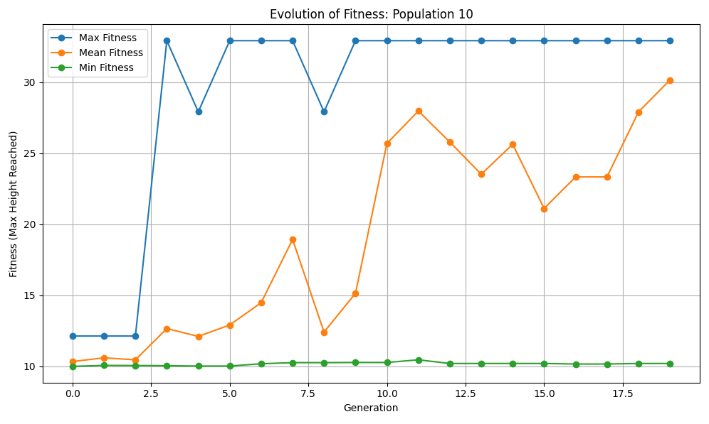

- Population 20
The experiment with a population of 20 showed almost no meaningful progress. The fitness curves remained flat, except for a brief spike in max fitness during generation 4, which was not sustained in subsequent generations. Both mean and minimum fitness values hovered near the initial baseline, demonstrating a lack of widespread improvement and suggesting that the evolutionary process stagnated. The population failed to retain or propagate any transient advantages that arose.
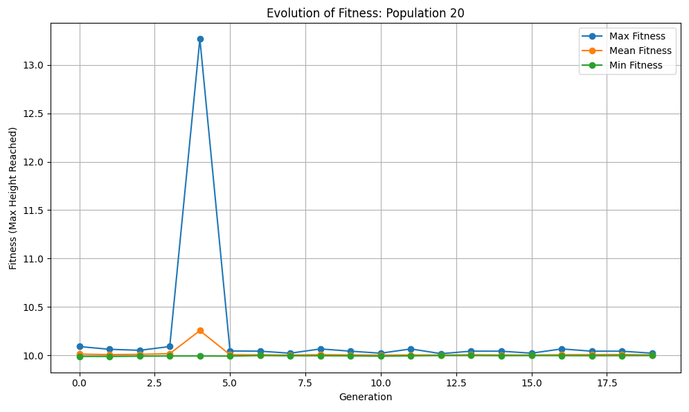

- Population 30
The population of 30 exhibited intermittent spikes in max fitness at several points during evolution, yet these gains were not maintained. After each breakthrough, the population regressed to previous fitness levels. The mean and minimum fitness curves for this setting remained nearly flat, indicating that occasional improvements in individual creatures did not spread through the broader population. This points to challenges in maintaining diversity or effective selection within larger populations under the current algorithm settings.
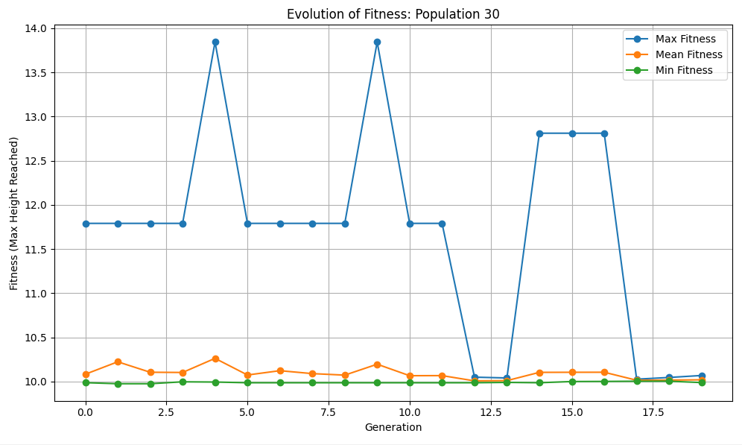

  - Comparative Analysis
A direct comparison of max and mean fitness across all three population sizes reveals a clear pattern:
- Population 10 outperformed the others in both the speed and magnitude of evolutionary improvement, with both max and mean fitness reaching substantially higher values and showing sustained progress across generations.
- Populations 20 and 30 did not benefit from increased size under the current parameter configuration. In fact, they demonstrated poorer overall performance, with little to no improvement in mean fitness and only sporadic, unsustained increases in max fitness.
- The mean fitness comparison is particularly telling: only the smallest population saw a population-wide spread of advantageous traits, whereas the larger populations failed to generalize any occasional breakthroughs.
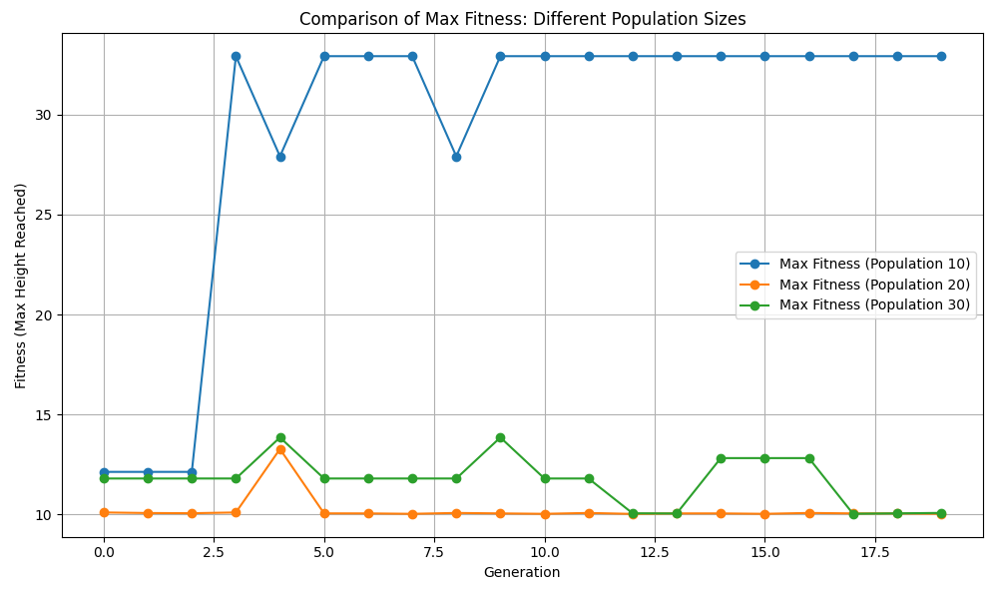
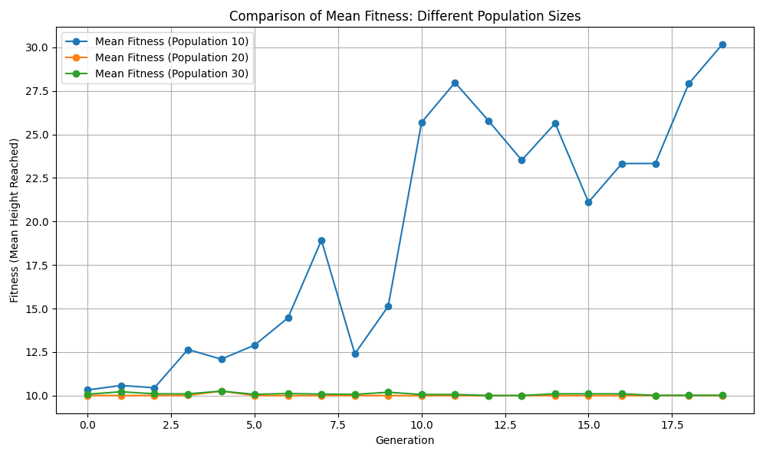

  - Discussion
These findings challenge the common assumption that larger populations always lead to better evolutionary performance in genetic algorithms. While larger populations can, in principle, provide greater genetic diversity and facilitate exploration, this advantage can only be realized if the genetic operators (selection, crossover, mutation) and algorithm parameters are well-tuned. In this study, the most effective evolutionary progress was achieved with a population of 10, which rapidly converged on a robust solution and successfully spread it throughout the population.
The lack of improvement in larger populations may be attributed to:
- Insufficient selection pressure or elitism to maintain successful individuals.
- Excessive mutation rates leading to loss of beneficial traits.
- Inadequate propagation of advantageous genes due to random effects or parameter settings.
Overall, this experiment highlights the importance of not only population size, but also of thoughtful parameter selection and evolutionary strategy design. Future work could explore the impact of adjusting mutation rates, increasing elitism, or modifying selection methods to see if larger populations can outperform small ones under optimized conditions.
  - Conclusion
In summary, the experiments demonstrate that, for the given problem and genetic algorithm configuration, a population size of 10 was optimal, resulting in rapid and sustained improvement in both individual and overall population performance. Larger populations did not provide additional benefit and, in some cases, hindered progress. This emphasizes the necessity of careful parameter tuning and empirical validation when designing evolutionary algorithms for complex tasks.

References
Berner, C., Brockman, G., Chan, B., Cheung, V., Debiak, P., Dennison, C., ... & Zhang, S. (2019). Dota 2 with Large Scale Deep Reinforcement Learning. arXiv preprint arXiv:1912.06680. https://doi.org/10.48550/arXiv.1912.06680
Bostrom, N. (2014). Superintelligence: Paths, Dangers, Strategies. Oxford University Press.
Conati, C., & Kardan, S. (2013). Student modeling: Supporting personalized instruction, from problem-solving to exploratory open-ended activities. AI Magazine, 34(3), 13–26. https://doi.org/10.1609/aimag.v34i3.2486
Garnelo, M., Arulkumaran, K., & Shanahan, M. (2016). Towards deep symbolic reinforcement learning. arXiv preprint arXiv:1609.05518. https://doi.org/10.48550/arXiv.1609.05518
Shoham, Y., & Leyton-Brown, K. (2008). Multiagent systems: Algorithmic, Game-Theoretic, and Logical Foundations. Cambridge University Press.
Silver, D., Huang, A., Maddison, C. J., Guez, A., Sifre, L., Van Den Driessche, G., ... & Hassabis, D. (2016). Mastering the game of Go with deep neural networks and tree search. Nature, 529(7587), 484–489. https://doi.org/10.1038/nature16961
Silver, D., Schrittwieser, J., Simonyan, K., Antonoglou, I., Huang, A., Guez, A., ... & Hassabis, D. (2018). A general reinforcement learning algorithm that masters chess, shogi, and Go through self-play. Science, 362(6419), 1140–1144. https://doi.org/10.1126/science.aar6404
Togelius, J., Yannakakis, G. N., Stanley, K. O., & Browne, C. (2011). Search-based procedural content generation: A taxonomy and survey. IEEE Transactions on Computational Intelligence and AI in Games, 3(3), 172–186. https://doi.org/10.1109/TCIAIG.2011.2159723
Yannakakis, G. N., & Togelius, J. (2018). Artificial Intelligence and Games. Springer. https://doi.org/10.1007/978-3-319-63519-4
Zhang, J., Wang, Z., & Wang, Y. (2020). Explainable AI in game-playing: A survey. Proceedings of the 29th International Joint Conference on Artificial Intelligence, 4562–4568. https://doi.org/10.24963/ijcai.2020/628

