CITS3200 Group J

User Manual for GUI and Visualiser
Guide on how to use the GUI and the visualizer for viewing a Road Network and the individuals from a specific generation
Rohit Gopalan

i. PREFACE 2
ii. REQUIREMENTS 2
1. USING THE USER INTERFACE (SOME THINGS TO NOTE FOR THE USER) 2
1.1 How to load .dll files (refer to figure 1.2) 3
1.2 Load map file: refer to Figure 1.3 4
1.3 Load Output file: refer to Figure 1.4 5
2. THE MAIN FUNCTIONALITY OF THE FINDER INTERFACE 5
2.1 Run the Step process (refer to figure 2.1) 6
2.2 The run process (refer to figure 2.2) 6
2.3 The repeat process (refer to Figure 2.3) 7
2.4 Viewing the output generation (refer to figure 2.4) 8
2.5 Close the Output (refer to figure 2.5) 9
2.6 Stopping a current process (refer to figure 2.6) 9
3. USING THE VISUALISER 10

PREFACE
This document explains how to use the User Interface and the Visualiser for the Genetic Engine Project. It contains instructions with screen shots of the interface to aid these instructions. This user manual assumes that the user will have some knowledge of genetics and genetic algorithms. For guidelines on how to install the User Interface and the Visualiser, please refer to INSTALL.txt.

REQUIREMENTS

Users can run this software on any Windows operating system ranging from Windows 2000 to Windows 7 (includes Windows XP and Vista) on either a PC or Laptop.
But to view the code, the user must also have Visual Studio 2010 or Visual Studio C# 2010 Express. This is because, the code has been written with both of these Integrated Development Environments (or IDEs for short). If the user has Visual Studio 2008, they will not be able to see the code because the code has been constructed through using the later version of Visual Studio. Because, the program uses a decent amount of memory to save generation and individual XML files, the user’s PC or Laptop must have at least 64MB.

USING THE USER INTERFACE (SOME THINGS TO NOTE FOR THE USER)

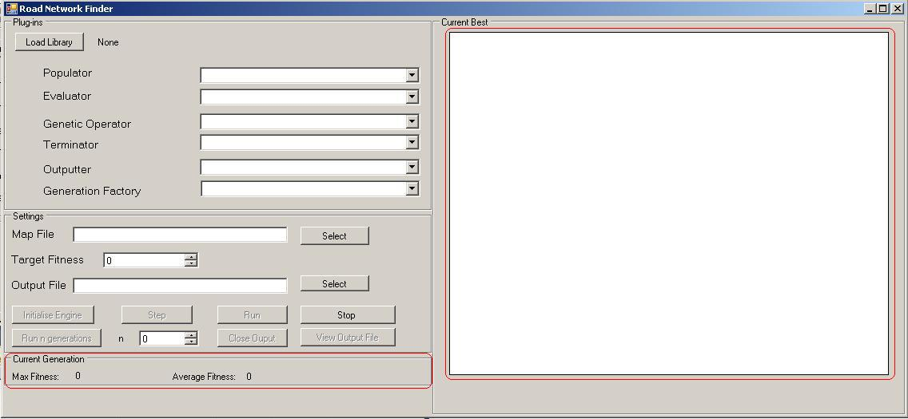

Figure 1.1: The user interface when it first loads up. The large white space is the drawing area while the fitness values are shown on the bottom left hand corner.

On the interface there is a Current Generation section which is on the bottom left hand corner. This is where the Max and Average fitness values are displayed when the generation is first initialized and when a new generation is created.
When these values are updated at the user’s actions, the individual of this generation is displayed on the large white space which is on the right hand side. Upon loading, it will be blank, but when the generation is initialized, then it will be drawn on this space.

When the user interface is loaded, it will look exactly the same as shown above in Figure 1.1. Most of the functionality in the buttons is disabled from the user. This is because; the user has to load the .dll files first before they can proceed.

1.1 How to load .dll files (refer to figure 1.2)
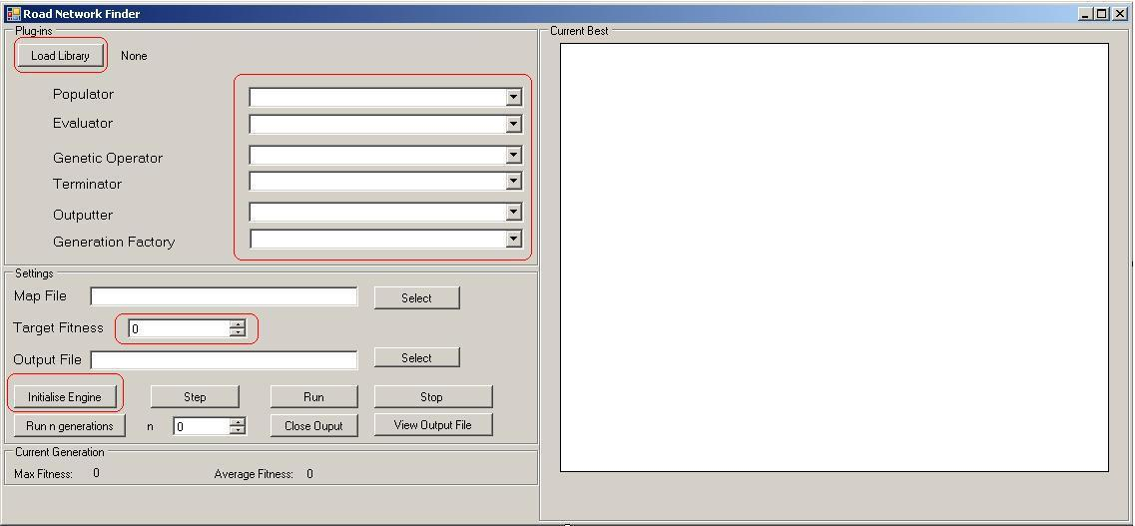
Figure 1.2: click on the circled ‘Load Library’ button to load .dll file
and the drop-down lists shown will be populated, then click on the ‘Initialise Engine’ button

- Firstly, click on ‘Load Library’ which will open a file directory which will require the user to load a .dll file from any directory on the computer you are using.
- Once a .dll file is loaded, the program will attempt to populate the drop downs in shown in Figure 1.2. If the population is unsuccessful, it means that either the file is not a .dll file or the .dll file does not contain any populator, evaluator, genetic operator or terminator. For the engine to be created, it is important that there is at least one option for the populator, evaluator, genetic operator and the terminator.
- Once the drop-down lists is populated, then the user must select an option from each drop-down list and click on ‘Initialise Engine’. For a simple engine to be created, the user must only need to select an option from the populator, evaluator, genetic operator and terminator drop-downs. This is a mandatory step. If this mandatory step is not completed when the user clicks on the button, an error message will pop up asking the user to complete this step and retry the initialization. Choosing an outputter and the generation factory from their drop-down lists are optional and not necessary to initialize the engine.
- Once the engine is initialized, the ‘Run’, ‘Run n generations’ and ‘Step’ buttons are activated to the user. However these steps we will discuss later.

Before the user can press these buttons, it is important for the user to load a map file and an output file. Both files need to be an XML File. Firstly if the files are not loaded up, then the user is notified with a brief reason why they need to load up both files. Then if the files are not of an XML type, then an error message is displayed. The reason why an error message is displayed is because, there are XML read and write classes that can only read and write XML data to/from XML files.

1.2 Load map file: refer to Figure 1.3
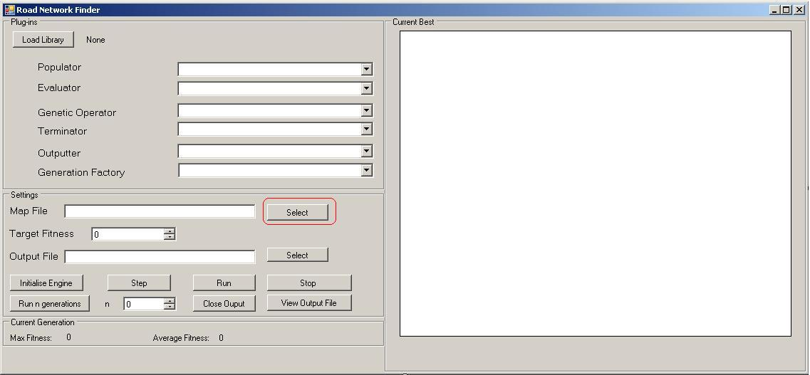
Figure 1.3: Note the oval around the first select button. Click on this button to select an XML file.

Firstly click on the ‘Select’ button. Then the file directory will open up. This implies that the user needs to select a XML map file. When the file is successfully loaded, the program will check if the file is an XML file. If so, then the file directory is recorded on the textbox next to the Select button.
Once a Map file is chosen and successfully loaded and read, it will then create an instance of a Map, and draw that map on the large white space on the right hand side of figure 1.3

1.3 Load Output file: refer to Figure 1.4
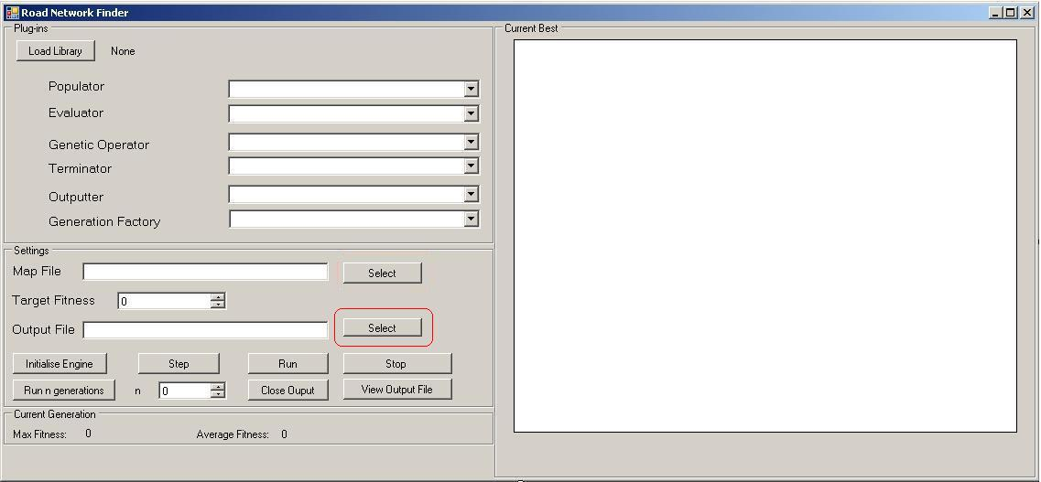
Figure 1.4: Note the oval around the second select button. Click on this button to select an XML file.

Firstly click on the ‘Select’ button. Then the file directory will open up. This implies that the user needs to select a XML output file. When the file is successfully loaded, the program will check if the file is an XML file. If so, then the file directory is recorded on the textbox next to that Select button. The output file upon successful loading will be used as a reference for writing XML data to this file.
Another way to load up an output file is to write the directory in the text box next to the ‘Select’ button. Again, checks will be made to make sure the file path specified is an XML file. If the file path does not exist, an XML document is created and saved into the user specified directory.

2. THE MAIN FUNCTIONALITY OF THE FINDER INTERFACE
The next section discusses the main functionality behind the Step, Run, Run n Generations, View Output File, Stop and Close output buttons. These buttons affects the current generation values and the drawing area on the interface as discussed earlier. When one button is pressed, the other buttons are deactivated from the user because when one process is running, another one cannot run otherwise the fitness values will be updated with very strange values and the individuals of the best generation may not be viewed visually to the user.
2.1 Run the Step process (refer to figure 2.1)
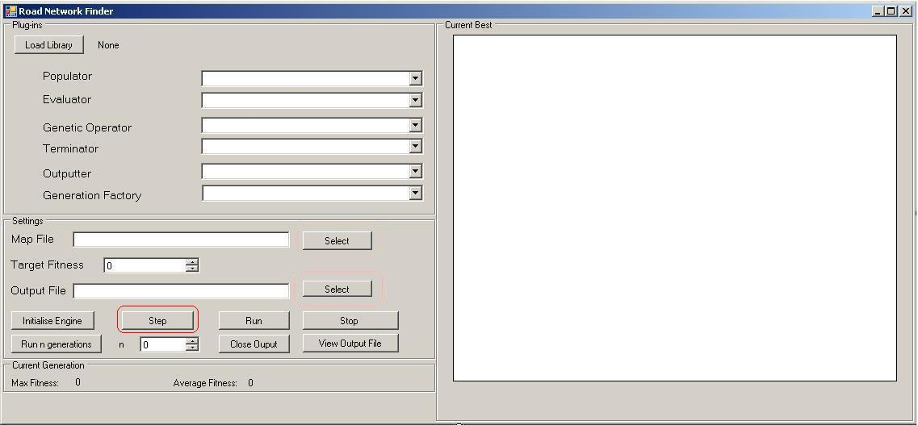
Figure 2.1: Click on the ‘Step’ button to step through a generation

To run the step process, the user needs to click the ‘Step’ button. This can only happen if the user had initialized the engine. When ‘Step’ is pressed, the program will process the current generation to create a new generation. In doing so, the new average and max fitness values are calculated and displayed along with displaying the best individual of the current generation in the large white space in figure 2.1.
2.2 The run process (refer to figure 2.2)

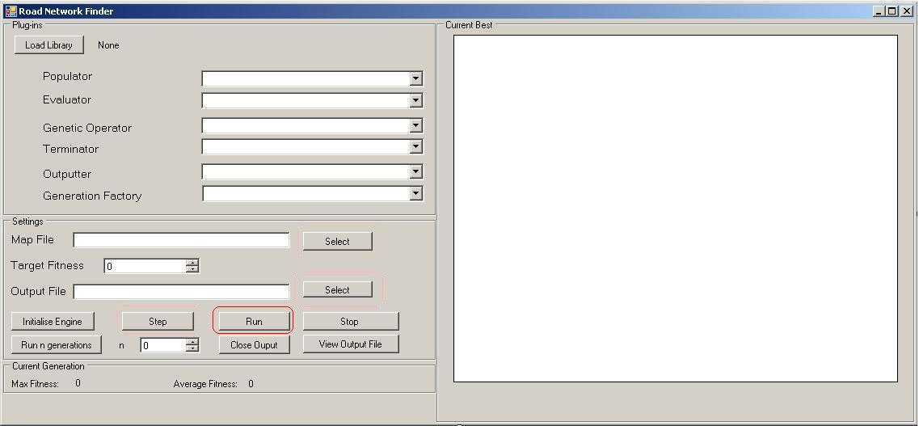
Figure 2.2: Click on ‘Run’ to execute the run process

Click on ‘Run’ to execute this process. Run is only executed if the generation has not met its termination condition (in other words, does not meet the requirement for termination. The termination is based on what the user chose earlier when initialising the engine). Then, a new generation is created with the existing generation. The fitness values are displayed and the best individual of this new generation is displayed on the white space

2.3 The repeat process (refer to Figure 2.3)
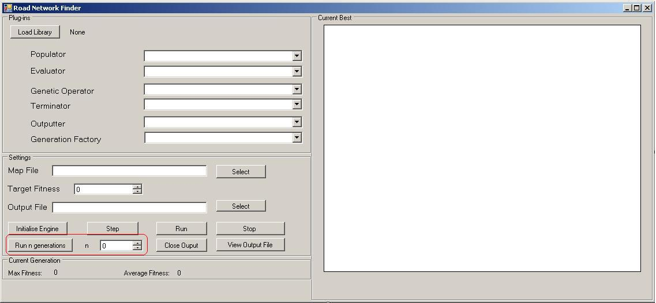
Figure 2.3: Note the eclipse around the 2 controls; this is what the user needs to use to run the repeat process.

To run the repeat process, the user needs to click ‘Run n generations’. Before that, they need to select a value of n by using the scroller next to the button. The acceptable value of n is at least 1 up to a maximum value of 900.
The repeat process is simply running the Step process n times (depending on the user input) provided the engine does not reach the termination condition specified by the user.
So the result is the new generation after running through n generations. The individual of this new generation is displayed on the large white space of the interface while the maximum and average fitness is displayed in the ‘Current Generation’ section.
2.4 Viewing the output generation (refer to figure 2.4)
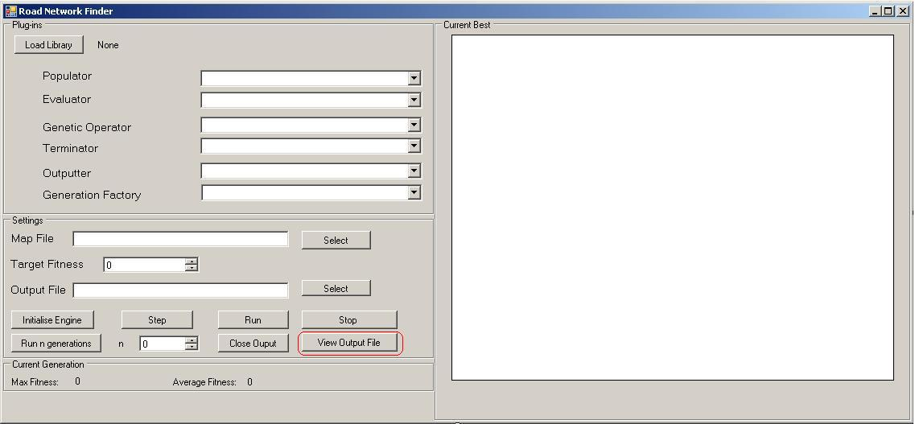
Figure 2.4: View Output File button shown by the eclipse.

The ‘View Output File’ button will only work if the engine has been complete and an XML output file has been loaded by the user.
If the user wants to see the output visually, the user will need to click on this button as shown above in figure 1.8. Once the button is clicked, the generation is written to the loaded up XML file using an internal XML writer and it will open up a new interface which is the Visualiser. The visualiser will check if the output file is an XML file before attempting to read the XML data and load the Visualiser as a separate window while keeping maintaining the state of the finder user interface. More detail is covered in Section 3.0 which is based around how to use the Visualiser.

2.5 Close the Output (refer to figure 2.5)
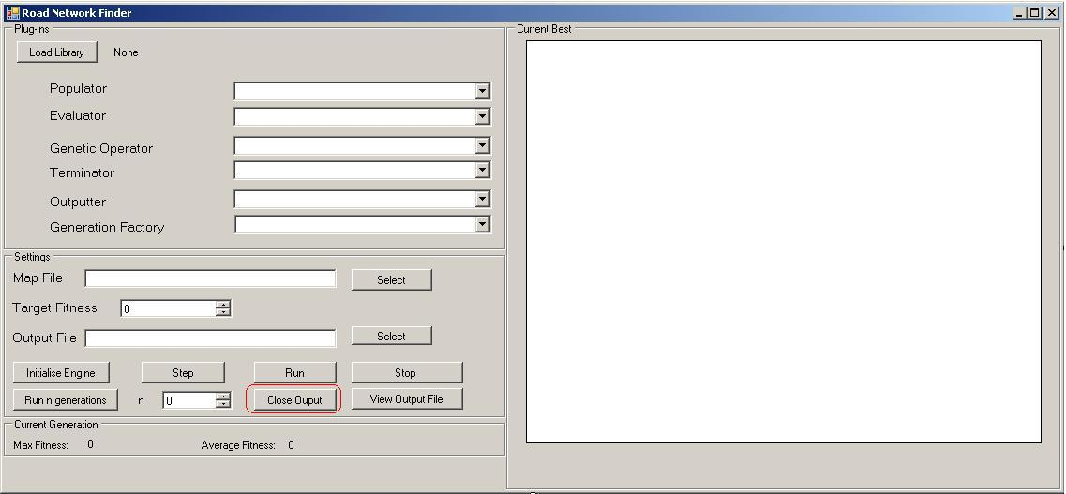
Figure 2.5: Cleanup button circled in red
The ‘Close Output’ button is only activated to the user after a run, a repeat or a step process has been performed. If the user clicks on ‘Clean up’ the engine within the GUI is to complete the outputting of the generation

2.6 Stopping a current process (refer to figure 2.6)
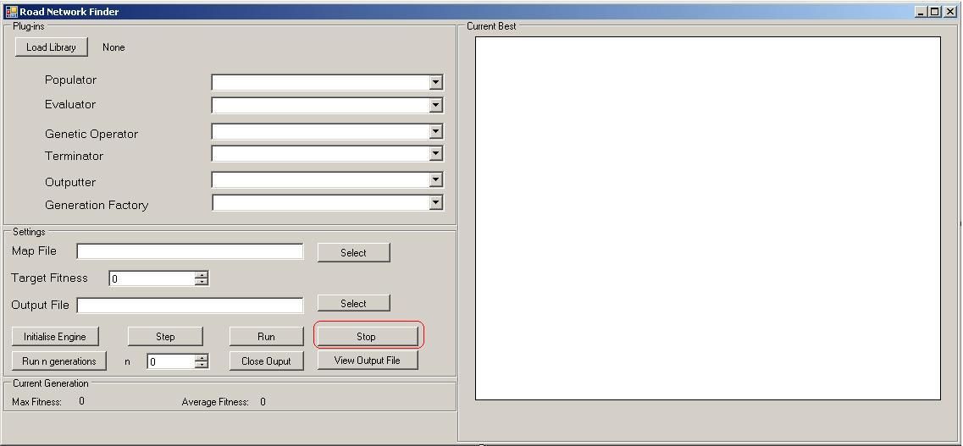
Figure 2.6: Stop button in red.

If the engine is running through a current Run, Repeat and Step process, a user may wish to kill the current process before the termination condition is even met. To do, the user has to click the ‘Stop’ button.

USING THE VISUALISER
The main use of the Visualiser is to view any individual from a list of generations which are extracted from the XML output file opened by the user.
The Visualiser has very basic steps that the user needs to follow.

- The user will get a message asking the user to select an output file. Then the user then needs to click ‘OK’ which will lead the user to the file browser as shown in figure 3.1

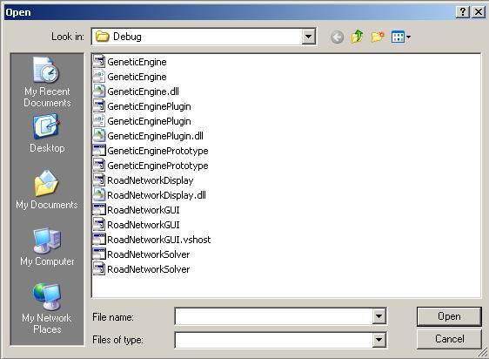

Figure 3.1: The File browser that the user uses to load the output file

- Once the user gets to the file browser, they will need to select an output file of an XML form, the program is expecting that XML data is contained in the file. If the user doesn’t load up a file, then the error message is displayed alerting the user that because they didn’t choose a file, the program is terminating. It will also terminate, if the file chosen is not an XML one.
- Once the file is successfully loaded, this leads the user to the main interface shown in Figure 3.2 below

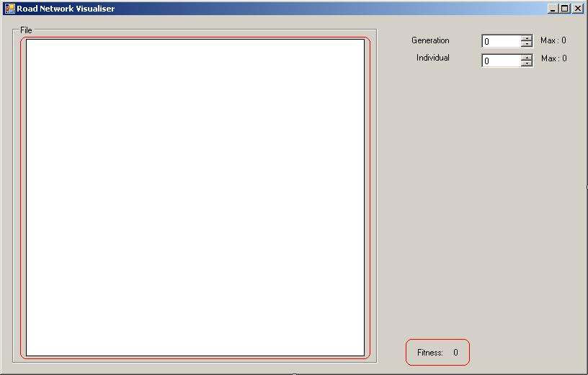

Figure 3.2: The Visualiser

- The Visualiser has a large white space on the left hand side which is to display an individual of that generation. The individual fitness value is shown on the bottom right hand corner of the interface (where the label says ‘Fitness’).
- Once the file is successfully loaded, a list of generation values are extracted from the output file and are used to populate the Generation Scroller as shown below in Figure 3.3
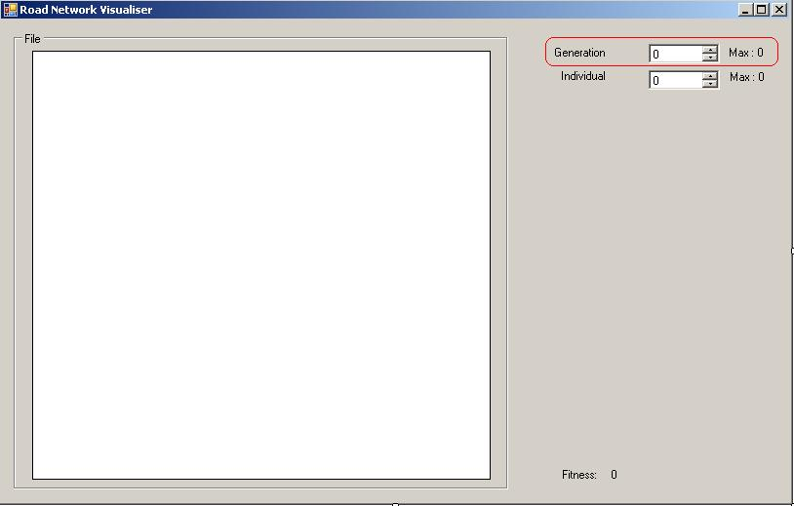

Figure 3.3: Note the generation scroller circled above. That is dynamically populated once the generation values.

If the generation scroller is not populated, then a message is shown to the user, and the Visualiser terminates. Once the generation scroller is populated, the user will need to select an index to refer to a specific generation. This is necessary because there will be multiple generations that got extracted from a single output file. Once the generations are populated, the maximum generation value is shown to the user. Once the user accidentally specifies a value greater than the maximum, the generation value is set to zero.
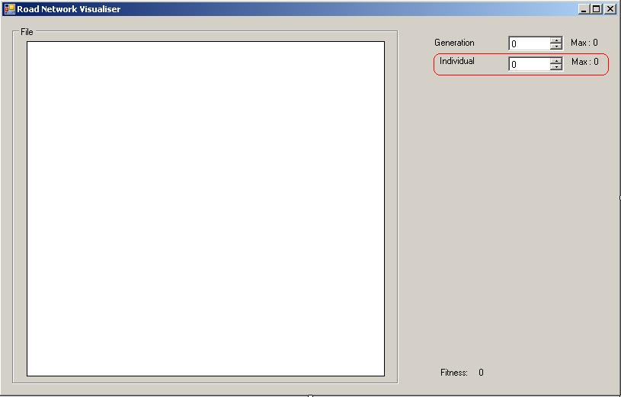

Figure 3.4: Note the eclipse on the scroller, users will need to select an individual from a specified generation

- Once a generation index is chosen, the individual scroller shown in figure 3.4 is populated with the number of individuals from the user-specific generation and the maximum individual value for the selected generation is shown to the user. If the generation has no individuals, an error message pops up explaining that as there is no individual from the generation, it may be impossible for an individual to be shown on the large white space and therefore request the user to select another generation.
- Once the individual scroller is successfully populated, the user can then select an individual to view on the large white space. Once the choice is made, the individual will be shown along with its fitness value been displayed on the bottom right hand corner. If the user accidentally selects an index greater than the maximum value, the individual index is set to zero.

