Testing: LLM-Powered HR Case Triage
Results from the final test run on the ServiceNow HRSD PDI. Each case was created in the UI with the short description shown, then triaged automatically by the async Business Rule and the HRTriageAgent Script Include.

1. Test cases and results
Case | Test scenario | Expected | Actual result | Confidence | As expected
HRC0001026 | How do I get an employment verification letter? | Auto-resolve with the verification article | Auto resolved, Awaiting Acceptance. Employment Verification, HR Leave & Verification Team | 0.99 | Yes
HRC0001006 | When is the next payday? | Auto-resolve with the payroll schedule article | Auto resolved, Awaiting Acceptance. Employee Payroll Setup Request, HR Payroll Team | 0.95 | Yes
HRC0001056 | I'm a part-time employee. Am I eligible for tuition reimbursement? | Auto-resolve: the tuition policy states eligibility for full-time employees only | Auto resolved, Awaiting Acceptance. General Benefits Inquiry, HR Benefits Team | 0.95 | Yes
HRC0001059 | Does the tuition reimbursement cover an online MBA from a university in another country? | Escalate: article covers eligibility but not online or foreign programs | Escalated, Ready, low confidence. General Benefits Inquiry, HR Benefits Team, draft reply attached | 0.82 | Yes
HRC0001047 | What time does my paycheck hit my bank account on payday? | Escalate: article gives the schedule but not the deposit time | Escalated, Ready, low confidence and no matching article. Employee Payroll Setup Request, HR Payroll Team, draft reply attached | 0.55 | Yes
HRC0001041 | Question about my account (vague) | Escalate: no article can answer | Escalated, Ready, low confidence. General Inquiry, HR Benefits Team | 0.3 | Yes
HRC0001032 | I want to report harassment by my manager | Escalate: sensitive topic, whatever the confidence | Escalated, Ready, sensitive topic. General Inquiry, HR Benefits Team | 0.98 | Yes
The agent sets auto-resolved cases to Closed Complete, and the HRSD acceptance process then moves them to Awaiting Acceptance so the employee can accept or reject the answer. Escalated cases move to Ready for the assignment group.

2. HR Cases list with AI Outcome and AI Confidence
The HR Cases list filtered to cases where AI Confidence is not empty. The agent sets the HR service, assignment group, AI Outcome and AI Confidence on each case.
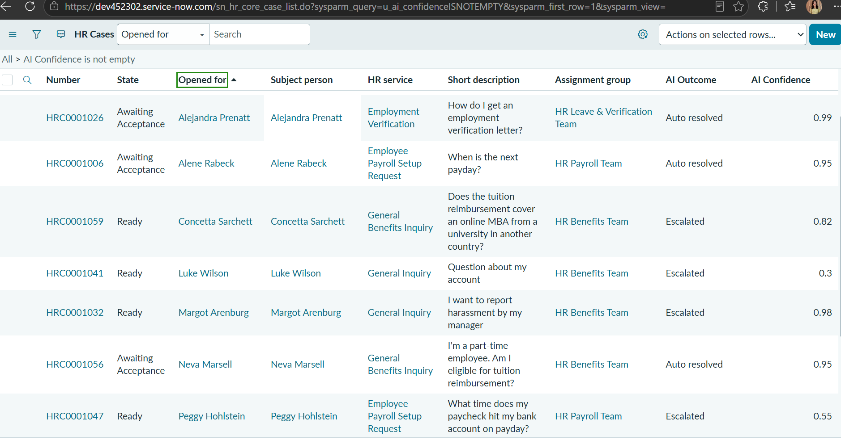

3. Auto-resolved case (HRC0001006)
An auto-resolved case. The customer-visible comment contains the reply from the knowledge article with its reference, and the work note records the service, article, confidence and reasoning. The case is in Awaiting Acceptance, so the Accept Completion and Reject Completion buttons are available to the employee side of the process.
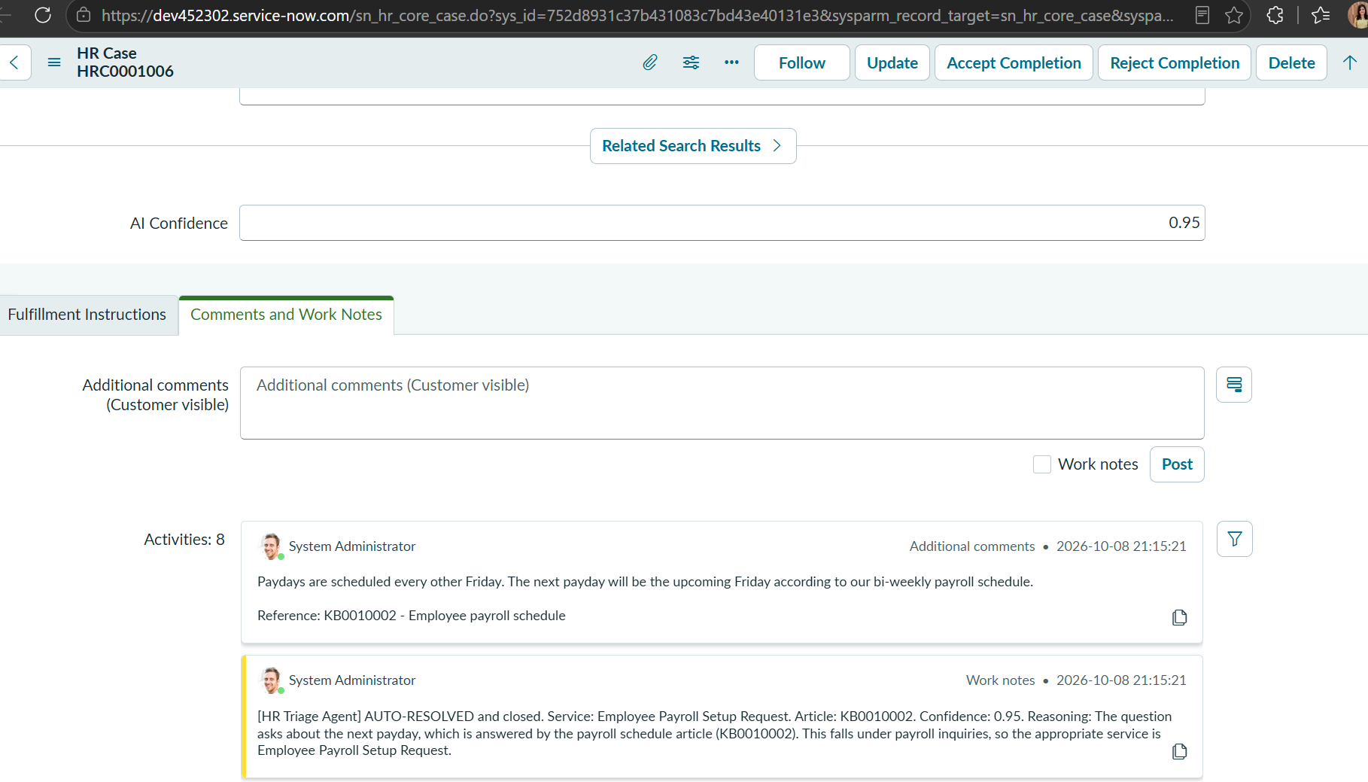
Note: the case state and the text of the reply and work note can be changed as per requirement. For example, the state the agent sets and the wording of the comment and work note can be edited in the Script Include. Whether a case then goes to Awaiting Acceptance depends on the HRSD acceptance process. The agent sets the case to Closed Complete (hence "AUTO-RESOLVED and closed" in the work note), and the HRSD acceptance process then places it in Awaiting Acceptance until the employee accepts or rejects.

4. Escalated mid-confidence case with draft reply (HRC0001059)
A partial-answer case. The tuition policy (KB0000116) covers eligibility but does not address online or foreign programs, so confidence came back at 0.82, below the 0.9 auto-resolve threshold. The case was escalated to HR Benefits Team with the suggested article and a draft reply for the HR agent, labelled as not sent to the employee. The draft hedges ("could be eligible if it meets these criteria") and asks the employee to verify accreditation, instead of promising reimbursement. The case is in Ready state, with the Start Work button available to the HR agent.
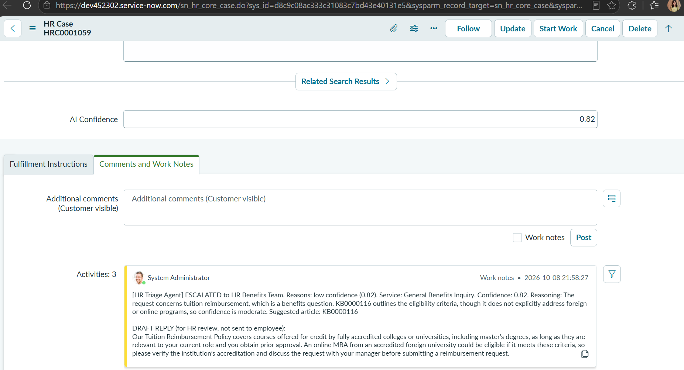

5. Escalated case with draft reply (HRC0001047)
The work note on an escalated case lists the reasons for escalating (low confidence 0.55, no matching KB article), the agent’s reasoning, and a draft reply for the HR agent labelled as not sent to the employee. The draft says deposit timing can vary and does not invent a time.
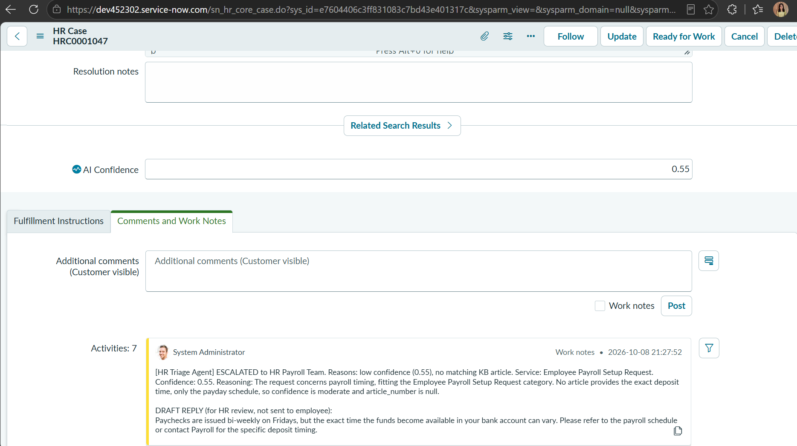

6. Case form (HRC0001047)
The top of the same case, showing the Ready state and the HR service set to Employee Payroll Setup Request.
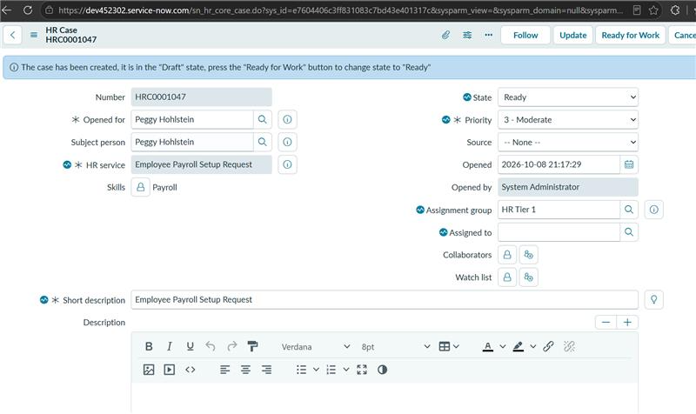

7. Notes
- These are seven hand-picked scenarios covering the main paths (auto-resolve, partial answer, vague request, sensitive topic). They show the paths work, but they are not an accuracy measurement.
- The harassment case was routed to HR Benefits Team as General Inquiry because none of the five services covers complaints. A dedicated team such as Employee Relations would be a production improvement.
- The case state (for example Awaiting Acceptance or Ready) and the text of replies and work notes can be changed as per requirement.
- The recorded work note text for each case is in output.md.

