P B L - 2 P R O J E C T R E P O R T
Assessment date: 16 October 2026
Technology Stack and Result Analysis
Cross-Manipulation Generalizable Audio-Visual Deepfake Detection via Reliability-Aware Lightweight Fusion
Technologies for implementation | Preliminary result analysis
Team member | Register number
Aditya Sahu | RA2311026010814
Akash Cherian | RA2311026010852
Prachurya Subhasmita | RA2311026010855
Course: Report Writing (21CSC402P)
Department of Computing Technologies
SRM Institute of Science and Technology, Kattankulathur, Chennai
Status: preliminary implementation with one-epoch validation runs. All results are validation-only snapshots; no final test metrics are reported.

Abstract
This report identifies and justifies the technologies selected to implement a reliability-aware, lightweight audio-visual deepfake detector, and analyses the results obtained so far. The stack is built on Python and PyTorch, with FFmpeg, OpenCV and torchaudio for decoding and feature extraction, a MobileNetV3-Small visual encoder, a depthwise-separable CNN audio encoder, and a small multilayer-perceptron gate that estimates per-window modality weights. Reproducibility is supported by identity-grouped split manifests, YAML configuration, mixed-precision training on a single 6–8 GB GPU, and a scikit-learn/SciPy evaluation layer.
The result analysis covers the data-pipeline verification (15,018 / 2,136 / 4,390 identity-disjoint clips for training, validation and testing) and a one-epoch validation snapshot in which equal-weight fusion reaches an AUROC of 0.9426, ahead of audio-only (0.8625), visual-only (0.7974) and reliability-aware fusion (0.7957). These values are preliminary and validation-only. They neither support nor refute the project hypotheses, and the report specifies the diagnostic and evaluation work required to reach a defensible conclusion.

1. Introduction and Problem Context

1.1 Problem addressed
Given an audio-video clip x = (V, A), the task is to predict y ∈ {0, 1}, where 0 denotes a genuine clip and 1 a manipulated one. A conventional audio-visual detector computes the prediction from the two encoded streams with a fixed fusion rule:
ŷ = f( E_{v}(V), E_{a}(A) ) (1)
The project’s premise is that the usefulness of each stream is instance dependent. Video may be compressed, blurred, occluded or lack a detectable face; audio may be silent, noisy, clipped or not actually manipulated; a synthetic clip may be well synchronised; and a model may memorise generator- or identity-specific artefacts instead of transferable evidence. Prior work shows that fusion is not automatically better than unimodal detection [1], that dynamic weighting already exists [2], and that cross-modal consistency is useful but insufficient on its own [3, 4]. The proposed detector therefore estimates a reliability weight for each modality in every two-second window and uses those weights in fusion, while treating audio-visual synchronisation strictly as an auxiliary feature.

1.2 Technology requirements derived from the problem
Technologies were chosen against the requirements that follow directly from the problem definition rather than by popularity. Table 1 maps each requirement to its technological implication and the selected tools.
Table 1. Requirements and the technologies selected to meet them.
Requirement | Technological implication | Selected technology
Aligned short windows of face frames and audio | Deterministic decoding at 25 fps and 16 kHz; fixed 2-second windows with recorded timestamps | FFmpeg/ffprobe, OpenCV, torchaudio
Compact per-modality encoders on a 6–8 GB GPU | Small pretrained or shallow CNNs, mixed precision, cached features | MobileNetV3-Small, depthwise-separable CNN, PyTorch AMP
Per-window estimate of modality reliability | Transparent quality measures plus a small learnable gate | OpenCV (Laplacian blur), NumPy, two-layer MLP with softmax gate
Leakage-resistant, reproducible experiments | Identity-grouped manifests, file hashing, logged seeds, configuration saved with every checkpoint | pandas, hashing utilities, YAML, versioned CSV manifests
Calibrated, statistically defensible evaluation | Threshold-free and calibration metrics; intervals resampled over source identities | scikit-learn, SciPy, bootstrap, temperature scaling
Licensed media must not be redistributed | Dataset roots outside the repository; ignored caches and checkpoints | Environment variables, .gitignore, local-only storage

1.3 Status labels used in this report
Implemented means the component exists in the project repository and is covered by the unit-test suite or by a recorded run. Proposed means a design option that is specified but not yet implemented. Where a figure comes from the team’s earlier reports rather than from the repository, the text says so.

2. Technologies to Implement the Defined Problem

2.1 Selection criteria
- Fit for a single modest GPU. Every model component must train on a 6–8 GB consumer GPU using mixed precision, with batch size 8 and gradient accumulation to an effective batch of 32.
- Open and installable. All runtime packages come from standard registries; FFmpeg and ffprobe are system tools. No proprietary service is required.
- Deterministic and auditable. Decoding, splitting and feature caching must be reproducible, so that no preprocessing step can leak information across partitions.
- Licence-compatible. Dataset media stays on the user’s local volume; only code, configuration and permitted manifests are versioned.
- Ablatable. Each design decision marked as proposed is exposed as a configuration flag (for example use_sync_features, use_quality_features, fusion_mode) so that it can be switched off in an ablation.

2.2 Technology stack
Figure 1 shows the six layers of the stack, and Table 2 lists each technology, its role and its current status. The architecture that these technologies implement is shown in Figure 2.
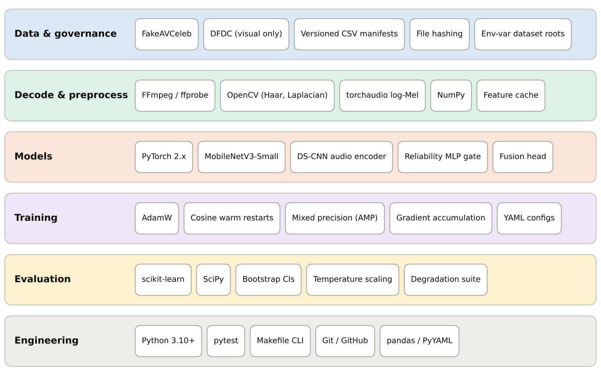
Figure 1. Layered technology stack of the proposed detector.
Table 2. Technology stack, roles and implementation status.
Layer | Technology | Role in the project | Status
Language and configuration | Python 3.10+, PyYAML | Configuration-driven data, model, training and evaluation settings stored in configs/*.yaml. | Implemented
Deep-learning framework | PyTorch ≥ 2.2, torchvision ≥ 0.17, torchaudio ≥ 2.2 [5] | Model definition, automatic differentiation, mixed precision, pretrained backbones, audio transforms. | Implemented
Video and audio decoding | FFmpeg/ffprobe, OpenCV (headless, 4.9 to <5) | Decoding at 25 fps; extraction of 16 kHz mono audio from video containers. | Implemented
Face detection | OpenCV Haar cascade [6]; RetinaFace / MediaPipe | Haar cascade is the offline baseline (20% box expansion, 160×160 crop). RetinaFace/MediaPipe with landmark alignment remain proposed. | Baseline implemented; alternatives proposed
Audio features | torchaudio / FFmpeg | 80-bin log-Mel spectrogram (25 ms window, 10 ms hop, 16 kHz). | Implemented
Visual encoder | torchvision MobileNetV3-Small [7] | ImageNet-pretrained per-frame backbone followed by a depthwise temporal Conv1D; output z_{v} ∈ ℝ^{8×256}. | Implemented
Audio encoder | PyTorch depthwise-separable CNN | Five depthwise-separable blocks, frequency pooling and projection; output z_{a} ∈ ℝ^{8×256}. | Implemented
Fusion and reliability | PyTorch MLP modules | Alignment projector (128-D), synchronisation features, modality heads, reliability gate, fusion classifier. | Implemented
Optimisation | AdamW [8], cosine warm restarts [9], AMP [10] | Weight-decayed optimisation, learning-rate schedule, half-precision training, gradient accumulation. | Implemented
Data control | NumPy, pandas, hashing utilities, CSV manifests | Source table, identity-grouped 70/10/20 split, duplicate detection, class-balanced sampling. | Implemented
Evaluation | scikit-learn [11], SciPy | AUROC, PR-AUC, balanced accuracy, F1, Brier score, ECE, NLL; validation-fitted threshold and temperature. | Implemented; full runs pending
Testing | pytest | CPU-runnable unit tests on small fixture clips; 67 tests passing at the team’s pipeline verification. | Implemented
Reporting | matplotlib, seaborn | Figures generated from saved evaluation outputs. | Available; final plots pending
Optional extensions | ONNX, dynamic INT8 quantisation, MLflow / TensorBoard, Albumentations | Faster CPU inference, experiment tracking and richer augmentation. | Proposed

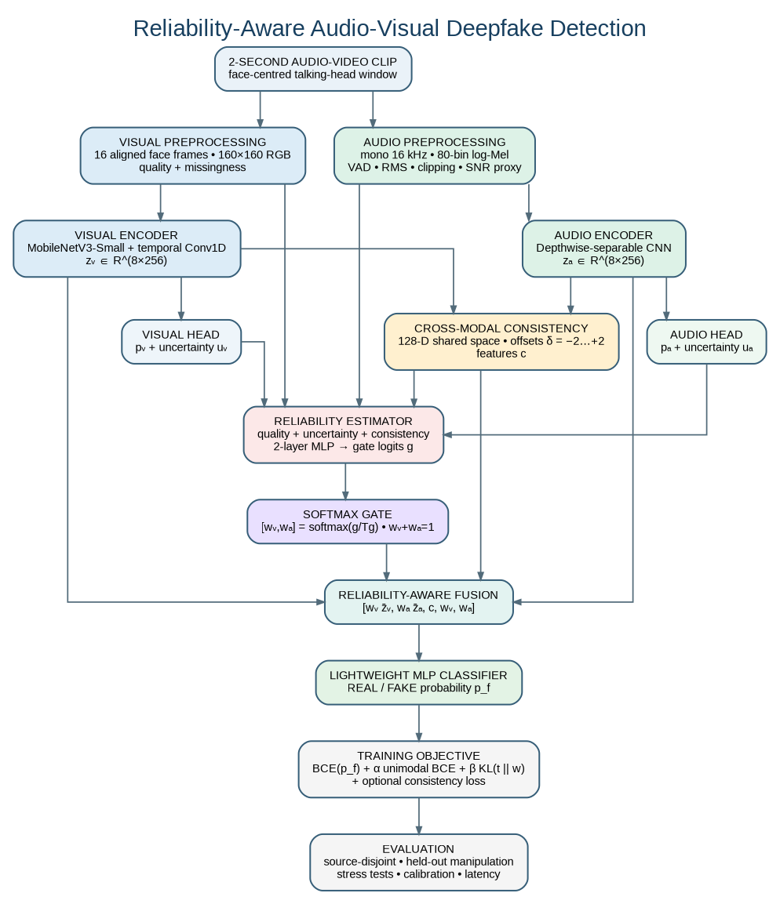
Figure 2. System architecture implemented with the stack in Table 2: two compact encoders, quality and synchronisation features, a reliability estimator with softmax gate, and a weighted fusion classifier.

2.3 Component choices and alternatives
Table 3 records, for each model component, what was selected, what the literature offers instead and why the selection suits the constraints in Section 2.1. The selections deliberately favour small, inspectable components over the larger transformer-based detectors in the literature.
Table 3. Component selection against alternatives in the literature.
Component | Selected | Alternatives in the literature | Rationale and trade-off
Visual encoder | MobileNetV3-Small [7] with depthwise temporal Conv1D | 3-D CNN streams [12, 13]; dense Swin Transformer [14]; ResNet-18 with multi-scale temporal convolution [15] | A small 2-D backbone captures appearance and short-range motion without 3-D convolutions and fits the GPU budget. Capacity is lower, so results are not equal-compute comparisons with large models.
Audio encoder | Depthwise-separable CNN on 80-bin log-Mel | RawNet2 [16]; AASIST graph attention [17]; Swin audio branch [14] | Log-Mel with separable convolutions is far cheaper than raw-waveform networks and suits 2-second windows. Phase information in the raw waveform is not exploited.
Face detection | OpenCV Haar cascade [6] | RetinaFace; MediaPipe | Runs offline with no weight download and is deterministic. It is less robust on non-frontal faces; failures are recorded through missingness flags rather than dropped.
Sync feature | Cosine similarity over offsets −2…+2 in a shared 128-D space (SyncNet-style [4]) | Dissonance score used as the decision [3] | Used only as an input to the gate and classifier, which avoids the premise that “out of sync” means “fake”.
Fusion | Softmax gate over (w_{v}, w_{a}) with a weighted fusion head | Concatenation; equal weights; cross-attention [13, 18]; transformer-confidence weights [2] | Gate inputs are physical quality measures, unimodal uncertainty and synchronisation, so its behaviour can be inspected. The gate itself is small (68,482 parameters).
Gate training signal | Detached soft-target KL loss L_{rel} | Gate trained only through the final loss; gradient blending [19]; gradient modulation [20] | Gives the gate an observable target from unimodal losses without back-propagating through the heads. Quality-conditioned reliability is also motivated by quality estimation work [21].
Missing modality | Zeroed embedding and masked gate logit | Auxiliary AVSR pre-training with modality dropout [22] | Guarantees a near-zero weight for an absent stream by construction, without extra pre-training.
Calibration | Temperature scaling [23] | Platt or isotonic calibration (not adopted) | One parameter fitted on validation data only, so it is difficult to overfit.

The mathematical core that these components implement is compact. The gate produces normalised weights, the fusion head receives the weighted embeddings together with the weights and synchronisation features, and the reliability loss pulls the gate towards the modality that is currently more predictive:
[ w_{v}, w_{a} ] = softmax( g / T_{g} ), g = MLP( [ h_{v}, h_{a}, c ] ) (2)
t_{m} = exp( − sg(ℓ_{m}) / τ_{r} ) / Σ_{j ∈ {v,a}} exp( − sg(ℓ_{j}) / τ_{r} ), L_{rel} = KL( t ‖ w ) (3)
L = BCE(y, p_{f}) + α [ BCE(y, p_{v}) + BCE(y, p_{a}) ] + β L_{rel} + γ L_{con} + η L_{bal} (4)
Here sg(·) is the stop-gradient operator, ℓ_{m} is the per-window unimodal cross-entropy, and L_{con} is an optional InfoNCE alignment loss [24]. The weights w_{v} and w_{a} estimate the usefulness of each stream under the training distribution; they are not measures of media quality or authenticity.

2.4 Model size of the implemented components
Table 4 gives trainable-parameter counts that were derived analytically from the layer definitions in the repository code. They are included because model size is one of the project’s stated evaluation criteria (research question RQ4). The visual encoder and the full model are to be measured with the efficiency-profiling module on named hardware; no estimate is quoted here.
Table 4. Trainable parameters derived from the repository code.
Component | Configuration | Trainable parameters
Audio depthwise-separable CNN | Width multiplier 1.0 (repository default) | 381,824
Audio depthwise-separable CNN | Width multiplier 0.75 | 241,504
Reliability gate (two-layer MLP) | 532 → 128 → 2 | 68,482
Fusion classifier | 518 → 256 → 1 | 133,121
Visual encoder (MobileNetV3-Small + temporal conv) | ImageNet-pretrained | To be measured
The gate input of 532 values is the concatenation of the pooled visual embedding (256), visual uncertainty (1), pooled audio embedding (256), audio uncertainty (1), visual quality features (7), audio quality features (5), synchronisation features (4) and the two missingness flags (2). The fusion input of 518 values is [w_{v}·z̄_{v}, w_{a}·z̄_{a}, c, w_{v}, w_{a}] = 256 + 256 + 4 + 1 + 1.

2.5 Data technologies, datasets and storage
The detector is trained and evaluated on FakeAVCeleb [25], the only dataset in the plan that carries paired audio and video manipulation. DFDC [26] is a face-swap benchmark whose audio manipulation labels are not verified, so it is reserved for visual-transfer experiments. Neither dataset may be redistributed; access is granted per user under each dataset’s own terms. Three label fields are kept (video_manipulated, audio_manipulated and a derived clip_fake), and an audio label is never inferred from a video label.
Table 5 lists the alternative datasets assessed in the project’s dataset plan. They are candidates, not approved training sets: each needs an audit of its labels, terms, identities and split compatibility before it is added to the protocol.
Table 5. Candidate datasets assessed for possible extension (from the project dataset plan).
Dataset | Modality and possible role | Storage and terms | Priority
LAV-DF | Audio-visual manipulation with temporal localisation; closest additional match | Terms agreement required; size to be measured; identity-disjoint manifests must be rebuilt | First audio-visual alternative to assess
AV-Deepfake1M / ++ | Large-scale audio-only, video-only and joint manipulation | Challenge-hosted access; storage not yet established | Later, with external storage
MLAAD-tiny | Audio-only development or out-of-domain audio test | 3.54 GB; CC BY-NC 4.0 | Best small audio candidate
WaveFake | Audio-only cross-generator evaluation | 28.9 GB; CC BY-SA 4.0 | Optional if space remains
ASVspoof 5 | Audio-only spoof detection | 142.3 GB; exceeds the available disk | Not on this machine
DeeperForensics-1.0 | Visual robustness under perturbations | About 284 GB; non-commercial terms | Defer
The Linux environment has roughly 130 GB of disk in total. Dataset media and derived caches are therefore capped at about 70–80 GB combined, which leaves room for the operating system, environments, temporary decode files and checkpoints. The plan is to start with FakeAVCeleb, add at most one further audio-visual dataset after measuring it, and keep feature caches reproducible and disposable. Audio-only and visual-only results are always reported separately from paired audio-visual results.

2.6 Training and optimisation configuration
Table 6 lists the configured training settings. They are starting values to be tuned on the validation partition only; they are not published constants.
Table 6. Training configuration (from configs/train_config.yaml).
Setting | Configured value
Optimiser | AdamW [8]: learning rate 1×10⁻³, weight decay 1×10⁻⁴, β = (0.9, 0.999)
Schedule | Cosine annealing with warm restarts [9]: T₀ = 10, T_{mult} = 1, η_{min} = 1×10⁻⁶; 3 warm-up epochs
Batching | Batch size 8 with 4 accumulation steps (effective batch 32)
Precision | Automatic mixed precision (float16) with gradient scaling [10]
Epoch budget | Unimodal 30; fixed fusion 30; reliability fusion 50; distillation 20; early stopping with patience 10
Staged unfreezing | Encoders frozen for the first 5 epochs, then the last 2 blocks unfrozen
Loss weights | α = 0.25, β = 0.10, γ = 0.05, η = 0; soft-target temperature τ_{r} = 1.0; gate temperature T_{g} = 1.0
Augmentation (one modality at a time) | Video: resize 0.3, re-encode 0.2, blur 0.2, frame drop 0.1. Audio: noise 0.3, reverberation 0.2, low-pass 0.2, dropout 0.1. Modality dropout probability 0.15
Sampling and seeds | Class-balanced sampling each epoch; final seeds 42, 123 and 7
Model selection | Best validation AUROC; the test partition is never used for selection

2.7 Evaluation and statistical tooling
- Discrimination: ROC-AUC (primary), PR-AUC for the imbalanced setting, balanced accuracy, F1, precision, recall and a confusion matrix at the threshold chosen on validation data (Youden’s J).
- Calibration: Brier score, expected calibration error with 15 equal-mass bins, negative log-likelihood and a reliability diagram; temperature scaling fitted on validation data only [23]. Raw and scaled results are reported separately.
- Reliability behaviour: mean weights by degradation level, correlation with degradation severity and unimodal loss, gate entropy, and a collapse flag when max(w_{v}, w_{a}) exceeds 0.95.
- Efficiency: parameters, checkpoint size, peak GPU memory, and p50/p95 per-window latency on named hardware, with preprocessing reported separately and end to end.
- Uncertainty: stratified bootstrap (1,000 iterations, 95% intervals) over source identities, with three seeds for the final contenders and no best-seed headline.
- Stress suite: H.264 CRF 18/28/38, resizing to 720/480/360 lines, Gaussian blur, frame drop; additive noise at 20/10/0 dB, codec resampling, low-pass filtering and packet-like dropout (following the ASVspoof 2021 practice [27]); and zeroed-audio and no-face cases for missing-modality behaviour.

2.8 Software engineering and reproducibility
The repository is organised so that each stage of the pipeline is a small module with a single purpose, driven by configuration rather than hard-coded values. Table 7 summarises the layout, and the commands below show the order in which the stages are run.
Table 7. Repository layout.
Directory | Contents
src/decode, src/preprocess | Video and audio decoding, face extraction, log-Mel features, quality features, temporal alignment, augmentation, feature cache.
src/models | Visual and audio encoders, alignment projector, synchronisation features, modality heads, reliability estimator, fusion classifier, full model.
src/train | Losses, trainer, unimodal / fixed-fusion / reliability-fusion training scripts, distillation.
src/evaluate | Metrics, calibration, degradation suite, cross-manipulation and cross-dataset evaluation, efficiency profiling, reliability diagnostics.
src/utils, manifests/ | Configuration loader, seeding, logging, hashing, manifest builder, identity-grouped splitting; versioned source table and split manifests.
configs/, tests/, scripts/ | One YAML file per concern; pytest suite with small fixture clips; command-line entry points and a Makefile.

python scripts/run_data_audit.py --config configs/data_config.yaml
python -m src.train.train_unimodal --modality visual # then: --modality audio
python -m src.train.train_fixed_fusion --mode equal_weight
python -m src.train.train_reliability_fusion
python scripts/run_full_evaluation.py --checkpoint artifacts/checkpoints/reliability_fusion/best_model.pt
python -m pytest tests -q
Reproducibility is built in at each step. Splits are versioned CSV manifests rather than random seeds, so training scripts never re-split data. Every checkpoint is saved with its configuration and seeds. The validation partition alone is used for thresholds and temperature, and the test partition is traversed once. Dataset roots are supplied through the environment variables FAKEAVCELEB_ROOT and DFDC_ROOT, and media, caches and checkpoints are excluded from version control.

2.9 Known gaps between the specification and the implementation
- The face detector is the OpenCV Haar cascade. RetinaFace/MediaPipe and landmark-based alignment are not implemented, so crops are not landmark-aligned.
- PyTorch pretrained weights are optional. If they are unavailable, the visual encoder falls back to a compact convolutional network, and the configuration used must be recorded with each result.
- ONNX export, quantisation, experiment tracking and Albumentations are optional ideas and are not dependencies.
- Exact package, CUDA and FFmpeg versions must be resolved and recorded for the final runs.

3. Result Analysis

3.1 Scope and status of the evidence
Two kinds of evidence exist at this stage. First, the data pipeline has been built and verified: the master source table and the identity-disjoint split manifests have been generated from the local FakeAVCeleb copy. Second, one validation epoch has been recorded for each of four model variants. There are no test-set metrics, no multi-seed estimates, no confidence intervals, and no calibration, degradation, missing-modality or cross-manipulation results. The analysis below is therefore limited to what these two sources can support, and every conclusion is worded accordingly.

3.2 Data-pipeline results
The 21,544 clips of the local FakeAVCeleb copy were partitioned at source-identity level into the splits shown in Table 8 and Figure 3. All real and fake derivatives of a source video, and all clips of one identity, sit in the same partition, and hash-based duplicate checks are applied across partitions. The team’s pipeline verification reports zero identity overlap between splits and 67 passing unit tests, including tests for split exclusivity, duplicate hashes, missing-modality masking and gate weights summing to one.
Table 8. Identity-disjoint split sizes.
Partition | Clips | Share of total | Use
Training | 15,018 | 69.7% | Model fitting; class-balanced sampling
Validation | 2,136 | 9.9% | Model selection, threshold, temperature
Test | 4,390 | 20.4% | Single final evaluation
Total | 21,544 | 100%
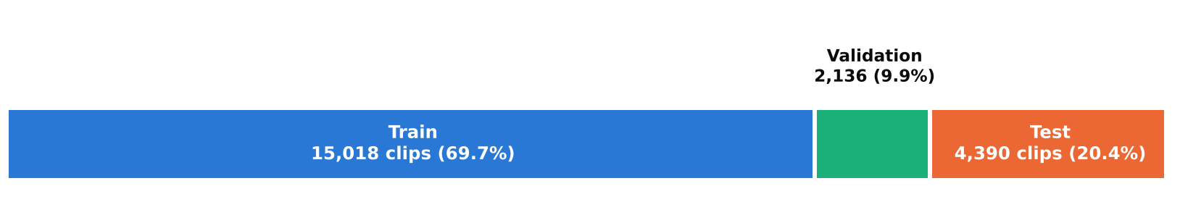
Figure 3. Partition sizes of the identity-disjoint split.
The result is methodologically important because high scores on FakeAVCeleb can be inflated when the same identity or source video appears in both training and test data. The published FakeAVCeleb table is also strongly imbalanced (500 real against 19,500 fake clips) [25], so accuracy alone would be misleading. The class composition of each local split should be stated in the data-audit report, and class-balanced sampling, AUROC, PR-AUC and balanced accuracy are used for that reason.

3.3 One-epoch validation snapshot
Table 9 and Figure 4 give the validation AUROC recorded after the first epoch for each model variant. AUROC is the primary metric because it does not depend on a decision threshold. The right-hand columns express each result relative to the two unimodal baselines and to fixed fusion.
Table 9. One-epoch validation AUROC and differences between variants.
Model | Validation AUROC | Rank | Δ vs audio-only | Δ vs visual-only | Δ vs fixed fusion
Visual-only baseline | 0.7974 | 3 | −0.0651 | — | −0.1452
Audio-only baseline | 0.8625 | 2 | — | +0.0651 | −0.0801
Equal-weight fixed fusion | 0.9426 | 1 | +0.0801 | +0.1452 | —
Reliability-aware fusion | 0.7957 | 4 | −0.0668 | −0.0017 | −0.1469
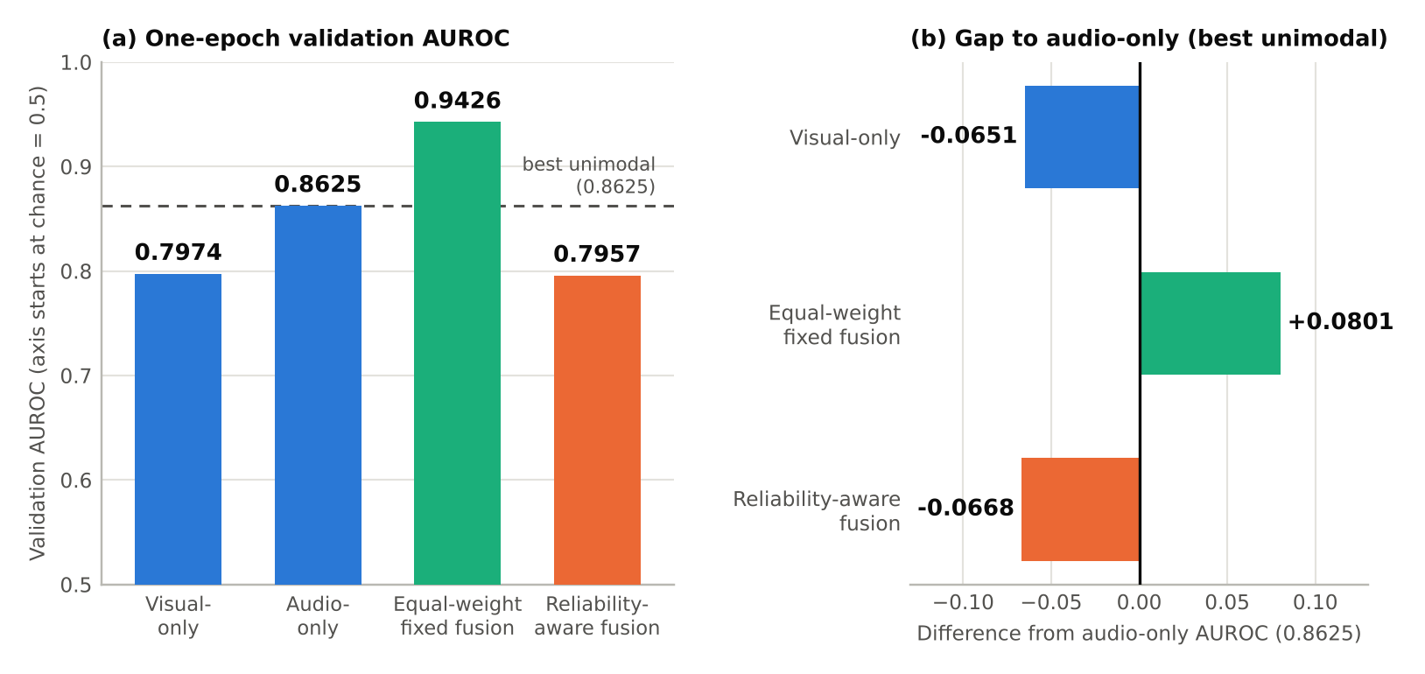
Figure 4. Validation AUROC after the first recorded epoch (preliminary; validation split only).
Four observations follow directly from the numbers.
- Fusion helps in this snapshot. Equal-weight fusion exceeds the stronger unimodal branch (audio-only) by 0.0801 AUROC, a relative gain of about 9.3%, and the weaker branch (visual-only) by 0.1452. This meets the stage-3 exit criterion of the training plan, which requires fixed fusion to beat the better unimodal branch before a gate is introduced.
- The audio branch learns faster than the visual branch. Audio-only leads visual-only by 0.0651 after one epoch. This is an early-training observation and says nothing yet about the final ranking of the two branches.
- The reliability-aware model trails every fused or audio-based variant. It is 0.1469 below fixed fusion and 0.0668 below audio-only, and is level with visual-only (−0.0017).
- The gate model scores below its own best component. Because it contains the same encoders and can in principle approximate equal weighting, a result below audio-only points to an optimisation problem in this run rather than to a verdict on reliability gating.

3.4 Interpretation

Why equal-weight fusion leads on clean validation data
On uncorrupted clips both streams are informative, and the two kinds of artefact are complementary: face-swap blending boundaries in the video and vocoder artefacts in the audio. A parameter-free equal-weight combination can exploit both without learning any routing, and acts as a simple ensemble that reduces variance. This is consistent with the argument that joint audio-visual modelling can improve detection [12]. It is not a general guarantee: prior work reports that naive fusion can underperform unimodal models on some manipulation subsets [1], which is why the project keeps unimodal baselines throughout.

Why the reliability gate may lag in epoch one
The following explanations are consistent with the observation, but none has been tested. They are therefore reported as candidates, each paired with a diagnostic that the repository already supports (Table 10).
Table 10. Candidate explanations for the gate’s early deficit and the diagnostic for each.
Candidate explanation | Mechanism | Diagnostic to confirm or reject
E1. Gate cold start | A randomly initialised gate produces fluctuating weights that perturb the fused representation in the first updates. | Log per-epoch weight distributions and gate entropy; try the balance term L_{bal} (η > 0) during warm-up only.
E2. Noisy early soft targets | The target t_{m} is computed from unimodal losses that are still uncalibrated in epoch one, and the KL term (β = 0.10) competes with the main classification loss. | Sweep β and τ_{r}; delay L_{rel} until the unimodal heads stabilise.
E3. Modality learning-speed imbalance | The faster audio branch dominates the gradient, as described for multimodal training [19, 20]. | Plot per-branch loss curves; compare against staged freezing.
E4. Joint training from step 0 | Encoders, projectors, heads and gate are all trained together from the first step; the planned staged schedule was not active. | Rerun with encoders frozen for 5 epochs, then unfreeze the last 2 blocks.
E5. Run-to-run variance | One epoch of one run cannot separate a real effect from optimisation noise. | Repeat with seeds 42, 123 and 7 and report identity-bootstrap intervals.

What the gate is, and is not, expected to do
The reliability gate is not designed to outperform simple ensembling on clean, high-quality data. Its hypothesis is that it provides resilience when one stream is degraded or missing, which are the conditions in which equal weighting passes uninformative evidence into the joint decision. The clean-data snapshot cannot test that hypothesis. If the gate fails to help after proper warm-up and under degradation, that is a reportable finding and the project’s claim is adjusted to match it.

3.5 Validity and limitations of the current evidence
- Single epoch, single run. Each variant has one recorded epoch and no repeated seeds, so differences of a few hundredths in AUROC cannot be distinguished from noise. In particular, the 0.0017 gap between reliability-aware and visual-only fusion should not be interpreted.
- Validation split only. The validation partition is reserved for selection, so these values are not generalisation estimates. No test metric is reported.
- No uncertainty estimates. Bootstrap intervals over source identities have not yet been computed.
- Clean conditions only. No compression, noise, blur, missing-modality or held-out-manipulation condition has been run, so the central robustness question is open.
- Metric coverage. Only AUROC is available. PR-AUC, balanced accuracy, F1, calibration error and latency are needed for a full assessment, particularly because the dataset is imbalanced.
- Provenance of the numbers. The saved history files are local derived artefacts and are excluded from version control, so the values in this report are those recorded by the team and should be re-exported with the final runs.

3.6 Status of the research hypotheses
The project’s four hypotheses are all untested at this stage. Table 11 states what each one requires, so that the final result analysis can be written against explicit criteria.
Table 11. Hypothesis status and the evidence required.
ID | Hypothesis | Current status | Evidence required
H1 | Reliability-aware fusion has higher mean AUROC than equal-weight and concatenation fusion on the degradation suite. | Not evaluated. The clean snapshot currently favours fixed fusion. | Mean AUROC across the video and audio degradations, three seeds, with an identity-bootstrap interval for the difference.
H2 | Under isolated audio or video degradation the gate shifts in the expected direction and reduces the performance drop relative to fixed fusion. | Not evaluated. | Mean w_{v}, w_{a} by degradation level; correlation with severity; drop from the clean metric for each model.
H3 | On unseen manipulation categories the model matches or exceeds the strongest unimodal baseline. | Not evaluated. | Per-family AUROC with 95% intervals for a family held out before training, against the best unimodal baseline.
H4 | A compact model achieves practical short-window latency with a documented accuracy cost. | Not evaluated; parameter counts partly derived (Table 4). | Parameters, checkpoint size, peak GPU memory, p50/p95 latency on named GPU and CPU, end to end.

3.7 Plan to complete the result analysis
Table 12 sets out the runs needed to turn the snapshot into a defensible set of results. The order follows the staged plan: no stage is started until the previous one has produced a reproducible validation result.
Table 12. Remaining experiments and exit criteria.
Step | Run | Output | Exit criterion
1 | Full-length unimodal baselines (30 epochs, early stopping, seeds 42/123/7) | Validation histories per branch | Reproducible runs; final visual-versus-audio ranking
2 | Fixed-fusion baselines: late equal-logit average, concatenation with MLP, learned global weights, equal weights | Fusion comparison table | Fusion beats the better unimodal branch, or the negative result is documented
3 | Reliability fusion with staged training: encoders frozen for 5 epochs, then partial unfreezing; sweep β, τ_{r}, T_{g} | Gate diagnostics (weights, entropy, collapse flag) | Explanations E1–E5 each accepted or rejected with evidence
4 | Ablations: gate without synchronisation features; gate without quality features | Full versus ablated comparison | Contribution of each input measured
5 | Robustness: cross-manipulation hold-out, video and audio degradation, missing-modality tests | Degradation curves and gate-shift plots | H1–H3 each supported or not supported
6 | Calibration, efficiency and final test: temperature fitted on validation, latency profiling, test partition traversed once | Calibrated and raw test metrics, latency table, model card | Reproducibility checklist complete

4. Conclusion
The technologies for the defined problem have been selected against explicit requirements: a Python and PyTorch stack, FFmpeg, OpenCV and torchaudio for aligned inputs, compact MobileNetV3-Small and depthwise-separable CNN encoders, an inspectable MLP reliability gate, and an identity-grouped, configuration-driven pipeline with scikit-learn and SciPy evaluation. Most of this stack is implemented and tested; the face detector is a Haar-cascade baseline, and the heavier extensions remain proposals.
The result analysis is deliberately conservative. The data pipeline delivers identity-disjoint partitions of 15,018, 2,136 and 4,390 clips. In the one-epoch validation snapshot, equal-weight fusion leads (AUROC 0.9426) and clearly exceeds both unimodal baselines, while reliability-aware fusion (0.7957) does not yet show a benefit. Because the evidence is a single validation epoch, it cannot decide whether reliability gating helps. The remaining work is staged training with gate diagnostics, repeated seeds, and the degradation, missing-modality and cross-manipulation tests that the gate was designed for. Whatever those tests show will be reported as found.

References
[1] S. Muppalla, S. Jia, and S. Lyu, “Integrating audio-visual features for multimodal deepfake detection,” in Proc. IEEE MIT Undergraduate Res. Technol. Conf. (URTC), 2023, pp. 1–6.
[2] R. Wang, D. Ye, L. Tang, Y. Zhang, and J. Deng, “AVT²-DWF: Improving deepfake detection with audio-visual fusion and dynamic weighting strategies,” IEEE Signal Process. Lett., vol. 31, pp. 1960–1964, 2024.
[3] K. Chugh, P. Gupta, A. Dhall, and R. Subramanian, “Not made for each other – Audio-visual dissonance-based deepfake detection and localization,” in Proc. ACM Int. Conf. Multimedia (MM), 2020, pp. 439–447.
[4] J. S. Chung and A. Zisserman, “Out of time: Automated lip sync in the wild,” in Computer Vision – ACCV 2016 Workshops, LNCS vol. 10117, Springer, 2017, pp. 251–263.
[5] A. Paszke et al., “PyTorch: An imperative style, high-performance deep learning library,” in Proc. Adv. Neural Inf. Process. Syst. (NeurIPS), 2019, pp. 8024–8035.
[6] P. Viola and M. Jones, “Rapid object detection using a boosted cascade of simple features,” in Proc. IEEE Comput. Soc. Conf. Comput. Vis. Pattern Recognit. (CVPR), 2001, pp. I-511–I-518.
[7] A. Howard, M. Sandler, G. Chu, L.-C. Chen, B. Chen, M. Tan, W. Wang, Y. Zhu, R. Pang, V. Vasudevan, Q. V. Le, and H. Adam, “Searching for MobileNetV3,” in Proc. IEEE/CVF Int. Conf. Comput. Vis. (ICCV), 2019, pp. 1314–1324.
[8] I. Loshchilov and F. Hutter, “Decoupled weight decay regularization,” in Proc. Int. Conf. Learn. Represent. (ICLR), 2019.
[9] I. Loshchilov and F. Hutter, “SGDR: Stochastic gradient descent with warm restarts,” in Proc. Int. Conf. Learn. Represent. (ICLR), 2017.
[10] P. Micikevicius et al., “Mixed precision training,” in Proc. Int. Conf. Learn. Represent. (ICLR), 2018.
[11] F. Pedregosa et al., “Scikit-learn: Machine learning in Python,” J. Mach. Learn. Res., vol. 12, pp. 2825–2830, 2011.
[12] Y. Zhou and S.-N. Lim, “Joint audio-visual deepfake detection,” in Proc. IEEE/CVF Int. Conf. Comput. Vis. (ICCV), 2021, pp. 14800–14809.
[13] W. Yang, X. Zhou, Z. Chen, B. Guo, Z. Ba, Z. Xia, X. Cao, and K. Ren, “AVoiD-DF: Audio-visual joint learning for detecting deepfake,” IEEE Trans. Inf. Forensics Security, vol. 18, pp. 2015–2029, 2023.
[14] H. Ilyas, A. Javed, and K. M. Malik, “AVFakeNet: A unified end-to-end dense Swin Transformer deep learning model for audio–visual deepfakes detection,” Appl. Soft Comput., vol. 136, p. 110124, 2023.
[15] A. Haliassos, K. Vougioukas, S. Petridis, and M. Pantic, “Lips don’t lie: A generalisable and robust approach to face forgery detection,” in Proc. IEEE/CVF Conf. Comput. Vis. Pattern Recognit. (CVPR), 2021, pp. 5039–5049.
[16] H. Tak, J. Patino, M. Todisco, A. Nautsch, N. Evans, and A. Larcher, “End-to-end anti-spoofing with RawNet2,” in Proc. IEEE Int. Conf. Acoust., Speech Signal Process. (ICASSP), 2021, pp. 6369–6373.
[17] J.-w. Jung, H.-S. Heo, H. Tak, H.-j. Shim, J. S. Chung, B.-J. Lee, H.-J. Yu, and N. Evans, “AASIST: Audio anti-spoofing using integrated spectro-temporal graph attention networks,” in Proc. IEEE Int. Conf. Acoust., Speech Signal Process. (ICASSP), 2022, pp. 6367–6371.
[18] T. Oorloff, S. Koppisetti, N. Bonettini, D. Solanki, B. Colman, Y. Yacoob, A. Shahriyari, and G. Bharaj, “AVFF: Audio-visual feature fusion for video deepfake detection,” in Proc. IEEE/CVF Conf. Comput. Vis. Pattern Recognit. (CVPR), 2024, pp. 27102–27112.
[19] W. Wang, D. Tran, and M. Feiszli, “What makes training multi-modal classification networks hard?,” in Proc. IEEE/CVF Conf. Comput. Vis. Pattern Recognit. (CVPR), 2020, pp. 12695–12705.
[20] X. Peng, Y. Wei, A. Deng, D. Wang, and D. Hu, “Balanced multimodal learning via on-the-fly gradient modulation,” in Proc. IEEE/CVF Conf. Comput. Vis. Pattern Recognit. (CVPR), 2022, pp. 8238–8247.
[21] P. Terhörst, J. N. Kolf, N. Damer, F. Kirchbuchner, and A. Kuijper, “SER-FIQ: Unsupervised estimation of face image quality based on stochastic embedding robustness,” in Proc. IEEE/CVF Conf. Comput. Vis. Pattern Recognit. (CVPR), 2020, pp. 5650–5659.
[22] Y. Cai, P. Chen, J. Tian, J. Liu, J. Dai, X. Wang, Y. Chai, S. Jia, S. Lyu, and J. Han, “Modality-agnostic deepfakes detection,” in Proc. ACM Workshop Inf. Hiding Multimedia Security (IH&MMSec), 2025.
[23] C. Guo, G. Pleiss, Y. Sun, and K. Q. Weinberger, “On calibration of modern neural networks,” in Proc. Int. Conf. Mach. Learn. (ICML), PMLR vol. 70, 2017, pp. 1321–1330.
[24] A. van den Oord, Y. Li, and O. Vinyals, “Representation learning with contrastive predictive coding,” arXiv:1807.03748, 2018.
[25] H. Khalid, S. Tariq, M. Kim, and S. S. Woo, “FakeAVCeleb: A novel audio-video multimodal deepfake dataset,” in Proc. NeurIPS Datasets and Benchmarks Track, 2021.
[26] B. Dolhansky, J. Bitton, B. Pflaum, J. Lu, R. Howes, M. Wang, and C. Canton Ferrer, “The DeepFake Detection Challenge (DFDC) dataset,” arXiv:2006.07397, 2020.
[27] X. Liu, X. Wang, M. Sahidullah, J. Patino, H. Delgado, T. Kinnunen, M. Todisco, J. Yamagishi, N. Evans, A. Nautsch, and K.-A. Lee, “ASVspoof 2021: Towards spoofed and deepfake speech detection in the wild,” IEEE/ACM Trans. Audio, Speech, Lang. Process., vol. 31, pp. 2507–2522, 2023.

