**Superstore Sales Dashboard Insights**

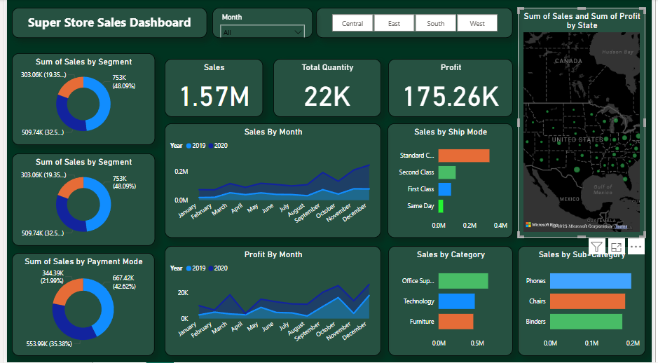

# Dashboard Overview

This dashboard presents a comprehensive view of Superstore Sales performance, with a focus on sales, profit, quantity, regional distribution, and product categories.

# Key Insights

1. Total Sales and Profit: The store recorded a total sales value of **1.57M** and a profit of **175.26K**, with a total quantity sold of **22K** units.

2. Top Segment: The 'Consumer' segment leads the market with 48.09% of sales contribution.

3. Payment Modes: A significant portion (42.62%) of transactions was conducted through a particular payment mode, indicating customer preference.

4. Regional Performance: The dashboard provides a region-wise filter (Central, East, South, West) to analyze performance geographically.

5. Sales & Profit Trend: Monthly trends from 2019 and 2020 show a steady increase in both sales and profit, peaking in November and December.

6. Shipping Modes: 'Standard Class' is the most used shipping method, contributing the most to sales volume.

7. Category Analysis: Office Supplies generated the highest sales, followed by Technology and Furniture.

8. State-wise Sales: The map indicates that states with high-density dots (e.g., California, New York) are major contributors to total sales and profit.

9. Sub-Category Sales: Phones dominate among sub-categories, with Chairs and Binders trailing behind.