Task-1 Iris Species Classification

Notebook: https://github.com/thepramanjain/InternSpark-Task1/blob/main/Iris.ipynb
Model file: iris_best_model.joblib

Executive Summary:
This project develops an Iris species classification pipeline using machine learning techniques to identify Iris-setosa, Iris-versicolor, and Iris-virginica from four morphological measurements: sepal length, sepal width, petal length, and petal width. The notebook follows a structured machine learning workflow that includes exploratory data analysis, feature evaluation, model training, performance comparison, and model serialization. Exploratory analysis revealed that petal length and petal width are the most informative features for species classification, providing clear separation between classes, while sepal measurements exhibit significant overlap and contribute less discriminative power. The modeling workflow evaluates three classification algorithms—k-Nearest Neighbors (k-NN), Logistic Regression, and Decision Tree—using an 80-20 stratified train-test split. All three models achieved an accuracy of 93.33% on the hold-out test dataset, correctly classifying 28 out of 30 samples. Among the evaluated models, the k-Nearest Neighbors classifier was selected as the final model due to its superior weighted precision of 94.44%, reducing false positive classifications compared to the alternative models. The final production pipeline integrates feature standardization through StandardScaler and classification through KNeighborsClassifier, ensuring that incoming data undergoes the same preprocessing steps used during training. The trained pipeline is serialized as iris_best_model.joblib, enabling seamless deployment and inference without manual feature scaling. An inference example is included within the notebook to demonstrate how the saved model can be loaded and used to predict species labels and class probabilities for new flower measurements. The complete pipeline provides a lightweight, reproducible, and deployment-ready solution for Iris species classification while maintaining consistent preprocessing and prediction behavior across training and production environments.
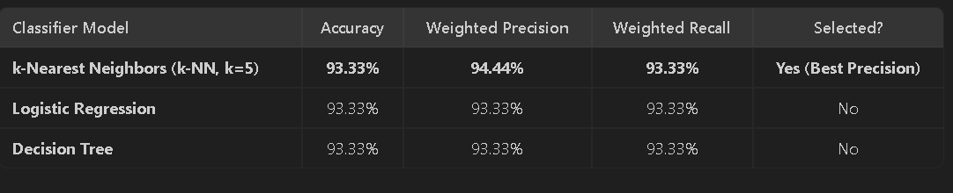
Model Comparison

Pairplot Screenshot
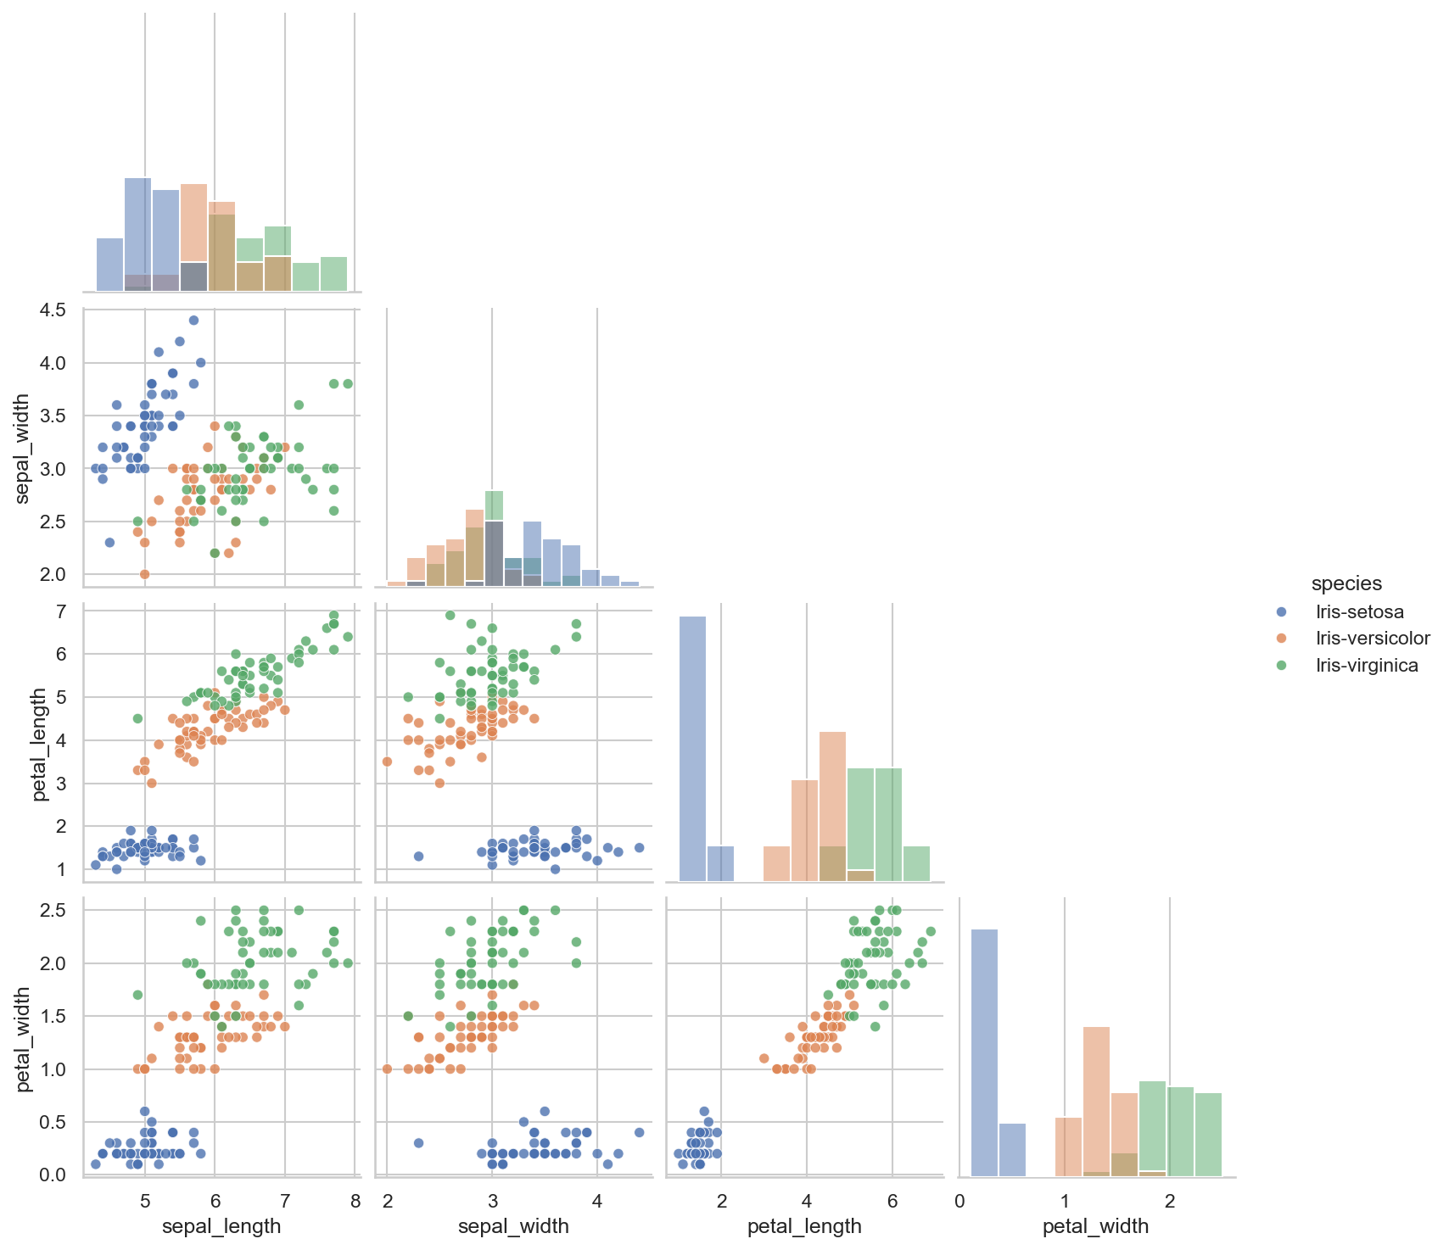

Separability
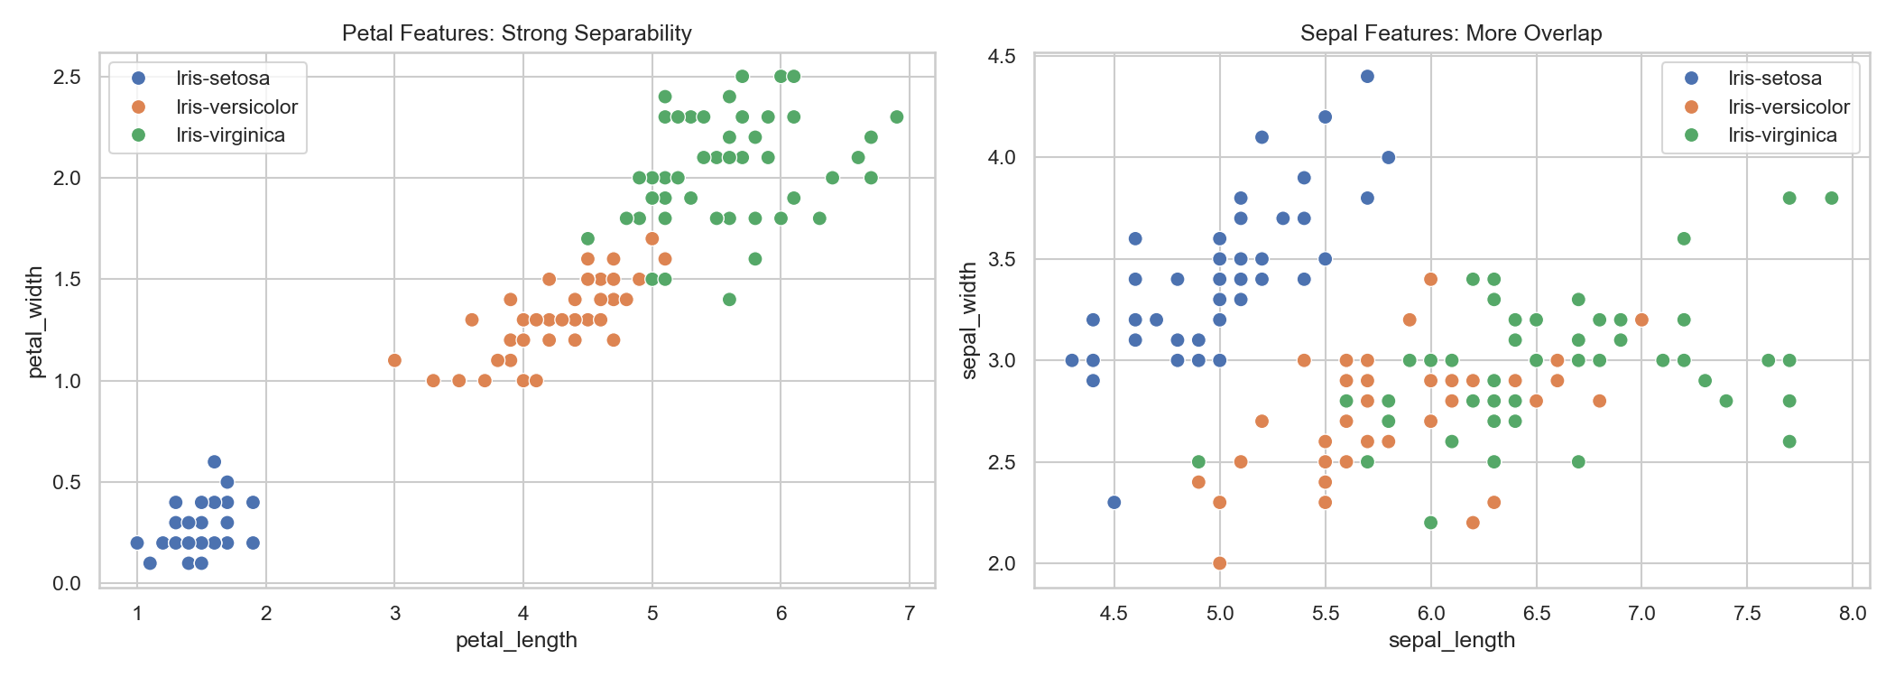

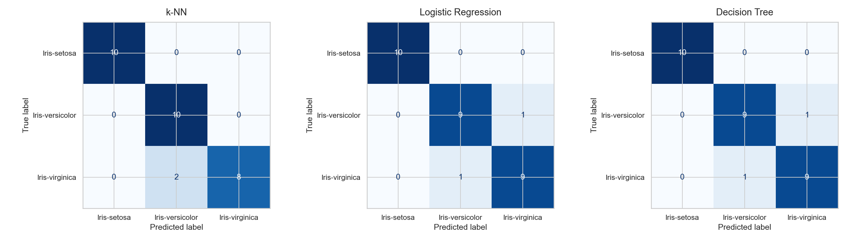
Confusion Matrices

