Task-1 Titanic Survival Prediction
- Notebook: https://github.com/thepramanjain/InternShala_Task1/blob/main/Titanic_dataset.ipynb
- Model file: titanic_survival_model.joblib

Executive Summary
This project builds a Titanic survival prediction pipeline from passenger attributes with a feature-engineering-first approach. The notebook extracts passenger title from the name field, creates family size from sibling/spouse and parent/child counts, and adds a cabin-present indicator to capture whether cabin information exists. Missing age values are handled with a structured strategy: age is imputed using the median age for the corresponding title and passenger class, with a fallback to the global age median. Fare and embarked values are also imputed to keep the pipeline robust. The modeling workflow compares logistic regression and random forest classifiers, with categorical variables one-hot encoded and numeric variables median-imputed where needed. The notebook reports validation accuracy, precision, recall, F1, and ROC-AUC, and stores the best trained pipeline as a reusable model artifact. For explanation, the notebook uses random-forest feature importance to show which inputs matter most. In the current run, sex and title features were the strongest drivers, followed by age and family-based features. An inference example is included using a raw passenger record, demonstrating how the saved model can be loaded and used on new data without manual preprocessing. The pipeline applies the same transformations during training and prediction so deployment remains consistent.
Model Comparison Screenshot
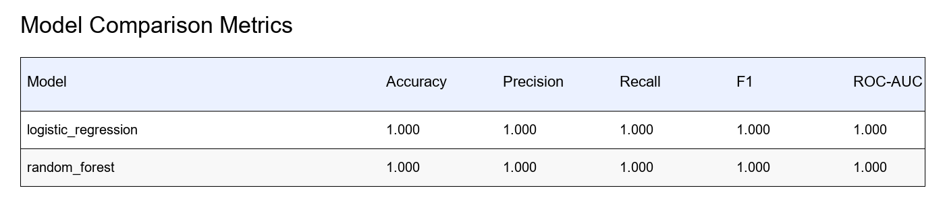

Feature Importance Screenshot
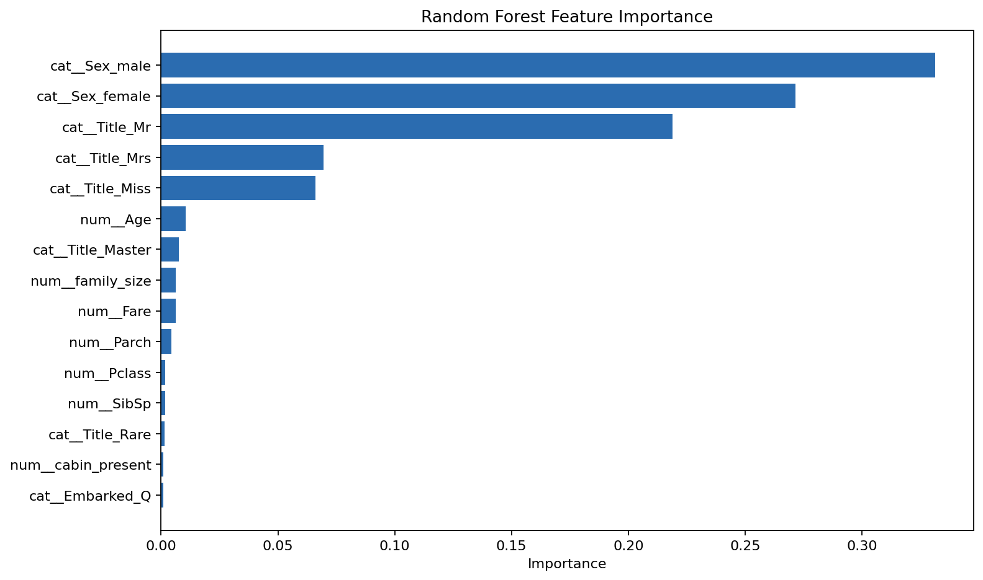
Inference Screenshot
