Task-2 House Price Prediction

- Notebook: https://github.com/thepramanjain/InternSpark_Task2/blob/main/HousePricePred.ipynb
- Model file: house_price_model.joblib

Executive Summary
This project develops a house price prediction pipeline using a regression-based machine learning workflow on a dataset containing approximately 4,600 residential property records and 18 feature columns. The notebook follows a feature-engineering-first approach and implements a fully automated preprocessing framework using Scikit-Learn's Pipeline and ColumnTransformer architectures. A custom HouseFeatureEngineer class creates additional predictive features, including transaction date attributes, property age, renovation indicators, renovation age, room density measures, and living-area-to-lot-size ratios. Numeric features with high positive skewness are processed through median imputation, logarithmic transformation, and standard scaling, while categorical variables are handled using most-frequent imputation and one-hot encoding with frequency-based category filtering. To improve target distribution stability, the entire pipeline is wrapped in a TransformedTargetRegressor, applying logarithmic scaling during training and automatically converting predictions back to the original price scale during inference. The modeling workflow evaluates Linear Regression, Gradient Boosting Regressor, and Random Forest Regressor using an 80-20 train-test validation split. Linear Regression achieved the best overall performance with an RMSE of $993,263.22, MAE of $196,247.99, and an R² score of 0.0326, making it the selected model for deployment. The relatively low predictive performance is primarily influenced by the presence of zero-valued property prices and several extreme multimillion-dollar outlier properties within the dataset. An inference example is included to demonstrate how the serialized model can generate predictions directly from raw property records without requiring manual preprocessing. The final pipeline ensures consistent feature engineering, preprocessing, training, and prediction behavior, making it suitable for deployment and future extension with additional location-based and neighborhood-level features.
Model Comparison Screenshot
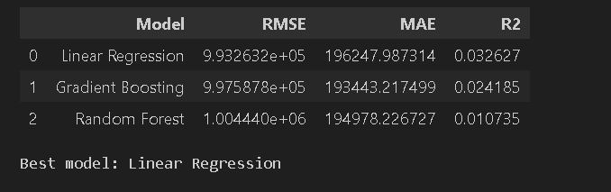

Residual Analysis
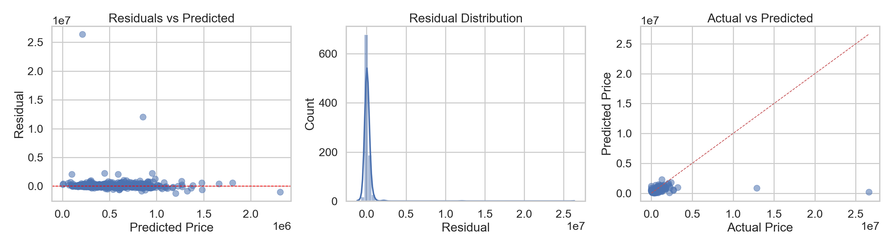

Price Distribution
