Customer Shopping Behavior Analysis
An End-to-End Business Analytics Case Study:
Python, PostgreSQL & Power BI

Prepared by: Pranish Pradhan
Role: Business Analyst / Business Analytics
Date: July 2026
Status: Final

TABLE OF CONTENTS
Executive Summary 3
1. Project Overview 1
2. Dataset Summary 1
3. Data Preparation- Python 1
4. Data Analysis- SQL (PostgreSQL) 2
Technical highlights 3
5. Power BI Dashboard 4
6. Business Recommendations 4
APPENDIX - SUPPORTING SCREENSHOTS 5

Executive Summary
This report presents an end-to-end analysis of 3,900 customer transactions, covering data cleaning in Python, ten SQL-driven business questions answered in PostgreSQL, and a final interactive Power BI dashboard. Revenue is concentrated among specific age groups and shipping preferences, a meaningful share of high-spending customers still respond to discounts, and top-performing products differ meaningfully by category rather than following one global bestseller list. Five actionable recommendations are provided in Section 6, covering subscription growth, loyalty programs, discount policy, product positioning, and targeted marketing.

Project Overview
This project analyzes 3,900 customer transactions to uncover spending patterns, customer segments, product performance, and subscription behavior, translating raw retail data into decision-ready insights via a full Python → SQL → Power BI pipeline.

Dataset Summary
3,900 rows × 18 original columns, covering customer demographics (age, gender, location, subscription status), transaction details (item, category, amount, season, size, color), and behavioral signals (discount usage, previous purchases, purchase frequency, review rating, shipping type). The Review Rating field contained 37 missing values, identified and addressed during cleaning.

Data Preparation- Python
Raw data was loaded and profiled with df.info() and df.describe() to assess structure, types, and completeness before any transformation.
- Missing values: the 37 nulls in review_rating were imputed using the median rating within each product category, preserving category-level rating distribution rather than skewing toward a single global average.
- Standardization: all column names converted to snake_case for consistency across the SQL and Power BI layers.
- Feature engineering: derived age_group (binned from age) and purchase_frequency_days to support segment-level analysis downstream.
- Redundancy check: confirmed discount_applied and promo_code_used were highly correlated; dropped the redundant promo_code_used column after backing up the original DataFrame.
- Persistence: loaded the cleaned DataFrame directly into PostgreSQL via SQLAlchemy (create_engine + to_sql), skipping an intermediate CSV so the pipeline stayed fully scripted and reproducible.

Data Analysis- SQL (PostgreSQL)
Ten business questions were answered directly in SQL, moving from simple aggregation to correlated subqueries, CTEs, and window functions:
# | Business Question | Technique
1 | Revenue by Gender | GROUP BY, SUM()
2 | High-Spending Discount Users (above average spend) | Subquery in WHERE
3 | Top 5 Products by Rating | AVG(), ORDER BY, LIMIT
4 | Shipping Type Comparison (Standard vs. Express) | GROUP BY, AVG()
5 | Subscribers vs. Non-Subscribers (spend & revenue) | GROUP BY, SUM(), AVG()
6 | Discount-Dependent Products (top 5 by % discounted) | CASE + SUM, decimal casting
7 | Customer Segmentation (New / Returning / Loyal) | CTE, CASE
8 | Top 3 Products per Category | CTE + ROW_NUMBER() OVER (PARTITION BY)
9 | Repeat Buyers vs. Subscription Likelihood | WHERE, GROUP BY
10 | Revenue by Age Group | GROUP BY, SUM(), alias in ORDER BY

Technical highlights
- Resolved SQL's logical execution order constraints (WHERE runs before SELECT and cannot reference SELECT aliases or raw aggregates) using subqueries and CTEs instead.
- Diagnosed and fixed a PostgreSQL type-resolution error- ROUND() only accepts numeric, not double precision - via explicit ::numeric casting.
- Caught and corrected silent integer-division truncation in a percentage calculation by forcing decimal arithmetic, avoiding a subtly wrong (all-whole-number) result.
- Applied ROW_NUMBER() OVER (PARTITION BY category ORDER BY ...) to solve a 'top-N-per-group' problem - a pattern that recurs constantly in business reporting.

Power BI Dashboard
Findings were consolidated into an interactive Power BI dashboard: KPI cards for headline metrics, category and segment-level visuals built directly on the SQL outputs above, and slicers (with custom sort order and styling) enabling stakeholders to filter by attributes such as discount usage. Native cross-filtering means selecting any data point automatically updates every other visual on the page.

Business Recommendations
- Boost Subscriptions- promote exclusive benefits to convert high-frequency shoppers into subscribers.
- Customer Loyalty Programs- reward repeat buyers to move them from 'Returning' into the 'Loyal' segment.
- Review Discount Policy- the discount-dependent products list (Q6) shows where discounting may be eroding margin rather than driving incremental demand.
- Product Positioning- feature top-rated (Q3) and top-selling per category (Q8) products in campaigns.
- Targeted Marketing- prioritize the highest-revenue age groups (Q10) and express-shipping customers (Q4).

APPENDIX - SUPPORTING SCREENSHOTS
Python / Jupyter (data loading, cleaning, feature engineering, PostgreSQL load):
Screenshot 1: Data Loading & Initial Structure Check
The raw customer_shopping_behavior.csv file was loaded into a pandas DataFrame and inspected using df.head() and df.info(). This confirmed the dataset's shape (3,900 rows, 18 columns) and data types before any cleaning began.
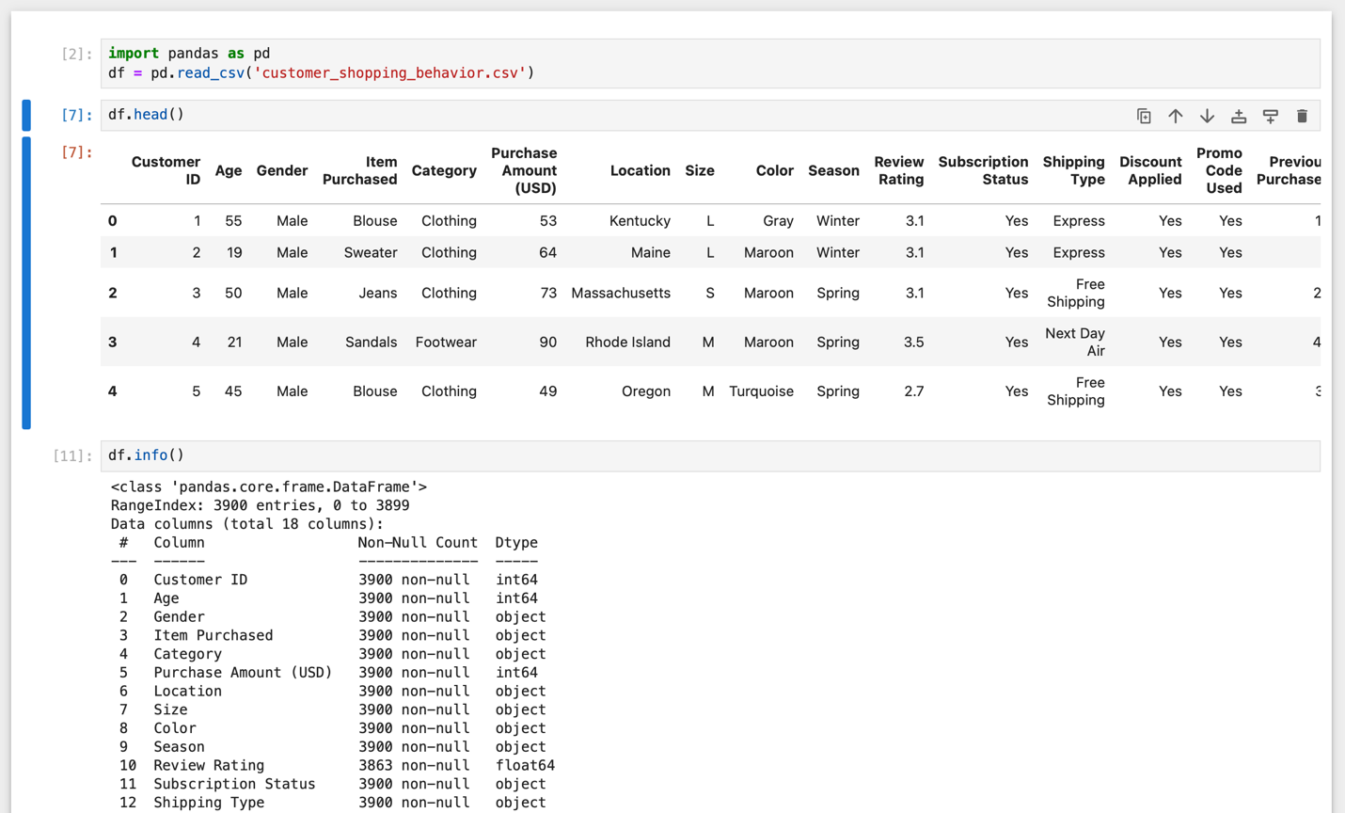

Screenshot 2: Missing Value Detection & Imputation
df.isnull().sum() identified 37 missing values, isolated entirely to the Review Rating column. Rather than dropping those rows or filling with a single global average, missing ratings were imputed using the median rating within each product category, preserving category-specific rating patterns. A follow-up null check confirmed zero missing values remained.
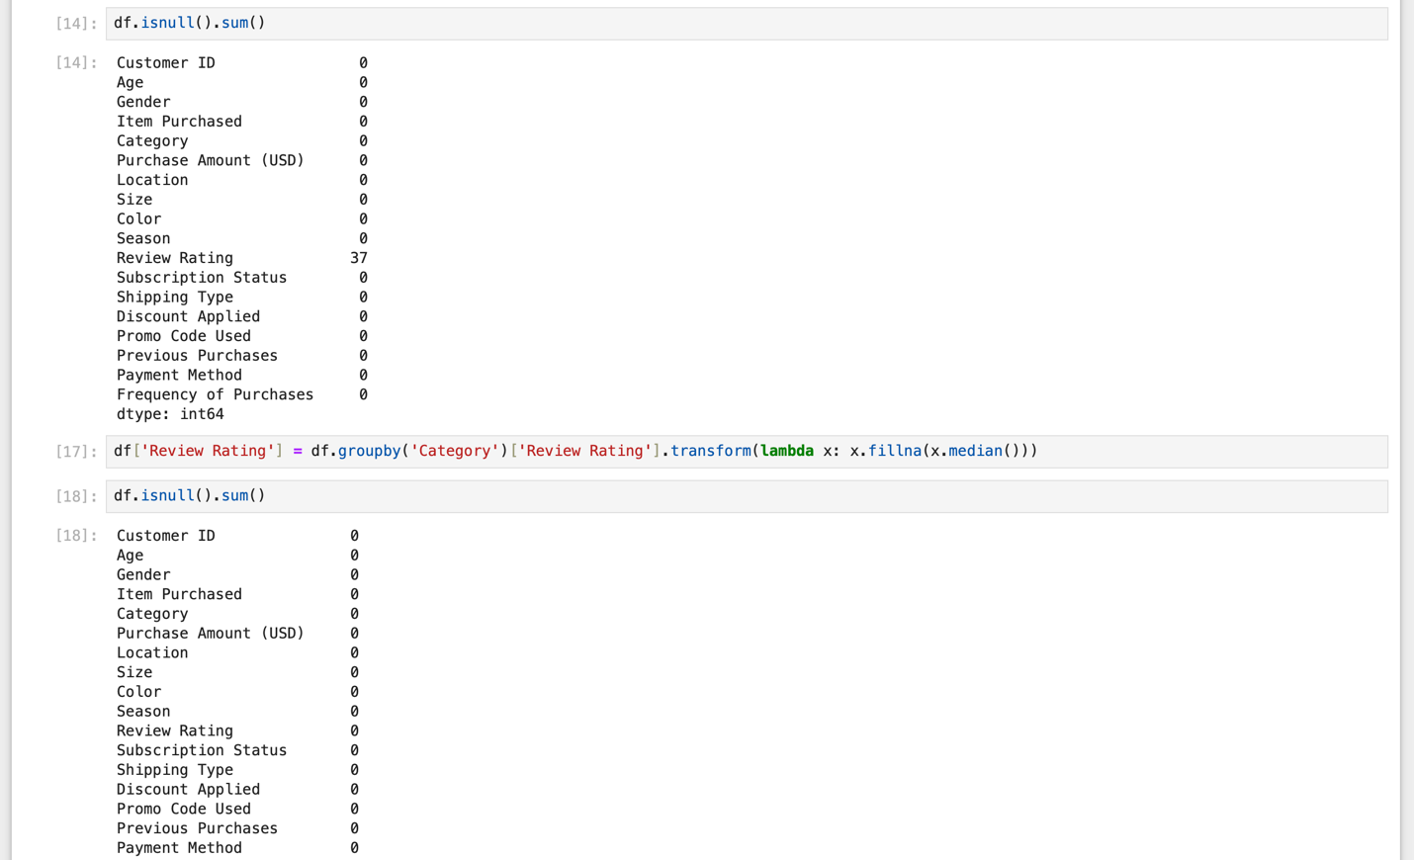

Screenshot 3: Column Standardization & Age Segmentation
Column names were standardized to lowercase snake_case for consistency across the SQL and Power BI layers. Customers were then split into four age_group bins (Young Adult, Adult, Middle-aged, Senior) using pd.qcut(), a quantile-based cut that creates four evenly sized groups rather than fixed, arbitrary age ranges.
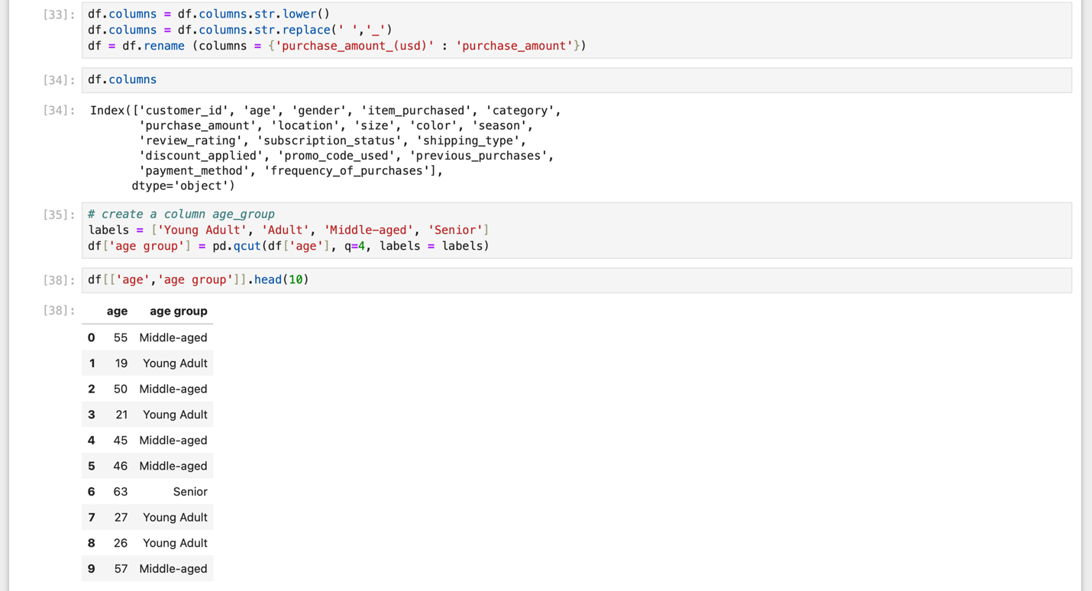

Screenshot 4: Purchase Frequency Encoding & Redundancy Check
The categorical frequency_of_purchases field (e.g., "Weekly," "Quarterly") was mapped to a numeric purchase_frequency_days column via a dictionary lookup, making frequency usable in quantitative analysis. A redundancy check then confirmed discount_applied and promo_code_used were identical across all 3,900 records, justifying removal of one as duplicate information.
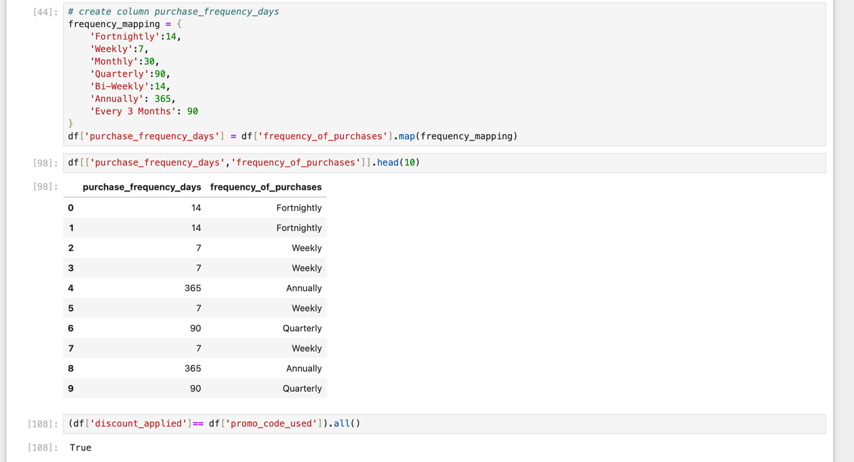

Screenshot 5: Backup, Column Cleanup & Database Load
Before dropping the now-redundant promo_code_used column, a full backup of the DataFrame was created to preserve the ability to roll back. The cleaned DataFrame- 19 columns after adding age_group and purchase_frequency_days, was then loaded directly into a PostgreSQL customer_behavior database via SQLAlchemy, completing the handoff from Python to SQL without an intermediate file.
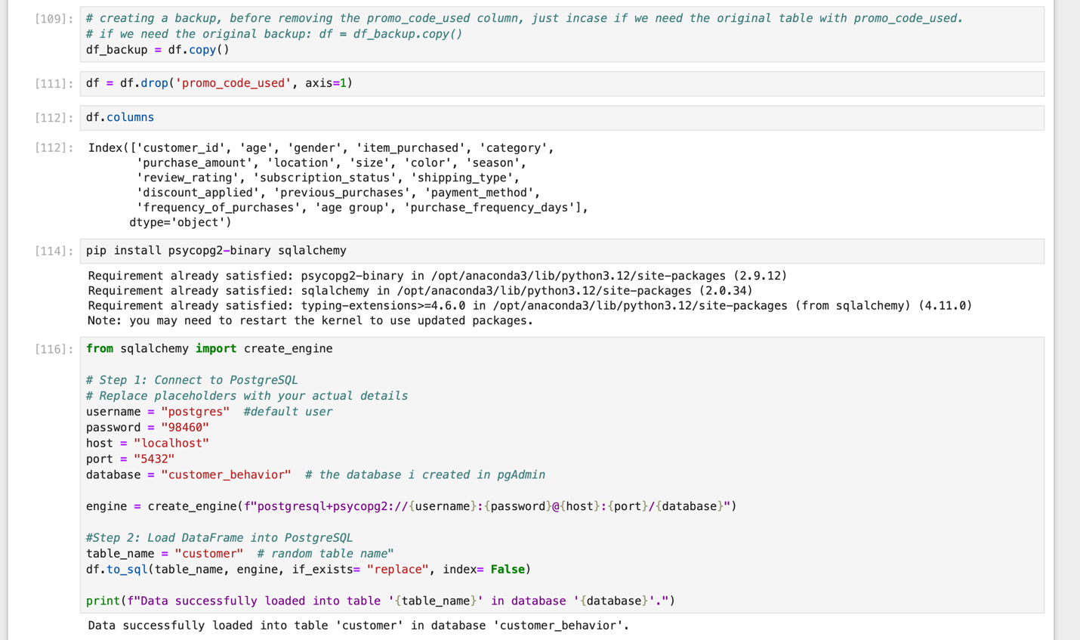

SQL / pgAdmin (queries and result sets for the 10 business questions above):
Question 1. What is the total revenue generated by male vs female customers?
Query:
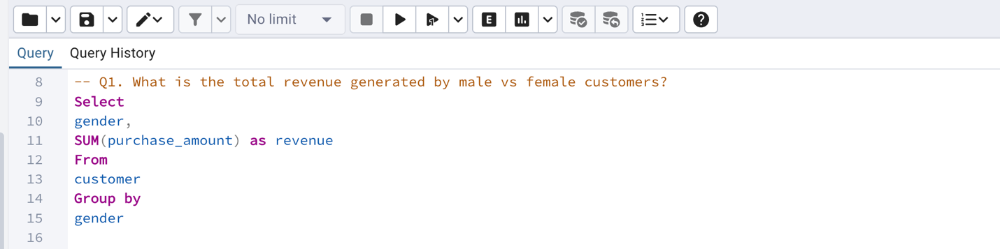
Output:
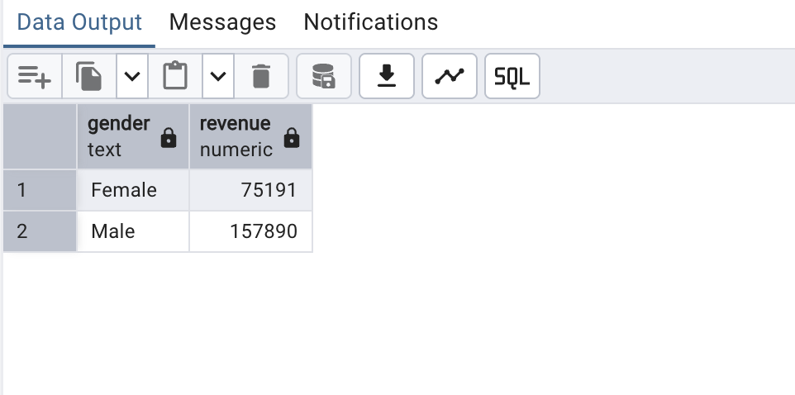

Question 2. Which customers used a discount but still spent more than the average purchase amount?
Query:
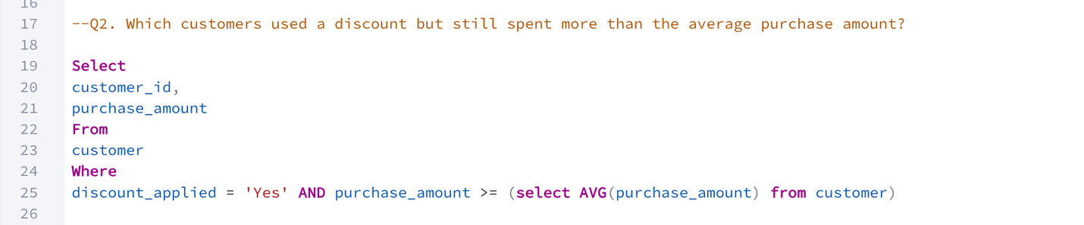
Output:
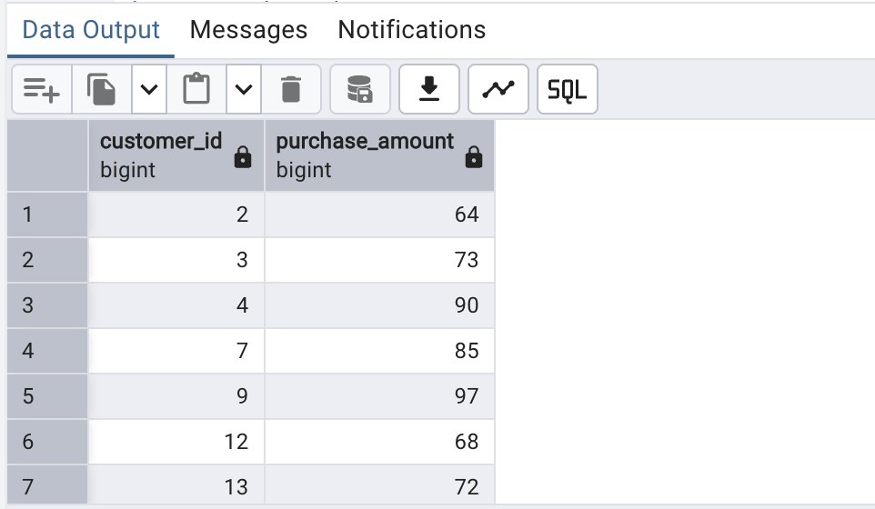

Question 3. Which are the top 5 products with the highest average review rating?
Query:
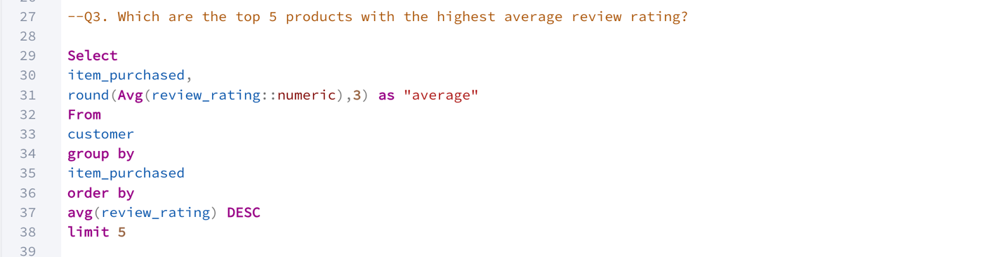
Output:
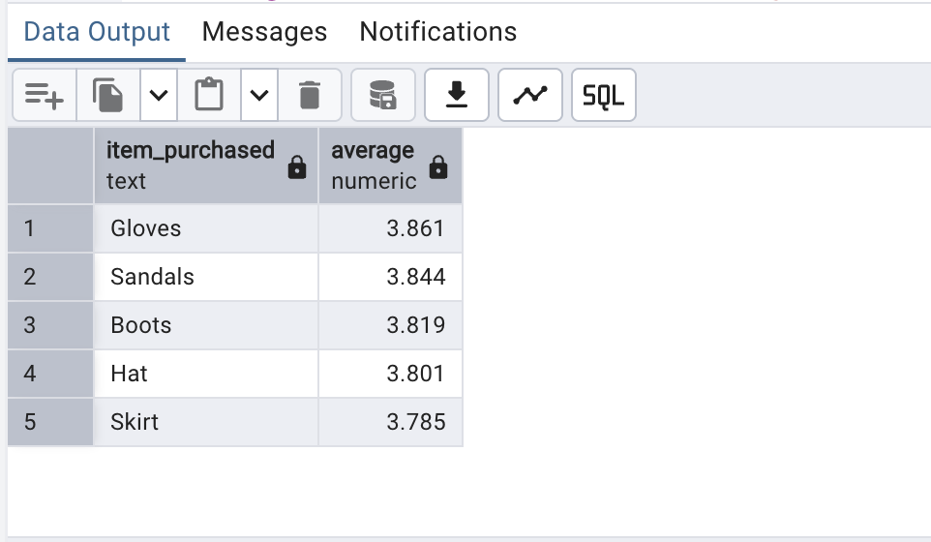

Question 4. Compare the average purchase amount between standard and express shipping.
Query:
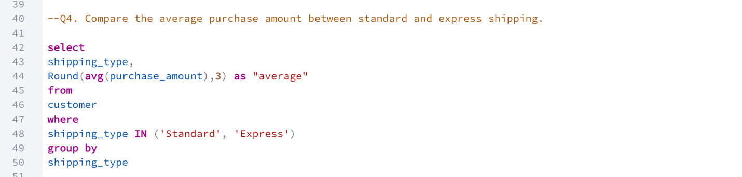
Output:
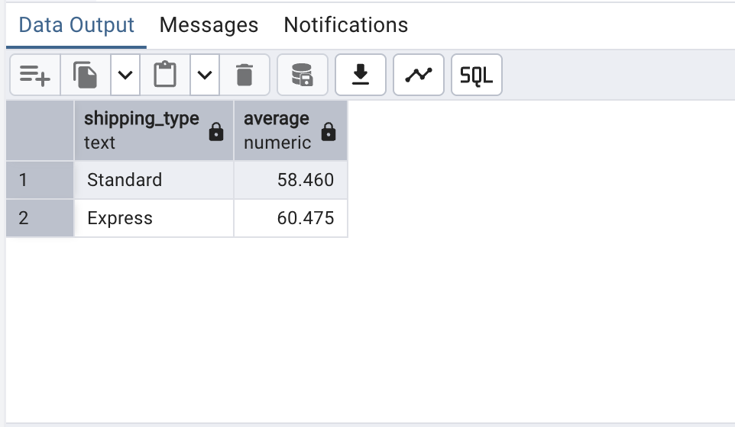

Question 5. Do subscribed customers spend more? Compare average spend and total revenue between subscribers and non-subscribers.
Query:
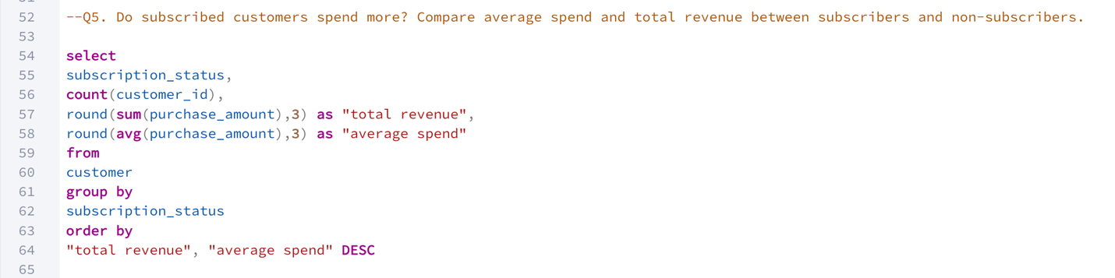
Output:
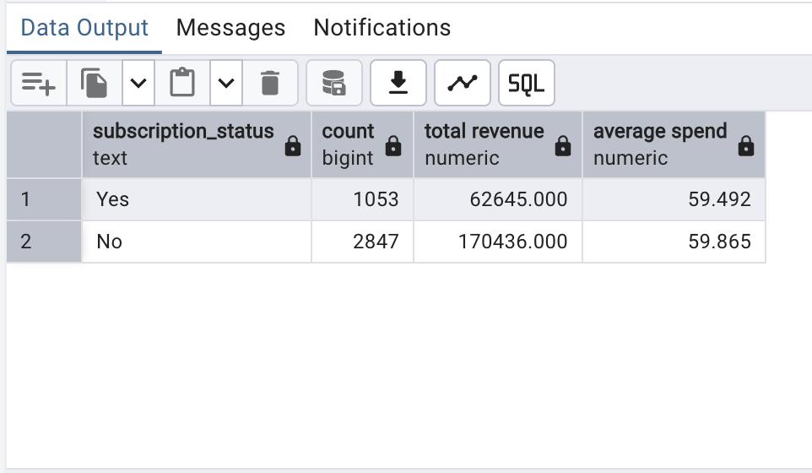

Question 6. Which 5 products have the highest percentage of purchases with discount applied?
Query:
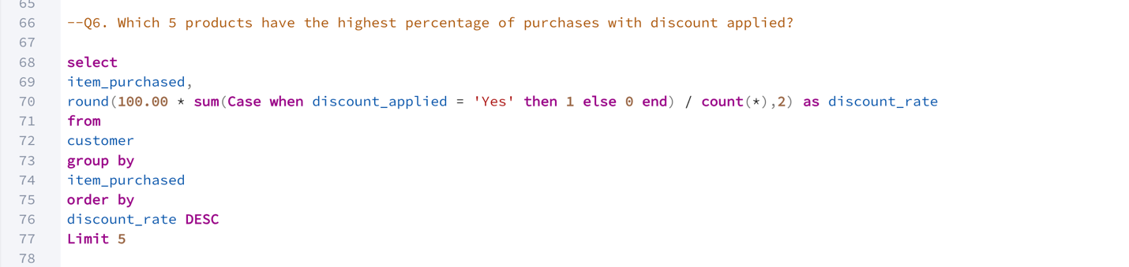
Output:
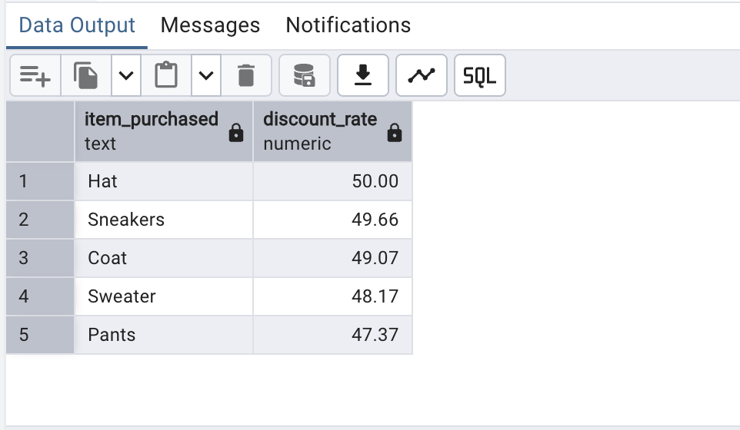

Question 7. Segment customers into New, Returning and Loyal based on their total number of previous purchases and show the count of each segment.
Query:
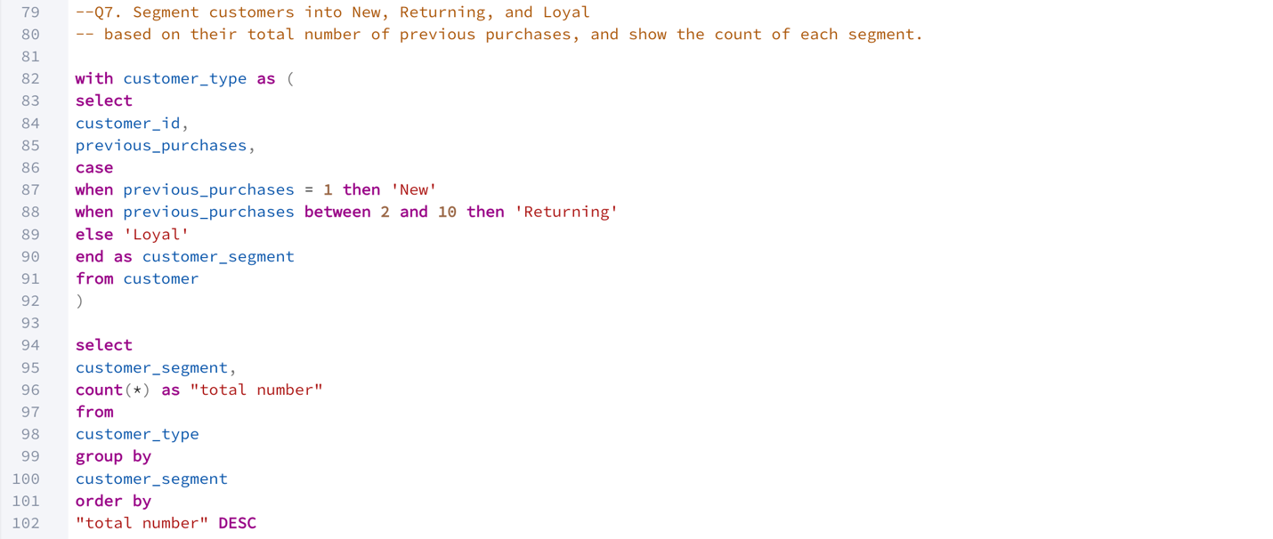
Output:
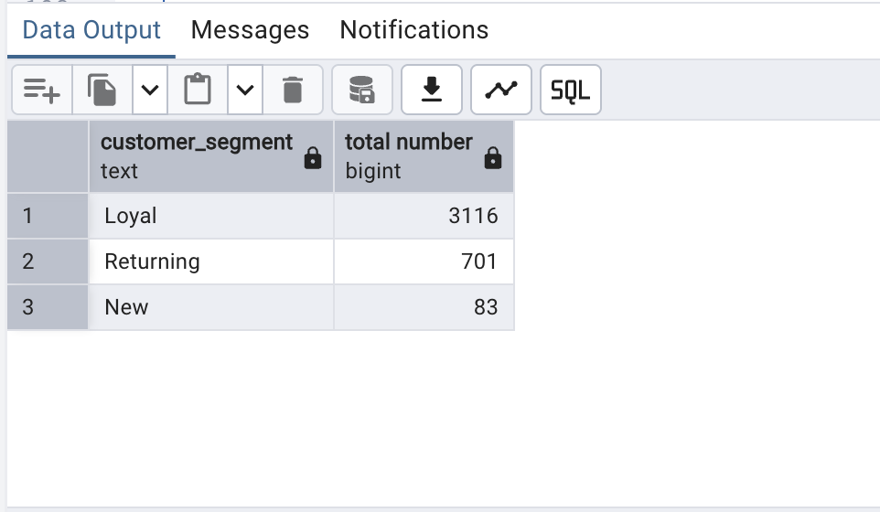
Question 8. What are the top 3 most purchases products within each category?
Query:
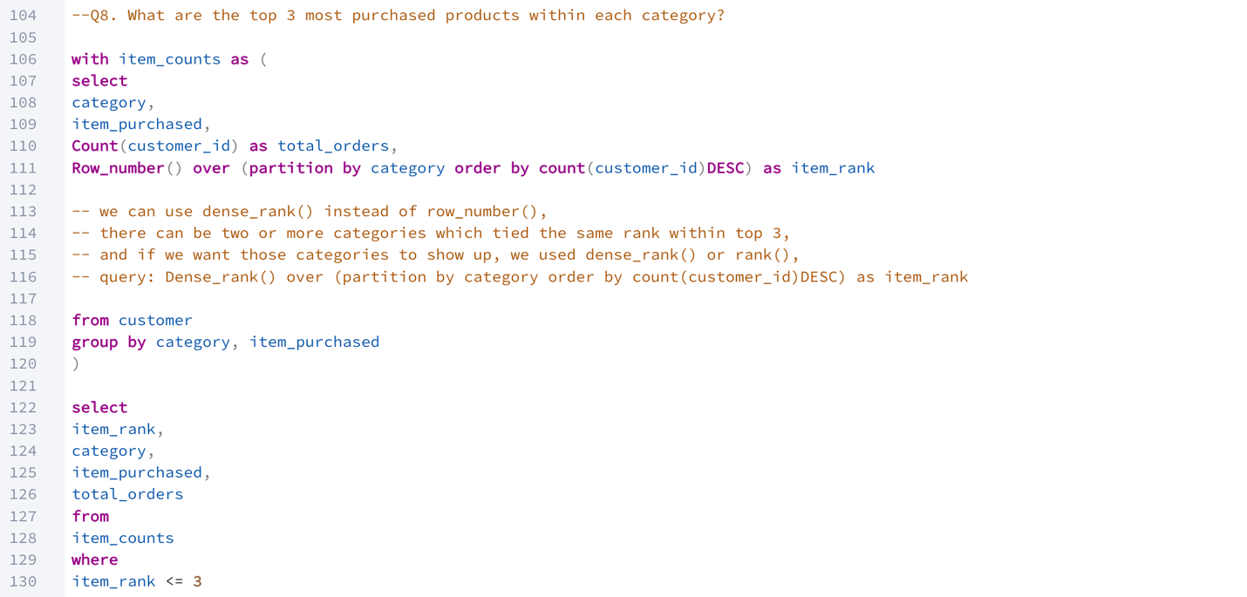
Output:
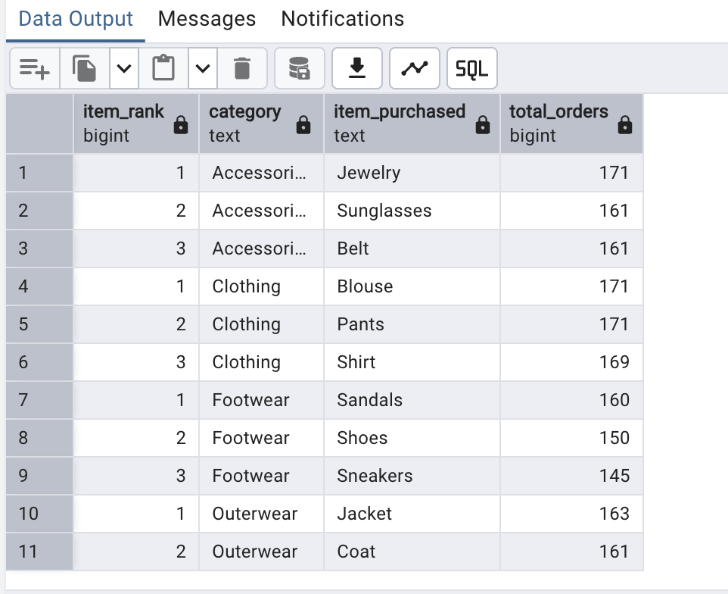
Question 9. Are customers who are repeat buyers (more than 5 previous purchases) also likely to subscribe?
Query:
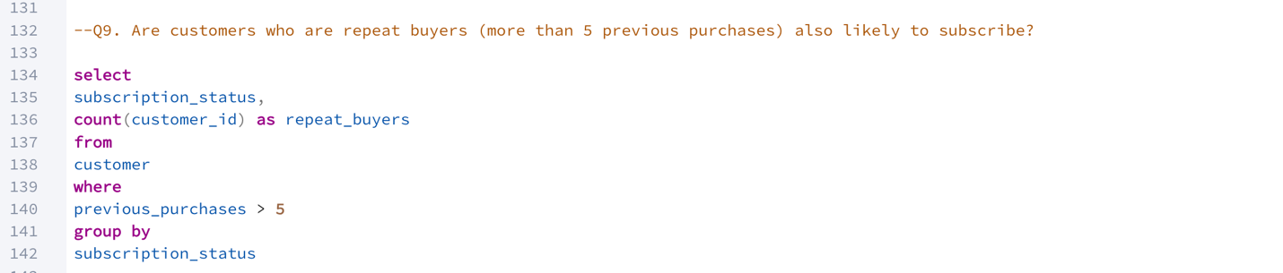
Output:
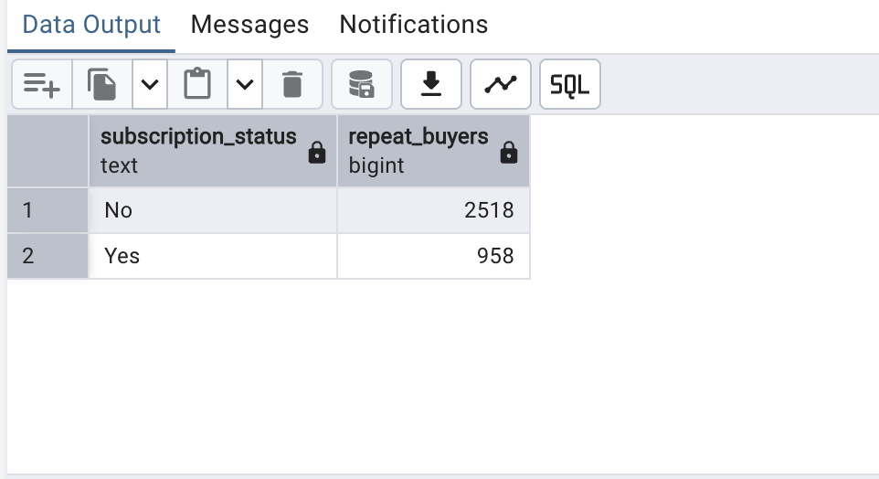

Question 10. What is the revenue contribution of each group?
Query:
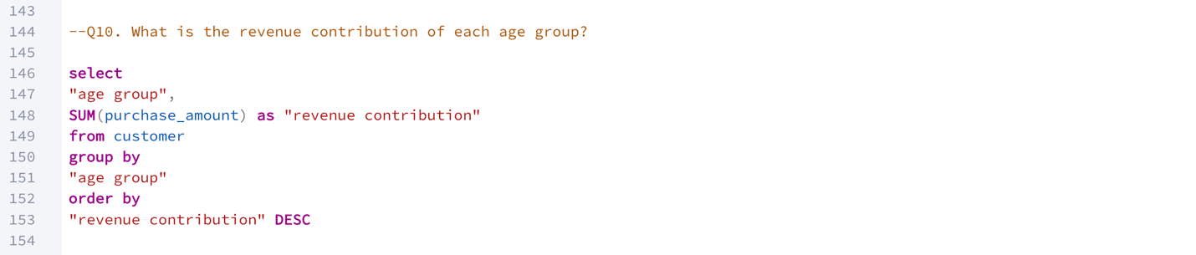
Output:
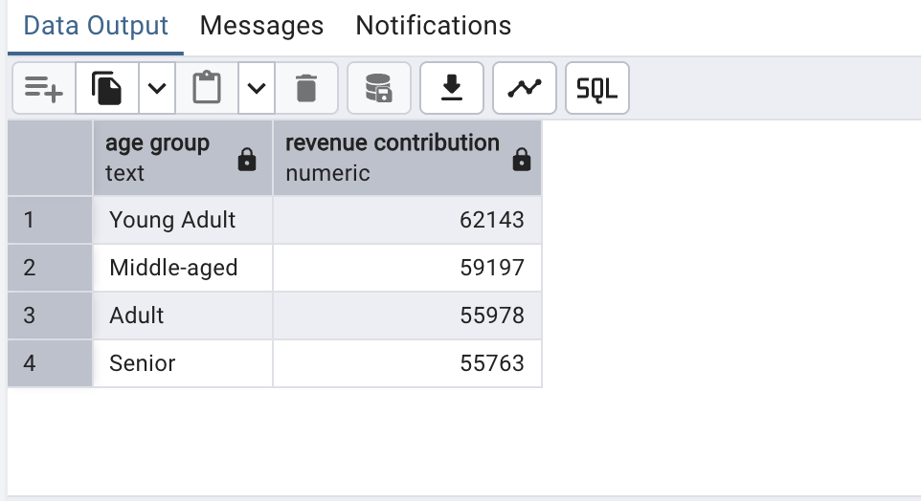

Power BI Interactive Dashboard (final report view):
