2.1 Process to improve quality of teaching and learning

Adherence to Academic Calendar:

- Based on the academic calendar given by the university (that contains Commencement of Semesters, In-semester/Online theory exams, End-semester exams, practical/ TW exams, project exams etc.), the institute calendar is prepared.

Planning:

The Electrical Engineering department strictly follows timeline execution of academic conduction in accordance to departmental academic calendar. Figure 2.1.1 Component of academic planning

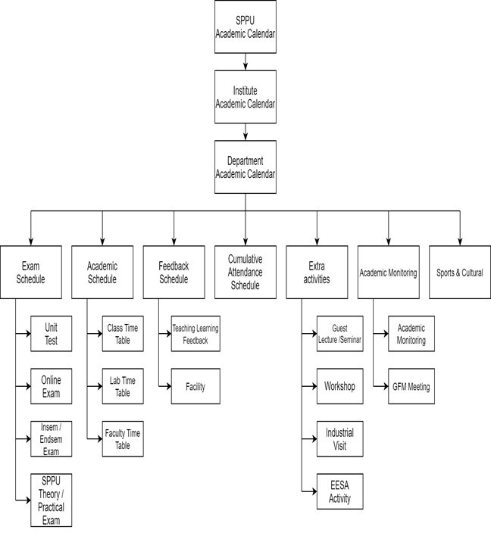 Figure 2.1.1 Component of academic planning

Based on the academic calendar given by the university (that contains Commencement of Semesters, In-semester/Online theory exams, End-semester exams, practical/ TW exams, project exams etc.), the institute calendar is formulated.

Based on the SPPU academic calendar, the institute calendar is formulated in which following activities are taken into consideration:

        - The departmental Academic calendar is prepared before the commencement of the semester based on the Institute Academic calendar which is based on SPPU academic calendar.
        - Academic calendar includes the dates of start and end of the commencement of the semester, time table of Unit test, online exam, Insem and End sem exam, schedule of SPPU practical and theory examination
        - Academic calendar also includes planned dates of display and submission of assignments, unit test result and feedback of faculty to be taken from students and monthly cumulative attendance
        - The academic calendar consists of planned schedule of all activities to be conducted during the semester... It also includes planned schedule of industrial visit, guest lecture, workshop, placement activities and various activities under Electrical Engineering Student Association (EESA).
        - Distribution of load and portfolio is done well in advance before the commencement of the semester so that faculty can prepare notes, teaching plan, lab plan, course file, lab file of allotted subject. The notes of faculties are get verified by Module coordinator and IQAC in charge.
        - As per SPPU syllabus 8 -10 experiments are to be conducted. The continuous assessment of lab work is strictly followed by all faculties
        - IQAC ensures effective and efficient implementation to adhere academic calendar. In case of deviation remedial actions are taken immediately

Adherence to academic calendar with Sample Format of Institute, Department academic calendar

            - The snap shot of SPPU Academic Calendar

Figure 2.1.2 Snapshot of SPPU Academic Calendar

            - Institute Academic Calendar

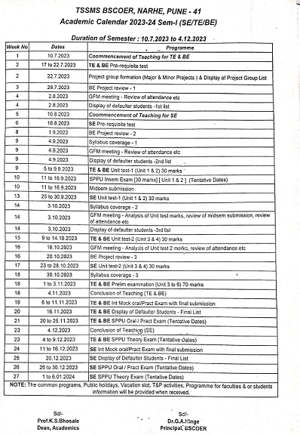

Figure 2.1.3 Screenshot of Institute Academic Calendar

            - Screen shot of Department Academic Calendar
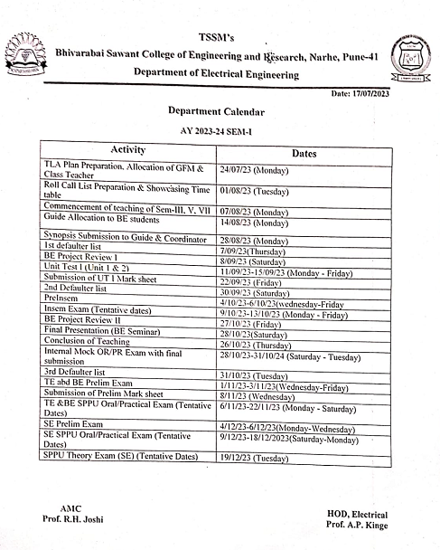

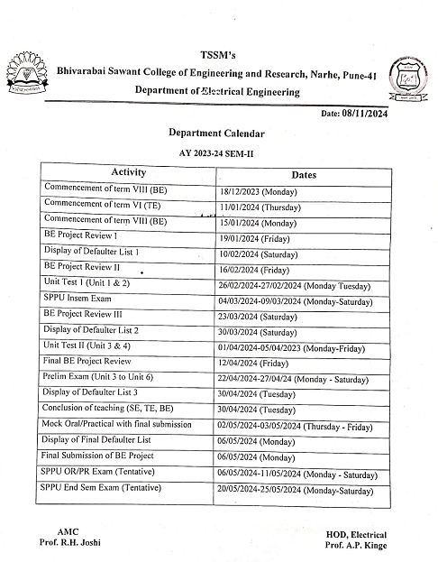

Figure 2.1.4 Screenshot of Department Academic Calendar

            - Screen shot of Adherence to Department Academic Calendar

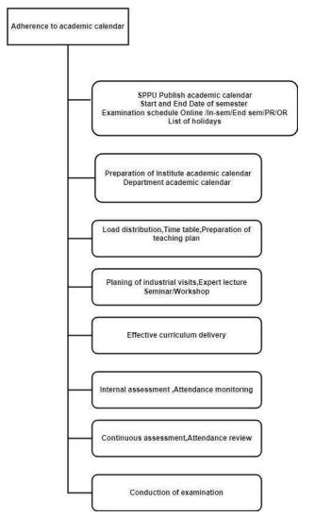

figure 2.1.5: Screenshot of Adherence to Department external

Academic Calendar Note: 5% deviation may occur in case of practices like Guest lecture, Industrial visit.

          - Teaching and learning: Use of various Instructional methods and pedagogical initiatives

Teaching methods:

- The departmental faculty uses various innovative teaching methods such as chalk and board, presentation, group discussion, peer teaching etc. Faculty uses models, charts, during lecture and practical for better understanding of students
- Guest lecture, workshop, seminar, training are arranged by faculties for the betterment of students.
- Faculty uses Smart TV for interactive teaching.
- Faculty uses software tool “MOODLE” on which all study material is uploaded. Each student is having their own user ID and password through which they can login to Moodle and take the benefit of uploaded study material.
- Industrial visits are arranged for students to bridge the gap between academic and Industry.

To achieve expected learning outcomes different teaching methods are used suitable with contents of course

Following are the teaching methods implemented in the department:

              - Interactive: This method ensures interaction with students while learning and provides them opportunities to raise their opinions and queries.

              - Demonstration: With direct demonstration method, the theoretical as well as practical concepts are delivered and demonstrated in classroom and laboratory respectively. It ensures learning of theory and practical concepts related to a course and its applications

              - Collaborative: Through this approach attempts are made to nurture professional appearances like team work, leadership, resource applications, sharing ideas, recognizing problems and selecting probable solutions are developed among students.

              - Project Based: In project based teaching and learning, mini projects are distributed among students in small sub groups. Students understand the theoretical concepts learnt in classrooms while working on mini projects. Apart from academic skills the professional skills like team spirit, leadership and communication skills are also developed among students. Students learn to identify technical problems and find suitable solutions for it

Delivery Tools

Different course delivery tools are utilized while teaching few of them are mentioned below

              - Chalk board – The conventional chalk and board tool is used in direct instructional teaching method. It supports understanding of basic concepts of course.

              - ICT Tools – Different ICT tools like LCD projectors, smart boards, Wi-Fi, LAN and LMS-MOODLE software are used while teaching. Video clips, video lectures, virtual laboratories, MOOCs and other e-resources are made available for teachers as well students in classrooms and laboratories through ICT tools.

              - Models / Charts - In some courses, the design and experimentation issues are also discussed in the form of models/charts. · Industrial setups (Visits) – Industrial setups are made available through industrial visits to the students while teaching specific courses.

              - VC facilities - Video lectures of difficult courses are delivered by expert faculties to reinforce the basic concepts VC facility is available in the institute.

Methodologies to support weak students and encourage bright students:

The identification of fast learner and slow learner carried out course wise based on

Unit tests result analysis and also interaction with GFM; IF the student secures more than 50% marks in UT identify as fast learner and slow learner secures less than 50% marks.

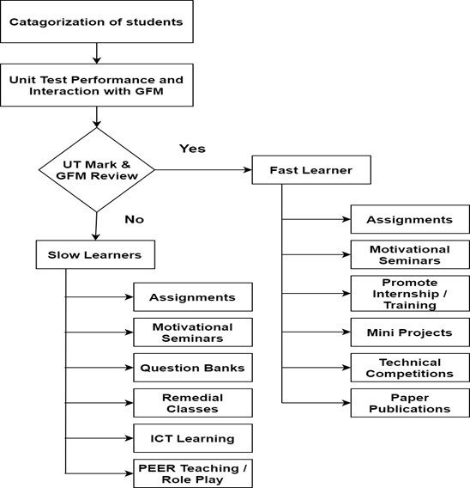

Figure 2.1.6 Methodologies to support slow and fast learner students

Methodologies to support bright students:

Identified group of slow learner students is counseled by mentor and supported with additional inputs so that the observed weakness can be eliminated in due course of time.

- Provide ICT learning material in simple language
- Specific pedagogical initiatives used as per learning style of student
- Conducting Remedial classes for weak students on difficult topic of particular subjects during extra teaching hours. Providing Question bank.
- Providing Solved SPPU Question papers Counseling students by GFM and subject teacher.
- Motivating students to ask question in class or lab to build their confidence level. Conducting tutorials for more practices.

Methodologies to support bright students:

- Department motivate fast learner students to extend necessary inputs for improvement of their skill sets in order to meet industrial needs and achievement of good score in board examinations Awarding bright students as a best academic performer.

- Arranging various activities for e.g. workshop, seminar and hands on training. Arranging placement related trainings.

- Motivating and permitting for Internship.

- Arranging guest lecture for new technologies, recent trades and competitive exam. Motivating to participate in project competition.

- Specially designed assignments are given to achieve higher level of learning and to strengthen skill competency, add-on courses are offered Bright students are critically assessed in internal tests and assignments which help them to improve the score in board examinations Specific activities mini projects, technical competitions are organized for bright students

- Special seminars are conducted for personality development, positive mind setup, interview skills and industrial-technical skill enhancement Opportunity is provided to lead the team during group or collaborative learning.

Impact analysis:

- It is observed that the performance of average students is improved in the internal test & SPPU examination results also their voluntary participation in various technical competitions is improved. It is observed that more & more bright students get involved in various project competitions & placement activities.

- The number of students placed in companies like KPIT, TCS & Infosys has increased as compared to the previous year. The number of students who have been placed with a good package has also increased than the previous year

Quality of classroom teaching:

Teachers apply different pedagogical strategies for delivering lecture already stated in their respective teaching plan. Quality of classroom teaching is decided by; how well the students can grab the contents and learn best in the stipulated time itself. The quality of classroom teaching is also monitored from time - to - time by various authorities like Principal, HOD and DAC.

Following are the parameters which are considered during monitoring Classroom teaching.

- Effective Communication and lecture delivery skills.

a. English is the medium of instruction in class however in view of clear understanding of the topic, sometimes support of native language is permitted as majority of the students at our institute come from Marathi medium schools.
            - Style of Content delivery

            - Interaction with students

            - One- to- one discussion, interaction between student and teacher in classroom to boost confidence level of the students and encourage barrier-free problem-solving environment.

            - Innovative teaching learning process

            - Whether Course teacher is using various ICT tools for teaching.

            - Teaching methodologies and pedagogical initiatives taken to make the learning more effective.

            - Punctuality and regularity in conduction of lecture

            - Effective Syllabus Coverage.

a. Department Academic coordinator and Head of Department takes review of the progress of the course at the end of each month through feedbacks collected from course coordinators as well as students. Corrective measures in the form of extra lectures are taken in case some course is lagging in schedule.
            - Accessibility of the course teacher inside and outside the class to clear the student doubts.

            - Quality of question paper and assignment questions framed by course teacher..

a. Continuous Assessment of students is carried out through workbook/Assignment questions solved by the students, their performance in unit tests and prelim exams, mock exams, etc. for their practice and better performance. Remedial classes are conducted for the average learners based on their performance after the first unit test.
            - Overall Satisfaction

- Ambience of the classroom plays a vital role in setting the mode of the students to ‘happy learning’.

- Instructional ethics followed by teachers are discussed with respective course coordinator after completion of their lecture

            - Attendance and attentiveness of students during the lecture.

            - The lecture is attended by HOD/Principal if required, in case of any complaints from the students.

            - Sample of session in Figure

SCREENSHOT OF SESSION PLAN

Conduct of Experiments:

The process of conduction of laboratory experiment as follow

Before commencement of semester, faculties perform all the laboratory Experiments and maintain the records of it. The hands-on skill of faculty and the correct functioning of laboratory equipment are ensured with this.

Electrical labs are fully equipped with equipment’s, hardware, software like Auto cad, MATLAB, keel, C, C++ etc.

The labs are provided with notice board which displays the vision and mission of Institute and Department, list of experiment, lab cost, Electrical safety instructions, Do’s and Don’ts, knowledge wall. The faculties are following lab plan based on SSPU syllabus.

The experiments are conducted as per SPPU syllabus. Standard procedure is adopted for performing experiments.

The lab duration is of 2 hours. During this, students perform experiment in a group and also complete their lab journals.

The continuous assessment of lab work is strictly followed by faculty. It improves the student’s performance. Lab manual is available with subject teacher which is useful for students.

Lab utilization and lab Maintenance register is available in each laboratory.

Performance of experiment is done in a group of 6 students. The students are doing connection and note down the readings under the guidance and observation of subject teacher and lab assistant.

The students are motivated to use laboratories for their project work. For example students are using PLC of PLC lab for their project work.

Continuous Assessment in the Laboratory:

The lab session is of two hours.

During this time period the faculty explains the theory related to experiment to be performed and then there will be actual performance of the experiment in a group of students. There is a continuous evaluation of lab work for which we are following one common format as shown below –

