**CSCE 221 Cover Page   
Programming Assignment #1**

First Name: Pratik Patel UIN: 527004337

User Name: p.pratik99 E-mail address: [p.pratik99@tamu.edu](mailto:p.pratik99@tamu.edu)

Please list all sources in the table below including web pages which you used to solve or implement the current homework. If you fail to cite sources you can get a lower number of points or even zero, read more in the Aggie Honor System Office.

|  |  |  |  |
| --- | --- | --- | --- |
| Type of sources | 1 | 2 | 3 |
| People |  |  |  |
| Web pages (provide URL) |  |  |  |
| Printed material | Textbook |  |  |
| Other Sources | Lecture Slides |  |  |

1. The program contains a class named My_matrix, which lets the user store a matrix of a size (n, m), where n represent number of rows and m represents number of columns. The user can further initialize the matrix using one of the constructors provided in the class or read from an input file. The user can also perform simple matrix calculation such as Addition and Multiplication. The purpose of this program can vary from using it just store the data to perform calculation on stored data and get the wanted results.
2. I have used a 2-D dynamic array to implement the program.
3. To run the program in a Unix environment, go to the folder using a terminal window where the files are saved. Type the following commands (without quotes): “make all ; ./main” If you want to read the data through a file, please put your data inside input.txt. It should be in the following format.

(number of rows) (number of columns)

(data) (data) … (data)

(data) (data) … (data)

.

.

.

(data) (data) … (data)

1. Addition will only be performed if both the matrices have same dimensions. Multiplication will only be performed if the number of columns of the first matrix is equal to the number of rows of the second matrix. Your input file should not have less or more data points than expected. It should only contain numbers.
2. The program does have generic features. The user can use any datatype for a given matrix.

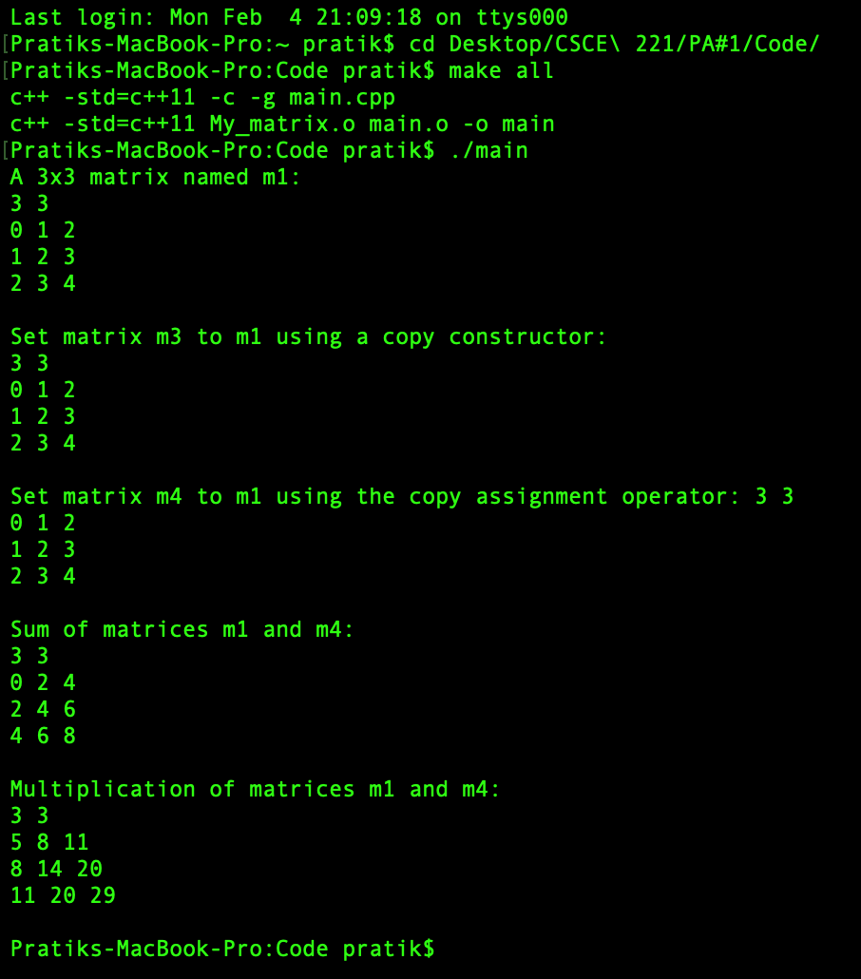

I certify that I have listed all the sources that I used to develop the solutions/code to the submitted work.

“*On my honor as an Aggie, I have neither given nor received any unauthorized help on this academic work.*”

Your Name: Pratik Patel Date: 02/04/2019