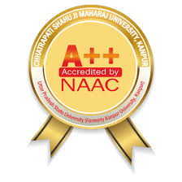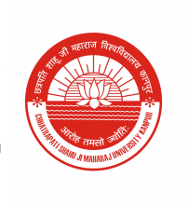

**International Conference on Recent Advances in Emerging Computing and Communication Technologies**

**(ICRAECCT) - 2025 Hybrid Mode**

**Jointly organized by:**

**Department of Computer Application**

**Department of Computer Science & Engineering**

**Department of Electronics and Communication Engineering**

**School of Engineering and Technology (UIET)**

**Conference Date: 11th & 12th April, 2025**

**\*\*\*\*\*\*\*\*\*\*\*\*\*\*\*\* CALL FOR PAPERS \*\*\*\*\*\*\*\*\*\*\*\*\*\*\*\***

**SPECIAL SESSION ON**

**[Insert Session Name]**

**SESSION ORGANIZERS:**

**[Name, University or Organization, Country, e-mail]**

**EDITORIAL BOARD: (Optional)**

**[Name, University or Organization, Country, e-mail]**

**SESSION DESCRIPTION:**

**[Insert descriptive paragraph]**

**RECOMMENDED TOPICS:**

Topics to be discussed in this special session include (but are not limited to) the following:

* **[Please insert a minimum of 5 topics]**

**SUBMISSION PROCEDURE:**

Researchers and practitioners are invited to submit papers for this special theme session on **[insert special session topic]** ***on or before*****[insert due date]**. All submissions must be original and may not be under review by another publication. INTERESTED AUTHORS SHOULD CONSULT THE PAPER SUBMISSION GUIDELINES FOR MANUSCRIPT SUBMISSIONS at <https://csjmu-conference.vercel.app/submission-guidelines>. All submitted papers will be reviewed on a single-blind, peer review basis.

**NOTE:** While submitting paper in this special session, please specify [**insert special session title**] at the top (above paper title) of the first page of your paper.