Group Project 07 – Project Plan
Author: Mosopefoluwa David Adejumo
Config Ref: SE_07_PM_01
Date: 6/11/2013
Version 1.8
Status: Release

Department of Computer Science
Aberystwyth University
Aberystwyth
Ceredigion
SY23 3DB
Copyright © Aberystwyth University 2013

Table of Contents
Table of Contents 2
1. Introduction 4
1.1. Purpose 4
1.2. Scope 4
1.3. Objective 4
2. Project Overview 5
2.1. Platforms 5
2.1.1. Android 5
2.1.2. HTML 5 5
2.1.3. PHP 5
2.1.4. MySQL 5
2.1.5. OpenSpace API 5
2.2. Target Audience 5
2.3. System Overview 6
2.3.1. Android Application 6
2.3.2. Online Offline 6
2.3.3. Walk List 6
2.3.4. Map Screen 6
2.3.5. Walk Recorder 6
2.3.6. Walk Viewer 6
2.3.7. Local Database 7
2.3.8. Database Protocol 7
2.3.9. Server 7
2.3.10. Request Handler 7
2.3.11. User Walks 7
2.3.12. Other Walks 7
2.3.13. Physical Database 7
2.3.14. Website 7
2.3.15. Online Walk List 7
2.3.16. Accounts 7
2.3.17. Online Walk Viewer 7
3. Use Case 8
3.1. Android 8
3.2. Website 9
3.3. Database 10
3.4. Interaction System 11
3.5. Descriptions 12
4. Android User Interface design 13
4.1. Start Screen 13
4.2. Main Menu 14
4.3. View My Walks Screen 14
4.4. View Online Walks Screen 15
4.5. View My Walk Screen 15
4.6. View Online Walk Screen 16
4.7. New Walk Screen 16
4.8. Recording Screen 17
4.9. New Point of Interest 18
4.10. Recording Screen With Walk 19
4.11. Locations on Walk List 20
4.12. Walk Complete 21
4.13. Options Screen 22
5. Website User Interface Design 23
5.1. Home Page 23
5.2. View Walks Page 24
5.3. Log-in Page 24
5.4. Registration Page 25
5.5. View My Walks Page 26
5.6. Walk Page 27
5.7. Point of Interest Selected Page 28
5.8. Point of Interest Image Page 29
5.9. Edit Point of Interest Page 30
6. Navigation Overview 31
6.1. Android 31
6.2. Website 31
7. Gantt Chart 32
8. Risk Assessment 33
9. Document History 34

Introduction

Purpose
This document displays how the project will be completed and any risks involved. It outlines the requirements specified by the client as a series of documents.

Scope
This document should be read by all members of the group. It contains a list of tasks, the schedule and risks involved in the project. It also details what the application and server will be required to do.

Objective
- List the platforms to be used for the project
- Provide a task schedule for the project
- Provide a description of how the application and website will be used.
- Provide a list of risks and how to reduce their effects
- Provide an idea of the UI for the Android application and the website
- Provide a description of how the application and website can be navigated

Project Overview
The proposed system is an application running on the Android operating system that will be used to record walks for a particular user. The application will allow the user to start a recording of a new walk and add points of interest to that walk, save the walk and view the walk later.
The website will allow the user to manage their uploaded walks and delete them as well as view walks created by other users. The user also has to create an account via the website if they want to be able to log-in on the Android application.

Platforms

Android
As stated by the client, the operating system used will be Android. This will be developed for mobile devices. The operating system version will be 4.2

HTML 5
The website will be built using HTML 5 alongside CSS 2 and CSS 3. This will allow the latest version of HTML to be used for the website.

PHP
PHP will be used to handle the communication between the mobile device and the server. It will be run server side and is understood to a working level by the web programmers.

MySQL
The database will be built using MySQL. It shall store information about each walk and the walk themselves. Information stored will include all points of interest added, their associated long and short descriptions and any pictures taken.

OpenSpace API
This API by Ordinance Survey, will be used instead of Google Map’s. This is because this map allows offline use, enabling recording whilst not connected to the internet as well as having many useful features.

Target Audience
This application is aimed at Second Year Computer Science students. Precautions had to be taken while designing the user interface to prevent the user from having to navigate through too many screens.

System Overview

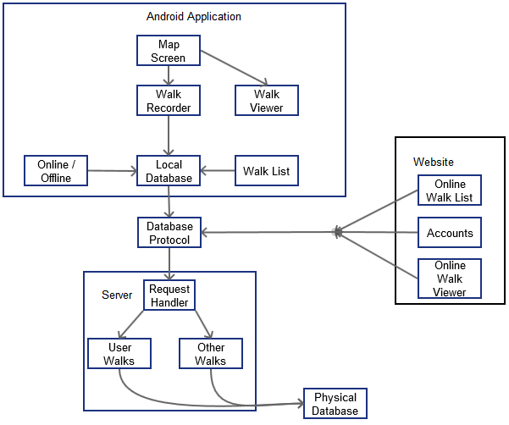

Android Application
This is the application. All modules here are running on the mobile device

Online Offline
This module handles the location where data is stored. If the user is connected to the internet, it makes sure any uploads can be tied to the user.

Walk List
This module handles the listing of walks from the local database. (See Fig. 4.3 & Fig. 4.4)

Map Screen
This module handles the displaying of all visual elements from the walk. (See Fig. 4.8)

Walk Recorder
This module handles the storage of points of interest, the time taken for a walk and the walks location during recording.

Walk Viewer
This module handles loading of walks from the local database and converting them back into a visual form

Local Database
This module stores all locally saved walks and maps cache. It handles the retrieval and uploading of walks to the server.

Database Protocol
This module handles the conversion of database request to their required language such as from POST to HTTP for the website.

Server
This is the server that handles all requests between the database, website and android application

Request Handler
This module deals with linking data between users

User Walks
This module handles the retrieval and editing of walks of the associated user

Other Walks
This module handles all walks not owned by the user

Physical Database
This is the machine where all request are handled

Website
This module serves as the control for everything on the website

Online Walk List
This module handles all lists being displayed to anyone on the website

Accounts
This module handles the retrieval and creation of accounts

Online Walk Viewer
This module handles the conversion of data into visual form for browser based viewing of walks

Use Case

Android
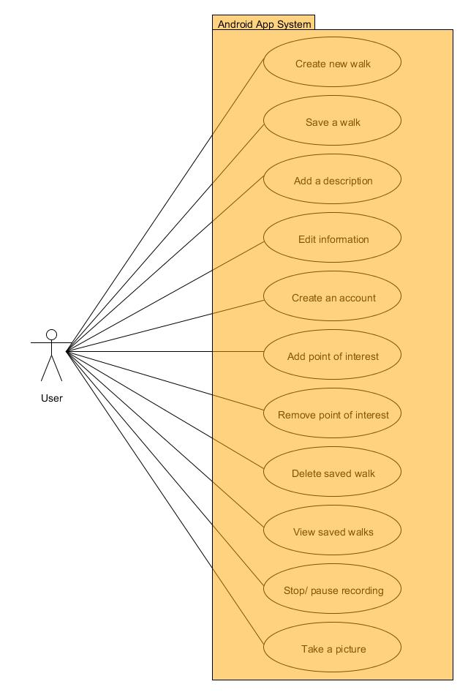

Website
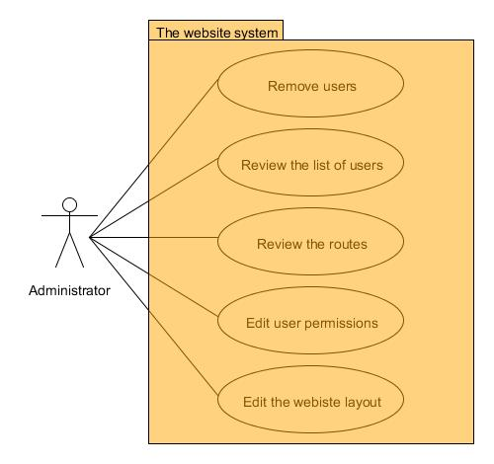

Database
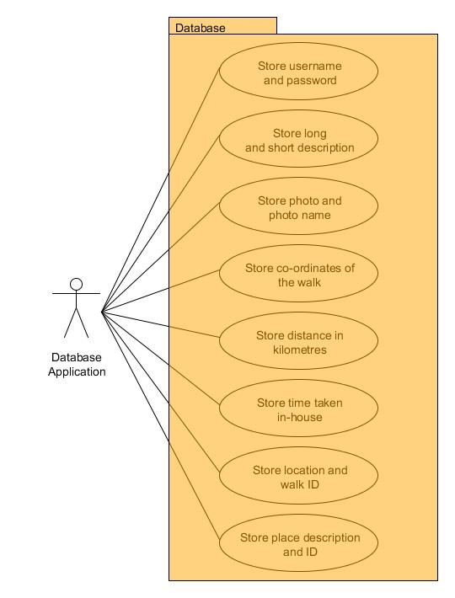

Interaction System
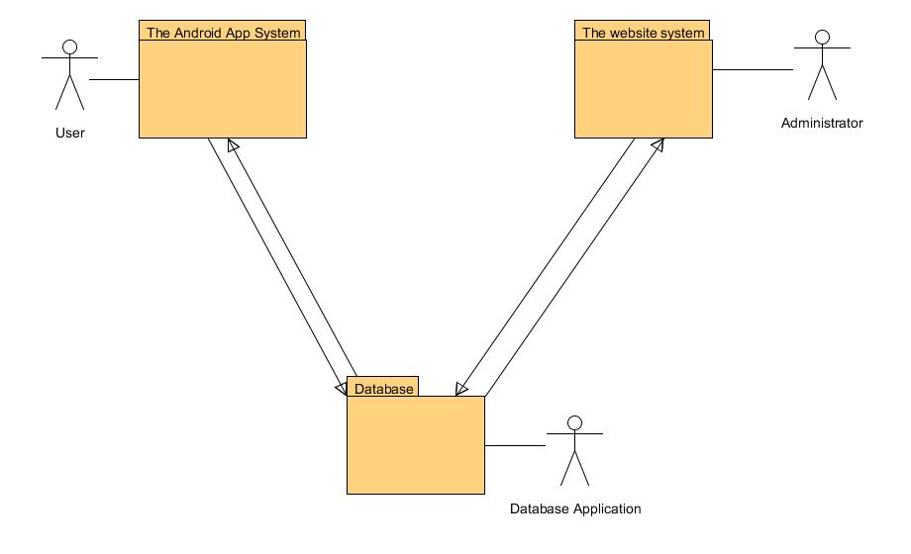

The diagram above represents the interaction of the whole system. The user interacts with both Android application and the website. The walks recorded by the user along with all the other information like description and the photos, are stored in the database and can be easily accessed later via the website or locally. Every action that creates or adds data is stored in the database.
The Android application downloads a list of walks from the server and uploads walks from the local database. The Android application does not have a direct link to the website. Registration is done via the browser and logging in sends a query the database. The two way interaction system is used to reflect this. The website and the database have a two way interaction to give the administrator access to the data stored and the changes made on the website have to be updated in the database. The website also pulls a list of walks from the database and uploads any changes back into the database.

Descriptions
Diagram Name | Use case name | Description
Android App Use Case | Create new walk | Allows the user to start recording a new walk
Android App Use Case | Save a walk | The user can save walks locally or upload them and save locally if they have internet access
Android App Use Case | Add a description | The user must add a short and long descriotion to describe the walk they are starting
Android App Use Case | Edit information | A menu with certain options (e.g. Filters) which makes reviewing more convenient
Android App Use Case | Create an account | The user will be able to create a new account via the website. Selecting register on the options screen of the application will open the mobile device browser redirecting them to the registration page on the website
Android App Use Case | Add point of interest | The user must add points of interest on the walk. This includes a short description, an optional long description and optional images. A timestamp is automatically taken when a point of interest is saved
Android App Use Case | Remove point of interest | The user will be able to remove points of interest via the swipe screen
Android App Use Case | Delete saved walk | Users can delete their walks. Deleting a walk on the mobile device only deletes it locally. Uploaded walks can only be deleted via the website
Android App Use Case | View saved walks | Views the list of locally saved walks or uploaded walks
Android App Use Case | Stop/ pause recording | Walk recording can be paused or stopped when necessary. Stopping a walk will prompt the user to save or upload it or return them to the main menu if there are no points of interest added.
Android App Use Case | Take a picture | The user can take a picture of a location and add it to the walk. Alternatively, they can add a picture from their photo library
Database Use Case | Store accounts and data | The accounts created by the user are stored in the database and all walks are associated with the database
Database Use Case | Store long and short description | If the user adds a description to the walk it is also saved in the database
Database Use Case | Store image | The pictures taken by the user are sent to the database
Website Use Case | Remove users | The administrator can remove accounts that violate the terms and conditions
Website Use Case | Review the list of users | The administrator can view all registered users. Useful to determine if a user has violated the terms of use.
Website Use Case | Review the walks | Uploaded walks can be reviewed by the administrator to ensure they do not violate the terms of service
Website Use Case | Edit user permissions | The administrator can add or remove permissions from the users
Website Use Case | Edit the website layout | The website layout can be changed if there is such a neccessity

Android User Interface design

Start Screen
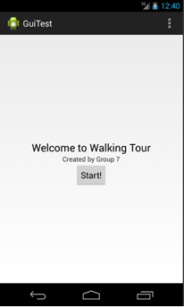

Displays only the program name, logo and group name. Tap to continue to main menu. This screen may be replaced with a tutorial or help screen on first launch.
NAVIGATION
Start → Main Menu (Fig. 4.2)

Main Menu
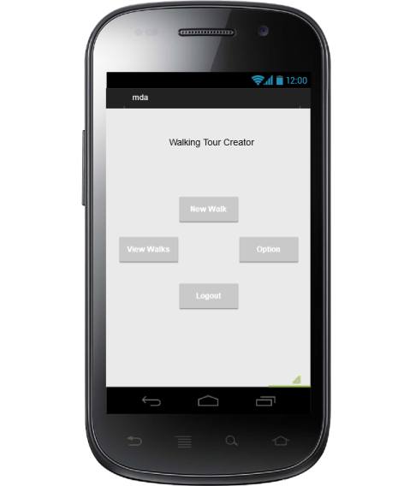

This screen is the main menu. It will allow users to view past walks, log-in or logout, view the options and start new walks. Users will be returned to this screen after exiting or completing a walk.
NAVIGATION
Start Walk → New Walk Screen (Fig. 4.4)
Sign in/Logout → Sign in screen / logout
View Walks → View Walks Screen (Fig. 4.3)
Options → Options Screen (Fig. 4.13)

View My Walks Screen
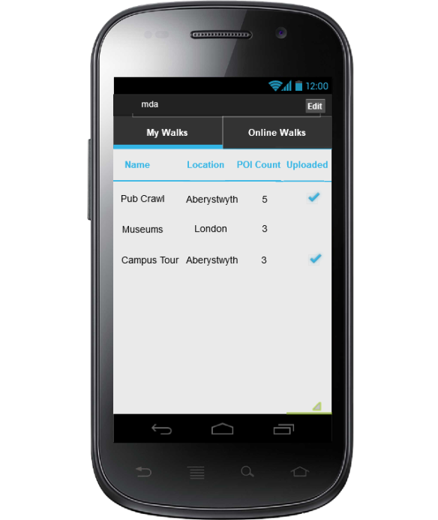

Above image is for viewing my walks. If a walk is selected, another screen opens with an image of the walk. If the walk is uploaded an upload option is available. Other options are load walk, delete walk and cancel. Tapping edit allows walks to be deleted. Deleting walks only occurs locally and not on the server
NAVIGATION
Back to main menu arrow → Main Menu (Fig. 4.2)
Online Walks → View Online Walks Screen (Fig. 4.4)
Select Walk → View My Walk Screen (Fig. 4.5)

View Online Walks Screen
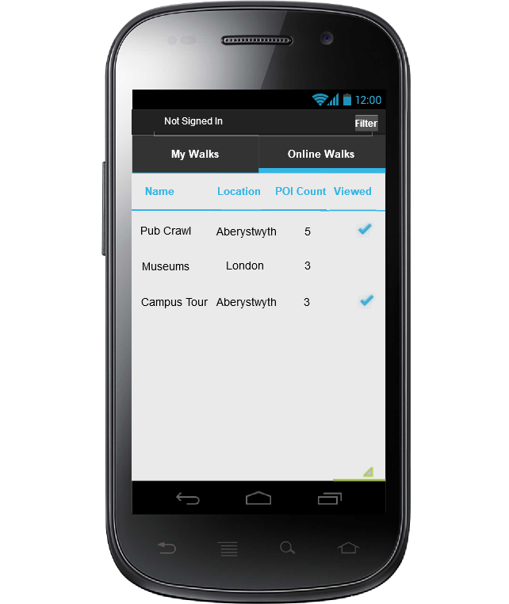

This screen displays the walks downloaded from the server. These walks can be downloaded from the server for use. Walks may be filtered in this screen based on location, number of points of interest and viewed.
NAVIGATION
Back to main menu arrow → Main Menu (Fig. 4.2)
My Walks → View My Walks Screen (Fig. 4.3)

View My Walk Screen
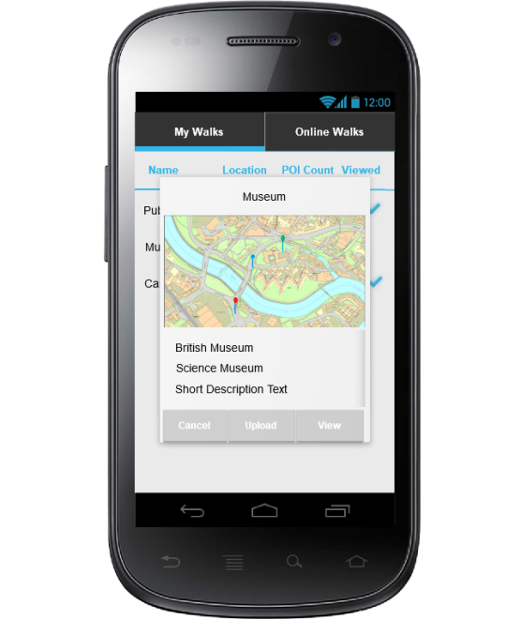

This screen displays a small scrollable list of all points of interest on of the selected walk and a small map of the areas covered by the walk. If they haven’t been uploaded, It walks can be uploaded via this screen. Walks can also be loaded from here.
NAVIGATION
Cancel → View My Walks Screen (Fig. 4.3)
Load → Recording Screen With Walk (Fig. 4.10)

View Online Walk Screen
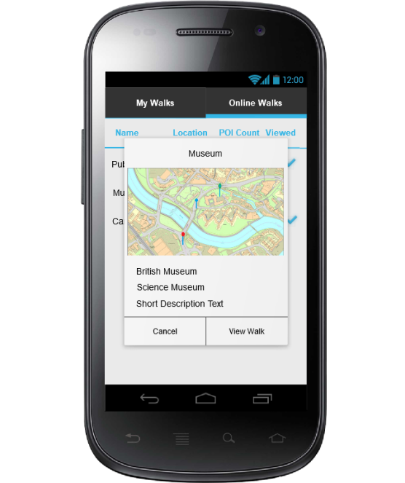

This screen is used to view other walks from the server. They can loaded from this screen. It displays a list of Points of Interest for the walk and a small map displaying points of interest from the walk
NAVIGATION
Cancel → View Online Walks Screen (Fig. 4.4)
Load → Recording Screen With Walk (Fig. 4.10)

New Walk Screen
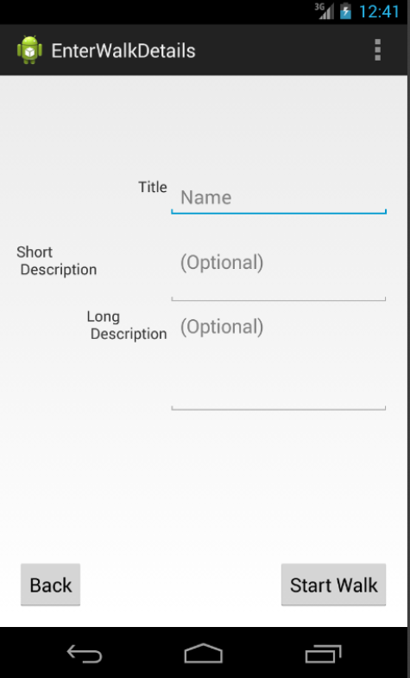

This is the walk creation screen. It allows a short and long description to be added to a walk.
NAVIGATION
Back → Main Menu (Fig. 4.2)
Start Walk → Recording Window (Fig. 4.4)

Recording Screen
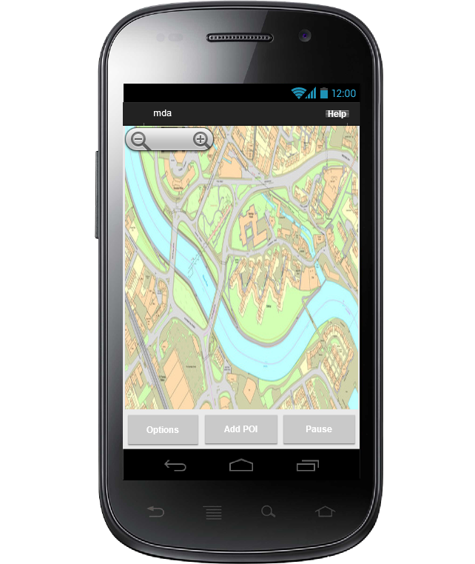

This screen only displays the map around the users’ current location. When a point of interest is added, it will be displayed as a pin on this screen. The options button will allow the user to sign in/logout. When viewing a walk, only the option button and the swipe menu will be available. Pinch zoom may be used instead of button zoom. If the user taps the pause button, the recording will pause. If the user taps it again, the recording will resume. Holding down the button will stop the recording and take the user to the walk complete screen. The options menu will allow the user to exit the walk without saving.
NAVIGATION
Option → Option Menu
Add Point of Interest → New Point of Interest Screen (Fig. 4.9)
Stop → Walk Complete (Fig. 4.12)
Swipe left across screen → Locations on Walk List (Fig. 4.11)

New Point of Interest
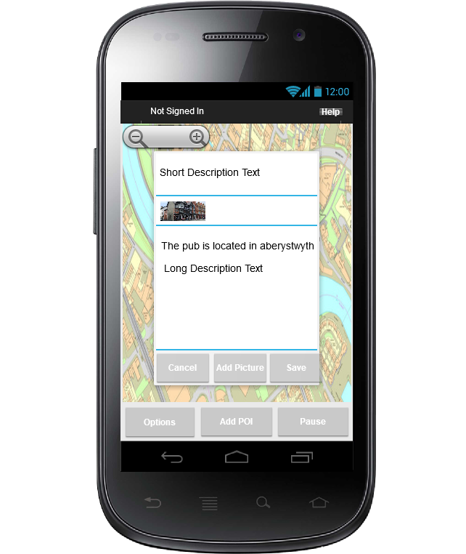

This screen is used to add a point of interest. It will appear semi-transparent over the map. Adding images will open a dialogue asking whether to go to the photo library or the camera app, allowing images to be added. Images will appear between the short and long description and can be removed from here. Pressing save stores the point of interest but can be removed later.
NAVIGATION
Cancel → Recording screen with walk (Fig. 4.10) or Recording screen (Fig. 4.9)
Add Image → Dialogue for Camera or Photo Library
Save → Recording screen with walk (Fig. 4.10) or Recording screen (Fig. 4.9)

Recording Screen With Walk
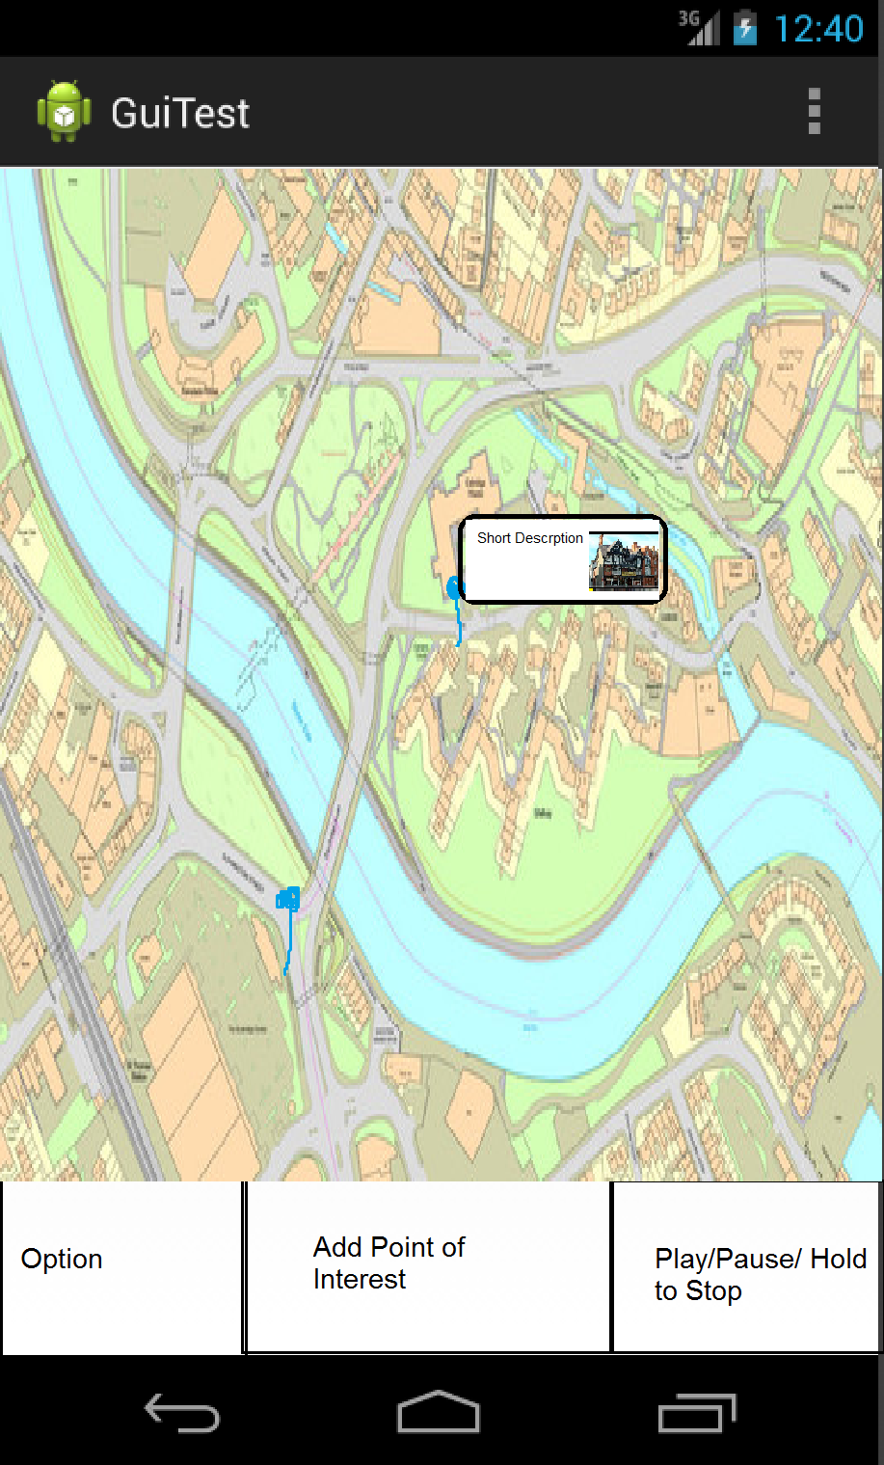

This screen is the default recording screen. All points of interest are noted as a pin on the screen. Tapping the pin displays the long and short description and any images of the point of interest. When a walk is stopped the user is prompted to save the walk. Only signed in users can upload a walk to the server. When viewing a walk, only the option button and the swipe menu will be available.
NAVIGATION
Option → Option Menu
Add Point of Interest → New Point of Interest Screen (Fig. 4.9)
Stop → Walk Complete (Fig. 4.12)
Swipe left across screen → Locations on Walk List (Fig. 4.11)

Locations on Walk List
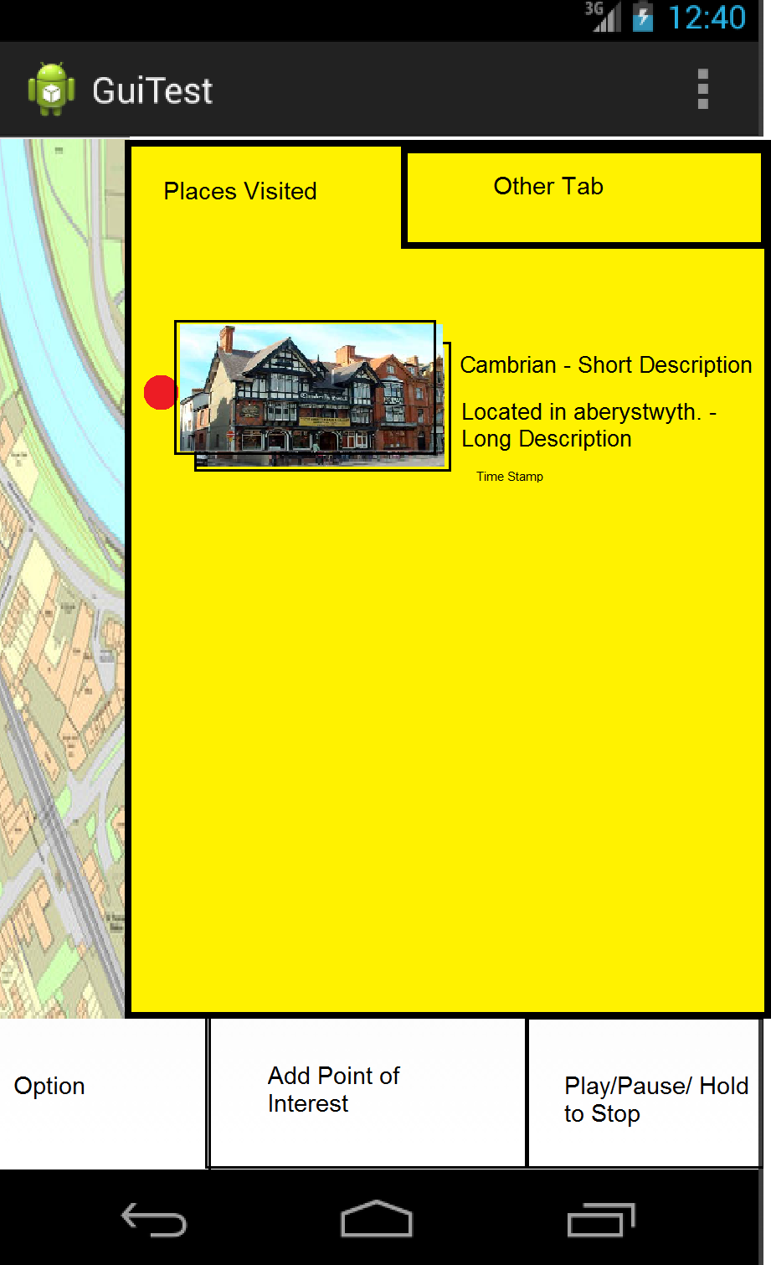

This screen can be accessed by swiping left across the screen. To hide the menu, the user swipes right. It displays a list of all points of interest added to a walk. Tapping an image cycles through all the list of images for a point of interest, bringing them to the top. Points of interest can be removed from a walk via this screen. The walks users can also edit the long and short descriptions on this screen. This screen will pause the recording while active.
NAVIGATION
Swipe right across screen → Recording Window (Fig. 4.5) or Recording Screen (Fig. 4.8)

Walk Complete
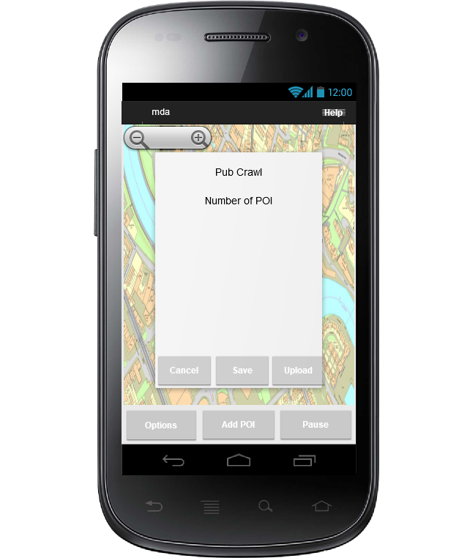

This screen allows the user to save a walk. If upload is pressed, the walk is saved then uploaded to the server provided the user is signed in. This screen should be unavailable if there are no points of interest to prevent uploading or saving an empty walk. This screen also shows the time taken to complete a walk, the name of the walk, the number of points of interest added and the location of the walk.
NAVIGATION
Cancel → Recording Screen with walk (Fig. 4.10)
Save → View My Walks Screen (Fig. 4.3)
Upload → View My Walks Screen (Fig. 4.3)

Options Screen
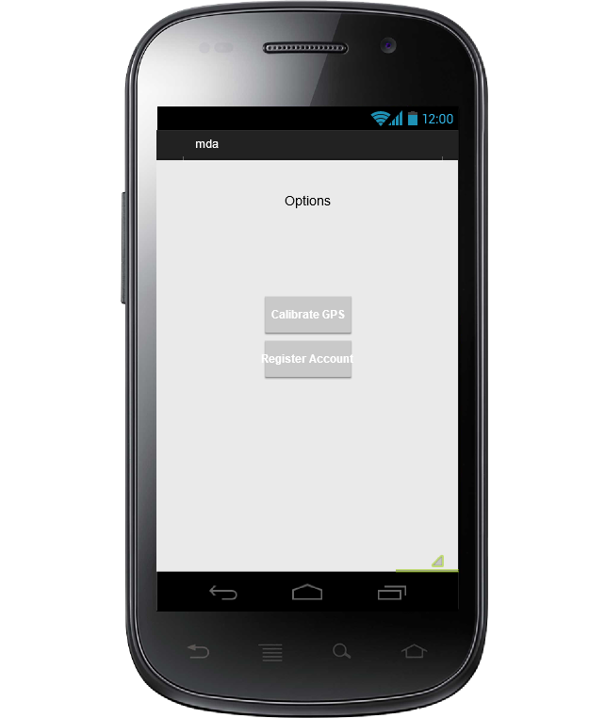

This screen is only accessible from the main menu. It allows the user to calibrate their compass and check the GPS is accurate. They can also register an account which will open the browser and redirect them to the website registrations screen.
NAVIGATION
Back to Main Menu → Main Menu (Fig. 4.2)
Register Account → Registration Page in phone browser (Fig. 5.4)
Calibrate GPS → GPS and Compass Calibration screen.

Website User Interface Design

Home Page
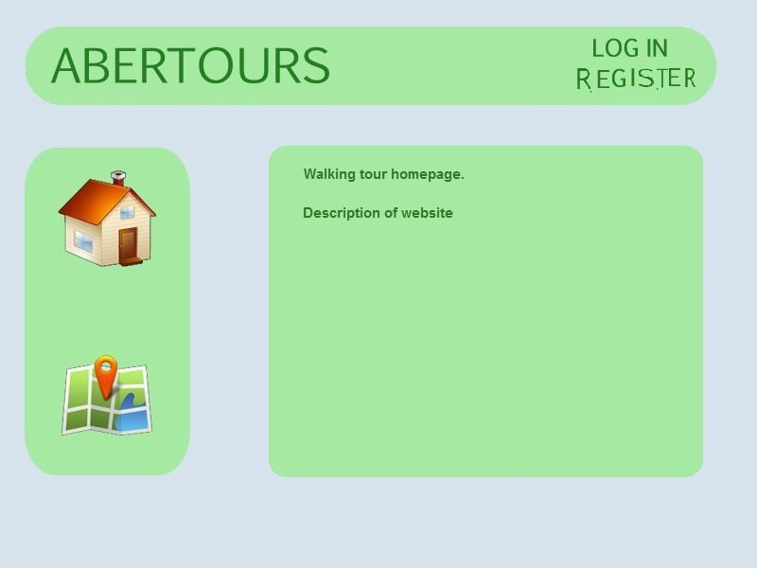

This is the homepage of the website. From here the user can find information about the application and a link to where the mobile application can be downloaded. They can also log-in or register via this page and can view walks.
NAVIGATION
Log-in → Log-in Page (Fig. 5.3)
Register → Registration Page (Fig. 5.4)
View Walks → View Walks Page (Fig. 5.2)

View Walks Page
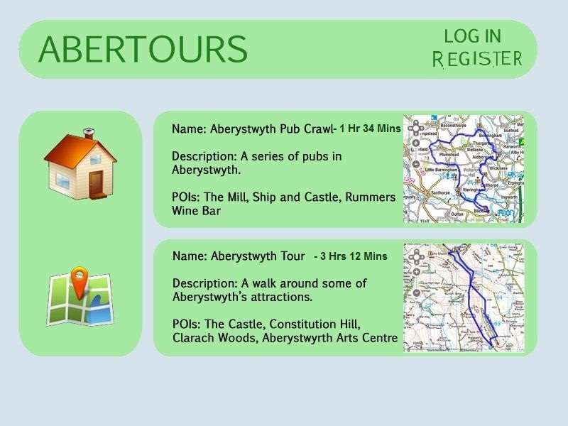

The user can view all uploaded walks via this screen. From here the user can see a small map overview of the walk and the short description of the points of interest. If the user is signed in, they can view their walks from this page.
NAVIGATION
Click on Walk → Walk Page (Fig. 5.6)
Log-in → Log-in Page (Fig. 5.3)
Register → Registration Page (Fig. 5.4)
View My Walks → View My Walks Page (Fig. 5.5)
Home → Home Page (Fig. 5.1)

Log-in Page
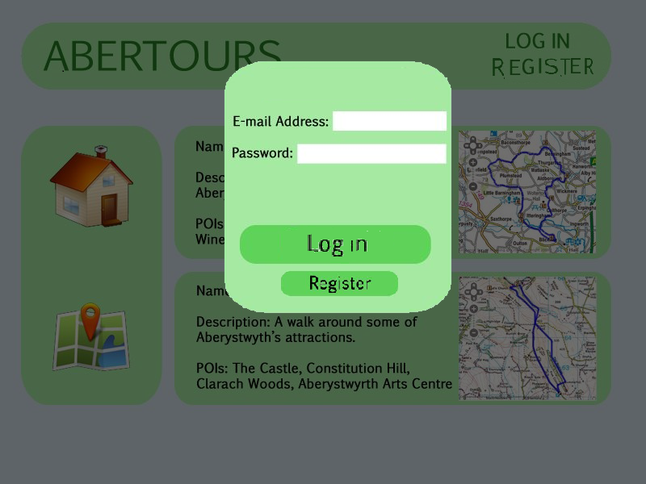

The user can log-in to their account via this page. Clicking the log-in button will refresh the current page. If the user doesn’t have an account, they can click register. Clicking outside the box will take them back without logging in.
NAVIGATION
Log-in → Previous Page
Register → Registration Page (Fig. 5.4)
Click Outside Box → Previous Page

Registration Page
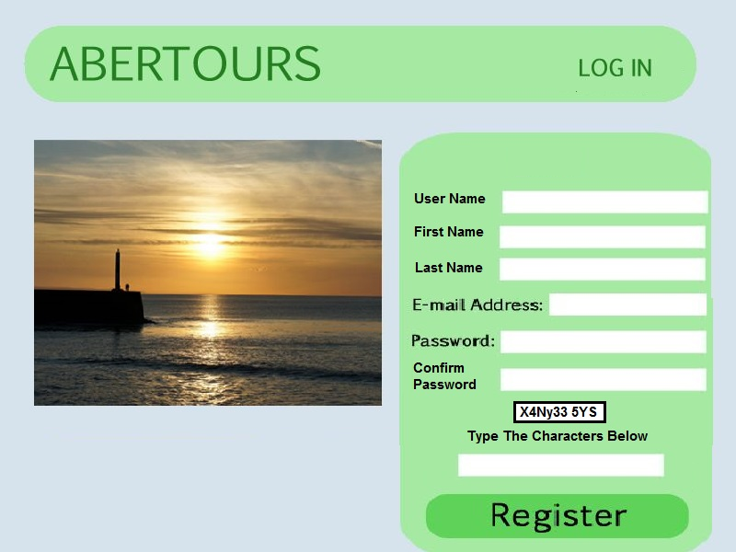

This page allows new users to create an account. Existing users may also click log-in via this page. New users must perform an authentication to prevent automated accounts being created.
NAVIGATION
Register → View Walks Page (Fig. 5.2)
Log-in → Log-in Page (Fig. 5.3)
Home → Home Page (Fig. 5.1)

View My Walks Page
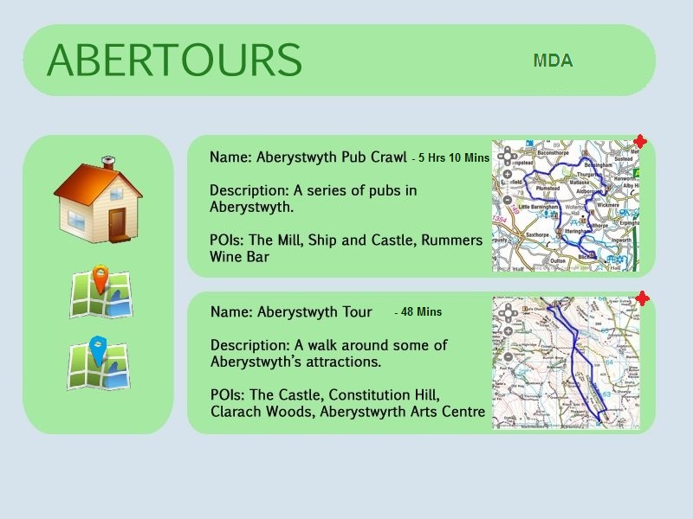

This page lets users view their uploaded walks. The user can delete their walk from this screen. They can also see the time taken to delete a walk. To sign out or access account settings, a menu will be available by clicking their username. Users can also view other walks separately.
NAVIGATION
Sign out → View Walks Page (Fig. 5.2)
Click on Walk → Walk Page (Fig. 5.6)
View Walks → View Walks Page (Fig. 5.2)
Home → Home Page (Fig. 5.1)

Walk Page
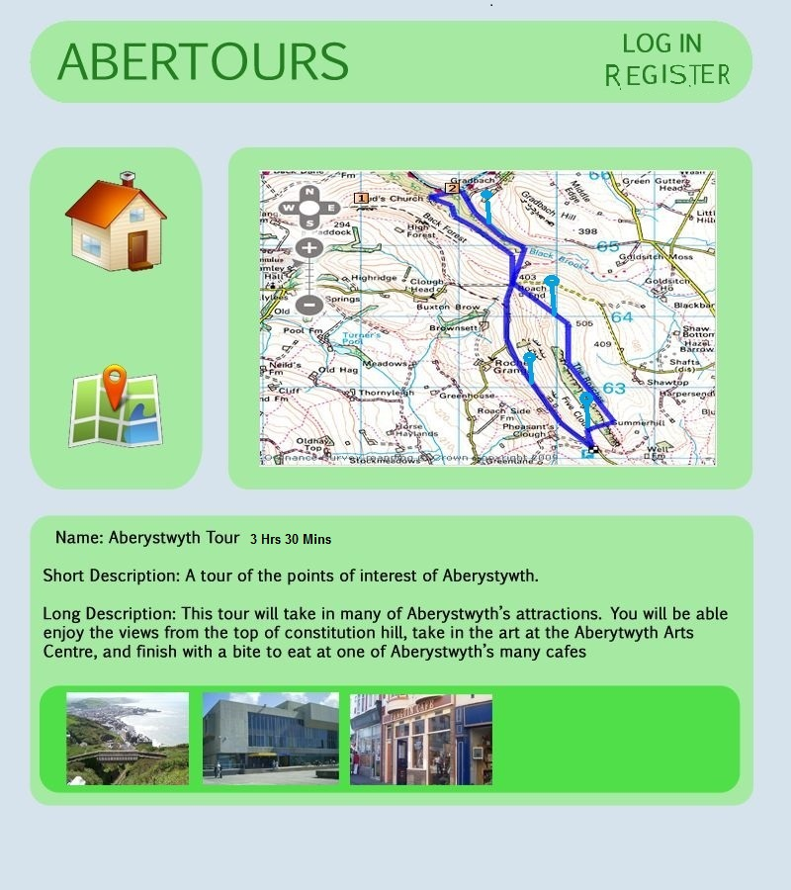

This page displays a map overview of the walk, the average time taken to complete the walk and the long and short descriptions. The first image from every point of interest is displayed at the bottom of the screen.
NAVIGATION
Click on Image → Point of Interest Image Page (Fig. 5.8)
Click Pin on Map → Point of Image Selected Page (Fig. 5.7)
Delete Walk (if owner) → View Walks Page (Fig. 5.2)
View Walks → View Walks Page (Fig. 5.2)
Register → Registration Page (Fig. 5.4)
Log-in → Log-in Page (Fig. 5.3)
Home → Home Page (Fig. 5.1)
Sign out (if logged in) → View Walks Page (Fig. 5.2)

Point of Interest Selected Page
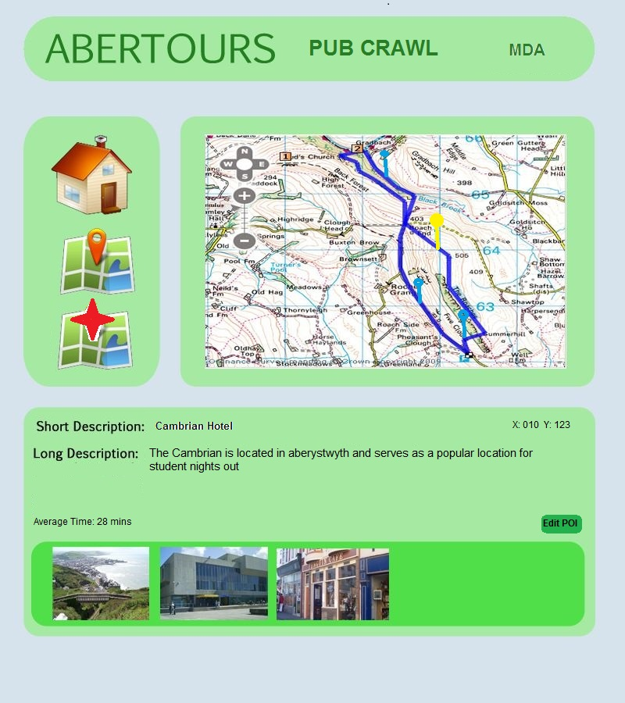

Clicking on a pin on the map opens this page. The selected pin is also highlighted. The page displays the average time taken from the start of the walk to arrive at this point of interest. If there are any images taken from this point of interest, the user is can view them. If the user owns this walk, they will be able to edit the descriptions and add more images. The latitude and longitude of this point of interest is also displayed opposite the short description.
NAVIGATION
Edit POI → Edit Point of Interest Page (Fig. 5.9)
Delete Walk (if owner) → View My Walks Page (Fig. 5.5)
Click on Image → Point of Interest Image Page (Fig. 5.8)
Click Pin on Map → Point of Image Selected Page (Fig. 5.7)
View Walks → View Walks Page (Fig. 5.2)
Register → Registration Page (Fig. 5.4)
Log-in → Log-in Page (Fig. 5.3)
Home → Home Page (Fig. 5.1)
Sign out (if logged in) → View Walks Page (Fig. 5.2)

Point of Interest Image Page
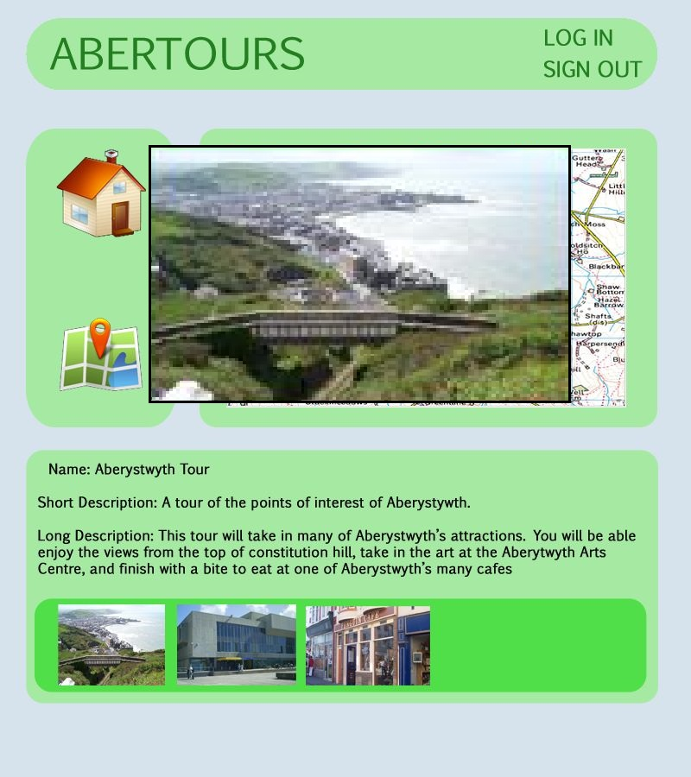

This simply enlarges the image clicked. Clicking outside the box minimizes the image back into the tray.
NAVIGATION
Click Outside Image → Previous Page

Edit Point of Interest Page
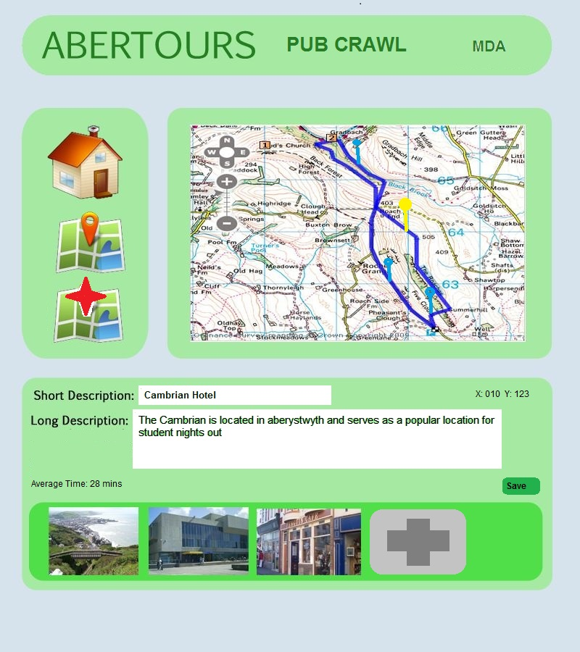

This page is only available if the user owns the walk. It allows users to add more images to the point of interest as well as edit the descriptions. Clicking anything other than save will undo any changes including image uploads.
NAVIGATION
Save → Walk Page (Fig. 5.6)
Delete Walk (if owner) → View My Walks Page (Fig. 5.5)
Click on Image → Point of Interest Image Page (Fig. 5.8)
Click Pin on Map → Point of Image Selected Page (Fig. 5.7)
View Walks → View Walks Page (Fig. 5.2)
Register → Registration Page (Fig. 5.4)
Log-in → Log-in Page (Fig. 5.3)
Home → Home Page (Fig. 5.1)
Sign out (if logged in) → View Walks Page (Fig. 5.2)

Navigation Overview

Android
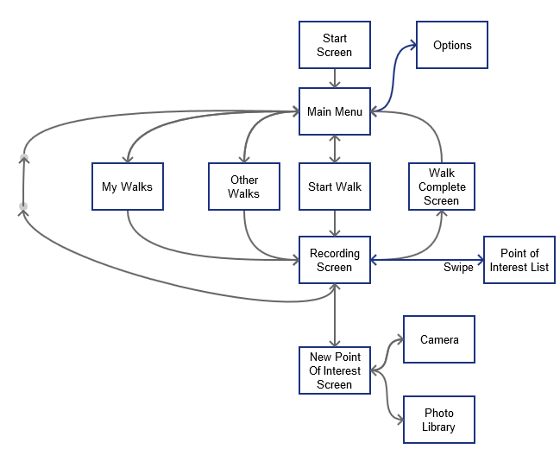
Start screen is the entry point. All navigation is done via buttons and icons unless otherwise stated

Website
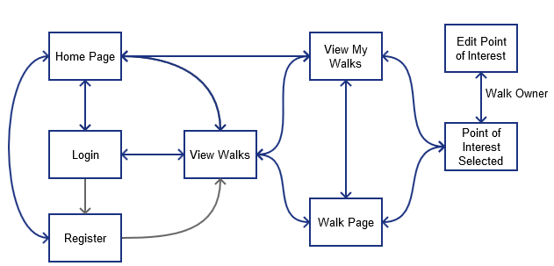

Home page is the entry point. All pages link back to the home page

Gantt Chart
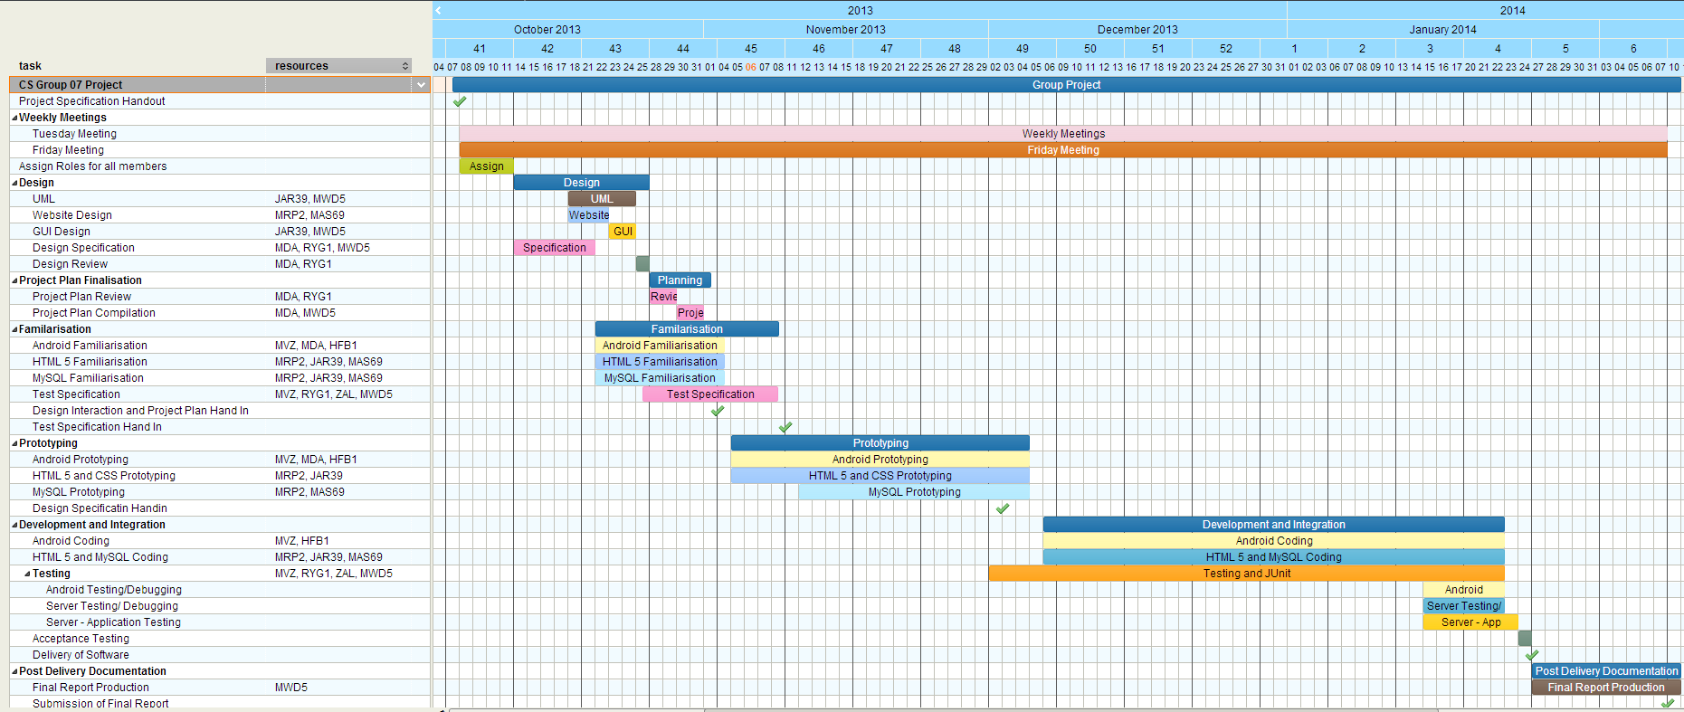

Risk Assessment
Event | Risk | Mitigation
Git Downtime | Low | All work should be backed up on multiple devices, preferably the University of Aberystwyth M: Drive and local backup locations.
Absence of Team Leader | Low | The deputy team leader will take up responsibilities as required.
QA Manager Absence | Low | Team leader or deputy team leader will take up responsibilities as required.
Poor Quality Work | Low | All work must be verified and monitored by both the QA Manager and the Team Leader. Deadlines for tasks are given before official deadlines to provide a window in which work is brought up to standard.
Problems with Maps API | Medium | In the event of inability to use the OpenSpace API, Google Maps API will be used due to its wide use.
Absence of Team Member | Medium | In the absence of any member, work will proceed as normal. All members should notify the group leader if they will be absent at the next meeting. Any absent member should read the minutes of the last meeting and any other documents produced. Continued unauthorized absence will result in warnings then penalties.
Project Off Schedule | Medium | Members are required to stick to the schedule and provide weekly reports on all project related tasks throughout the week. In the event of failure to stick to the schedule, tasks must be revised to bring project back on schedule.
Server Downtime | Medium | Website and server development should be done locally and added to the university server regularly. In the event of downtime, work should proceed as normal locally. A local LAMP or similar server may be used for testing
Unrequired Features | Medium | Extra features should not be a priority and should not be added unless the final product meets the required specification. A copy of the final product must be used for adding any extra features.
Lack of knowledge of platforms | Medium | In the event of any team member being unable to do work due to not knowing how to perform a task on the platform, the team leader must be notified. Any members capable who know how to proceed will be assigned to performing that task. All members are required to gain as much knowledge about the API and languages during the familiarisation stage.
Member Unable to Continue Project | High | If for any reason a member is unable to continue the project, tasks will be reshuffled to accommodate the change. Multiple members are assigned similar tasks to help reduce the risk in such an event.
Loss of Data | High | Users are required to regularly backup data. If for any reason data is not backed up and is lost, the group leader must be notified immediately and more work must be done to bring the project back on schedule. Tasks may be reprioritised to ensure deadlines are met.
Change in Requirements | High | If requirements are changed by the client, a meeting will be called immediately to meet the new requirements. Regular communication between the client and the team leader is required.
Hardware Incompatibility | High | The application must be thoroughly tested on at least 2 android mobile devices. Tablet compatibility is not required. In the event of hardware incompatibility or related issues, extensive debugging and testing must be done and the team leader must be notified immediately.
Application – Server Incompatibility | High | The application should send data in the format specified. The server must be able to parse the data accurately. In the event of incompatibility, android and server side debugging must be done to determine the cause of the incompatibility.

Document History

Version | CCF No. | Date | Section Changes From Previous Version | Changed By
1.0 | N/A | 28/10/13 | Original draft of document written by Mosopefoluwa David Adejumo | MDA
1.1 | N/A | 31/10/13 | Added new screens. Updated project overview | MDA
1.2 | N/A | 31/10/13 | Updated Android user interface | MDA
1.3 | N/A | 2/11/13 | Updated Android user interface and description.  Added Website User Interface Description  Added Gantt chart. Added Navigation overview  Updated risk assessment | MDA
1.4 | N/A | 2/11/13 | Added use case and descriptions. Added system overview. Updated project overview | MDA
1.5 | N/A | 2/11/13 | Updated system overview. Updated use case. Updated UI descriptions | MDA
1.6 | N/A | 3/11/13 | Updated Fig. 5.3 and Fig 5.4 images. Added interaction system diagram and description.  Moved risk assessment to item 8 | MDA
1.7 | N/A | 4/11/13 | Updated Interaction System and replaced image. Corrected config ref number | MDA
1.8 | N/A | 6/11/13 | Updated Gantt chart. | MDA

