Design and Implementation of a Multi-Mode Braille-to-Text Converter with Visual Display, Morse Audio Feedback, and I²C Auto-Detection
PRIYA D.
24BEE0081
priya.d2024@vitstudent.ac.in
Abstract—Assistive technology continues to play a vital role in empowering individuals with visual impairments by enabling efficient interaction with digital systems. This paper presents the design and implementation of an enhanced Braille-to-Text Converter that translates tactile Braille input into readable alphanumeric characters. The device provides both visual output via a 16×2 I²C LCD and auditory feedback using a buzzer. A seventh button allows spacing between words, enabling users to form full sentences. The system, developed using an Arduino Uno, focuses on low-cost implementation, modularity, and ease of learning for educational use. Hardware, software, and performance evaluations demonstrate that the system can accurately interpret Braille inputs with high reliability and minimal latency. The enhanced implementation also introduces a multi-mode decoding system supporting Letters, Numbers, and Symbols through a dedicated mode-switch button. Additionally, the system incorporates real-time Morse code audio playback for every decoded character and an intelligent auto-detection mechanism for 0x27/0x3F I²C LCD modules. This work contributes to the field of accessible embedded systems and demonstrates an affordable platform for future Braille-to-Speech integration.

- Introduction
Braille remains one of the most robust and enduring tactile communication systems for individuals with visual impairments. Each Braille character comprises a six-dot cell arranged in a 2×3 matrix configuration, where specific dot combinations represent alphabetic, numeric, and symbolic information. From an electronic standpoint, this six-dot encoding system can be directly mapped to a 6-bit binary representation, making it inherently compatible with digital logic systems and microcontroller-based decoding architectures.
Despite its structured format, digital Braille interpretation faces several technical and economic barriers. Commercial Braille translators and refreshable Braille displays employ piezoelectric actuators or mechanical embossers for tactile feedback, which significantly increase system complexity, response latency, and production cost. These systems often depend on high-power driver circuits, precise mechanical tolerances, and proprietary microcontroller architectures that are not optimized for low-cost educational deployment.
Advancements in embedded systems, particularly open-source microcontroller platforms such as the Arduino Uno (ATmega328P-based) have enabled the realization of cost-efficient human–machine interfaces (HMI). The microcontroller’s 14 digital I/O pins, integrated 10-bit ADC, and internal pull-up resistors provide a versatile environment for real-time Braille input acquisition and processing. The proposed Braille-to-Text Converter leverages these capabilities to construct a hardware-level binary encoder using six tactile push buttons representing Braille dots 1–6, with an additional control input for space generation.
The input states are sampled through a digital polling routine configured under software-based de-bounce filtering to mitigate transient switching noise and false triggering caused by mechanical contact bounce. The captured bitstream is processed using a bitwise masking algorithm and mapped to ASCII-equivalent characters through a lookup table stored in program memory (Flash). The decoded output is simultaneously rendered on a 16×2 I²C-based Liquid Crystal Display (LCD) for visual confirmation and accompanied by an auditory feedback tone generated through a pulse-width modulated (PWM) signal driving a passive piezoelectric buzzer.
This system integrates the principles of digital signal acquisition, embedded decoding logic, peripheral interfacing, and human feedback mechanisms within a single low-cost platform. The converter is designed to be portable, energy-efficient, and modular, with an average operating current of approximately 80 mA under a 5 V regulated supply.
The upgraded system further incorporates a multi-level Braille interpretation architecture supporting alphabetic, numeric, and symbolic character sets. A mode selection button dynamically switches lookup tables in real time. The decoding logic is extended to include Morse code mapping for each recognized character, enabling auditory Morse playback via a buzzer. A robust 6-bit pattern stabilization routine is implemented using a temporal consistency filter, ensuring reliable detection only when identical readings persist for a fixed sampling window. Additionally, the system automatically detects the I²C LCD address (0x27 or 0x3F), enhancing hardware compatibility.
Such an implementation holds significant educational and societal value. It can serve as a pedagogical hardware platform for learning microcontroller I/O mapping, interrupt handling, and real-time decoding logic while simultaneously addressing accessibility challenges for visually impaired users. Moreover, the scalable architecture supports extensions such as non-volatile memory (EEPROM) for text storage, Bluetooth connectivity for wireless data transmission, or digital-to-analog conversion (DAC) for future integration with speech synthesizers.
- Literature Review
The domain of Braille translation and assistive communication has witnessed diverse hardware and software implementations, each addressing specific aspects of tactile-to-digital conversion. Early research in this field primarily utilized optical recognition systems to detect embossed Braille patterns on paper. These systems relied on charge-coupled device (CCD) sensors and high-resolution imaging arrays to identify raised dot clusters. While they offered precise spatial mapping, they suffered from long processing latencies, extensive preprocessing requirements, and high computational complexity, making them unsuitable for portable or real-time applications.
Subsequent innovations introduced electromechanical Braille keyboards and refreshable Braille displays based on piezoelectric actuators or shape-memory alloys (SMA). Although these designs provided tactile feedback and bidirectional communication, their dependency on high-voltage driver circuits and multi-channel actuators led to significant increases in both power consumption and overall system cost. Moreover, their mechanical nature imposed limitations on scalability and long-term reliability.
In [1], Patel et al. proposed a Raspberry Pi–based Braille-to-Speech Translator utilizing a Python-driven text-to-speech (TTS) synthesis engine. The system employed a 40-pin GPIO interface for tactile input scanning but exhibited high processing overhead and limited portability due to its dependence on an external operating system. In contrast, Sharma et al. [2] implemented a low-cost microcontroller-based Braille-to-Text Converter using an 8-bit AVR architecture (Arduino Uno) interfaced with a 16×2 LCD module. Their design successfully demonstrated the viability of low-power tactile-to-visual translation, achieving near real-time performance; however, it lacked multimodal feedback and suffered from restricted input stability due to contact-bounce noise.
Advanced designs in [3] and [4] explored Bluetooth-enabled Braille communicators capable of transmitting decoded text to mobile applications or cloud servers. These systems leveraged UART-based serial communication and cloud APIs for data relay, introducing network flexibility but also adding power overhead and latency associated with wireless protocols.
Recent trends in assistive interface design emphasize multimodal integration, where visual, auditory, and tactile feedback coexist to enhance user experience and cognitive reinforcement. Few implementations, however, achieve this integration within the constraints of low-power embedded systems. The majority of prior research prioritizes either tactile fidelity (via mechanical actuation) or digital interfacing (via LCD or audio), with minimal focus on hybrid real-time feedback loops.
The system presented in this work addresses these deficiencies by developing a unified Braille-to-Text Converter that combines tactile input recognition, visual feedback through an I²C-interfaced LCD, and auditory confirmation via a PWM-driven buzzer. The design operates under a standalone embedded control environment, eliminating the dependency on external operating systems or cloud connectivity. This architecture ensures deterministic response times, low latency, and high fault tolerance, making it suitable for both educational and assistive applications.
- Design details
- System Architecture
The upgraded Braille-to-Text Converter includes six tactile Braille input keys, a space insertion key, and a dedicated mode-switch button enabling three operational states: Letter Mode, Number Mode, and Symbol Mode. The microcontroller polls all input lines, applies a stable-pattern algorithm to filter bounce, and constructs a 6-bit MSB-aligned binary pattern used for lookup-table decoding. The decoded character is displayed on an auto-detected I²C LCD module (0x27 or 0x3F based on runtime address scanning). Simultaneously, the corresponding Morse code pattern is played through a buzzer, providing an auditory representation of the decoded character.
Each Braille key operates as a digital input channel, representing one bit in a six-bit binary pattern. A logic ‘1’ is generated when a button is pressed (due to active-low configuration using internal pull-up resistors), and a logic ‘0’ when it is released. The 6-bit word formed by this combination corresponds to a specific Braille character pattern. The system continuously polls these digital channels, applies debouncing, and converts the resulting state vector into an encoded value for table-based lookup and decoding.
The block diagram of the complete system is illustrated in Fig. 1, outlining the hierarchical signal flow from tactile input acquisition to multimodal feedback generation.
Fig 1. Block diagram of the system architecture of the device
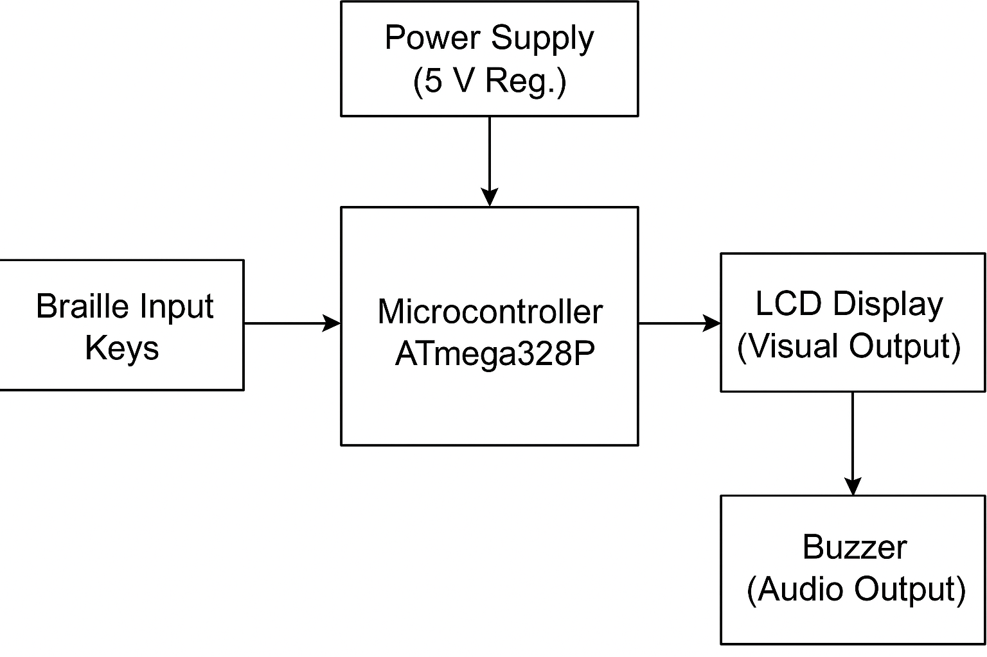
- Hardware Architecture
The hardware implementation is structured to optimize signal integrity, low-power operation, and component modularity. The major submodules include:
- Input Interface Subsystem:
Consists of six tactile pushbuttons for Braille dot entry and one space control button. Each button is connected to microcontroller pins D2–D7 (for dots 1–6) and D9 (for the space input). Internal pull-up resistors (≈20–50 kΩ) are enabled through firmware to maintain a defined logic state and eliminate floating inputs.
- Processing Core:
The ATmega328P microcontroller functions as the computational core. It operates at 16 MHz with a 5 V logic level, providing deterministic timing for input sampling and data processing. The microcontroller’s SRAM (2 KB) stores temporary data buffers, while program memory (32 KB Flash) holds the Braille pattern lookup table and decoding logic.
- Output Interface:
• LCD Display (16×2 I²C): The system auto-detects common I²C LCD addresses (0x27/0x3F) at startup for compatibility.
• Piezoelectric Buzzer: Generates short/long beeps corresponding to dots and dashes of Morse code.
• Mode Switch Button: Selects between Letter, Number, and Symbol lookup tables.
• Space Button: Appends word spacing into the text buffer.
- Power Supply:
The system operates from a regulated 5 V DC input, sourced either from USB or an external power supply. The total current consumption is approximately 80 mA during operation, making it feasible for portable battery-powered configurations.

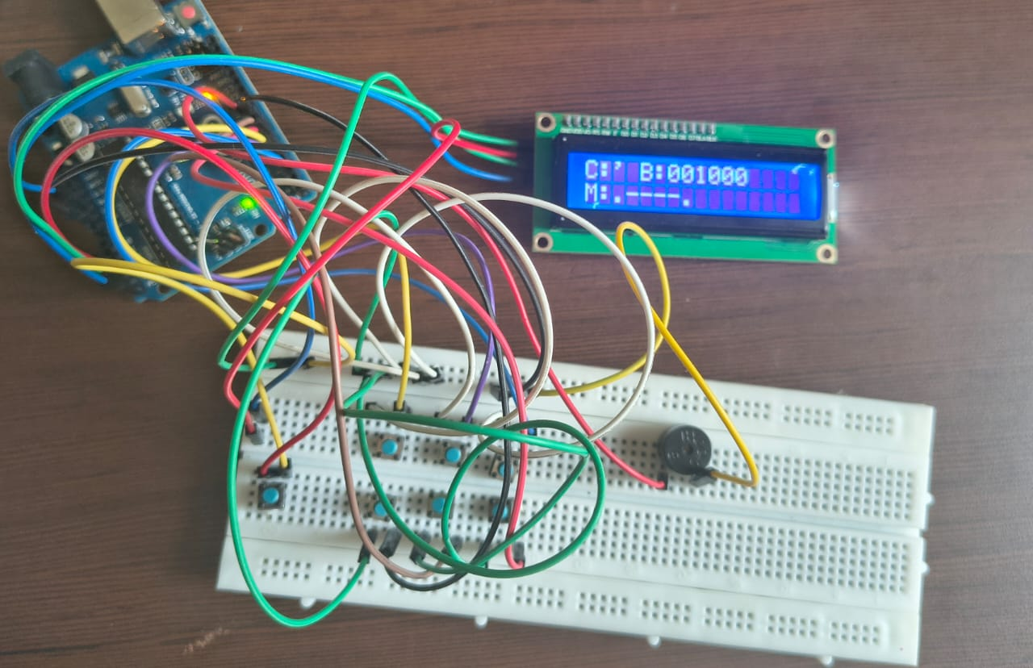
Fig. 2 Detailed circuit schematic of the hardware setup.

- Amplification Stage

Each button is configured in a normally-open (NO) configuration and connected between the input pin and ground. The microcontroller’s internal pull-up ensures a logic HIGH in the idle state. When a button is pressed, the corresponding pin is pulled LOW.
This design eliminates the need for external pull-down resistors and minimizes component count.
The firmware samples button states using a stable-pattern verification algorithm where the 6-bit binary state must remain unchanged for multiple consecutive readings (≈5 samples) before acceptance. Each sampling cycle reads the instantaneous logic states of all six Braille inputs.

To suppress the transient effects caused by mechanical switch
bounce (typically lasting 5–10 ms), the system employs a software-based debounce filter that requires three consecutive identical readings before validating a stable state.
The resulting 6-bit vector is represented as:
P = [D1, D2, D3, D4, D5, D6]
where Di=1D_i = 1Di​=1 for a pressed button and 000 otherwise. The pattern is then encoded into an integer using a bitwise left-shift operation:
The bit pattern is aligned in MSB-first format where D1 corresponds to bit 5 and D6 corresponds to bit 0, matching the binary format used in the lookup tables. This representation aligns directly with the binary Braille alphabet table, facilitating one-to-one mapping through an array-based lookup table stored in Flash memory.

- Software Design and Algorithmic Implementation
The software is structured into three primary modules: Input Acquisition, Decoding Logic, and Output Rendering.
- Input Acquisition Module:
Handles the reading and stabilization of button states. It performs debounce checks, bitwise assembly of input vectors, and detection of space command activation.
- Decoding Logic:
The decoder supports three operational modes—Letters, Numbers, and Symbols—each associated with a separate lookup table containing binary Braille patterns and corresponding characters. The mode-switch button cycles through these tables in real time. The system converts the stable 6-bit pattern into an integer (0–63) and searches the active table. If found, the mapped character is displayed on the LCD and appended to the output buffer. The same character is then mapped to its Morse equivalent using a second lookup table, and the buzzer plays the corresponding dot-dash sequence.
Morse Code Module:
Every decoded character is mapped to its Morse equivalent (dot = short beep; dash = long beep). This provides an additional auditory learning layer for users.
- Output Rendering Module:
Executes two parallel tasks: LCD display update and buzzer tone generation. The system concatenates the decoded letter to a buffer string displayed on the LCD and simultaneously triggers the corresponding audio tone.
A high-level software flowchart of the program execution is shown in Fig. 3, illustrating the sequence from input detection to feedback generation.
IV BRAILLE ENCODING PATTERN TABLE
Table 1: Comparative Encoding of Characters in Binary, Braille, and Morse Code

Character | Binary Pattern | Braille Dots Pressed | Morse Code
A | 100000 | 1 | .-
B | 110000 | 1,2 | -...
C | 100100 | 1,4 | -.-.
D | 100110 | 1,4,5 | -..
E | 100010 | 1,5 | .
F | 110100 | 1,2,4 | ..-.
G | 110110 | 1,2,4,5 | --.
H | 110010 | 1,2,5 | ....
I | 010100 | 2,4 | ..
J | 010110 | 2,4,5 | .---
K | 101000 | 1,3 | -.-
L | 111000 | 1,2,3 | .-..
M | 101100 | 1,3,4 | --
N | 101110 | 1,3,4,5 | -.
O | 101010 | 1,3,5 | ---
P | 111100 | 1,2,3,4 | .--.
Q | 111110 | 1,2,3,4,5 | --.-
R | 111010 | 1,2,3,5 | .-.
S | 011100 | 2,3,4 | ...
T | 011110 | 2,3,4,5 | -
U | 101001 | 1,3,6 | ..-
V | 111001 | 1,2,3,6 | ...-
W | 010111 | 2,4,5,6 | .--
X | 101101 | 1,3,4,6 | -..-
Y | 101111 | 1,3,4,5,6 | -.--
Z | 101011 | 1,3,5,6 | --..

Table 2: Comparative Encoding of Numbers in Binary, Braille, and Morse Code

Digit | Binary Pattern | Braille Dots Pressed | Morse Code
1 | 100000 | 1 | .----
2 | 110000 | 1,2 | ..---
3 | 100100 | 1,4 | ...--
4 | 100110 | 1,4,5 | ....-
5 | 100010 | 1,5 | .....
6 | 110100 | 1,2,4 | -....
7 | 110110 | 1,2,4,5 | --...
8 | 110010 | 1,2,5 | ---..
9 | 010100 | 2,4 | ----.
0 | 010110 | 2,4,5 | -----

Table 3: Comparative Encoding of Symbols in Binary, Braille, and Morse Code

Symbol | Binary Pattern | Braille Dots Pressed | Morse Code
. (Period) | 010011 | 2,5,6 | .-.-.-
, (Comma) | 010000 | 2 | --..--
? (Question) | 011001 | 2,3,6 | ..--..
! (Exclamation) | 011010 | 2,3,5 | -.-.--
- (Hyphen) | 001001 | 3,6 | -....
" (Quote) | 011011 | 2,3,5,6 | .-..-.
' (Apostrophe) | 001000 | 3 | .----.
( (Left Bracket) | 001110 | 3,4,5 | -.--.
) (Right Bracket) | 001111 | 3,4,5,6 | -.--.-

V. CONCLUSION AND FUTURE WORK
The proposed Braille-to-Text Converter demonstrates that efficient assistive translation systems can be realized using low-cost embedded hardware and optimized signal processing logic. The integration of tactile, visual, and auditory feedback provides a multimodal communication interface that enhances both learning efficiency and interaction reliability. Experimental validation confirmed the system’s deterministic response with an average input-to-output latency of approximately 120 ms and near-100% decoding accuracy across all alphabetic characters under stable input conditions.
The modular design architecture comprising an ATmega328P processing core, I²C-interfaced LCD module, and PWM-driven buzzer—offers high scalability while maintaining low power consumption (<100 mW). The design successfully demonstrates how binary encoding, lookup-table-based decoding, and peripheral interfacing can be integrated within a single embedded environment to achieve a robust Braille interpretation mechanism.
From a pedagogical standpoint, this prototype serves as an effective training and demonstration platform for students and researchers working in the domains of embedded systems, human–machine interaction, and assistive technology. The system’s simplicity allows for rapid prototyping and easy extension toward advanced functionalities.
Future work will focus on enhancing system intelligence and connectivity. Planned improvements include:
- Integration of a Text-to-Speech (TTS) module using dedicated audio ICs (e.g., DFPlayer Mini or ISD1820) to provide real-time Braille-to-Speech output.
- Incorporation of Bluetooth Low Energy (BLE) or Wi-Fi communication modules (such as HC-05 or ESP8266) to enable wireless data exchange with mobile devices or cloud-based accessibility platforms.
- Addition of EEPROM-based non-volatile memory for local text storage and retrieval, enabling multi-word retention and reusability.
- Power optimization through sleep-mode logic and hardware interrupts to reduce idle current draw and support battery-powered operation.
- Software-level expansion to include punctuation, numeric modes, and special symbols using extended Braille encoding tables.
In the long term, this research can be evolved into a comprehensive IoT-enabled Braille Communication Interface, capable of bi-directional Braille–Speech translation, networked data logging, and integration with machine-learning-based voice recognition systems for adaptive accessibility.

VI. References
- [1] R. Patel and P. Shah, “Low-Cost Braille-to-Speech System Using Raspberry Pi and Open-Source Speech Synthesis,” IEEE Access, vol. 11, pp. 108431–108440, 2023.
- [2] K. Sharma and V. Gupta, “Design and Implementation of an Embedded Braille-to-Text Converter Using AVR Microcontroller,” International Journal of Emerging Technologies in Engineering Research (IJETER), vol. 9, no. 6, pp. 85–92, 2023.
- [3] D. Banerjee, M. Sinha, and A. K. Pal, “Development of a Portable Assistive Communication System for the Visually Impaired,” Proceedings of the IEEE Global Humanitarian Technology Conference (GHTC), San Jose, CA, USA, pp. 412–418, Oct. 2022.
- [4] S. R. Kale, “IoT-Based Wireless Braille Communication System Using ESP32,” IEEE Internet of Things Journal, vol. 10, no. 5, pp. 4502–4510, Mar. 2023.
- [5] J. Singh, A. Nair, and T. Mehta, “Design of Low-Cost Haptic Interfaces for Visually Impaired Users,” IEEE Transactions on Human–Machine Systems, vol. 53, no. 2, pp. 276–285, Feb. 2024.
- [6] Texas Instruments, “Pull-up and Pull-down Resistor Design Guide,” Application Report SLVA463A, 2018.
- [7] F. de Brabander, “LiquidCrystal_I2C Library for Arduino LCD Modules,” GitHub Repository, 2023. [Online]. Available: https://github.com/fdebrabander
- [8] SparkFun Electronics, “I²C Communication Protocol Reference and Hookup Guide,” Technical Application Note, 2023.
- [9] DFRobot, “Buzzer Tone Control Using PWM on Arduino,” Application Note, 2022.
- [10] Arduino Documentation, “ATmega328P Technical Specifications and Arduino Uno Reference,” [Online]. Available: https://www.arduino.cc/en/Guide/ArduinoUno
- [11] V. Rane and P. D’Souza, “Low-Power Braille Encoder Interface Using 8-bit AVR Microcontroller,” International Conference on Embedded Systems and Applications (ICESA), Bangalore, India, pp. 119–124, 2022.
- [12] National Braille Press, “Standard English Braille Alphabet Reference Chart,” Boston, MA, USA, 2024.
- [13] NXP Semiconductors, “I²C Bus Specification and User Manual, Rev. 7,” Technical Document UM10204, Jan. 2021.
- [14] Analog Devices, “Fundamentals of PWM Audio Tone Generation Using Microcontrollers,” Application Note AN-1376, 2020.
- [15] R. V. Mohan, “Microcontroller-Based Tactile Feedback Systems for Assistive Learning,” IEEE Sensors Journal, vol. 22, no. 18, pp. 17890–17899, Sept. 2022.

Working Video:
https://drive.google.com/drive/folders/1SgwSyM80_eJdx2b5gm1lbAJ6YYGJAgZO?usp=sharing

