HARDWARE TASK:
PCB Designing
Block diagram
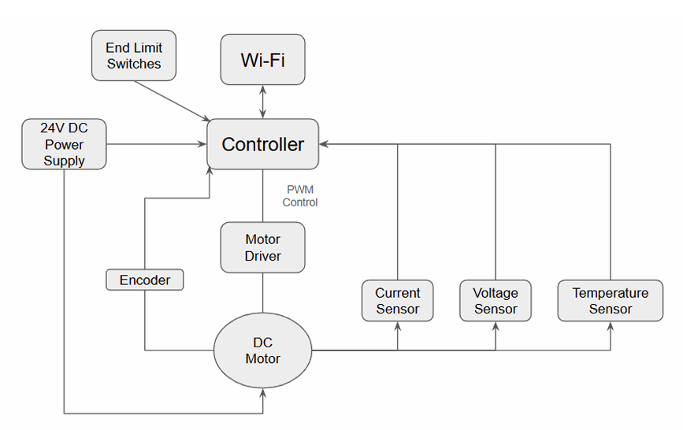
So, I’ve to build a closed loop motor controller PCB. The motor takes 24V power in, controls a DC motor bidirectionally with PWM, then reads the encoder feedback for position/velocity, monitors the current, voltage, and temperature, has 2 limit switches and communicates wirelessly to a web UI.
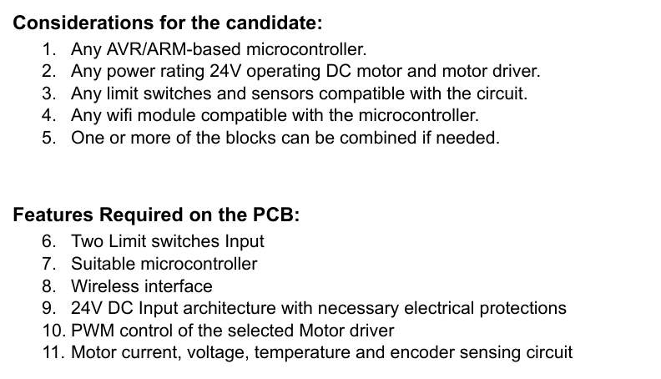
My component selection:
- Microcontroller: ESP32
Dual core Xtensa LX6, 240MHz
Built-in Wi-Fi module
ADC: 12 bit, multiple channels for current voltage and temperature
Alternative: STM32F401CCU6
Cons: Needs an external Wi-Fi module
Not required in this particular task, as it does not involve fast current control loops
- Motor: GoBilda 5303 Series 24V, 100 rpm
Integrated quadrature encoder
Quadrature encoders are used in bidirectional position sensing and length measuring applications.
Reference:
https://www.dynapar.com/knowledge/encoder-basics/encoder-output/quadrature-encoders/
(The only 24V motor available to me right now, from the lab)
- Motor driver: Cytron MD13S
13A continuous, 30A peak (from datasheet)
5-30 Operating voltage – so covers our 24V voltage
PWM + DIR interface which works well with ESP32
Cons: Needs protection on PCB as it has no reverse polarity protection on 24V input side, then it doesn’t have TVS diodes for voltage spikes
Alternatives:
L298N – no, because only 2A usuble continuous
VNH5019 – good, 24V, 12A but unavailable currently and pricey
- Wi-Fi integrated in ESP32, no external module required
- Sensors:
INA219
I2C, direct interfacing to ESP32, no ADC pin used
Measures both current and voltage
12 bit, 0-3.2A, 0-26V
So for voltage sensing we can add a resistor divider with INA219, so 100kohm and 10kohm resistor from 24V rail into ESP32, ADC pin works, as ESP32 ADC is 3.3V max, 24/((100k+10k)/(10k))=2.18V
NTC thermistor 10k – temperature sensing
- Limit switches
SPDT microswitches
Pull up resistors 10k to 3.3V
100nF debounce capacitors to GND
Input to ESP32 GPIO with interrupt capability
PCB Integration
Power section:
24V – Motor driver
3.3V for ESP32 and all sensors
So, from 24V input, we have
- TVS diode
- P-mos
- Fuse (resettable PTC)
- 24V motor rail to MD13S
- Buck converter 24V to 5V
- LDO 5V to 3.3V
So basically, we use a buck here because, dropping 24V to 3.3V through an LDO at even 100 mA wastes (24-3.3)*0.1 = 2.01 W as heat, so we would need a heatsink. And buck is 85% + efficient.
Protections to include:
- reverse polarity using PMos
- TVS across 24V input for inductive spikes
- Bulk capacitor
- 100nF ceramic decoupling caps at every IC power pin
- fuse on 24V input line
Signal connections
ESP32 GPIO mapping:
GPIO 32, 33 – encoder A,B (pcnt unit 0)
GPIO 25 – PWM to MD13S
GPIO 26 – DIR to MD13S
GPIO 34, 35 – Limit switch 1,2 (input only pins)
GPIO 21,22 – I2C SDA, SCL (INA219)
GPIO 4 – NTC ADC
GPIO 36 – Voltage divider ADC
In ESP32 GPIO 34 to 39 are input only pins, so good for limit switches.
ADC2 pins conflict with Wi-Fi, so used ADC1 pins from GPIO 32 to 39 for analog reads.

Components list I’ve used: BOM:
Component | Value/Part | Footprint | Purpose
J2 | Conn_01x02 screw terminal | Through-hole 5.08mm | 24V power input connector
F1 | MF-R1100 PTC 11A | Through-hole radial | Resettable overcurrent protection
D1 | SMAJ28CA TVS | DO-214AC (SMA) | 24V rail spike clamping, bidirectional
Q1 | AO3401A PMOS | SOT-23 | Reverse polarity protection
R3, R4 | 10kΩ resistors | 0805 SMD | PMOS gate voltage divider
C4 | 470µF 35V electrolytic | Through-hole radial 10mm | 24V bulk reservoir capacitor
C5 | 100nF ceramic | 0805 SMD | 24V rail HF decoupling
U2 | LM2596S-5.0 | TO-263-5 (D2PAK) | 24V → 5V buck converter
D2 | SS34 Schottky | DO-214AC (SMA) | Buck converter freewheeling diode
L1 | 100µH inductor | Through-hole/SMD | Buck converter output filter
C6 | 220µF 10V electrolytic | Through-hole radial | Buck converter output capacitor
C7, C8 | 100nF / 100µF | 0805 / radial | Buck output HF + input cap
U3 | AMS1117-3.3 LDO | SOT-223 | 5V → 3.3V regulator
C9, C10 | 10µF ceramic each | 0805 SMD | AMS1117 input/output stability
U1 | ESP32-WROOM-32E | Through-hole module | Microcontroller + Wi-Fi
R1, R2 | 10kΩ each | 0805 SMD | EN and GPIO0 pull-ups
C1 | 100nF ceramic | 0805 SMD | EN power-on reset filter
C2 | 10µF ceramic | 0805 SMD | ESP32 VCC bulk decoupling
C3 | 100nF ceramic | 0805 SMD | ESP32 VCC HF decoupling
SW1 | Tactile 6x6mm | Through-hole | Reset button
SW2 | Tactile 6x6mm | Through-hole | Boot mode button
U4 | INA219AIDR | SOIC-8 | Current and voltage monitor
R5, R6 | 4.7kΩ each | 0805 SMD | I2C bus pull-up resistors
R7 | 0.1Ω 2W shunt | 2512 SMD | Current sensing shunt resistor
C11 | 100nF ceramic | 0805 SMD | INA219 VCC decoupling
J3 | 6-pin header 2.54mm | Through-hole | MD13S motor driver interface
D3 | SMAJ30A TVS | DO-214AC (SMA) | Motor power line spike protection
J4 | JST B6B-PH-K-S | Through-hole JST-PH 2mm | Encoder connector
R8, R9 | 33Ω each | 0805 SMD | Encoder RC filter series resistors
C12, C13 | 100nF ceramic each | 0805 SMD | Encoder RC filter capacitors
J5, J6 | 2-pin connectors | Through-hole 2.54mm | Limit switch connectors
R10, R11 | 10kΩ each | 0805 SMD | Limit switch pull-up resistors
C14, C15 | 100nF ceramic each | 0805 SMD | Limit switch debounce capacitors
R12 | 100kΩ | 0805 SMD | Voltage divider top resistor
R13 | 10kΩ | 0805 SMD | Voltage divider bottom resistor
C16 | 100nF ceramic | 0805 SMD | ADC noise filter (voltage sense)
R14 | 10kΩ | 0805 SMD | NTC thermistor bias resistor
RT1 | NTC 10kΩ B3950 | Through-hole/SMD | Temperature sensor
C17 | 100nF ceramic | 0805 SMD | ADC noise filter (temperature)
J1 | 3-pin header 2.54mm | Through-hole | UART programming header

Process:
- LM2596S-5 Buck converter (24V to 5V)
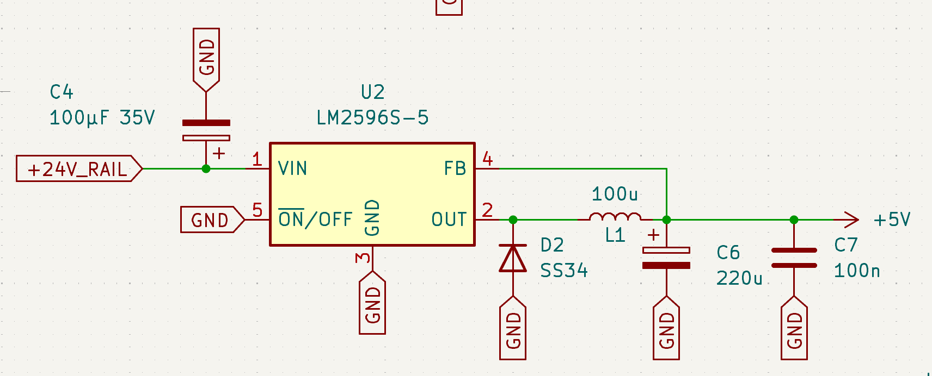
Fixed 5V step down (150kHz)
a) Schottky diode – D2 SS34(150kHz): when the internal switch opens, the L1 tries to maintain current flow, but without D2 the node would go to a large negative voltage seeking current path.
b) L1 100uH: averages switched output to DC. 100uH from LM2596 datasheet.
c) C6 – 200uF 10V: smoothens inductors ripple to stable 5V – bulk smoothening
d) C7 – 100nF: high f noise above self-resonant frequency
e) C4 – 100 uF 35V: prevents the back emf into input
f) ON/OFF tied to gorund implies always ON – sleep mode disabled

- LDO Regulator – AMS1117-3.3
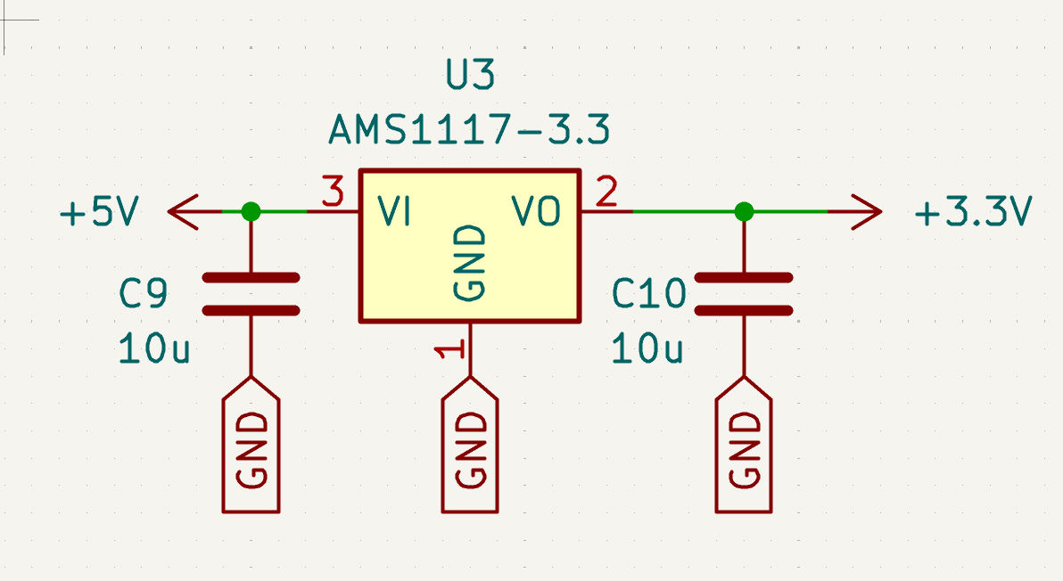
a) 5V input from buck
b) 3v3 ouput for ESP32, INA219, limit switches, encoder
c) C9 10uF: datasheet says it required input capacitor for stability
d) C10 10uF: without this LDO osciallates at output
- PMOS Q1 AO3401A
Reverse polarity preotection
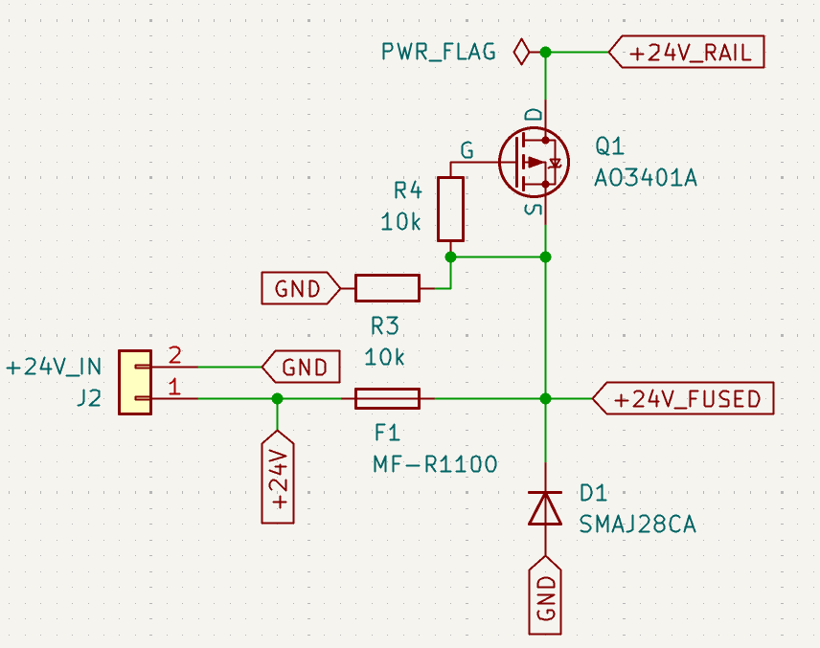
a) Gate resistor network: R3, R4 (10k) – voltage divider making gate to 12V, source 24V implied Vgs is 12-24 = -12V. [MOS threshold is around -1 to -2V right? So Vgs -12V turns device ON. Current flow from source to drain.
b) if supply V is accidently reversed, source goes to 0V, gate is at 12V. implied Vgs positive and PMOS is OFF. No current flow. Board protected.
c) Selection of 10k because 24/20k is like 1.2mA. Which is taken continuously which is not very high. And we also need to maintain response time so didn’t choose higher values.
d) AO3401A: 30V rated Vds. From datasheet voltage drop = 3^2 * 0.05 = 0.45 W which is acceptable.
e) TVS diode D1 SMAJ28CA
Transient Voltage Suppressor
Shunt across 24V rail
Under normal 24V – it is reverse biased
But when a motor gives an inductive spike and pushes above 28V, then TVS conducts heavily and clamps voltage
Here CA is bidirectional – so basically spikes created in both positibe and negative transients on rail
So complete protection for MOS and LM2596
F) FUSE F1 – MF-R1100 PTC Resettable fuse
If MOS shorts, 24V rail shorted, F1 opens – so no other component damaged
MF-R1100 because 11A hold current, MD13S is rated 13A continuous
Resettable fuse, so when current exceeds 11A, polymer matrix heats up and R rises a lot, limiting current, so when fault removed device cools and R drops back to normal
- Sensing with INA219
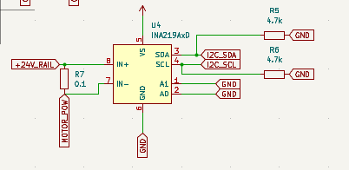
I2C interfaced IC
measures bus V and shunt I in one device
12 bit on both V n I channel
GPIO 21/22 used for I2C
Programmable gain and range
A0 and A1 – both GND so address is 0x40
+IN faces supply, -IN faces load
0.1 ohm shunt – all motor current flows through R7
At 3A, 0.3V drop
I2C pull up resistors 4.7k ohms each – I2C open drain implied SDA SCL need external pull up to supply. for 100kHz 4.7k ohm is standard and 400k Hz is Fast
100 nF at VCC – INA219 internal logic needs local charge storage
- Motor Driver interface MD13S
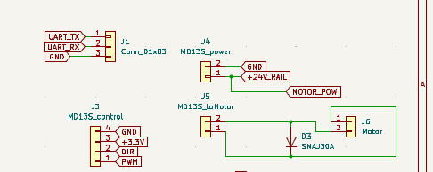
D3 TVS SMAJ30A on motor_pow as motor inductive
rapid pwm switching cause flyback voltage spikes
- Encoder interface
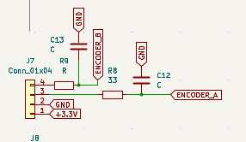
Quadrature encoders
A nd B 90 degree out of phase
ESP32’s PCNT (pulse counter) hardware GPIO32, 33 which counts quadrature pulses in hardware without CPU intervention
R8, R9 33 ohm with capactors is for RC filtering qwith cutoff (1/2pi33*100*10^-9) = 48kHz
filters high f EMI
- Limit switches
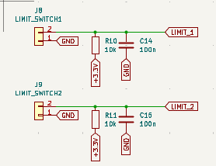
GPIO34, 35 – input only pins
Pull up 10k to hold logic HIGH when switch OPEN
C14, C15 – debounce capacitors
RC constant = 10k * 100 * 10^-9 = 1 ms
- Voltage monitoring using resistor divider network
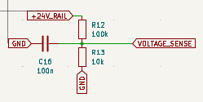
Network scales down 24 to 3.3 range for ESP32 ADC
10/(100+10) = 2.18
- Temperature monitoring NTC thermistor
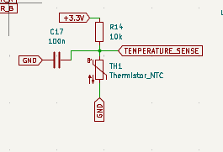
RT1 – NTC 10k ohm B3950 thermistor
GPIO4 – ADC1 channel 0
As T inc. NTC R drops, junction V low
At 25* RT – NTC 10k, 3.3/2 = 1.65 – junction midpoint of ADC
FINAL PCB:
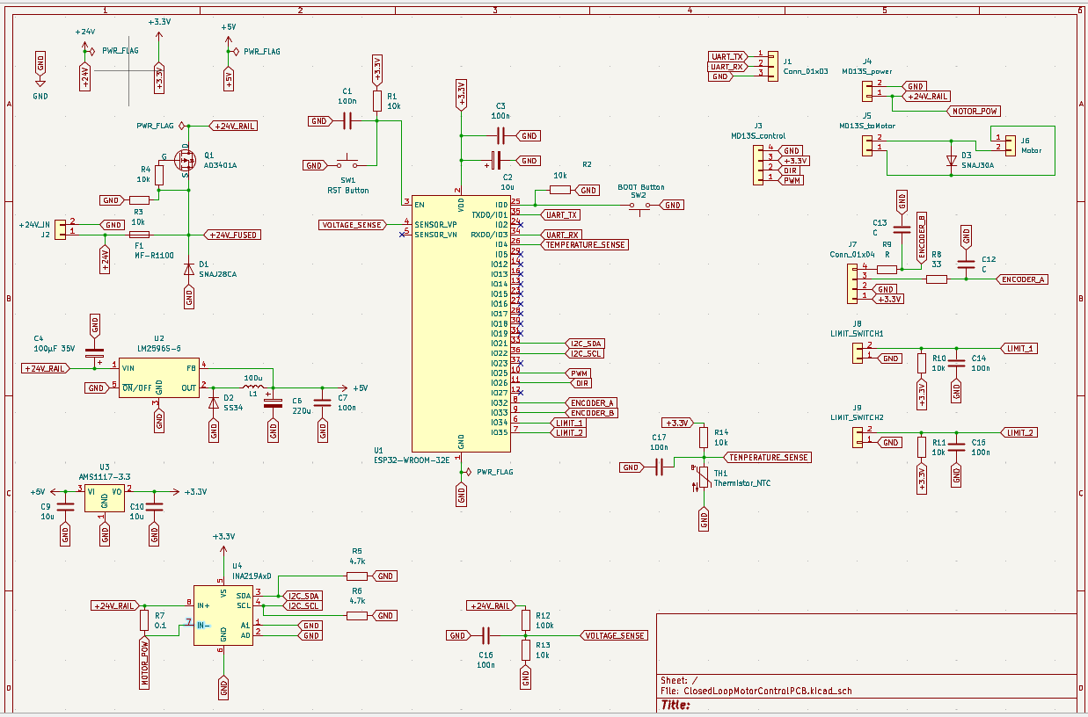
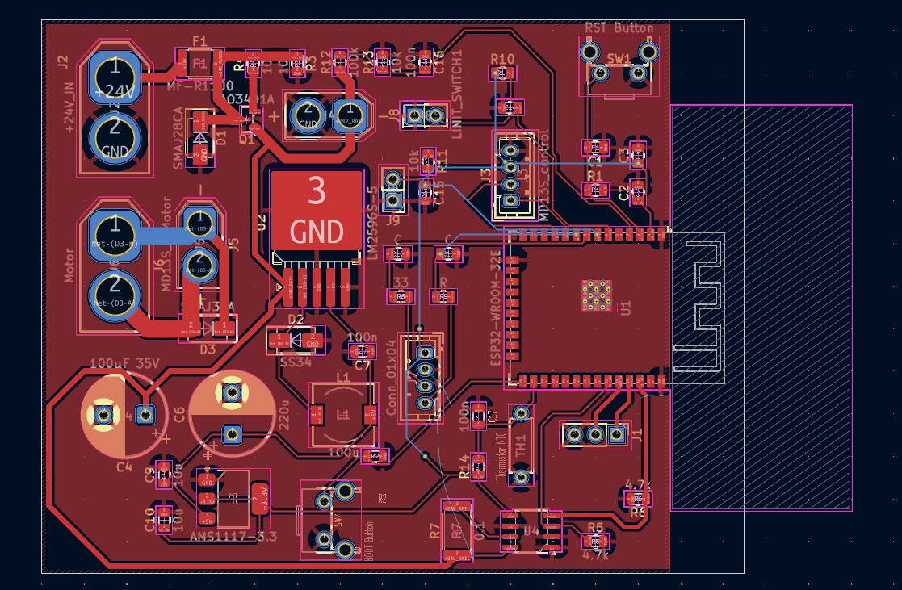
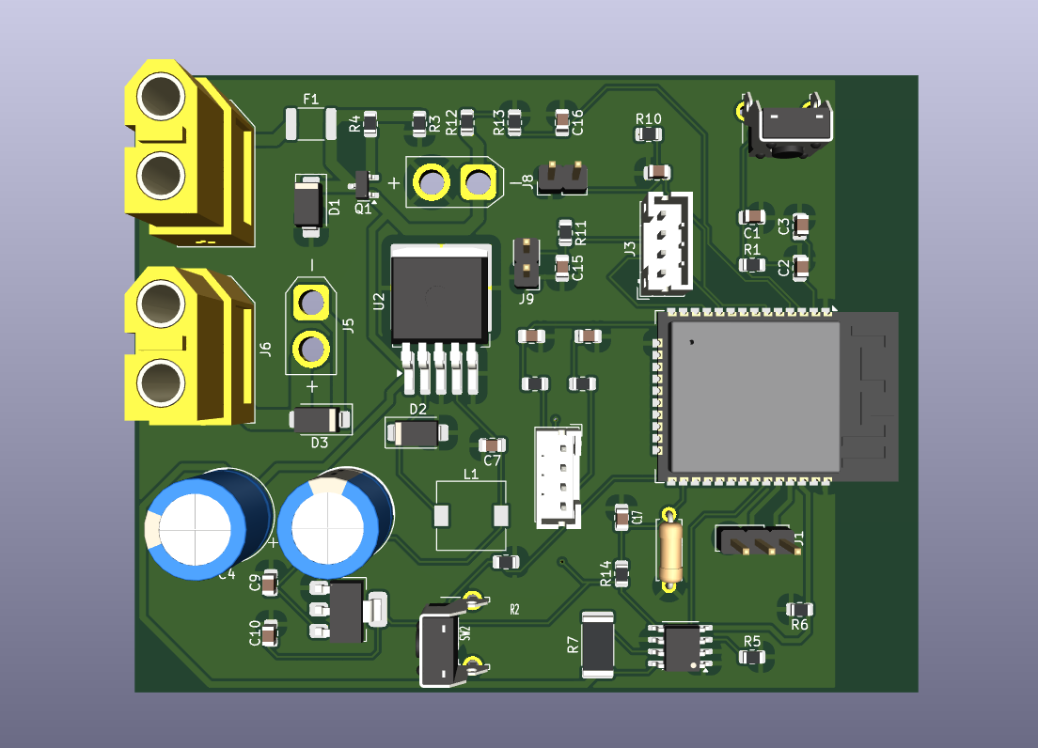

SOFTWARE TASK:
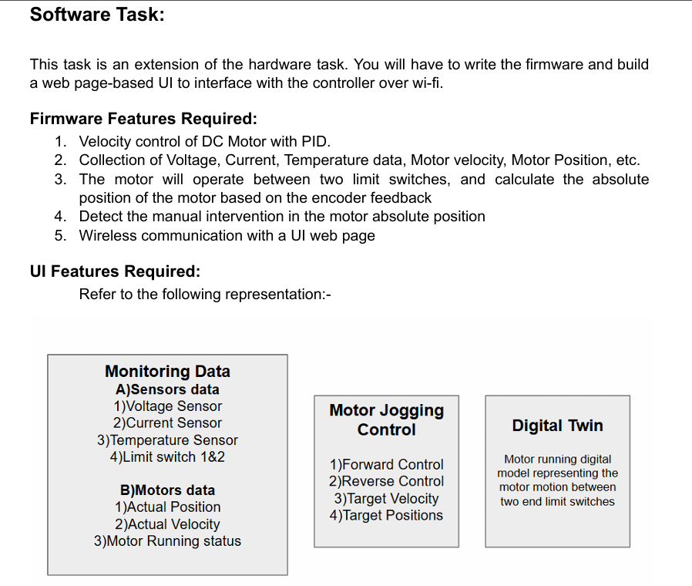
FIRMWARE:
FLOWCHART:
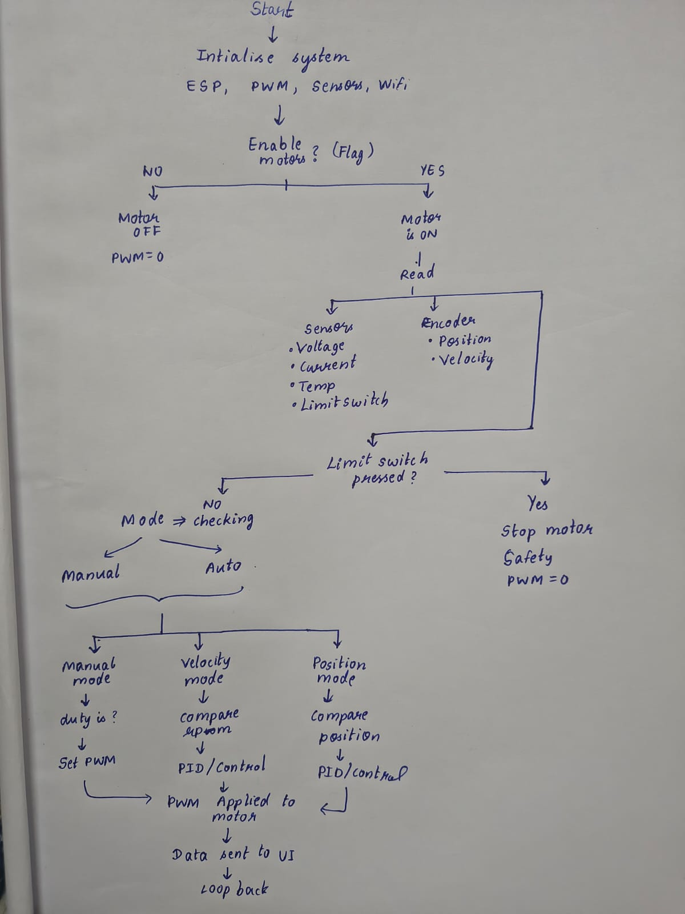
Pseudo Code:
START

Initialize serial communication

Setup GPIO pins
Set motor direction pin as OUTPUT
Set limit switches as INPUT

Setup PWM
Configure PWM channel, frequency, resolution
Attach PWM to motor pin

Setup encoder (PCNT)
Configure encoder pins
Enable counting and overflow interrupts

Setup limit switch interrupts

Setup I2C communication
Initialize INA219 sensor

Setup ADC (for temperature + voltage)

Connect to WiFi
IF connection fails
Start Access Point mode

Setup Web Server routes
"/" → UI page
"/api/status" → send data
"/api/control" → receive commands

Start Web Server

Start control task on Core 0

END SETUP

LOOP forever
Handle incoming HTTP requests
END LOOP

CONTROL TASK:
LOOP forever

IF 100 ms passed
Read motor current from INA219
Read bus voltage
Read rail voltage (ADC)
Read temperature (NTC)

Update velocity using encoder

IF motor is ENABLED

IF limit switch 1 active AND moving backward
STOP motor

ELSE IF limit switch 2 active AND moving forward
STOP motor

ELSE
IF control mode = VELOCITY
Run velocity PID

ELSE IF control mode = POSITION
Run position PID

ELSE (motor disabled)

IF manual duty ≠ 0
Apply manual motor output
ELSE
STOP motor

Wait 5 ms

END LOOP

VELOCITY CALCULATION:
Every 50 ms:

current_position = encoder count
delta = current_position - previous_position

velocity = (delta / time) → convert to RPM

previous_position = current_position

PID CONTROL (VELOCITY):

Every ~10 ms:

error = target_velocity - actual_velocity

integral += error * dt
limit integral (anti-windup)

derivative = (error - previous_error) / dt

output = Kp*error + Ki*integral + Kd*derivative

limit output between -255 and 255

Apply output to motor

previous_error = error

PID CONTROL (POSITION):

Every ~10 ms:

current_position = encoder count

error = target_position - current_position

integral += error * dt
limit integral

derivative = (error - previous_error) / dt

output = Kp*error + Ki*integral + Kd*derivative

limit output between -255 and 255

Apply output to motor

MOTOR OUPUT FUNCTION:
FUNCTION setMotorOutput(output):

Limit output between -255 and 255

IF output == 0
Stop PWM

ELSE IF output > 0
Set direction FORWARD
Apply PWM = output

ELSE
Set direction REVERSE
Apply PWM = absolute(output)

TEMPERATURE READ:

Read ADC value

Convert ADC → voltage

Convert voltage → resistance

Apply formula → temperature in °C
VOLTAGE READ:

Read ADC value

Convert to voltage

Divide by voltage divider ratio

Return actual voltage

HOMING FUNCTION:
Disable motor control

Move motor slowly toward limit switch 1

WAIT until:
limit switch is pressed OR timeout

Stop motor

Reset encoder count to 0

Set position = 0
WEB API:
When "/api/status" is requested:

Create JSON object

Add:
current
voltage
temperature
position
velocity
limit switch states
motor state

Send JSON response

When "/api/control" receives data:

Parse JSON

IF "enabled" present
update motor state

IF "target_rpm" present
update velocity target

IF "target_pos" present
update position target

IF "mode_velocity" present
switch mode

IF "manual_duty" present
update manual control

IF "kp, ki, kd" present
update PID values

IF "home" = true
run homing function

SAFETY LOGIC:

IF limit switch hit
Prevent motion in that direction

IF manual movement detected
raise alert

(Code from AI)
UI Page
Reference for HTML + CSS:
https://www.classcentral.com/classroom/freecodecamp-learn-html-css-full-course-for-beginners-119775
Page design:
