**Considered During Offer & Quotation.**

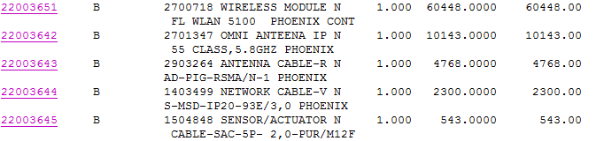

Master Wireless- Rs. 78201

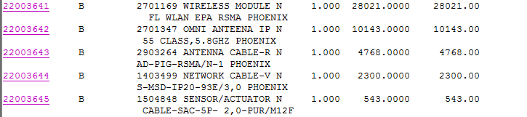

Carrier Wireless- Rs. 45775

AlterNet Solution – wich costed Rs. 30000 for Master panel & Rs. 30000 for carrier Panel.

