HOURS UTILIZED FOR CYK013_1819

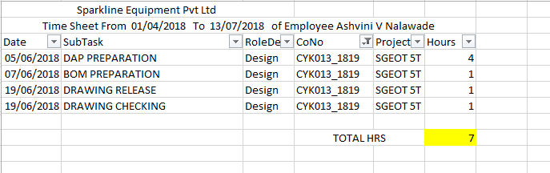

BUDGET HOURS

