Name: | Post Title:
Date of Meeting: | Period Under Review:
Contents
- Looking Back At The Previous Year
- Looking Forward – Objective Setting
- Personal Development Plan
- Appraiser’s Confirmation of Performance and Personal Development Plan
- Talent Map

Section 1: Looking Back At The Previous Year
Referring to the previous years agreed objectives, this section should be completed by the appraisee prior to the appraisal meeting and agreed by appraiser following the appraisal meeting. An assessment should be made on an employee’s performance based on the below criteria prior to the appraisal meeting:

Competency Levels (see guidance document for further definitions of the levels)

Exceptional Performer (EP): All expectations in terms of objectives, competencies and values have been met and some will have been exceeded.
Sound Performer (SP): Met all of the objective and meets expectations consistently.
Developing Performer (DP): Some expectations will have been met or exceeded.
Under Performer (UP): Consistently fails to meet some expectations. Immediate improvement is required.

Performance Objectives  To be extracted from historical appraisal documentation | Performance / Achievements / Outcomes | Competency Level
Appraisee’s comments and assessment:

Appraiser’s comments and assessment:

Appraisee’s comments and assessment:

Appraiser’s comments and assessment:

Appraisee’s comments and assessment:

Appraiser’s comments and assessment:

Insert additional rows to the table as required

Overall comments and summary of performance over the previous year:

Appraisee’s comments:

Appraiser’s comments (appraiser should seek and record feedback to support summarised comments from other service areas):

Section Two: Looking Forward – Objective Setting

Objectives (please ensure a minimum of 3)
Objectives should be:
Clear – unambiguous and understood and clearly recorded
Challenging – not too easy to achieve and would involve some effort to reach but be realistic
Measurable – what is the outcome, what are the milestones along the way, what information will we use to know that the objective is achieved
Agreed – between both the appraise and appraiser
Aligned – the objectives should be consistent with the goals of the team

Performance Objectives | Timescale | Performance / Achievements / Outcomes  To be completed at the 6 month review | Competency Level  Current level to be completed at 6 month review
1. |  | Appraisee’s comments and assessment:  Appraiser’s comments and assessment:
2. |  | Appraisee’s comments and assessment:  Appraiser’s comments and assessment:
3. |  | Appraisee’s comments and assessment:  Appraiser’s comments and assessment:
4. |  | Appraisee’s comments and assessment:  Appraiser’s comments and assessment:
Insert additional rows to the table as required

Section 3: Personal Development Plan (please ensure a minimum of 2 and a maximum of 5, in addition to Mandatory Training outlined below)

Development opportunities, training and new experiences the appraisee requires in order to develop themselves in line with development areas identified in the review of competence and performance (in Section 1 of this form) in order achieve the agreed objectives(in Section 2 of this form):

 | Development Activity | Target Completion Date | Formal or informal | Estimated Cost of Activity
1. | Mandatory Training:  - Safeguarding Training (Basic Level Awareness this may be higher dependent upon role)  - Fire awareness  - Manual Handling  - Information Governance Training  - Other (Clinical staff mandatory training/Health and Safety)
2.

3.

4.

5.

6.
Insert additional rows to the table as required

Review of Personal Development Plan and activities undertaken during the 6 months since the appraisal meeting
Development Activity undertaken in past 6 months | When | Level of usefulness and how this has been applied / implemented / shared

Part 4: Appraiser’s confirmation of Performance and Personal Development Plan:
I confirm that:
The above named employee is deemed competent to perform the duties outlined in their role profile and achieved a satisfactory level of competence
Professional registrations are up to date and valid
All Mandatory Training is complete and up-to-date, if not, please detail when it will be completed ________________________________________
All disability/specific personal needs and/or access requirements been discussed and actions identified if appropriate

I agree with the contents of this Appraisal and Performance Review Form  Appraisee’s signature:  ______________________________________ | Date:  ___________________________________________________________

Appraiser’signature: ______________________________________________ | Date:  ___________________________________________________________

Part 5: Talent Map (following conversations about performance and potential, please agree where the member of staff should be placed on the talent map in line with appraisal scoring
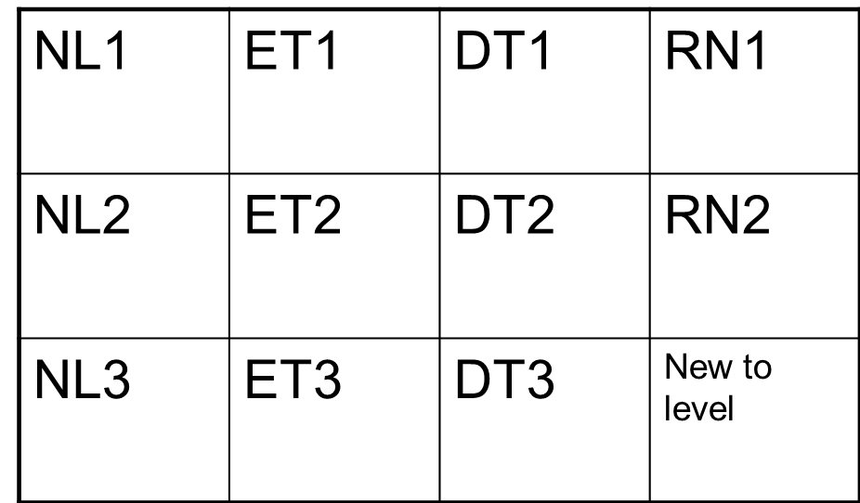
Performance
Exceeds expectations
Outstanding performance against objectives and behaviours required at level

Meets Expectations
Meets the expectations for performance against objectives and behaviours required at level
Partially Met Expectations
Below “met expectations” against performance objectives and behaviours required at level
Potential
EMERGING TALENT
Shows potential & motivation to develop at current level in some respects. Shows future promise and expected to progress within 3-5 years
DEVELOPING TALENT
Demonstrates the potential & motivation to develop at current level& to progress within 1-3 years
READY NOW
Demonstrates the
Potential, motivation
& experience to perform at next level.
In next <12 months, should focus on developing leadership behaviours at next level
NOT LIKELY TO BE READY
Shows limited potential to develop at current level within 3-5 years or shows no motivation / aspiration to want to progress

