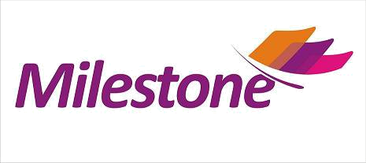

MEMORANDUM OF UNDERSTANDING

This MOU is entered into between Milestone Media Solutions, having its office located at 15, Kapil Woodrow, Azad nagar, Wanworie, Pune - 4110040 (hereinafter referred to as “MMS” Pices Events ,registered office in Daffodlling Building,Magarpatta City,Solapur Road,Hadapasar,Pune-28 will henceforth be called as “__________”.
In consideration of _____ having appointed Milestone as a service provider in terms of this MOU, Milestone hereby agrees and undertakes that it shall, through its ticketing platform Ticketexpress, be responsible for managing sales for “Koregaon Park Music Festival (KPMF)”
Event __________________________ PUNE happening on the_____________2016 from remote locations other than the venue, including but not limited to the following:
- Sales through the Internet to be facilitated through the websites owned or controlled by Milestone accessible through computers or WAP and GPRS enabled mobile phones;
- Sales through voice channels to be facilitated by Milestone.
____ will provide the following
- Minimum of tickets for the event to Milestone for sale through it’s brand Ticketexpress
- Ticketexpress, visibility on all its communications. Mentioning the contact number 020 697 88 000 on its communications
- Make Ticketexpress as Online partner

Milestone will provide the following

Sell the tickets through their website www.ticketexpress.in with the option of paying online for the customers.

Telephone booking service
- Promote the event through its website and other resources through the web.
- Send out mailers to the database in PUNE
- Ticketexpress personal will not be standing in the box office to honor tickets for the ticketexpress customers.
- Tickets booked on ticketexpress, the report will be sent a day prior to the event itself for keeping the tickets aside. Unsold Tickets will be available for sale at the box office.

Confidentiality
Any confidential information that has been disclosed by either party to the other party shall be maintained in the strictest confidence and trust by the non-disclosing party. For the purpose of this clause Confidential Information includes all the details of this MOU, pricing of the event, details regarding sale and promotion of the event, promotion discounts, special offer etc. and the details of the customer / Milestone clients that may become known to you as a result of this MOU.
Pricing
- This service is being made available to MMS at the following terms:
  - Milestone will charge 7% on the ticket value as its commission for all those sold through them.
  - Ticketexpress.com will charge a convenience charge of Rs.5 to Rs.25 depending on the ticket price to the end user.

  - The payment gateway charges will be borne by Milestone Media Solutions on the face value of the tickets, which means the above commission will include the payment gateway charges.
Payments
- _______________payments will be done within 5 working days after the show.
- The payment will be in the name of “______________”

For ___________________
(Name of the Client wit sign & Stamp) For Milestone Media Solutions

Milestone Media Solutions.
15 Kapil Woodrow, azad nagar, Wanworie,Pune – 4110040 I 020 697 88 000 I info@milestones.in
www.milestones.in I www.ticketexpress.in

