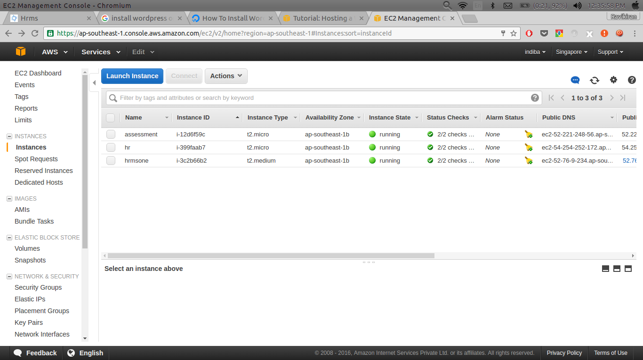
1. LAUNCH THE INSTANCE :

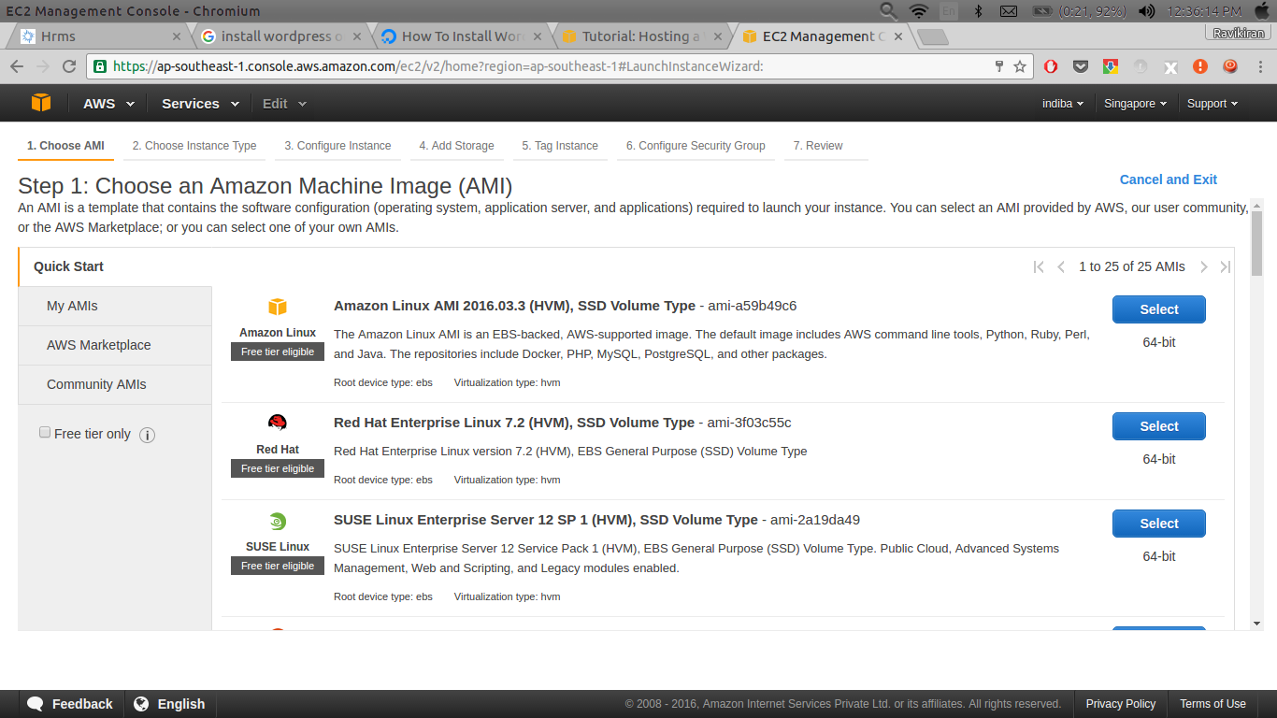
2. SELECT ANY OPERATING SYSTEM :

3. REVIEW AND LAUNCH THE INSTANCE : SELECT T2.MICRO INSTANCE.

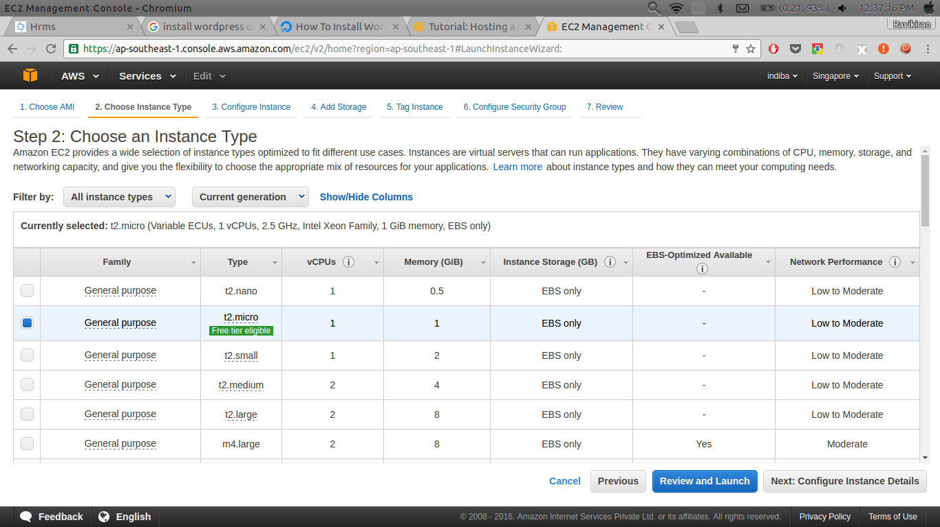

4. DOWNLOAD .PEM FILE. THIS PROVIDE PROVIDE ONLY ONCE SO TAKE CARE OF THIIS FILE.

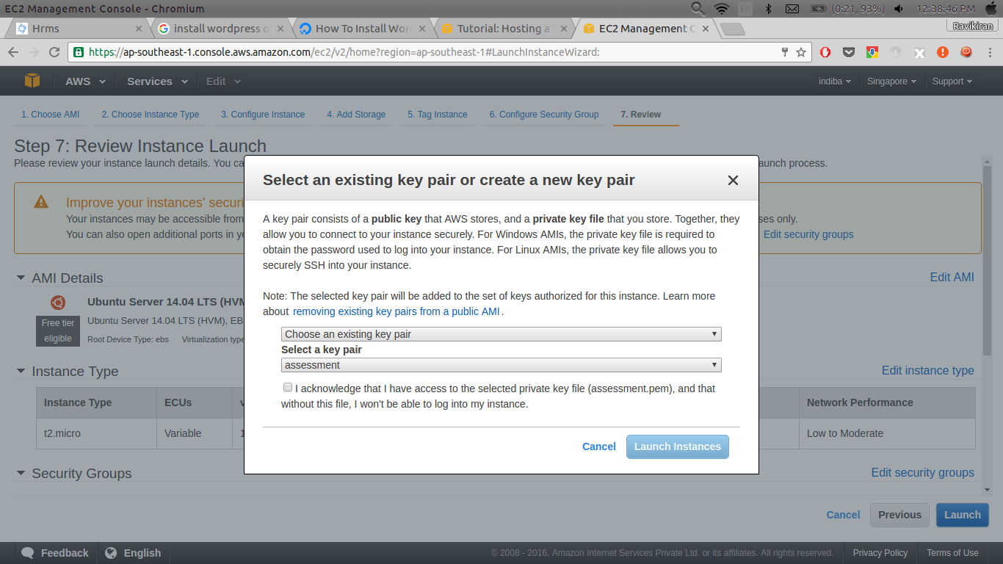

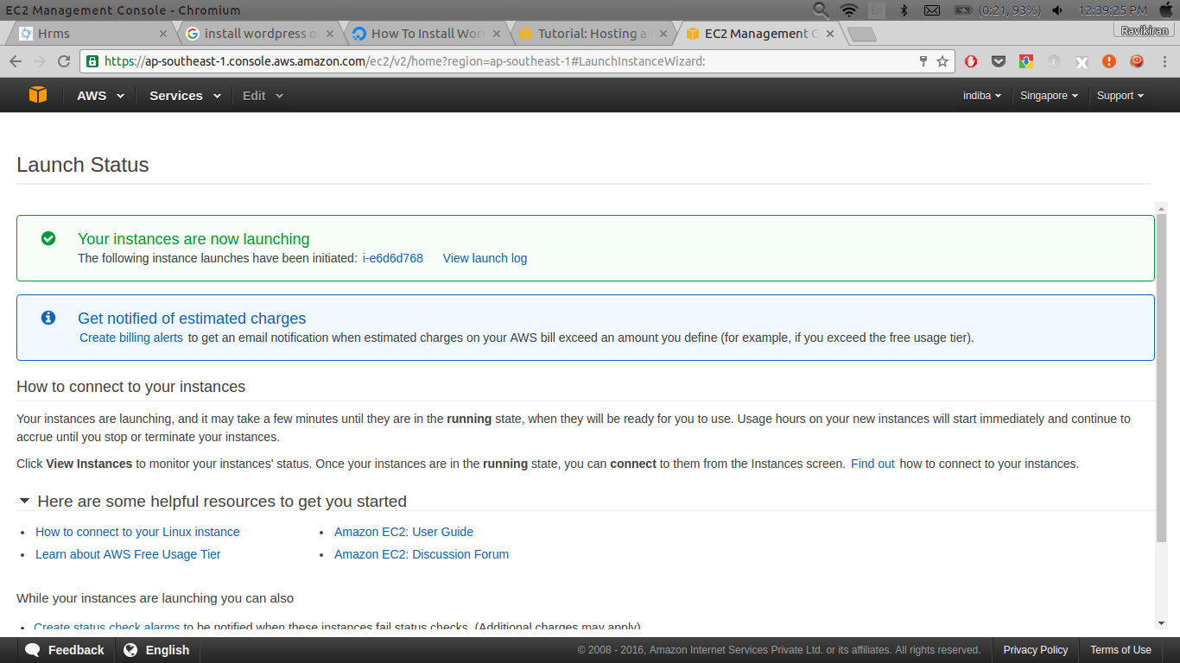
5. THIS IS THE LAST SCREEN YOU SEE AFTER CREATING INSTANCE :

6.) Put .pem file in the document folder .

7.) In console go in Document folder . Than run the ssh command and change .pem file copy the Public DNS from AWS screen .

8.) This error comes when we run ssh command to solve this error run the below command

@@@@@@@@@@@@@@@@@@@@@@@@@@@@@@@@@@@@@@@@@@@@@@@@@@@@@@
@ WARNING: UNPROTECTED PRIVATE KEY FILE! @
@@@@@@@@@@@@@@@@@@@@@@@@@@@@@@@@@@@@@@@@@@@@@@@@@@@@@@@@@@@

if this error comes than put the following command -

sudo chmod 400 span_pump.pem

9.) Than again run the ssh command .

Now the system is ready we have to launh the project on cloud .

10.) First install the ruby on rails by running following commands -

sudo apt-get install git-core
sudo add-apt-repository ppa:webupd8team/sublime-text-3
sudo apt-get update
sudo apt-get install sublime-text-installer
sudo apt-get install curl
gpg --keyserver hkp://keys.gnupg.net --recv-keys D39DC0E3
curl -L get.rvm.io | bash -s stable
rvm requirements --autolibs=enable
curl -L get.rvm.io | bash -s stable --rails
source ~/.rvm/scripts/'rvm'
rvm requirements
rvm get head
rvm fix-permissions
sudo apt-get install build-essential bison openssl curl git-core zlib1g zlib1g-dev libssl-dev libsqlite3-0 libsqlite3-dev sqlite3 libxml2-dev
sudo apt-get install libcurl4-openssl-dev
sudo apt-get install rails
gem install rails
sudo apt-get install mysql-server
sudo apt-get install libmysql-ruby
sudo apt-get install libmysqlclient-dev
gem install mysql

Step 4 — Install Apache
To install Apache, type this command:
a.)sudo apt-get install apache2
Yes, that’s all!

Step 5 — Install Passenger
First, install the PGP key for the repository server:
b.)sudo apt-key adv --keyserver keyserver.ubuntu.com --recv-keys 561F9B9CAC40B2F7
Create an APT source file:
c.)sudo nano /etc/apt/sources.list.d/passenger.list
Insert the following line to add the Passenger repository to the file:
d.)deb https://oss-binaries.phusionpassenger.com/apt/passenger trusty main
Press CTRL+X to exit, type Y to save the file, and then press ENTER to confirm the file location.
Change the owner and permissions for this file to restrict access to root:
e.) sudo chown root: /etc/apt/sources.list.d/passenger.list
f.) sudo chmod 600 /etc/apt/sources.list.d/passenger.list
Update the APT cache:
g.) sudo apt-get update
Finally, install Passenger:
h.) sudo apt-get install libapache2-mod-passenger
Make sure the Passenger Apache module; it maybe enabled already:
i.) sudo a2enmod passenger
Restart Apache:
j.) sudo service apache2 restart
This step will overwrite our Ruby version to an older one. To resolve this, simply remove the incorrect Ruby location and create a new symlink to the correct Ruby binary file:
k.) sudo rm /usr/bin/ruby
l.) sudo ln -s /usr/local/bin/ruby /usr/bin/ruby

NOTE – By default updated ruby and rails version are installed . We need to change ruby and rails version .

rvm use 2.2.1
rvm --default use 2.2.1
gem install rails -v 4.2.4

Log in into the git hub and copy the clone .

11.) on console write git clone https://github.com/indiba/hrms.git

12.) run command cd hrms

13.)bundle

14.) git status

15.)git add –all

16.)git commit -m “new”

17.)git pull origin “branch name “

bundle install

Now, we need to create a virtual host file for our project. We'll do this by copying the default Apache virtual host:
m.) sudo cp /etc/apache2/sites-available/000-default.conf /etc/apache2/sites-available/testapp.conf
Open the config file:
n.) sudo nano /etc/apache2/sites-available/testapp.conf
Edit it or replace the existing contents so your final result matches the file shown below. Changes you need to make are highlighted in red. Remember to use your own domain name, and the correct path to your Rails app:
<VirtualHost *:80>
ServerName hrms.com
ServerAlias www.hrms.com
ServerAdmin webmaster@localhost
DocumentRoot /home/ubuntu/hrms/public
RailsEnv development
ErrorLog ${APACHE_LOG_DIR}/error.log
CustomLog ${APACHE_LOG_DIR}/access.log combined
<Directory "/home/ubuntu/hrms/public">
Options FollowSymLinks
Require all granted
</Directory>
</VirtualHost>

Disable the default site, enable your new site, and restart Apache:
o.) sudo a2dissite 000-default
p.) sudo a2ensite testapp
q.) sudo service apache2 restart

After this on security group which is at the aws set the HTTP .

18.)rake db:create

19.)rake db:migrate

21.) It throughs rmagic error than run following command

1. sudo apt-get install imagemagick
2.sudo apt-get install libmagickwand-dev
3.gem install rmagick

22.) sudo apt-get install apache2

