Alexander Tran
CPSC 335-01
Project 1 Report

Project Contributor
Alexander Tran (altran@csu.fullerton.edu)

Screenshots
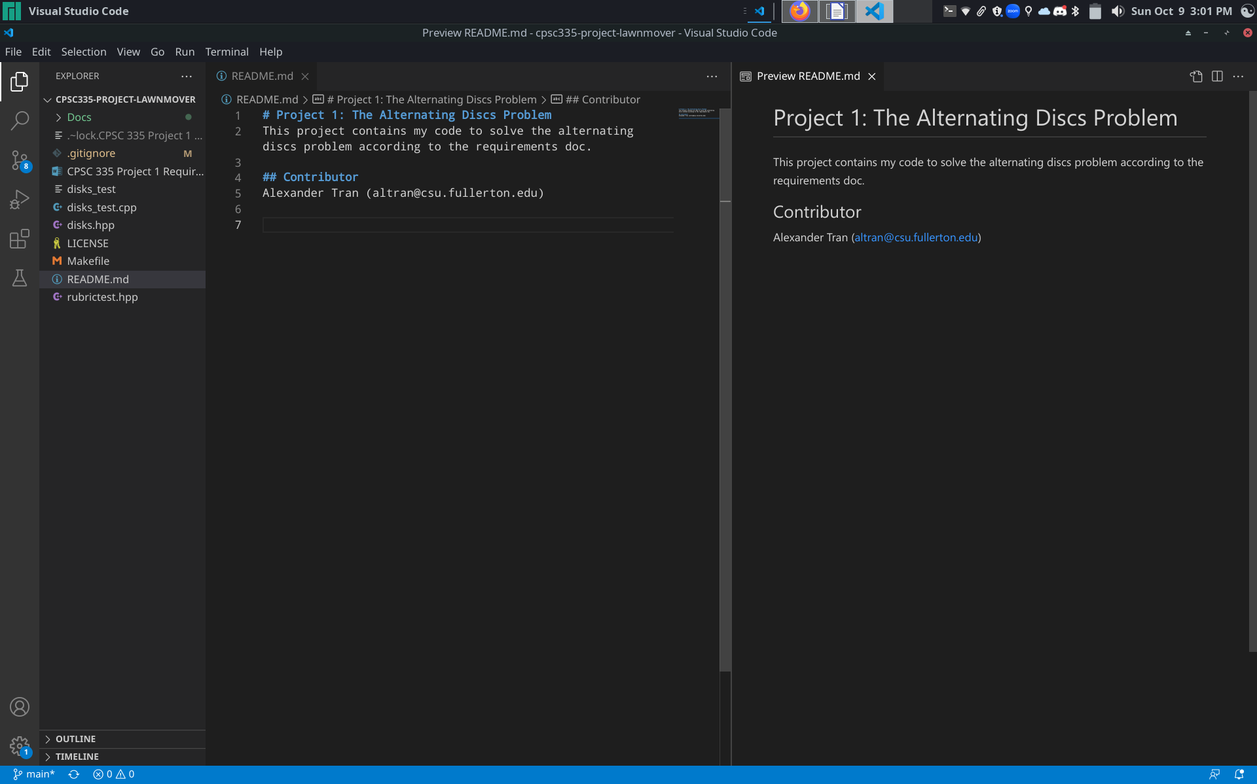
README.md with project contributor name

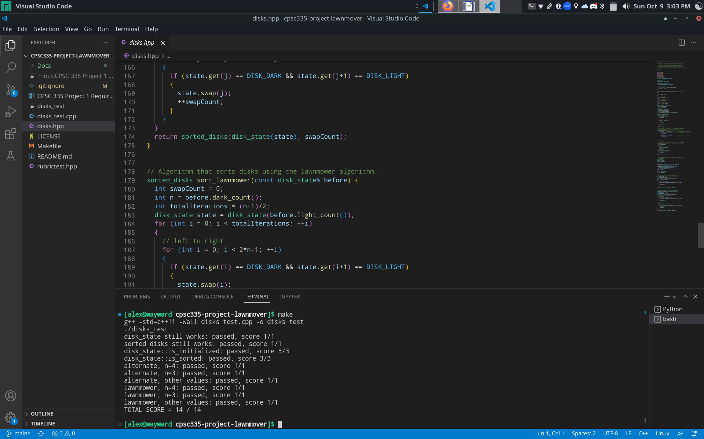
Compiling and running
The Algorithms
Let l be the given list of size 2n in any pseudocode presented.

Lawnmower
def lawnmower(n, l):
iterations = (n+1)/2
for _ from 0 to iterations:
# LEFT TO RIGHT
for i from 0 to 2*n-1:
if l[i] == 1 and l[i+1] == 0:
swap(l[i], l[i+1])
# RIGHT TO LEFT
for i from 2*n-1 to 0 in steps of -1:
if l[i] == 0 and l[i-1] == 1:
swap(l[i], l[i-1])

Step count formula:
Proof: Lawnmower algorithm has time complexity of O(n²)
Let:
,
,
,
and (an arbitrary value).

By definition, is in the order of if
where .

Alternate
def alternate(n, l):
for i in range(n+1):
for j in range(i, 2*n-1):
if l[j] == 1 and l[j+1] == 0:
swap(l[j], l[j+1])

Step count formula:
Proof: the alternate algorithm has time complexity of O(n²)
Let:
,
,
,
and (an arbitrary value).

By definition, is in the order of if
where .

