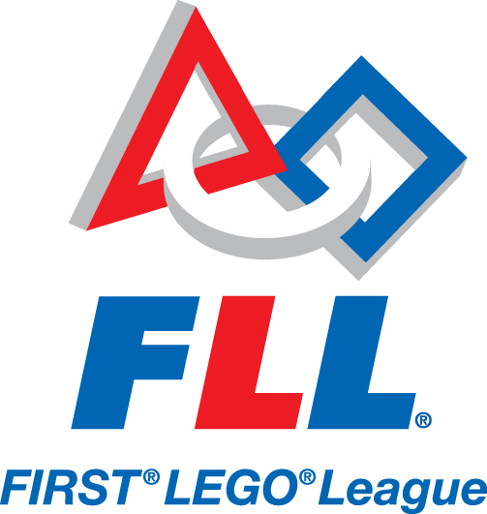 | FLL Team Information Sheet
 | FLL Team Number: 27544
 | Team Name: Probots
 | Location: North Fulton/Forsyth, GA
Team Members:  Devesh Venkateswaran  Karthik Mahakala  Luke Puttnam  Rahul Mathew  Soham Kale  Zidan Gadne  Zinnun Malikov | Coach:  Mark Puttnam  Venkat Govindarajan  Mentors:  Radha Venkatesan  Robot’s Name:  Prankster Gangster |  | 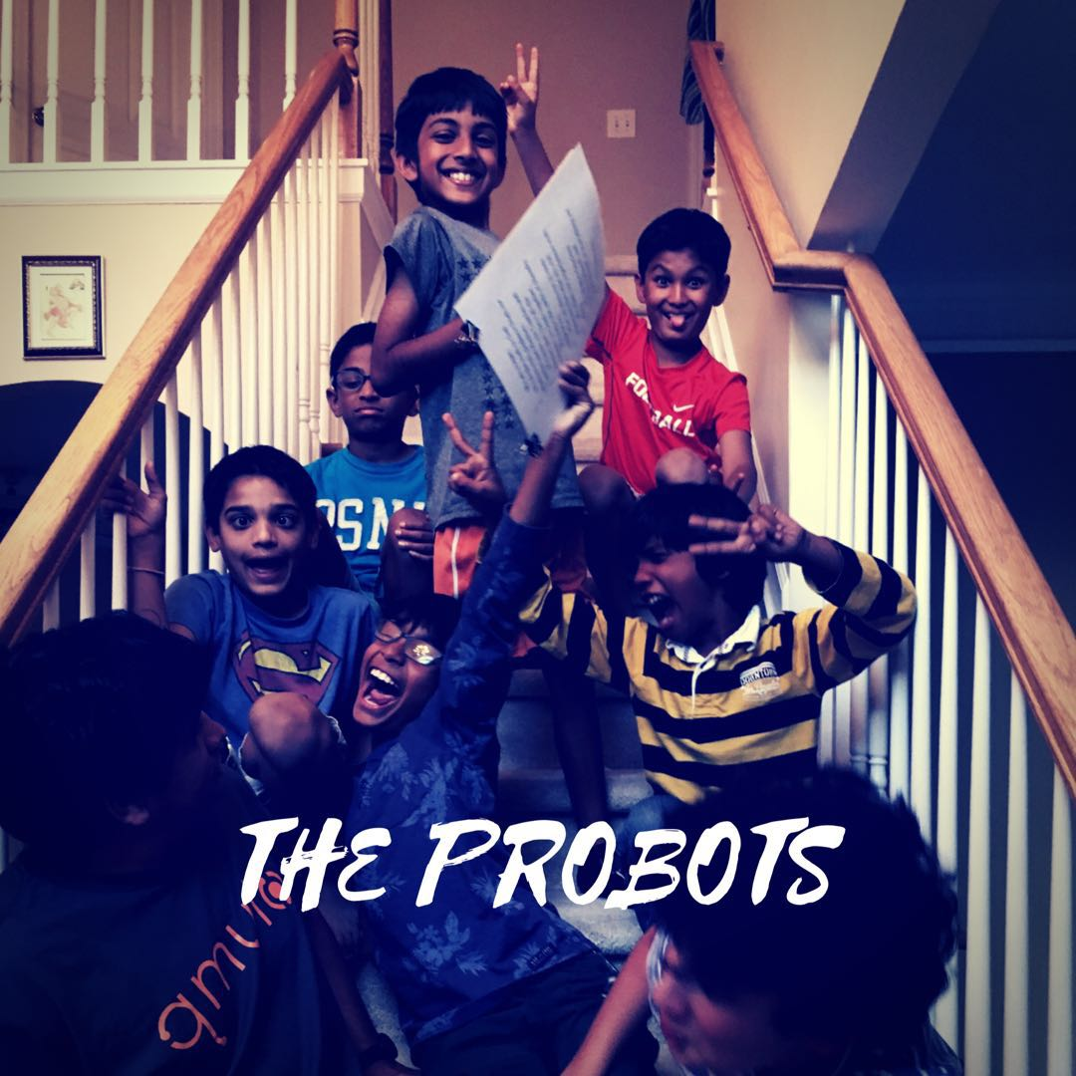
Robot Design Information  Our Robot “Prankster Gangster” a very compact and sturdy robot with easy to place modular attachments. The robot is easy to alter and run, because the buttons was facing us. We had to follow these principles to make our perfect robot. Our strategy was to go for the main missions like Shark Shipment, Service Dog, Milking Automation, Feeding, and Animal Conservation that gave us a lot of points, rather than going for ‘extra’ missions that don't give many points. |  | Research Project Information  Our research was about Dissection of Frogs in Middle/High Schools and why it is bad? We had a video conference with PETA (People for the Ethical Treatment of Animals). We also met some workers from Carolina (the world’s largest dissection supplier). In our research we found out about the harm Dissection of Frogs causes both the environment and us. We conducted a survey among middle and high school children about their desire to do dissection. We also presented our research to River Trail Middle schools and Northview High School’s science teacher.
Teamwork Information  We had fun synergizing and working together. Most importantly no one was left out. We cooperated to do the missions and the dissection project. All of us created our dialogs for the project based on our research. We all worked in shifts so the people who weren’t programming worked on the project, RDES, or Core Values. We also debugged our programs so we could find our mistakes in our programs. |  | Fun Facts About Our Team  We are 7 friends who have known each other and who get along quite well. We have had plenty of sleepovers, play dates, many teammates on our team played soccer on the same team even before we started meeting for FLL on a regular basis 4 months ago. Most of us new to FLL programming or building robots.  The best thing for our FLL group is that we get to play with robots along our friends while we are learning from these friends on how to program. Our coaches knew nothing about programming EV3 robots so we had to teach them a little so they understand what we told them.

