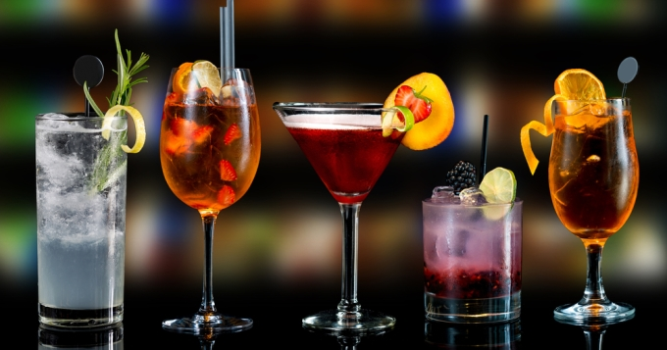
Nos cocktails

Negroni

Old Fashioned

Dry Martini

Margarita

Aperol Spritz

Espresso Martini

Manhattan

Mojito

Whisky Sour

