**To change watchlist column overbought and oversold**

Click wheel and then customize

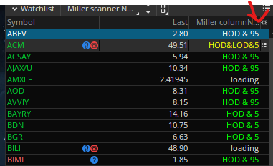

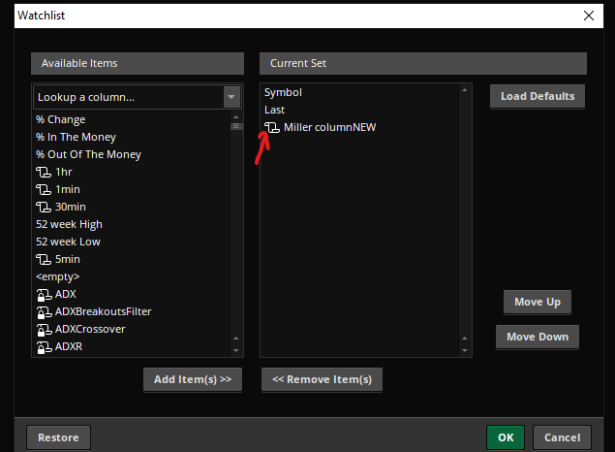Click the scroll next to study

Edit the values

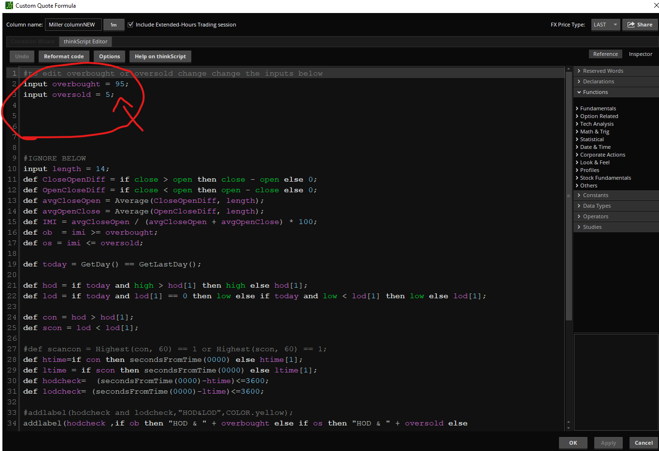

**To change scanner overbought and oversold**

Load scan and then click pencil

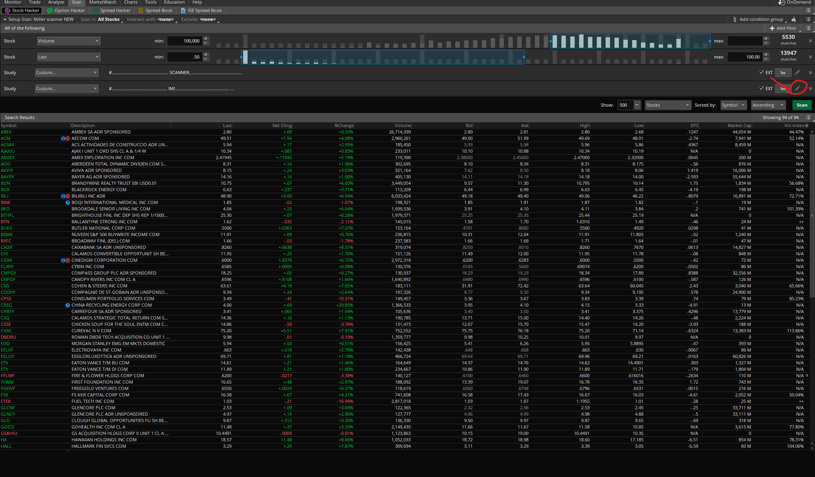

Change the levels

