With changing life style, people have adopted the digital living style. We can find prevalence of digital world can be observed in every nook and corner of one's daily life. Well one's daily life can be broadly divided into work life and social life. And here lies the root of our research, in the hidden schemes of digitalised social life. Here we take the privilege of defining digitalised social life from a different angle. Our concept came from the very thing of categorising social media into “platform for friends” and “platform for followers”.

FB, WhatsApp, Chatbox, Telegram, these all come under A where the target audiences are friends. Whereas Instagram, Twitter, Youtube come under B. As some social media consists of spreading of message in the form of picture, videos , we restrict them out of this domain and concentrating on Twitter for now.

Before getting to support our finding, I would like to present some facts.

**X** people use twitter in daily life. Also **Y** imp people using other social media along with twitter and **Z** imp people using social media only with twitter.

Also, twitter has also affected the NLP scientific society by providing use to get data to work upon sentiment analysis. Also **ALPHA** labs experimenting on twitter for sentiment.

In our daily life, we decode meaning of thousands of sentences. All this won’t be possible without a context. Our every conversation, lessons in book etc., are not self-explanatory, but social media messages are as they come with context. And tweets are one step ahead of all social media as they provide meta data within the message itself and provide explanation.

Also in my support argument, we would like dig deep to natural language development with Latin. The Latin script is used for English, Spanish, French, German and many more language (131 and more) all over world among a large number of societies irrespective of their origin, religion etc.

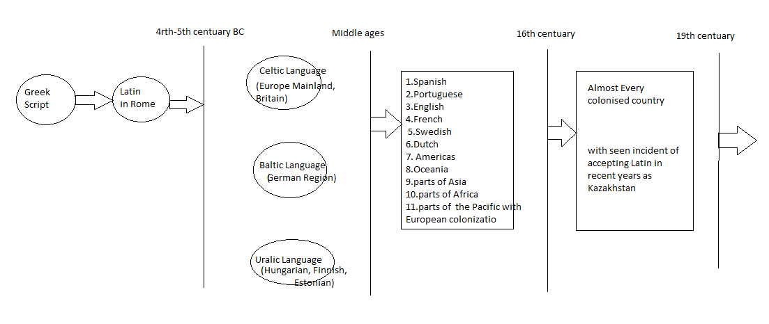

All this pointing towards one direction only. That is without even reaching the point of considering Twitter as a language the rules and theories had developed in the background of digital human society without their consciousness. Hence there has to be some pattern that is being followed in its inept sense. And accepting the challenge our scientific sagacity attempts to bring forward the hidden structure of tweets on the stage.