**Executive Summary**

Current ticketing practices leave ample room for improvement, especially in light of the COVID-19’s global impact. Most measures operate on single ticket processing and with intermittent queue flow, which creates long wait times across a variety of settings and venues. Additionally, a lot of these processes rely on workers interacting with each customer, something that also could be improved.

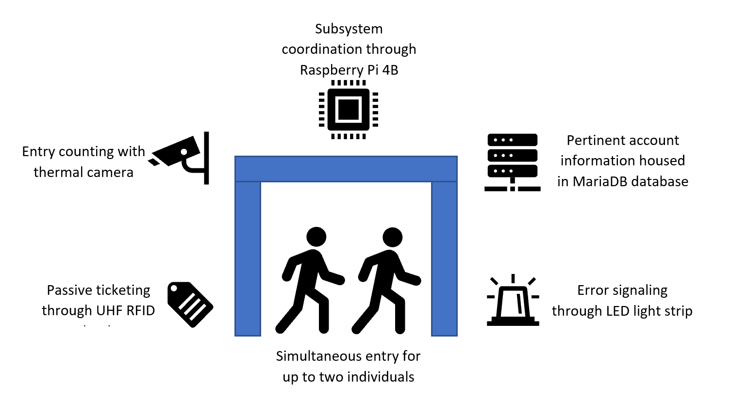

The Quicket System seeks to remedy many of the shortcomings of current ticketing measures through an innovative approach that focuses on reading multiple tickets at once and operating on a pass-until-fail basis. To operate successfully, The Quicket System must read up to two distinct tickets up to 2 meters away. Entry counting measures provide also provide a number of individuals which is compared to the number of tickets processed. After this initial check, the database receives the ticket identification information and checks to see if any valid tickets exist for those account and if those tickets have already been used for entry. The database then pushes a “pass” or “fail” code to an error signaling system.

The system utilizes ultra-high frequency radio identification technology to passively process tickets. Each ticket has its unique identifier stored in a MariaDB database. A thermal camera determines the number of individuals in the ticketing area. Both the reader and the thermal camera are implemented in a top-down orientation at least 80 inches from the ground to comply with ADA standards. This implementation allows both components to cover the required ticketing area. The various components utilize a Raspberry Pi that serves as the core processor for the system. The Raspberry Pi helps facilitate the transmission of data between subsystems. Finally, a programmable LED strip visually conveys the status of the system with green lights representing the base status and red lights signaling an error occurred which calls for human intervention.

The Quicket System brings innovation through its unique implementation of existing technology. This design incorporates several existing ideas into new roles but still holds room for further improvement. Once more widely available, ultra-wide band (UWB) technology offers better error detection for large groups and enables the system to simultaneously handle more customers. Overall, The Quicket System offers improved efficiency and throughput across a variety of setting and venues that rely on ticketed entry, positively impacting not only business and venue owners but also their customers.