An Ethical Evaluation of Tesla’s Autopilot

Tesla is an American electric vehicle manufacturing company, whose cars are known for their driver assistance and safety feature, called “Autopilot”. They are one of the biggest competitors in the self-driving car industry, an area in which once full autonomy is achieved, namely the implicit requirement of programmers to answer the trolley problem and also automation. This report instead focuses on the current day issues of self-driving software, specifically considering whether Tesla has acted ethically in its distribution of its self-driving software, Autopilot. [write introduction last]

Before covering the ethical issues surrounding Autopilot, it is necessary to first outline what it is. According to the Tesla website, Autopilot is a generic term for their “advanced **driver assistance** system”, which is powered by 8 external cameras, a forwards-facing radar, and 12 ultrasonic sensors that all serve as inputs to an onboard computer running a deep neural network [1]. Autopilot (AP) and Full Self-Driving (FSD) are two specific types of Autopilot, each offering different features. The most relevant features to this discussion include traffic aware cruise control (AP), automatic steering (AP), highway and city street navigation (FSD beta), and the ability to stop at traffic lights and stop signs (FSD). The full set of features can be viewed on the Autopilot support page [1]. Both packages fall under the industry standard [2] Society of Automotive Engineers level 2 classification of self-driving vehicles, which means **the driver is still required to be fully attentive, with hands on the wheel, ready to take control at all times** [3].

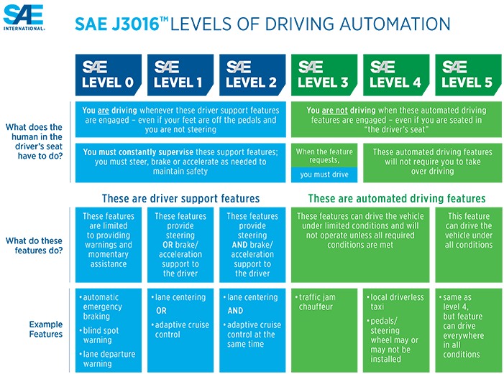

Figure 1: SAE's Levels of Vehicle Autonomy - Tesla Autopilot commonly classified as level 2 [2]

This requirement of driver attentiveness has been, and continues to be, a huge issue in the public deployment of Autopilot software. This is evident from the number of crashes and deaths that have occurred with Autopilot engaged. The first confirmed Autopilot death occurred on a Florida highway in 2016, when neither the driver nor the Autopilot were able to detect a semi-trailer crossing the road perpendicularly, resulting in collision [5]. The National Transportation Safety Board (NTSB) determined that the cause of the crash was partly due to the driver’s overreliance on the Autopilot system, stating that there was no human input to the car for 2 minutes prior to the crash, and only a mere 25 seconds of human input for the 37 minutes of Autopilot engagement [5] [6]. At the time of the incident, the only precautions put in place by Tesla to mitigate against driver distraction were warning messages, such as on the support page, which states Autopilot features are “… intended for use with a fully attentive driver, who has their hands on the wheel and is prepared to take over at any moment… [and] do not make the vehicle autonomous“ [1], as well as in Tesla car manuals, on the in-car display when it is first enabled, and subsequently whenever activated [4]. The NTSB criticised the fact that the driver was allowed to keep Autopilot engaged even though they were ignoring all warnings and weren’t detected to be paying attention [6]. Tesla initially either didn’t account for humans misusing their self-driving system, which is morally negligent, or they intentionally decided to not implement better safeguards to protect and combat against driver distraction, which is morally reckless.

In fairness, it must be said that Tesla has since updated the software to frequently check whether the driver is applying torque to the steering wheel, and provides visual and audible alerts if it doesn’t detect human input, eventually slowing to a stop if driver input remains undetected [4]. The problem is that this can take up to 60 seconds to complete, in which a lot can happen, and even though Autopilot is disabled for the rest of the drive after this occurs, a new drive can be started simply by putting the vehicle into park, then back into drive [15]. The consequence of such ineffective countermeasures is that there have since been more crashes and fatalities due to misuse. Coincidentally, a crash that was almost identical to the aforementioned 2016 semi-trailer crash occurred in 2019, in which the NTSB once again concluded that Autopilot was engaged and the driver hadn’t touched the wheel for 8 seconds prior to impact [16]. Other relevant crashes involving Autopilot and driver distraction include a spree of collisions with stationary vehicles, such as police cars [17] and fire trucks, in which one of the drivers was on her phone and hadn’t touched the wheel for over a minute prior to the crash [18], a fatal crash in which the driver, who was playing a video game on his phone, hit a concrete highway lane divider after 6 seconds of hands free driving [19], and very recently, and a non-fatal but incredibly obvious crash into an overturned truck [20], the video [21] of which indicates the driver clearly wasn’t paying attention.

Both the NTSB and Tesla’s own engineers requested

* ACM CoE principle 1.2 avoid harm : even though Tesla’s intentions may be to prevent crashes and save lives, it is clearly also leading to harm. The CoE states that when well intended actions lead to harm, the responsibility is
* ACM CoE professional responsibility 2.5 involves comprehensively evaluating the possible risks of a software systems

The fact is, Tesla can release statements saying the drivers are at fault because they aren’t keeping their hands on the wheel, but that doesn’t absolve them of their responsibilities. [try cite an ethical code here to do with computer science that states they shouldn’t just be making this excuse but instead implementing a better system, like the Cadillac one, reference that here]

Especially if they are going to test in the public

This leads into the first ethical issue, which is deciding whether Tesla has done enough to educate and enforce safe use of their Autopilot software.

This leads into the first ethical issue, the naming and marketing of Autopilot. It is misleading to call these packages Autopilot and Full Self-Driving, as the former implies it is an autonomous piloting software, and the latter a feature complete self-driving software. A survey conducted by the Insurance Institute for Highway Safety (IIHS), of which the results are depicted in figure 2, clearly reveals Tesla’s Autopilot naming is the worst offender amongst level 2 driving software when it comes to misleading the general public about the capabilities of the software, and what behavior is acceptable when using it [7]. Furthermore, Tesla CEO Elon Musk has also repeatedly neglected his own company’s safety advice by taking his hands off the wheel whilst Autopilot was engaged in multiple televised interviews, including on 60 Minutes [8], CBS This Morning [9], and Bloomberg [10]. Actions speak louder than words, and with the huge audiences that these mainstream outlets have, it’s morally reckless to normalise this kind of behaviour. This hasn’t gone unnoticed in the industry, in fact, The Center for Auto Safety and Consumer Watchdog launched a request for investigation to the Federal Trade Commission with regards to Tesla’s Autopilot marketing [11], and a German court recently banned Tesla from using such terms [12].

It’s clear that this marketing and behaviour is unethical from a deontological perspective because … Deontology is very theoretical and on principle, and so it is important to evaluate the consequences of these decisions as well, because …

Tesla questioned the relevance of this survey, arguing that whilst the general public may be misled by the term Autopilot, Tesla owners are not [13]. A German company, puls Marktforschung, surveyed Tesla owners specifically, finding that 98% of respondents were aware they had to maintain control of the vehicle at all times and were familiar with the numerous safety warnings and agreements (results shown in figure 3) [14]. It should definitely be noted that 7% of Tesla owners still thought Autopilot meant fully autonomous, not requiring any driver supervision, which contradicts an implied figure of 2% from the earlier questions (100%-98%=2%), questioning the reliability of the answers.

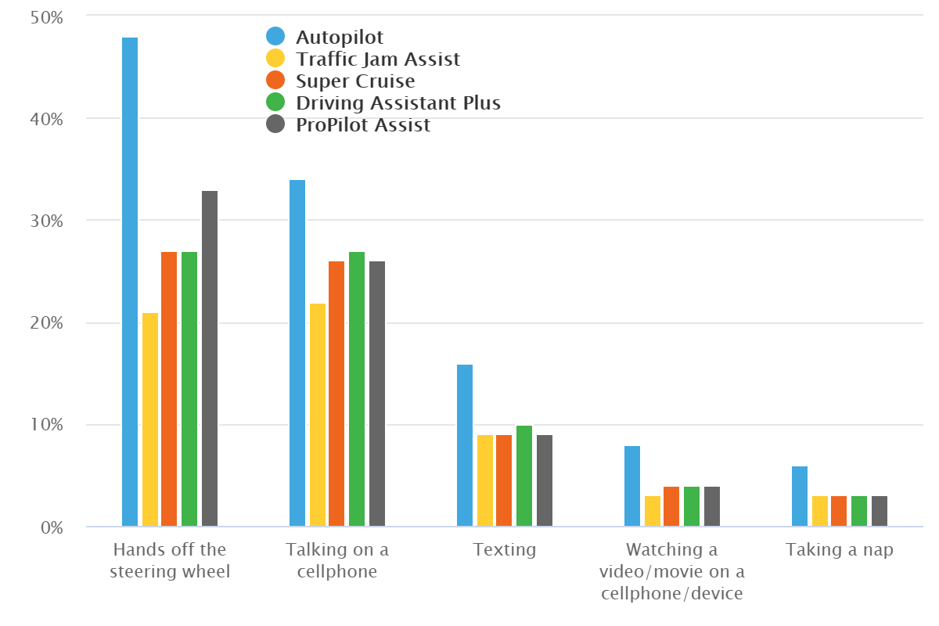

Figure 2: Results of the IIHS survey depicting the percentage of people who believe certain behaviours are safe whilst a level 2 system is being used - Tesla's Autopilot shown in blue [7].

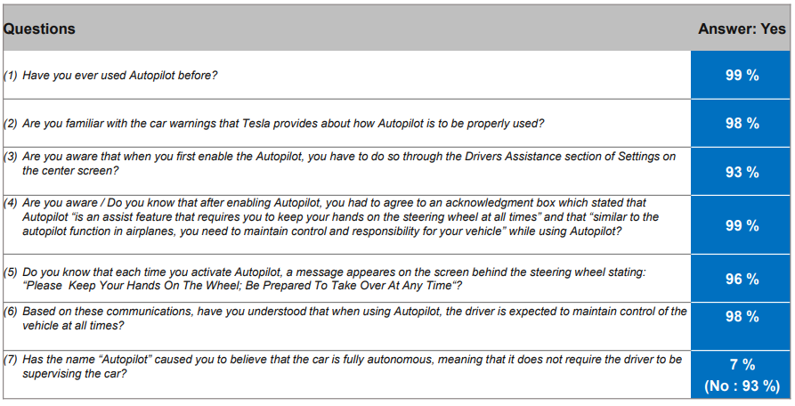

Figure 3: Results of the ‘puls Marktforschung’ survey 'Awareness and utilization of the Autopilot' [14]

[End all above arguments by saying the public testing of Autopilot has been criticized by many others in the industry. This links to the below into statement for the benefits of Tesla’s public Autopilot release.]

The distribution of Autopilot to the public is not all bad, however. [show how Tesla’s also prevent crashes and save lives, and cite some valid safety statistics].

Conclusion:

There are consequentialist arguments both for and against Tesla’s public testing of its Autopilot software, in that it both prevents crashes and causes them. The deontological perspective is much more punishing of Tesla, and it does reveal that there are actions the company could take to remedy these ethical issues (better driver attention software and marketing). There doesn’t seem to be a clear intention on Tesla’s part to be ethical [not adhering to ACM], they seem more concerned with merely getting their tech in the hands of the public. Acting ethical will become even more so important as self-driving software approaches the higher levels of autonomy, and so I advise not investing until these issues are redressed and they show a clear intention of being ethical.

# References

|  |  |
| --- | --- |
| [1] | Tesla, “Tesla Autopilot Support Page,” Tesla, 2020. [Online]. Available: https://www.tesla.com/support/autopilot. [Accessed 16 11 2020]. |
| [2] | SAE International, "SAE International Releases Updated Visual Chart for Its “Levels of Driving Automation” Standard for Self-Driving Vehicles," SAE International, 11 12 2018. [Online]. Available: https://www.sae.org/news/press-room/2018/12/sae-international-releases-updated-visual-chart-for-its-%E2%80%9Clevels-of-driving-automation%E2%80%9D-standard-for-self-driving-vehicles. [Accessed 16 11 2020]. |
| [3] | SAE International, "Taxonomy and Definitions for Terms Related to Driving Automation Systems for On-Road Motor Vehicles," SAE International, 15 June 2018. [Online]. Available: https://saemobilus.sae.org/content/J3016_201806/#toc. [Accessed 16 11 2020]. |
| [4] | Tesla, "A Tragic Loss," Tesla, 30 6 2016. [Online]. Available: https://www.tesla.com/en_AU/blog/tragic-loss?redirect=no. [Accessed 17 11 2020]. |
| [5] | National Transport Safety Board, "Collision between a Car Operating with Automated Vehicle Control Systems and a Tractor-Semitrailer Truck," National Transport Safety Board, 7 5 2016. [Online]. Available: https://www.ntsb.gov/news/events/Documents/2017-HWY16FH018-BMG-abstract.pdf. [Accessed 17 11 2020]. |
| [6] | S. Smith, "NTSB: Fatal Crash Involving Tesla Autopilot Resulted from Driver Errors, Overreliance on Automation," EHS Today, 14 9 2017. [Online]. Available: https://www.ehstoday.com/safety/article/21919260/ntsb-fatal-crash-involving-tesla-autopilot-resulted-from-driver-errors-overreliance-on-automation. [Accessed 17 11 2020]. |
| [7] | Insurance Institute for Highway Safety, "New studies highlight driver confusion about automated systems," Insurance Institute for Highway Safety, 20 6 2019. [Online]. Available: https://www.iihs.org/news/detail/new-studies-highlight-driver-confusion-about-automated-systems. [Accessed 16 11 2020]. |
| [8] | T. Greene, "Elon stokes stupidity by driving Tesla Model 3 unsafely on 60 Minutes," The Next Web, 12 12 2018. [Online]. Available: https://thenextweb.com/artificial-intelligence/2018/12/11/elon-stokes-stupidity-by-driving-tesla-model-3-unsafely-on-60-minutes/. [Accessed 16 11 2020]. |
| [9] | CBS News, "Elon Musk says Tesla's autopilot system will "never be perfect"," CBS News, 13 4 2018. [Online]. Available: https://www.cbsnews.com/video/elon-musk-says-teslas-autopilot-system-will-never-be-perfect/#x. [Accessed 16 11 2020]. |
| [10] | Bloomberg Quicktake, "Tesla Test Drive: Model P85D, Autopilot, Zero to 60," Bloomberg, 10 10 2014. [Online]. Available: https://youtu.be/MO0vdNNzwxk?t=120. [Accessed 16 11 2020]. |
| [11] | J. L. a. J. Simpson, "Request for Investigation of Deceptive and Unfair Practices in Advertising and Marketing of the “Autopilot” Feature Offered in Tesla Motor Vehicles," 'The Center for Auto Safety' and 'Consumer Watchdog', 23 5 2018. [Online]. Available: https://www.autosafety.org/wp-content/uploads/2018/05/CAS-and-CW-Letter-to-FTC-on-Tesla-Deceptive-Advertising.pdf. [Accessed 17 11 2020]. |
| [12] | BBC News, "Tesla's 'Autopilot' misleading, Germany rules," BBC News, 15 July 2020. [Online]. Available: https://www.bbc.com/news/technology-53418069. [Accessed 16 11 2020]. |
| [13] | K. Korosec, "Tesla to Germany: Our Owners Understand Autopilot Just Fine, Thank You," Yahoo Finance, 11 11 2016. [Online]. Available: https://finance.yahoo.com/news/tesla-germany-owners-understand-autopilot-220954859.html. [Accessed 17 11 2020]. |
| [14] | D. K. Wessner, "Awareness and utilization of the Autopilot: Tesla Survey," puls Marktforschung GmbH, 8 11 2016. [Online]. Available: https://www.tesla.com/sites/default/files/blog_attachments/tesla_survey_autopilot_awareness.pdf. [Accessed 17 11 2020]. |
| [15] | SpawnPoint, "THIS is what happens when you IGNORE Tesla's AutoPilot Warnings," SpawnPoint on YouTube, 15 4 2020. [Online]. Available: https://youtu.be/oBIKikBmdN8?t=85. [Accessed 17 11 2020]. |
| [16] | A. Davies, "Tesla’s Latest Autopilot Death Looks Just Like a Prior Crash," Wired, 16 5 2019. [Online]. Available: https://www.wired.com/story/teslas-latest-autopilot-death-looks-like-prior-crash/. [Accessed 17 11 2020]. |
| [17] | M. Matousek, "A Tesla Model S crashed into a parked police car while Autopilot was activated," Business Insider, 30 5 2018. [Online]. Available: https://www.businessinsider.com.au/tesla-model-s-with-autopilot-on-crashes-into-police-car-2018-5. [Accessed 17 11 2020]. |
| [18] | M. Matousek, "Tesla's data confirms Model S that crashed into fire truck had Autopilot engaged," Business Insider, 18 5 2018. [Online]. Available: https://www.businessinsider.com.au/tesla-model-s-had-autopilot-engaged-during-crash-data-confirms-2018-5. [Accessed 17 11 2020]. |
| [19] | M. Matousek, "The Tesla Model X that crashed into a barrier while in Autopilot sped up right before the accident, new report shows," Business Insider, 8 6 2018. [Online]. Available: https://www.businessinsider.com.au/tesla-model-x-in-fatal-autopilot-crash-sped-up-right-before-accident-2018-6. [Accessed 17 11 2020]. |
| [20] | R. Stumpf, "Autopilot Blamed for Tesla's Crash Into Overturned Truck," The Drive, 1 6 2020. [Online]. Available: https://www.thedrive.com/news/33789/autopilot-blamed-for-teslas-crash-into-overturned-truck. [Accessed 17 11 2020]. |
| [21] | D. T. Canada, "Tesla Model 3 crashes into overturned truck on highway," Drive Tesla Canada on YouTube, 1 6 2020. [Online]. Available: https://www.youtube.com/watch?v=LfmAG4dk-rU. [Accessed 17 11 2020]. |