An Ethical Evaluation of Tesla’s Autopilot – Nicholas Quinn (z5117408)

Tesla is an American electric vehicle manufacturing company and one of the biggest competitors in the self-driving industry, thanks to their Autopilot software. This report focuses on the current day issues of self-driving software, specifically those that arise due to full autonomy not yet being achieved, such as the **need for an attentive driver who understands the limitations of this software** to still be behind the wheel. In deciding whether to invest, I consider whether Tesla should be testing via, and distributing their Autopilot software to, the general public, specifically taking into consideration the two aforementioned issues of understanding and attentiveness.

*Background*

Before covering the ethical issues surrounding Autopilot, it is necessary to first outline what it is. According to the Tesla website, Autopilot is a generic term for their “advanced **driver assistance** system”, which is powered by 8 external cameras, a forwards-facing radar, and 12 ultrasonic sensors that all serve as inputs to an onboard computer running a deep neural network [1]. Autopilot (AP) and Full Self-Driving (FSD) are two specific types of Autopilot, each offering different features. The most relevant features to this discussion include traffic aware cruise control (AP), automatic steering (AP), and highway and city street navigation (FSD **beta**) [1]. Both packages fall under the industry standard [2] Society of Automotive Engineers level 2 classification of self-driving vehicles, which means **the driver is still required to be fully attentive, with their hands on the wheel, ready to take control at all times** [3]. It is also important to note that, due to the age of the industry and the techniques used within it (i.e. deep machine learning), there are naturally going to be many bugs [4]. Nevertheless, Tesla’s technical approach to the problem is sound when it comes to capability and performance [5] [6], with even their most controversial choice of not using LiDAR [7] being backed up by researchers [8]. In fact, no self-driving company is ethically required to program bugless and fully functional code immediately, as this is impossible. The ethical responsibility is therefore more about mitigating the ramifications of these bugs, especially for Tesla as they are testing and training their software via the public [9], a choice which they have been criticized for by members of the industry [10].

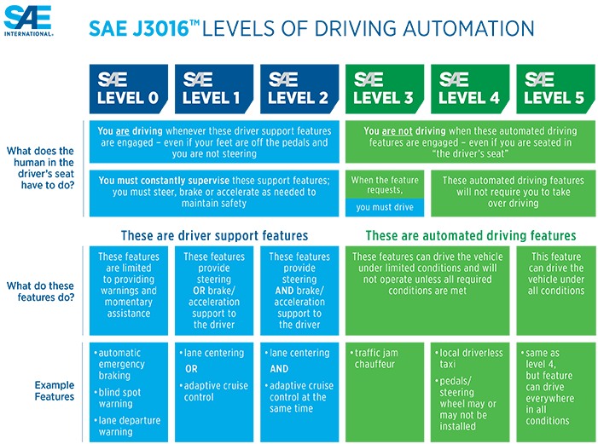

Figure 1: SAE's Levels of Vehicle Autonomy - Tesla Autopilot commonly classified as level 2 [2]

*The Situation*

Driver attentiveness has been, and continues to be, a huge issue in the public deployment of level-2 driving software, including Autopilot. In fact, it is one of the main metrics used to rate such software [5] [6]. The severity of this issue is evident by the number of crashes and deaths that have occurred with Autopilot engaged. The first confirmed Autopilot death occurred on a Florida highway in 2016, when neither the driver nor the Autopilot were able to detect a semi-trailer crossing the road perpendicularly, resulting in collision [11]. The National Transportation Safety Board (NTSB) determined that the cause of the crash was partly due to the driver’s overreliance on the Autopilot system, stating that there was no human input to the car for 2 minutes prior to the crash, and only a mere 25 seconds of human input for the 37 minutes of Autopilot engagement [11] [12]. At the time of the incident, the only precautions put in place by Tesla to mitigate against driver distraction were warning messages, such as on the support page, which states Autopilot features are “… intended for use with a fully attentive driver, who has their hands on the wheel and is prepared to take over at any moment… [and] do not make the vehicle autonomous“ [1], as well as in Tesla car manuals, on the in-car display when it is first enabled, and subsequently whenever activated [13]. The NTSB criticised the fact that the driver was allowed to keep Autopilot engaged even though they were ignoring all warnings and weren’t detected to be paying attention [12]. Tesla initially either didn’t account for humans misusing their self-driving system, which is morally negligent, or they intentionally decided to not implement better safeguards to protect and combat against driver distraction, which is morally reckless.

In fairness, it must be said that Tesla has since updated the software to frequently check whether the driver is applying torque to the steering wheel, and provides visual and audible alerts if it doesn’t detect human input, eventually slowing to a stop if driver input remains undetected [13]. The problem is that this can take up to 60 seconds to complete, in which a lot can happen, and even though Autopilot is disabled for the rest of the drive after this occurs, a new drive can be started simply by putting the vehicle into park, then back into drive [14]. The consequence of such ineffective countermeasures is that there have since been more crashes and fatalities due to misuse. Coincidentally, a crash that was almost identical to the aforementioned 2016 semi-trailer crash occurred in 2019, in which the NTSB once again concluded that Autopilot was engaged and the driver hadn’t touched the wheel for 8 seconds prior to impact [15]. Other relevant crashes involving Autopilot and driver distraction include collisions with stationary vehicles, such as police cars [16] and fire trucks, in which one of the drivers was on her phone and hadn’t touched the wheel for over a minute prior to the crash [17], a fatal crash in which the driver, who was playing a video game on his phone, hit a concrete highway lane divider after 6 seconds of hands free driving [18], and very recently, and a non-fatal but incredibly obvious crash into an overturned truck [19], the video [20] of which indicates the driver clearly wasn’t paying attention.

This obvious and persistent issue has not yet been adequately addressed despite the NTSB calling for Tesla to “develop applications to more effectively sense the driver’s level of engagement and alert the driver when engagement is lacking” all the way back in 2017 [11]. This sentiment was also backed by Tesla’s own engineers, suggesting they implement eye-tracking software similar to Cadillac’s Super Cruise [21], which was ranked the highest amongst 4 level-2 self-driving systems for driver engagement, compared to Autopilot which scored the lowest [6]. This request was ignored by Tesla executives, who passed it off as ineffective [22]. These actions are a clear violation of the Association for Computing Machinery’s Code of Ethics and Professional Conduct (ACM CoE), specifically the principle of avoiding harm, the responsibility to comprehensively analyse the risks of computer systems, and the responsibility to design and implement systems that are secure even when misused [23]. [MORE ETHICS ARGUMENT NEEDED HERE]

This naturally leads onto the second ethical issue, the naming and marketing of Autopilot, as it has a potentially compounding effect on the previous issue. It is misleading to call the Autopilot packages Autopilot and Full Self-Driving, as the former implies it is an autonomous piloting software, and the latter a feature complete self-driving software. A survey conducted by the Insurance Institute for Highway Safety (IIHS), of which the results are depicted in figure 2, clearly reveals Tesla’s Autopilot naming is the worst offender amongst level 2 driving software when it comes to misleading the general public about the capabilities of the software, and what behavior is acceptable when using it [24]. Furthermore, Tesla CEO Elon Musk has also repeatedly neglected his own company’s safety advice by taking his hands off the wheel whilst Autopilot was engaged in multiple televised interviews, including on 60 Minutes [25], CBS This Morning [26], and Bloomberg [27]. Actions speak louder than words, and with the huge audiences that these mainstream outlets have, it’s morally reckless to normalise this kind of behaviour. [Hypocritical to promote the software in this way given their numerous warnings about this very behaviour, and it is a violation of the ACM CoE principle about fostering public awareness and understanding of software systems, especially their limitations [23]]. This hasn’t gone unnoticed in the industry, in fact, The Center for Auto Safety and Consumer Watchdog launched a request for investigation to the Federal Trade Commission with regards to Tesla’s Autopilot marketing [28], and a German court recently banned Tesla from using such terms [29].

It’s clear that this marketing and behaviour is unethical from a deontological perspective because … Deontology is very theoretical and on principle, and so it is important to evaluate the consequences of these decisions as well, because …

Tesla questioned the relevance of this survey, arguing that whilst the general public may be misled by the term Autopilot, Tesla owners are not [30]. A German company, puls Marktforschung, surveyed Tesla owners specifically, finding that 98% of respondents were aware they had to maintain control of the vehicle at all times and were familiar with the numerous safety warnings and agreements (results shown in figure 3) [31]. It should definitely be noted that 7% of Tesla owners still thought Autopilot meant fully autonomous, not requiring any driver supervision, which may not seem like much at first, but considering there are over 800,000 Autopilot enabled vehicles, which have together driven over 3.3 billion miles [32], that’s a lot of unsupervised Autopilot driving. From a deontological perspective, in which morality is determined by the principle of the action itself and not its consequences, it doesn’t matter whether or not Tesla owners mostly understand the limitations of Autopilot anyway, but rather that Tesla, on principle, is being deceptive. This is another clear breach of the ACM CoE, including principle 1.3, which is concerned with being honest and trustworthy, and responsibility 2.7, which entails fostering public awareness and understanding of software systems, especially their limitations [23].

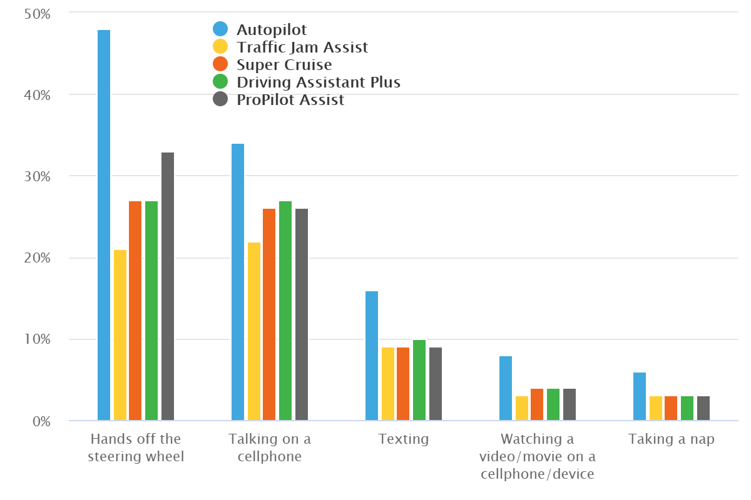

Figure 2: Results of the IIHS survey depicting the percentage of people who believe certain behaviours are safe whilst a level 2 system is being used - Tesla's Autopilot shown in blue [24].

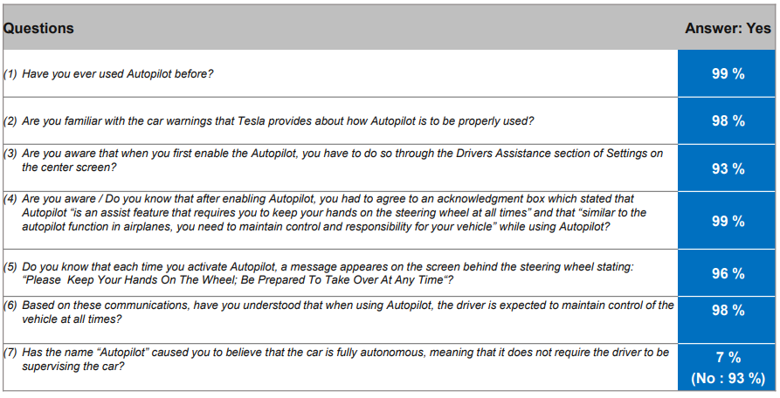

Figure 3: Results of the ‘puls Marktforschung’ survey 'Awareness and utilization of the Autopilot' [31]

The distribution of Autopilot to the public is not all bad, however. Despite the aforementioned crashes, Tesla’s that are driving with Autopilot enabled are reported to only have an accident every 4.53 million miles, whereas the US average is every 479,000 miles, a rate of almost 10 times less (see figure 4) [33]. Whilst it is unlikely that this data is completely reliable from a statistical perspective, the general trend of Autopilot accidents decreasing over the past couple of years, and the difference in accident rates between Tesla’s using Autopilot compared to those which aren’t, at least reveals that it does halve accidents purely amongst Tesla’s. Furthermore, there is an abundance of video evidence showing Autopilot both predicting and avoiding accidents [34] [35], as well as reports of drunk and asleep drivers being saved by Autopilot [36] [37]. From a consequentialist perspective, this is a huge benefit to society, especially when you consider that drink driving contributes to 1/3 of all vehicle fatalities in the US (NHTSA) [38], and sleep deprivation causes approximately 100,000 accidents annually, again in the US (NHTSA) [39].

It must also be said that, from a deontological perspective, Tesla isn’t completely at fault for the issue of driver attentiveness because the drivers are breaking their promise to remain in control at all times. If we set aside this issue of driver attention, focusing solely on the software itself, then, from a consequentialist perspective, Autopilot is ethical because it is preventing accidents, and therefore injury and death.

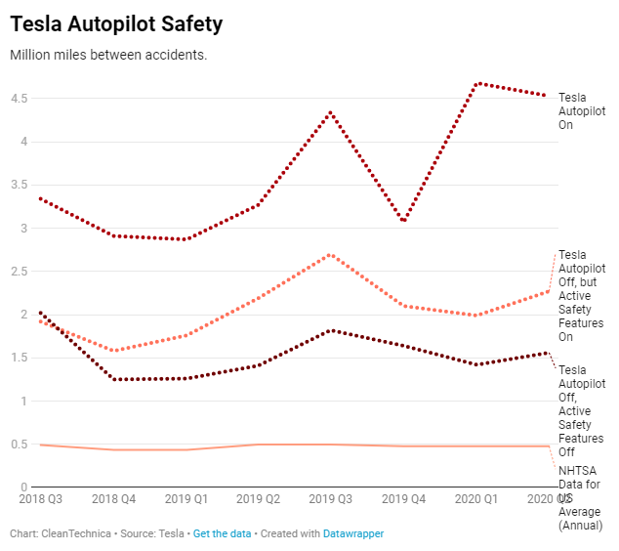

Figure 4: Tesla Autopilot Safety Statistics, by CleanTechnica [33]

*Ethical Reasoning*

*Conclusion*

There are consequentialist arguments both for and against Tesla’s public testing of its Autopilot software, in that it both prevents crashes and indirectly causes them. The deontological perspective is much more punishing of Tesla, and it does reveal that there are actions the company could take to remedy these ethical issues (better driver attention software and marketing). There doesn’t seem to be a clear intention on Tesla’s part to be ethical [not adhering to ACM], they seem more concerned with merely getting their tech in the hands of the public. Acting ethical will become even more so important as self-driving software approaches the higher levels of autonomy, and so I advise not investing until these issues are redressed and they show a clear intention of being ethical.

# References

|  |  |
| --- | --- |
| [1] | Tesla, “Tesla Autopilot Support Page,” Tesla, 2020. [Online]. Available: https://www.tesla.com/support/autopilot. [Accessed 16 11 2020]. |
| [2] | SAE International, "SAE International Releases Updated Visual Chart for Its “Levels of Driving Automation” Standard for Self-Driving Vehicles," SAE International, 11 12 2018. [Online]. Available: https://www.sae.org/news/press-room/2018/12/sae-international-releases-updated-visual-chart-for-its-%E2%80%9Clevels-of-driving-automation%E2%80%9D-standard-for-self-driving-vehicles. [Accessed 16 11 2020]. |
| [3] | SAE International, "Taxonomy and Definitions for Terms Related to Driving Automation Systems for On-Road Motor Vehicles," SAE International, 15 June 2018. [Online]. Available: https://saemobilus.sae.org/content/J3016_201806/#toc. [Accessed 16 11 2020]. |
| [4] | D. Heaven, "Why deep-learning AIs are so easy to fool," Nature, 9 10 2019. [Online]. Available: https://www.nature.com/articles/d41586-019-03013-5. [Accessed 21 11 2020]. |
| [5] | Reuters, "Tesla Autopilot gets low score for driver focus in European safety rating," Automotive News Europe, 1 10 2020. [Online]. Available: https://europe.autonews.com/automakers/tesla-autopilot-gets-low-score-driver-focus-european-safety-rating. [Accessed 20 11 2020]. |
| [6] | P. Olsen, "Cadillac Tops Tesla in Consumer Reports' First Ranking of Automated Driving Systems," Consumer Reports, 4 11 2018. [Online]. Available: https://www.consumerreports.org/autonomous-driving/cadillac-tops-tesla-in-automated-systems-ranking/. [Accessed 18 11 2020]. |
| [7] | The Verge, "IT’S ELON MUSK VS. EVERYONE ELSE IN THE RACE FOR FULLY DRIVERLESS CARS," The Verge, 24 4 2019. [Online]. Available: https://www.theverge.com/2019/4/24/18512580/elon-musk-tesla-driverless-cars-lidar-simulation-waymo. [Accessed 20 11 2020]. |
| [8] | S. Crowe, "Researchers back Tesla’s non-LiDAR approach to self-driving cars," The Robot Report, 25 4 2019. [Online]. Available: https://www.therobotreport.com/researchers-back-teslas-non-lidar-approach-to-self-driving-cars/. [Accessed 20 11 2020]. |
| [9] | Synced, "Tesla Rolls Out ‘Full Self-Driving’ Beta; Critics Apply the Brakes," Synced, 28 10 2020. [Online]. Available: https://syncedreview.com/2020/10/28/tesla-rolls-out-full-self-driving-beta-critics-apply-the-brakes/. [Accessed 20 11 2020]. |
| [10] | A. J. Hawkins, "Tesla’s ‘Full Self-Driving’ beta is here, and it looks scary as hell," The Verge, 22 10 2020. [Online]. Available: https://www.theverge.com/2020/10/22/21528508/tesla-full-self-driving-beta-first-reaction-video. [Accessed 20 11 2020]. |
| [11] | National Transport Safety Board, "Collision between a Car Operating with Automated Vehicle Control Systems and a Tractor-Semitrailer Truck," National Transport Safety Board, 12 9 2017. [Online]. Available: https://www.ntsb.gov/news/events/Documents/2017-HWY16FH018-BMG-abstract.pdf. [Accessed 17 11 2020]. |
| [12] | S. Smith, "NTSB: Fatal Crash Involving Tesla Autopilot Resulted from Driver Errors, Overreliance on Automation," EHS Today, 14 9 2017. [Online]. Available: https://www.ehstoday.com/safety/article/21919260/ntsb-fatal-crash-involving-tesla-autopilot-resulted-from-driver-errors-overreliance-on-automation. [Accessed 17 11 2020]. |
| [13] | Tesla, "A Tragic Loss," Tesla, 30 6 2016. [Online]. Available: https://www.tesla.com/en_AU/blog/tragic-loss?redirect=no. [Accessed 17 11 2020]. |
| [14] | SpawnPoint, "THIS is what happens when you IGNORE Tesla's AutoPilot Warnings," SpawnPoint on YouTube, 15 4 2020. [Online]. Available: https://youtu.be/oBIKikBmdN8?t=85. [Accessed 17 11 2020]. |
| [15] | A. Davies, "Tesla’s Latest Autopilot Death Looks Just Like a Prior Crash," Wired, 16 5 2019. [Online]. Available: https://www.wired.com/story/teslas-latest-autopilot-death-looks-like-prior-crash/. [Accessed 17 11 2020]. |
| [16] | M. Matousek, "A Tesla Model S crashed into a parked police car while Autopilot was activated," Business Insider, 30 5 2018. [Online]. Available: https://www.businessinsider.com.au/tesla-model-s-with-autopilot-on-crashes-into-police-car-2018-5. [Accessed 17 11 2020]. |
| [17] | M. Matousek, "Tesla's data confirms Model S that crashed into fire truck had Autopilot engaged," Business Insider, 18 5 2018. [Online]. Available: https://www.businessinsider.com.au/tesla-model-s-had-autopilot-engaged-during-crash-data-confirms-2018-5. [Accessed 17 11 2020]. |
| [18] | M. Matousek, "The Tesla Model X that crashed into a barrier while in Autopilot sped up right before the accident, new report shows," Business Insider, 8 6 2018. [Online]. Available: https://www.businessinsider.com.au/tesla-model-x-in-fatal-autopilot-crash-sped-up-right-before-accident-2018-6. [Accessed 17 11 2020]. |
| [19] | R. Stumpf, "Autopilot Blamed for Tesla's Crash Into Overturned Truck," The Drive, 1 6 2020. [Online]. Available: https://www.thedrive.com/news/33789/autopilot-blamed-for-teslas-crash-into-overturned-truck. [Accessed 17 11 2020]. |
| [20] | D. T. Canada, "Tesla Model 3 crashes into overturned truck on highway," Drive Tesla Canada on YouTube, 1 6 2020. [Online]. Available: https://www.youtube.com/watch?v=LfmAG4dk-rU. [Accessed 17 11 2020]. |
| [21] | S. O'Kane, "Tesla rejected more advanced driver monitoring features on its cars," The Verge, 14 5 2018. [Online]. Available: https://www.theverge.com/2018/5/14/17352814/elon-musk-tesla-autopilot-face-tracking-gm. [Accessed 18 11 2020]. |
| [22] | E. M. Techmeme, "Elon Musk clarifies eye-tracking was rejected for ineffectiveness, not cost," 15 5 2018. [Online]. Available: https://twitter.com/elonmusk/status/996102919811350528. [Accessed 18 11 2020]. |
| [23] | ACM Code 2018 Task Force, "ACM Code of Ethics and Professional Conduct," Association for Computing Machinery, 22 6 2018. [Online]. Available: https://www.acm.org/code-of-ethics. [Accessed 18 11 2020]. |
| [24] | Insurance Institute for Highway Safety, "New studies highlight driver confusion about automated systems," Insurance Institute for Highway Safety, 20 6 2019. [Online]. Available: https://www.iihs.org/news/detail/new-studies-highlight-driver-confusion-about-automated-systems. [Accessed 16 11 2020]. |
| [25] | T. Greene, "Elon stokes stupidity by driving Tesla Model 3 unsafely on 60 Minutes," The Next Web, 12 12 2018. [Online]. Available: https://thenextweb.com/artificial-intelligence/2018/12/11/elon-stokes-stupidity-by-driving-tesla-model-3-unsafely-on-60-minutes/. [Accessed 16 11 2020]. |
| [26] | CBS News, "Elon Musk says Tesla's autopilot system will "never be perfect"," CBS News, 13 4 2018. [Online]. Available: https://www.cbsnews.com/video/elon-musk-says-teslas-autopilot-system-will-never-be-perfect/#x. [Accessed 16 11 2020]. |
| [27] | Bloomberg Quicktake, "Tesla Test Drive: Model P85D, Autopilot, Zero to 60," Bloomberg, 10 10 2014. [Online]. Available: https://youtu.be/MO0vdNNzwxk?t=120. [Accessed 16 11 2020]. |
| [28] | J. L. a. J. Simpson, "Request for Investigation of Deceptive and Unfair Practices in Advertising and Marketing of the “Autopilot” Feature Offered in Tesla Motor Vehicles," 'The Center for Auto Safety' and 'Consumer Watchdog', 23 5 2018. [Online]. Available: https://www.autosafety.org/wp-content/uploads/2018/05/CAS-and-CW-Letter-to-FTC-on-Tesla-Deceptive-Advertising.pdf. [Accessed 17 11 2020]. |
| [29] | BBC News, "Tesla's 'Autopilot' misleading, Germany rules," BBC News, 15 July 2020. [Online]. Available: https://www.bbc.com/news/technology-53418069. [Accessed 16 11 2020]. |
| [30] | K. Korosec, "Tesla to Germany: Our Owners Understand Autopilot Just Fine, Thank You," Yahoo Finance, 11 11 2016. [Online]. Available: https://finance.yahoo.com/news/tesla-germany-owners-understand-autopilot-220954859.html. [Accessed 17 11 2020]. |
| [31] | D. K. Wessner, "Awareness and utilization of the Autopilot: Tesla Survey," puls Marktforschung GmbH, 8 11 2016. [Online]. Available: https://www.tesla.com/sites/default/files/blog_attachments/tesla_survey_autopilot_awareness.pdf. [Accessed 17 11 2020]. |
| [32] | L. Fridman, "Tesla Vehicle Deliveries and Autopilot Mileage Statistics," 2020. [Online]. Available: https://lexfridman.com/tesla-autopilot-miles-and-vehicles/. [Accessed 18 11 2020]. |
| [33] | Z. Shahan, "Tesla Autopilot Accidents: 1 out of 4,530,000 Miles; US Average: 1 out of 479,000 Miles," CleanTechnica, 1 9 2020. [Online]. Available: https://cleantechnica.com/2020/08/01/tesla-autopilot-accidents-1-out-of-4530000-miles-us-average-1-out-of-479000-miles/. [Accessed 19 11 2020]. |
| [34] | T. Tech, "Tesla Autopilot Saves Lives," Tesla Tech on Youtube, 5 8 2017. [Online]. Available: https://www.youtube.com/watch?v=5sicOh6LPBw. [Accessed 19 11 2020]. |
| [35] | N. McGill, "Teslas Avoiding Accidents Compilation 2 (NEW 2020!)," 19 11 2020. [Online]. Available: https://www.youtube.com/watch?v=RZldxMn7tWU. [Accessed 20 11 2020]. |
| [36] | F. Lambert, "Tesla driver was pulled over by cops after allegedly sleeping drunk on Autopilot for 7 miles," Electrek, 1 12 2018. [Online]. Available: https://electrek.co/2018/12/01/tesla-pulled-over-cops-sleeping-drunk-autopilot/. [Accessed 19 11 2020]. |
| [37] | A. J. Hawkins, "Tesla owner in Canada charged with ‘sleeping’ while driving over 90 mph," The Verge, 18 9 2020. [Online]. Available: https://www.theverge.com/2020/9/18/21445168/tesla-driver-sleeping-police-charged-canada-autopilot. [Accessed 19 11 2020]. |
| [38] | National Highway Traffic Safety Administration, "Drunk Driving," NHTSA, [Online]. Available: https://www.nhtsa.gov/risky-driving/drunk-driving. [Accessed 20 11 2020]. |
| [39] | National Safety Council, "Drivers are Falling Asleep Behind the Wheel," NSC, 11 2020. [Online]. Available: https://www.nsc.org/road-safety/safety-topics/fatigued-driving. [Accessed 20 11 2020]. |