<https://www.newscientist.com/article/2203857-dna-database-opts-a-million-people-out-from-police-searches/>

<https://www.youtube.com/watch?v=CigubAVY9MM>

* More than 90% of Americans support their DNA data being used to solve crime cases.
* Why the hell did they set it to opt-out by default when it’s clear the majority would prefer opt-in? If you can’t be bothered to click opt-out, then you clearly don’t care as much about your privacy as you think you do.
* Christine Franke – murdered at 17 years of age in 2001. 2018 a suspect is arrested. A cold case detective partnered with a genealogist. Together, using the DNA left at the crime scene, they were able to track down 2 relatives of the suspect. They then reverse engineered a family tree and interviewed the most probable families. One woman they interviewed gave a DNA sample which confirmed she was the mother of the suspect. The police then waited for one of the sons to flick a cigarette butt onto the ground, which they then tested. This confirmed he was the killer.
  + DNA left at the crime scene.
  + DNA submitted to DNA database.
  + If direct match then done, else build a family tree from the relatives found.
  + Research the relatives found to see who the suspect is most likely.
  + Perform tests on the family members of the suspect, rather than the suspect themselves (they are less likely to give a sample because they are guilty).
  + Try get a sample from the suspect (voluntarily, or via abandoned DNA).

<https://www.abc.net.au/news/2020-08-22/the-forty-year-hunt-for-the-golden-state-killer/12579638>

* The golden state killer was caught via GEDmatch, a genealogy website that allows people to submit their DNA samples to explore their family tree.
* 20 **distant** relatives had submitted their DNA.
* They constructed a de Angelo family tree. One person in this tree was found to have been a police officer and to have lived in the areas where the crimes happened. He even looked similar to sketches.
* They got his DNA by taking a tissue from his rubbish bin (abandoned DNA).

<https://en.wikipedia.org/wiki/List_of_suspected_perpetrators_of_crimes_identified_with_GEDmatch>

* List of criminals caught

<https://www.genome.gov/about-genomics/policy-issues/Privacy>

* Section on use in law enforcement

<https://www.vox.com/recode/2019/5/13/18547235/trust-smart-devices-privacy-security>

* People say they care about privacy, but their actions say otherwise.

Other notes

* It can provide closure by identifying otherwise unknown victims
* It can exonerate the innocent
* It deters crime from happening because the risk of getting caught these days is so much higher – preventative measures are the best

Off-topic

* In terms of insurance, I don’t think it’s necessarily a bad thing for insurance agencies to use genetic information to alter pricing.
* The basic premise of insurance is that a large amount of people pay a small amount of money so that the small amount who are actually affected by the issue at hand have the money to deal with it. This assumes that the risk of the issue is low (if everyone tries to claim, there won’t be enough money for everyone).
* People generally only buy insurance for things they need it for. If you can use your genetic information to see what you are most at risk of, then you can try get insurance towards this, but this breaks the core assumption of insurance – the risk is low. This will lead to the situation where a higher percentage of people are claiming (compared to what is to be expected from a random sampling from society).
* Therefore, it is not only unfair to the insurance company, but it could actually break the whole concept of insurance, and it becomes a first claim first serve system until the insurance company runs out of money.
* It is also not fair that some people get disabilities. Why should they have to pay lots of money for something they never asked for and have to suffer through? The answer is they shouldn’t have to.
* If the burden isn’t to be put on the insurance companies nor the people with disabilities/medical issues, then who should it be put on?
* I think it is fair for the government, funded via taxpayers (the public), to have to carry the burden collectively.

<https://www.23andme.com/en-int/transparency-report/>

* 23andme seem pretty legit tbh
* <https://www.youtube.com/watch?v=U3EEmVfbKNs>
  + The labs are separate from 23andme. 23andme uses email addresses and unique id, the lab uses unique id and samples. 23andme doesn’t even ever get your DNA.

Main points/key takeaways:

1. Catching criminals in cold cases
2. Exonerating wrongfully convicted people
3. Identifying unknown victims
4. Potentially prevents crime due to the fear of being caught

The core question being answered is: **Should law enforcement agencies have access to genomic data without individual consent?**

So **firstly, I think it’s a good idea to cover how and why they use genealogical databases**. Everyone here is no doubt aware of how DNA is used traditionally in criminal investigations – you find DNA at the crime scene, then you sample your suspects and check for matches. On the other hand, with genealogical databases, they no longer just test against their suspects (especially if there are none, which is quite common for a lot of cold cases), instead they test against as large of a pool of people as they can. Direct matches are obviously the best case result, but even without a direct match, police use what’s called a long range familial search, which is a fancy term for finding relatives. This allows them to then construct a family tree. With the use of medical records and other such public information, the familial genomes can be matched to people (if they aren’t already), and then police can research these people to figure out who it the most likely suspect. From here, they can try get DNA willingly supplied by direct family members of the suspect, or **take abandoned DNA from the suspect without their knowledge to see if they really are the perpetrator** (this is another ethical issue: is DNA you leave behind still yours? Should people/police be able to take that and sequence it?).

I personally believe they are one of the best parties to have access to your genomic data.

Remember how we stated earlier that privacy depends on security? GEDmatch is actually a perfect example of this. After the Golden State Killer was caught, there was an uproar about why the police were able to access the GEDmatch database without the specific consent of the individuals. This led to the company enacting changes that allow users to opt in/out of police having access to their genomic data. However, due to two SECURITY breaches in July of this year, all profiles settings were set to opt-in, thus removing the CHOICE from users (and hence eliminating privacy). As long as data breaches are around, privacy is not guaranteed. **Privacy is a right, but not a guarantee.**

In our dataveillance talk you may remember we mentioned a notion of expectation of privacy with regards to a user’s online data and the companies who store it. In this setting, the data is genomic, but I don’t think there’s always a ground for privacy. If you give your DNA to 23andme or ancestry.com etc. then sure, there’s an expectation that, without a warrant, they will not share your data to police or other third parties. However, with sites like GEDmatch, you’re willingly uploading your information to a public database, and if you’re doing that then you can’t really expect to have privacy (it’s kind of an oxymoron, making the decision to share you genome with the world, yet simultaneously wanting to be selective about who has access to it). Remember that privacy is a decision you make, and making the decision to publically post

False positives

* I believe this is a bit of a non-argument, not because it’s not true (it definitely is), but because of how slim the chances of it actually having a bad outcome is.
* For it to have an actual bad outcome there would first need to be a false positive, then it would need to be feasible that the false positive individual could have done the crime (i.e. even lives in the same country or whereabouts), and whether or not they have an alibi
* Furthermore, I think the wrong person being convicted is much more likely to occur if you don’t use the DNA. No one thinks “cars sometimes break down, so I’m just going to walk everywhere”. This is similar to the self-driving cars argument. People worry that they might glitch and kill you, but if it results in way less deaths than normal driving, then isn’t that worthwhile?

Framing

* I’ve come across a number of people raising concerns about being able to generate someones DNA once it is sequenced and use that to frame them for a crime. I’d argue it’s possible to do this more easily and cheaper without going the route of synthesis and generation, just because of the fact that we shed so much DNA in our day to day life that could be stolen and used.

Familial tree searches

* There are two main perspectives I’ve come across on this topic

1. By submitting your DNA you could be turning in one of your own family members
2. By submitting your DNA you may help in catching a criminal

* These are really the same thing, but one seems to be concerned with loyalty to family, whilst the other seems to be concerned with justice.
* Whilst loyalty would often be seen as an ethical trait, it’s perhaps only so when you are being loyal to someone/something that itself also ethical.
* The more virtuous person would risk turning in one of their friends/family if it means catching a criminal because in reality if you do the crime you do the time. It doesn’t matter if you are my family or friend, you have committed a (potentially heinous) crime and you have to be punished for it.
* To simultaneously believe that all criminals should be held accountable, but your friends and family should not is hypocritical and biased. Just because they are your family member or friend doesn’t mean they’re not a criminal. You cannot have two separate rules.
* Either you believe criminals should be held accountable for their crimes or you don’t. Whether a criminal is your family member or friend shouldn’t matter or be taken into account.

Photos:

People don’t really care

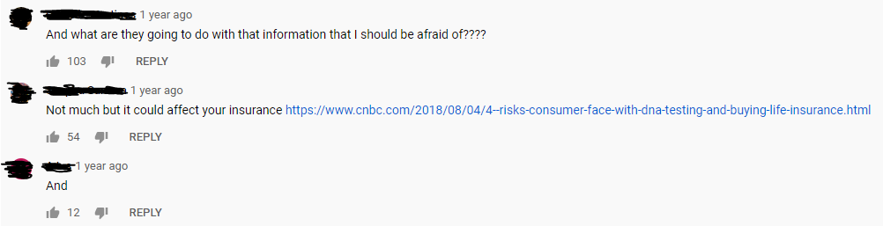

People want killers to be put behind bars

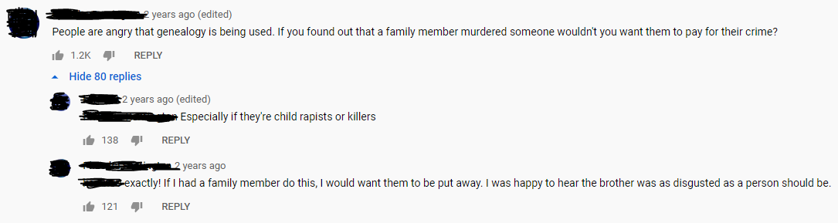

When it comes to police using genealogical databases, it’s not an ethical issue in the eyes of 90% of the population.

As this is an issue of privacy, as long as people are given the choice to decide how their genomic data can be used, who can use it, etc., and these decisions are enforced securely, then there is no problem.

Victim identification

The great part about not needing a sample to match against (instead you match against all samples in the database) is you can now identify victims who were previously unknown.