1.0 window下安装

## 1.0.1下载RabbitMQ

<http://www.rabbitmq.com/download.html>

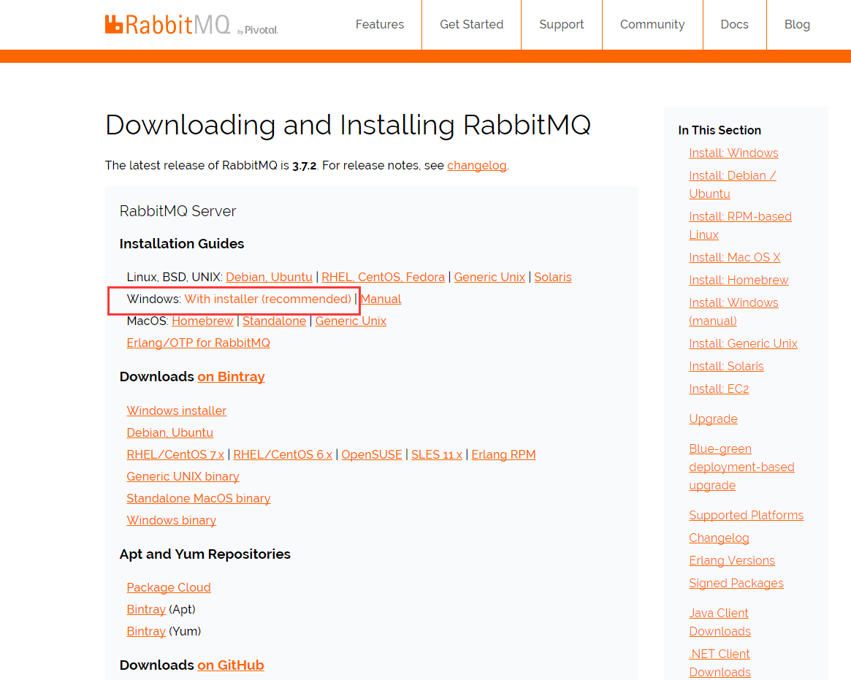

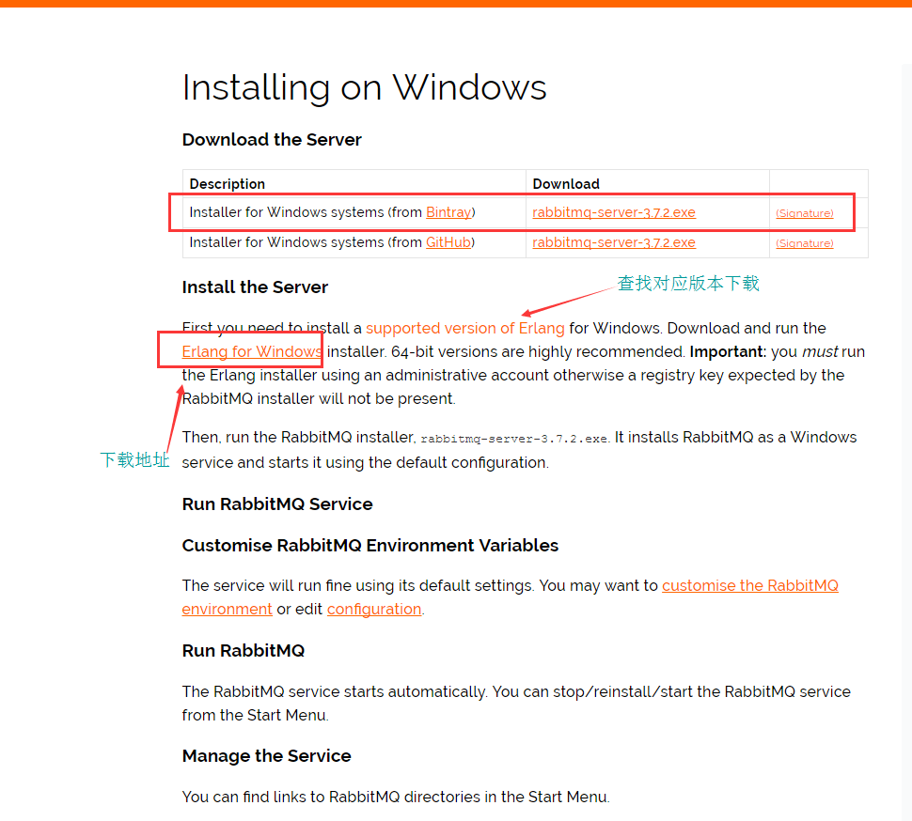

1. Erlang 的下载

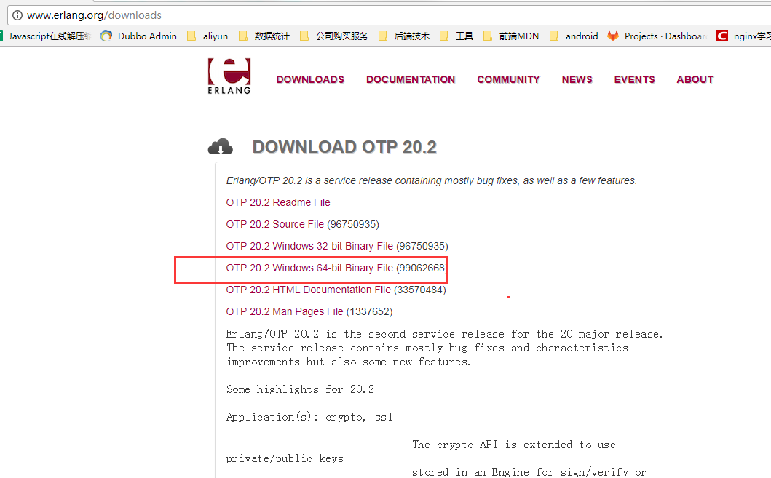

## 1.0.2 RabbitMQ对Erlang版本的对应

|  |  |  |  |
| --- | --- | --- | --- |
| **RabbitMQ** | **Minimum required Erlang/OTP** | **Maximum supported Erlang/OTP** | **Notes** |
| * **3.7.x** | * **19.3** | * **20.2.x** | * We recommend minimum Erlang/OTP 19.3.6.3, earlier versions have known bugs that can prevent RabbitMQ nodes from stopping * Erlang/OTP 20.2 changed [default cookie file location](http://www.rabbitmq.com/cli.html) on Windows * For the best TLS support, the latest version of Erlang/OTP 20.x is recommended |
| * 3.6.15 | * 19.3 | * 20.2.x | * [Erlang/OTP versions prior to 19.3 are not supported](https://groups.google.com/d/msg/rabbitmq-users/kXkI-f3pgEw/UFowJIK4BQAJ) * We recommend minimum Erlang/OTP 19.3.6.3, earlier versions have known bugs that can prevent RabbitMQ nodes from stopping * Erlang/OTP 20.2 changed [default cookie file location](http://www.rabbitmq.com/cli.html) on Windows * For the best TLS support, the latest version of Erlang/OTP 20.x is recommended |
| * 3.6.14 * 3.6.13 * 3.6.12 * 3.6.11 | * R16B03 | * 20.1.x | * We recommend minimum Erlang/OTP 19.3.6.3, earlier versions have known bugs that can prevent RabbitMQ nodes from stopping * For the best TLS support, the latest version of Erlang/OTP 20.1.x is recommended |
| * 3.6.10 * 3.6.9 * 3.6.8 * 3.6.7 * 3.6.6 * 3.6.5 * 3.6.4 | * R16B03 | * 19.3.x | * We recommend minimum Erlang/OTP 19.3.6.3, earlier versions have known bugs that can prevent RabbitMQ nodes from stopping * For the best TLS support, the latest version of Erlang/OTP 19.3.x is recommended |
| * 3.6.3 * 3.6.2 * 3.6.1 * 3.6.0 | * R16B03 | * 18.3.x | * For the best TLS support, the latest version of Erlang/OTP 18.3.x is recommended |
| * 3.5.x | * R14B04 | * 17.5.x | * RabbitMQ 3.5 was released 2015-03-11, and reached end of life 2017-09-11, we strongly discourage its use |
| * 3.4.x | * R13B03 | * 16B03 | * RabbitMQ 3.4 was released 2014-10-21, and reached end of life 2017-05-31, we strongly discourage its use |



1. 推荐使用默认的安装路径
2. 系统用户名必须是英文

## 1.0.3 安装Erlang

下载64位: <http://erlang.org/download/otp_win64_20.2.exe>

32位: http://erlang.org/download/otp_win32_20.2.exe

安装:

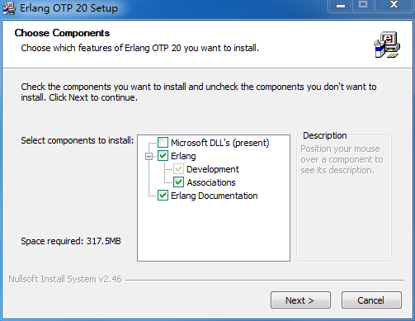

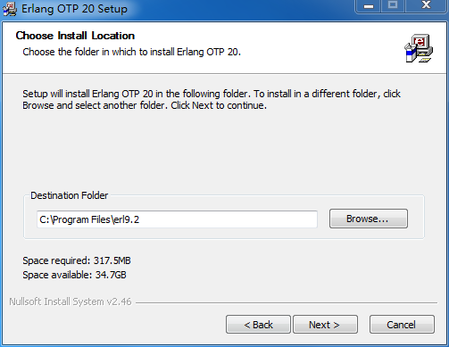

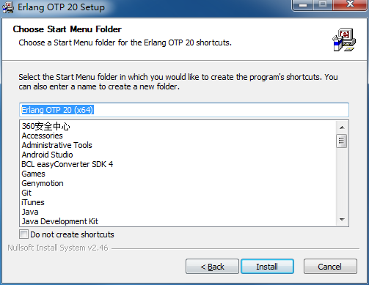

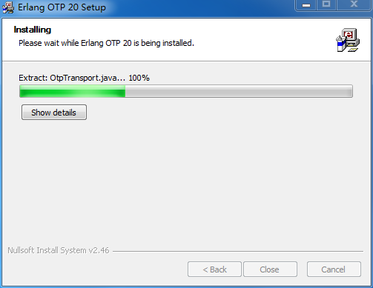

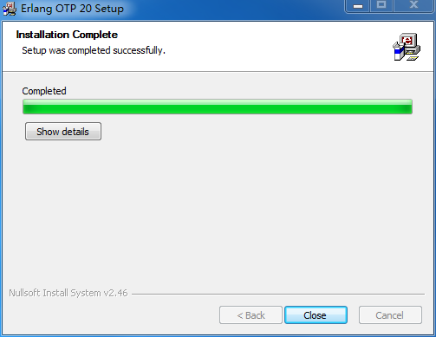

安装完成

## 1.0.4 安装RabbitMQ

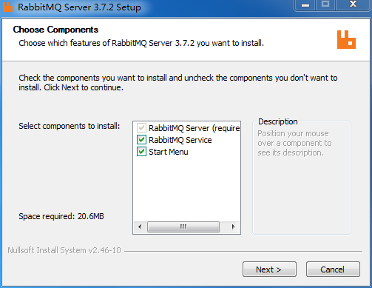

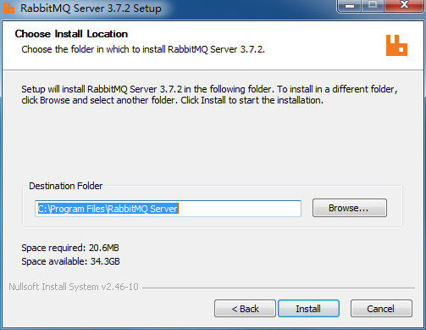

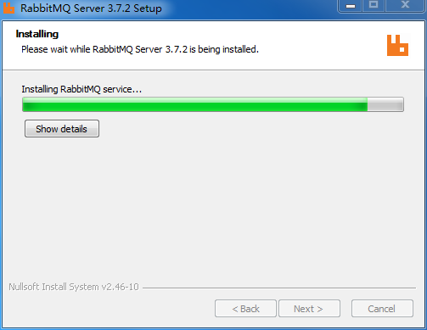

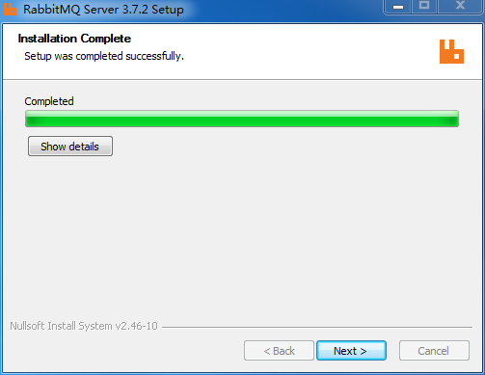

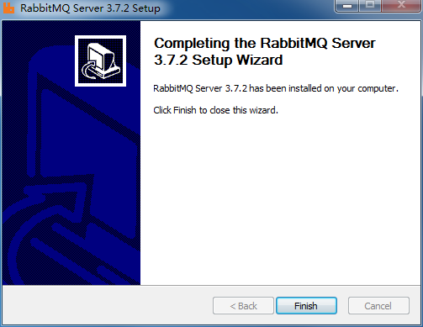

安装完成

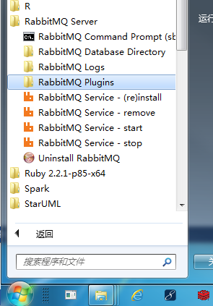

这里会出现启动、停止、重新安装等。

## 1.0.5 启用管理工具

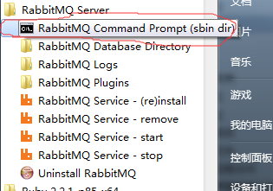

安装完之后 我们得验证一下安装是否成功,那么接下来如果你能成功启动并且登录,那么恭喜你安装成功,否则你得重新安装

1.点击

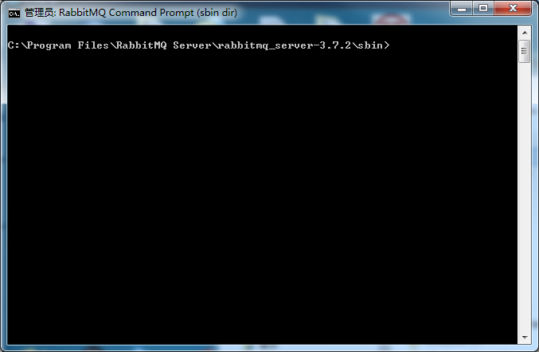

2.输入命令：

rabbitmq-plugins enable rabbitmq_management

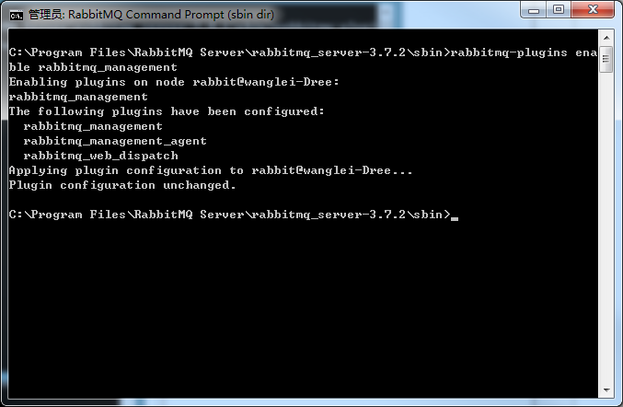

## 1.0.6 打开浏览器控制台

<http://localhost:15672/>

默认账号 guest guest

如果不能访问,

文件夹为隐藏 需要再文件夹选项中把隐藏文件夹打开显示

C:\Users\wanglei\AppData\Roaming\RabbitMQ\db 里面的数据删除 再次安装一下Rabbitmq.exe

然后执行

rabbitmq-plugins enable rabbitmq_management

就可以访问到了

2.0 Linux下载安装RabbitMQ

## 2.1 Erlnag安装

### 2.1.1 安装Erlang版本要求

Erlang安装需要对应各自的版本 http://www.rabbitmq.com/which-erlang.html

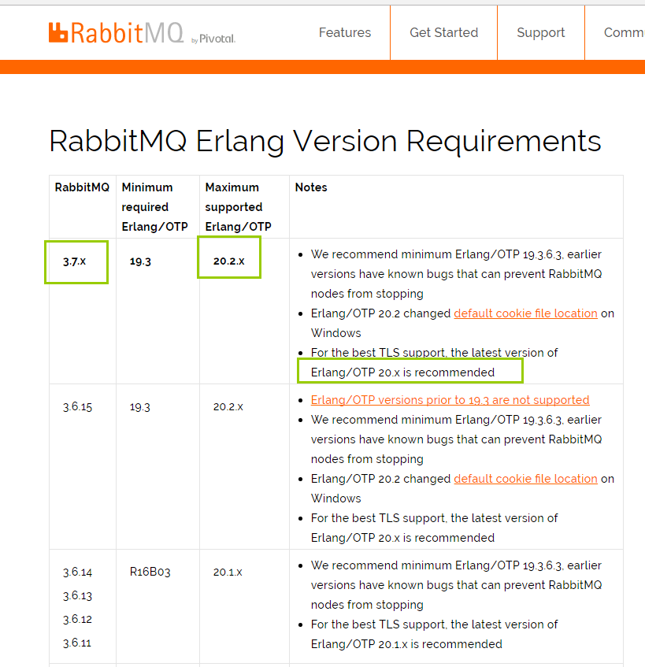

### 2.1.2 Erlang安装

**1.目录准备**

|  |
| --- |
| cd /usr/local/src/  mkdir rabbitmq  cd rabbitmq |

1. **添加仓库地址**

为了减少安装的错误 我们使用仓库安装 ,类似于maven

|  |
| --- |
| vi /etc/yum.repos.d/rabbitmq-erlang.repo |

|  |
| --- |
| **Erlang 20.x on CentOS 7:**  # In /etc/yum.repos.d/rabbitmq-erlang.repo  [rabbitmq-erlang]  name=rabbitmq-erlang  baseurl=https://dl.bintray.com/rabbitmq/rpm/erlang/20/el/7  gpgcheck=1  gpgkey=https://dl.bintray.com/rabbitmq/Keys/rabbitmq-release-signing-key.asc  repo_gpgcheck=0  enabled=1  **Erlang 20.x on CentOS 6:**  # In /etc/yum.repos.d/rabbitmq-erlang.repo  [rabbitmq-erlang]  name=rabbitmq-erlang  baseurl=https://dl.bintray.com/rabbitmq/rpm/erlang/20/el/6  gpgcheck=1  gpgkey=https://dl.bintray.com/rabbitmq/Keys/rabbitmq-release-signing-key.asc  repo_gpgcheck=0  enabled=1  对应版本可参考:  https://github.com/rabbitmq/erlang-rpm |

**3.安装erlang**

|  |
| --- |
| sudo yum install erlang    验证  erl |

## 2.2安装RabbitMQ

网站: <http://www.rabbitmq.com/install-rpm.html>

RabbitMQ-Server使用是分linux版本的,我们可以使用cat /etc/issue 或者 cat /etc/redhat-release命令查看linux版本

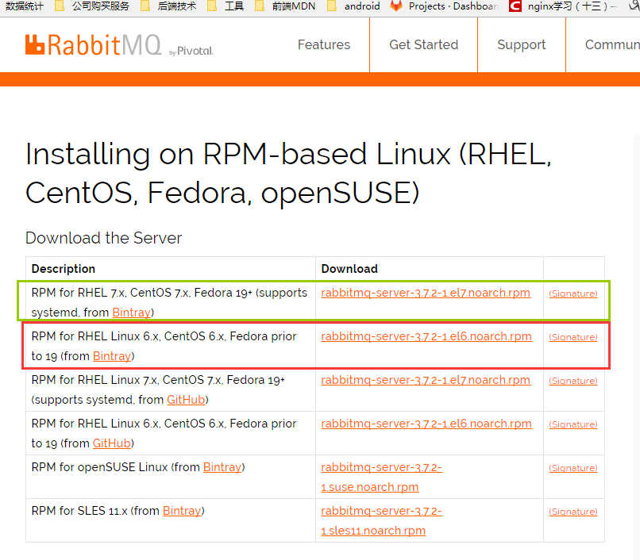

**下载:**

<https://dl.bintray.com/rabbitmq/all/rabbitmq-server/3.7.2/rabbitmq-server-3.7.2-1.el6.noarch.rpm>

上传到rabbitmq

**安装：**

|  |
| --- |
| rpm --import https://www.rabbitmq.com/rabbitmq-release-signing-key.asc  yum install rabbitmq-server-3.7.2-1.el6.noarch.rpm |

### 2.2.1启动、停止

service rabbitmq-server start

service rabbitmq-server stop

service rabbitmq-server restart



### 2.2.2设置开机启动

chkconfig rabbitmq-server on

### 2.2.3设置配置文件

cd /etc/rabbitmq

cp /usr/share/doc/rabbitmq-server-3.4.1/rabbitmq.config.example /etc/rabbitmq/

mv rabbitmq.config.example rabbitmq.config

### 2.2.4开启用户远程访问

vi /etc/rabbitmq/rabbitmq.config

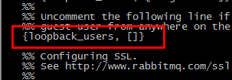

**注意要去掉后面的逗号。**

### 2.2.5开启web界面管理工具

rabbitmq-plugins enable rabbitmq_management

service rabbitmq-server restart



### 2.2.6防火墙开放15672端口

/sbin/iptables -I INPUT -p tcp --dport 15672 -j ACCEPT

/etc/rc.d/init.d/iptables save