

|  |
| --- |
| CO-301-Software Engineering Project Report |
|  |
| Made By:  Rahul Sharma-2K18/MC/087  Pritika-2K18/EE/144 |

|  |  |  |
| --- | --- | --- |
| S.No. | Index | Pg. No. |
| 1. | Introduction | 3 |
| 2. | Review Requirement & Design | 4 |
| 3. | Features To be Tested | 5 |
| 4. | Types of Tests | 5 |
| 5. | Pass/Fail Criteria | 7 |
| 6. | Environmental Requirement | 7 |
| 7. | Login Test Case | 8 |
| 8. | Staff Test Case | 12 |
| 9. | Course Test Case | 18 |
| 10. | Subject and Session Test Case | 21 |

Test Plan

1. Introduction

Purpose

This document describes the plan for testing the student management system [SMS]. This Test Plan document supports the following objectives:

* Identify SMS project information and its components that should be tested.
* List the recommended test requirements.

Scope

This Test Plan applies to unit test, integration test and system test that will be conducted on the Student Management System [SMS]. This Test Plan applies to test all requirements of the [SMS] as defined in the software requirement specification document.

References

[SRS document](https://drive.google.com/file/d/1n9Vi50ND22zEIiM43kLl1uvV_L04b9XN/view?usp=sharing)

[SRS Document](https://drive.google.com/file/d/1n9Vi50ND22zEIiM43kLl1uvV_L04b9XN/view?usp=sharing)

2. Review requirement and Design

Review requirement

Original requirement defined by us is that our system contains 13 use cases. You can see in the original use case model below.

The details of these use cases are described in the SRS document. Therefore, we will not do it again in this document.

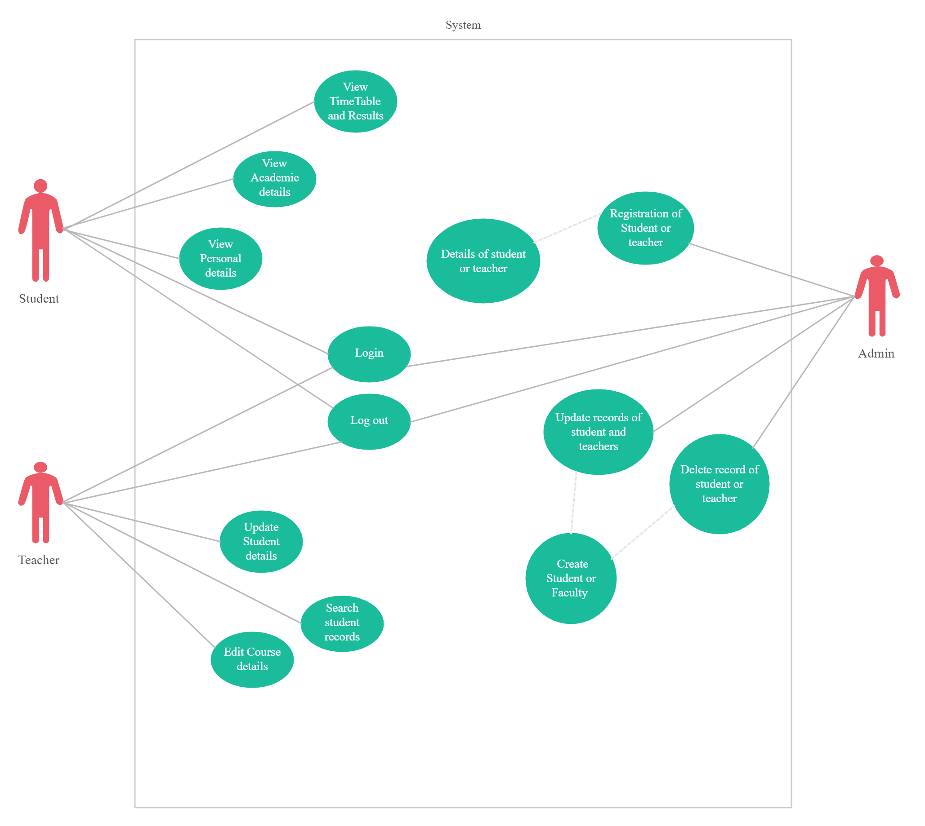

3. Features to be tested

All of the below features are supposed to be tested as an admin

* Login
* Logout
* Add Staff
* Manage Staff
* Add a Course
* Manage Course
* Add a Subject
* Manage a Subject
* Add a Session
* Manage a Session

4. Types of Tests

Kind of Tests

The tests below base on the use case specifications, functional requirements, and non-functional requirements which have been identified as the targets for testing

Besides, we also show the kinds of tests which can be intended to perform.

Unit Testing:

Each unit is tested thoroughly and independently to make sure it has no error. These tests have been performed and the screenshots are shown below.

Integrity Testing:

Data integrity and database integrity test techniques verify that data is being stored by the system in a manner where the data is not compromised by updating, restoration, or retrieval processing. This type of testing is intended to uncover design flaws that may result in data corruption, unauthorized data access, lack of data integrity across multiple tables, and lack of adequate transaction performance. The database, data files, and the database or data file processes should be tested as a subsystem within the application.

Security Testing:

The software should be secure. The password encryption and the way the data is stored and backed up should be consistently checked.

Recovery Testing:

If the software crashes, data should be recovered. This should be tested by ensuring that the backup data is safe and secure.

System testing:

System testing of software is testing conducted on a complete, integrated system to evaluate the system's compliance with its specified requirements. They include the following functions

Performance Testing:

Performance Testing covers a broad range of engineering or functional evaluations where a material, product, or system is not specified by detailed material or component specifications: Rather, emphasis is on the final measurable performance characteristics.

Load Testing:

Load testing is the process of creating demand on a system or device and measuring its response.

5. Pass / Fail Criteria

Failing Criteria:

The test is considered failed if any of the following is encountered: -

• The software crashes

• It results in wrong output

Passing Criteria:

The test is considered passed if any of the following is encountered: -

• The correct results are obtained

6. Environmental Requirements

Hardware:

* Working internet connection

Software:

The requirements for a client are:

* Operating System: - Windows/ Linux
* Html/CSS/JavaScript

Test Cases

1. Test Cases of Login and Logout Use Case

## **1.1 *User logs in successfully with valid username and password***

|  |  |
| --- | --- |
| Name | Test case: User logs in successfully with valid username and password |
| Requirement | The user is logged in correctly after providing correct username and password |
| Preconditions | The user is at the homepage or the login page |
| Steps | 1. Provide valid username in the username textbox 2. Provide valid password in the password textbox 3. Click on login button |
| Expected results | The user is redirected to the specific homepage of that user |

## 

## 

## 

## ***1.2 Fail to login the system when providing invalid username***

|  |  |
| --- | --- |
| Name | Test case: Fail to login the system when providing invalid username |
| Requirement | The user is not logged in when providing invalid username |
| Preconditions | The user is at the homepage or the login page |
| Steps | 1. Provide invalid username in the username textbox 2. Provide password in the password textbox or let password field be empty 3. Click on login button |
| Expected results | The user is redirected to the error page with a warning “You have provided invalid username or invalid password” |

## ***1.3 Fail to login the system when providing valid username and invalid password***

|  |  |
| --- | --- |
| Name | Test case: Fail to login the system when providing valid username and invalid password |
| Requirement | The user is not logged in when providing valid username and invalid password |
| Preconditions | The user is at the homepage or the login page |
| Steps | 1. Provide valid username in the username textbox 2. Provide invalid password in the password textbox 3. Click on login button |
| Expected results | The user is redirected to the error page with a warning “You have provided invalid username or invalid password” |

## ***1.4 Fail to login the system when providing empty username***

|  |  |
| --- | --- |
| Name | Test case: Fail to login the system when providing empty username |
| Requirement | The user is not logged in when providing empty username |
| Preconditions | The user is at the homepage or the login page |
| Steps | Provide empty username in the username textboxProvide password in the password textbox or let password field be emptyClick on login button |
| Expected results | The user is redirected to the error page with a warning “You must provide both username and password” |

## 

## 

## 

## ***1.5 Fail to login the system when providing valid username and empty password***

|  |  |
| --- | --- |
| Name | Test case: Fail to login the system when providing valid username and empty password |
| Requirement | The user is not logged in when providing valid username and empty password |
| Preconditions | The user is at the homepage or the login page |
| Steps | Provide valid username in the username textboxProvide empty password in the password textboxClick on login button |
| Expected results | The user is redirected to the error page with a warning “You must provide both username and password” |

## 

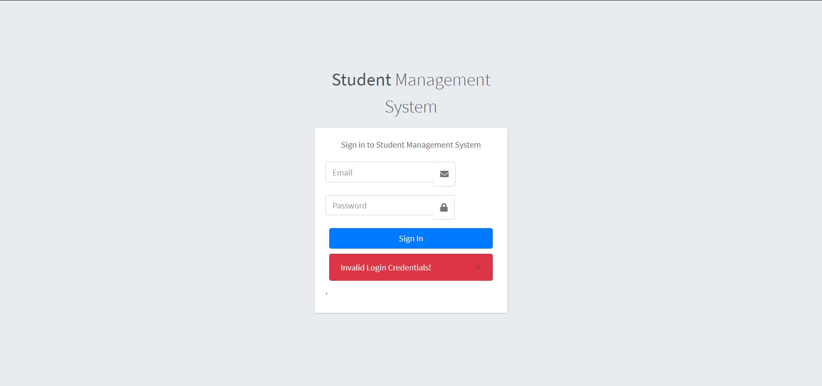

2. Test Cases of Manage Staff Information use case

## ***2.1 Add a lecturer with valid information successfully***

|  |  |
| --- | --- |
| Name | Test case: Add a lecturer with valid information successfully |
| Requirement | All fields are filled with valid data |
| Preconditions | The webpage that allows user to input information of a lecturer is displayed |
| Steps | 1. Provide lecturer’s email address 2. Choose lecturer’s Username 3. Choose lecturer’s Password for future authentication 4. Provide lecturer’s Name and Address |
| Expected results | 1. The lecturer’s info is added to the system 2. The summary of lecturer’s information has been added to the system is displayed |

## 

## 

## ***2.2 Fail to add a lecturer when one or some or all fields are empty***

|  |  |
| --- | --- |
| Name | Test case: Fail to add a lecturer when one or some or all fields are empty |
| Requirement | Not all fields are filled with data |
| Preconditions | The webpage that allows user to input information of a department is displayed |
| Steps | 1. Provide empty lecturer’s name in the name textbox or/and 2. Choose empty lecturer’s password or/and 3. Provide empty lecturer’s first name, last name and Address |
| Expected results | The system fails to add any information to the database |

## 

## ***2.3* *Look for a lecturer***

|  |  |
| --- | --- |
| Name | Test case: Look for a lecturer |
| Requirement | When an admin wants to update or delete a lecturer, he/she has to look for information of the lecturer he/she wants to delete or modify information. |
| Preconditions | The webpage allows the admin to look for information about a lecturer and update or delete lecturer’s information from the portal. |
| Steps | Admin has to navigate to manage staff to look for lecturer’s information  1. Admin can check all the info provided by the staff during registration 2. Admin can edit or delete the information provided by the staff |
| Expected results | 1. Information of the select lecturer is displayed |

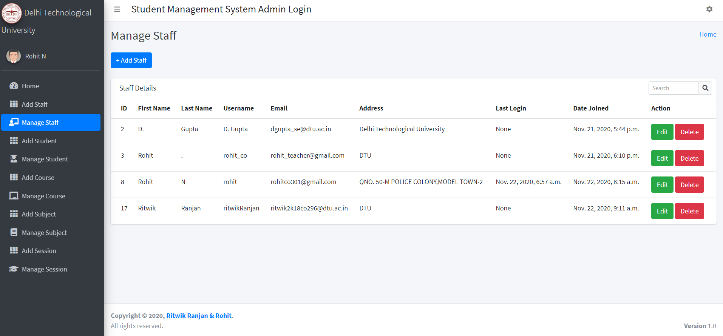

*2.4 Update a lecturer with valid information successfully*

|  |  |
| --- | --- |
| Name | Test case: Update a lecturer with valid information successfully |
| Requirement | All fields are filled with valid data |
| Preconditions | The webpage that allows the admin to update information of a lecturer is displayed. (To be noted that we have a test case for looking for a lecturer above already. There’s no need to repeat it here.) |
| Steps | 1. Click On the edit button of any lecturer to change their information 2. Assign valid email and username 3. Provide valid Name and Address 4. Click on update staff to update new information into the system |
| Expected results | 1. The lecturer is updated in the system  2. The summary of the lecturer has been updated is displayed |

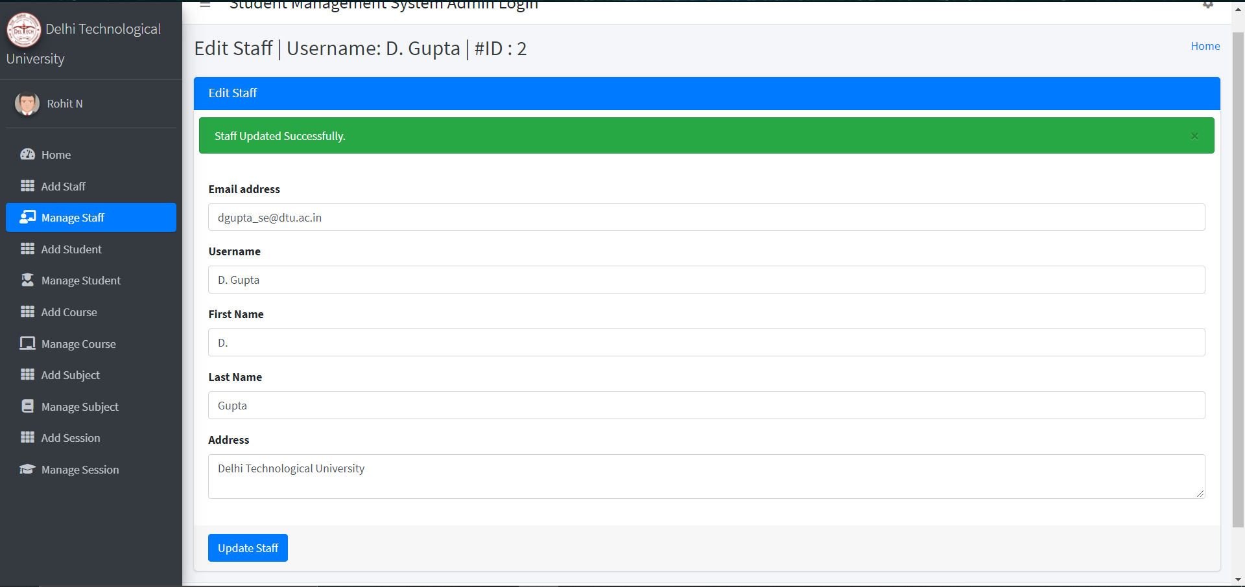

*2.5 Delete a lecturer*

|  |  |
| --- | --- |
| Name | Test case: Delete a lecturer |
| Requirement | When admin decides to delete the selected lecturer, the system removes that lecturer from the system |
| Preconditions | The webpage that allows the admin to delete information of a lecturer displayed. (To be noted that we have a test case for looking for a lecturer above already. There’s no need to repeat it here.) |
| Steps | 1. Click On the delete button of any lecturer to remove their info from the database |
| Expected results | 1. The system deletes the selected lecturer from the database 2. User is redirected to his/her main page |

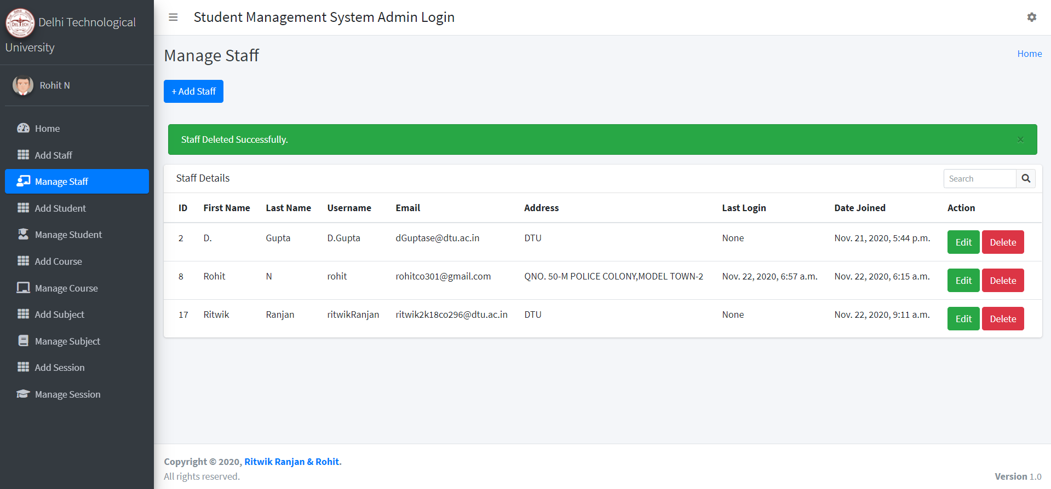

3.Test Case of Manage Course Offering Use Case

*3.1* *The User create a new course offering*

|  |  |
| --- | --- |
| Name | Test case: The user creates a new course offering |
| Requirement | The new course offering is created and distributed to the students |
| Preconditions | The user must log in as the Academic Affair Staff |
| Steps | 1. Click on the Add Course Button 2. Enter a valid Course Name and click on add course button |
| Expected Results | The new course offering is created in the system |

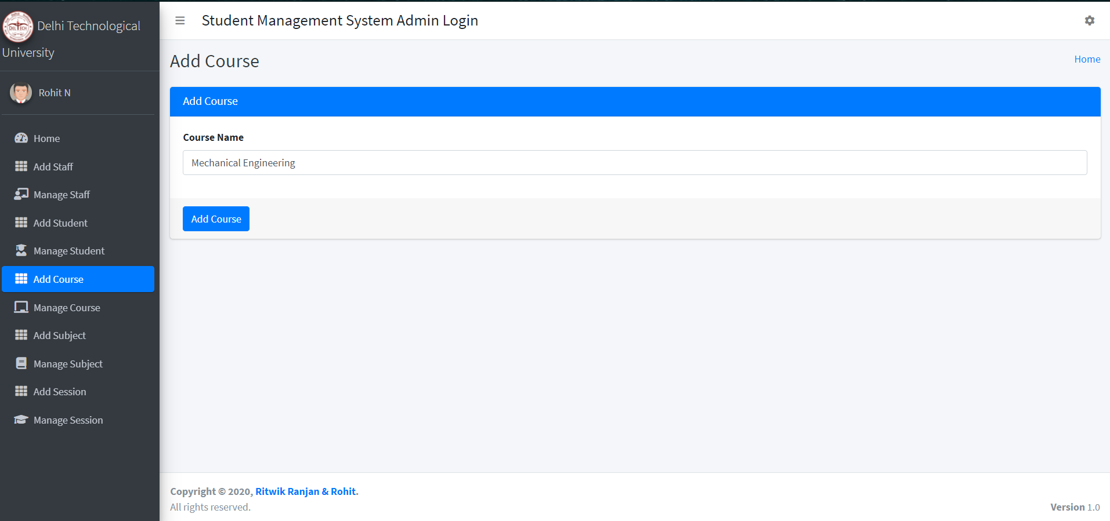

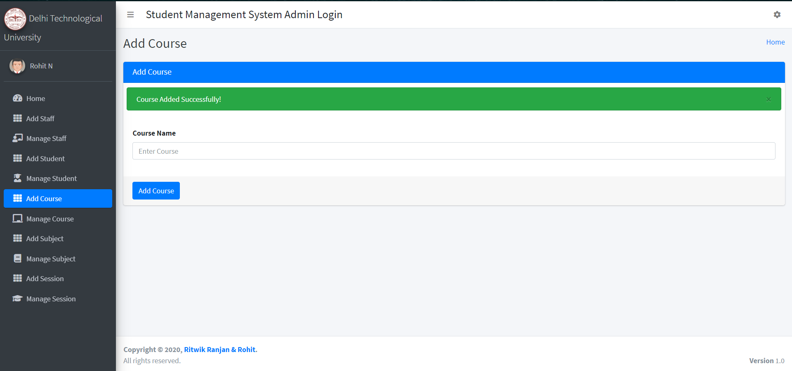

*3.2* *Update the list of course offering*

|  |  |
| --- | --- |
| Name | Test case: Update the list of course offering |
| Requirement | The list of course offering is updated |
| Preconditions | The user must log in as the Academic Affair Staff |
| Steps | 1. Click on the manage course section 2. All the academic courses will be displayed 3. Select the Edit button and change it to desired course you want to offer |
| Expected Results | The course is updated successfully into the system |

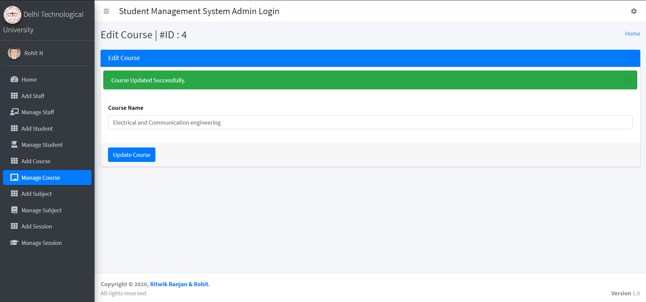

*3.3* Delete *the course offering*

|  |  |
| --- | --- |
| Name | Test case: Delete a course offering |
| Requirement | When admin decides to delete the selected course, the system removes that course from the system |
| Preconditions | The webpage that allows the admin to delete the course offering |
| Steps | Click On the delete button of any course to remove it from the database |
| Expected results | 1. The system deletes the selected course from the system 2. User is redirected to his/her main page |

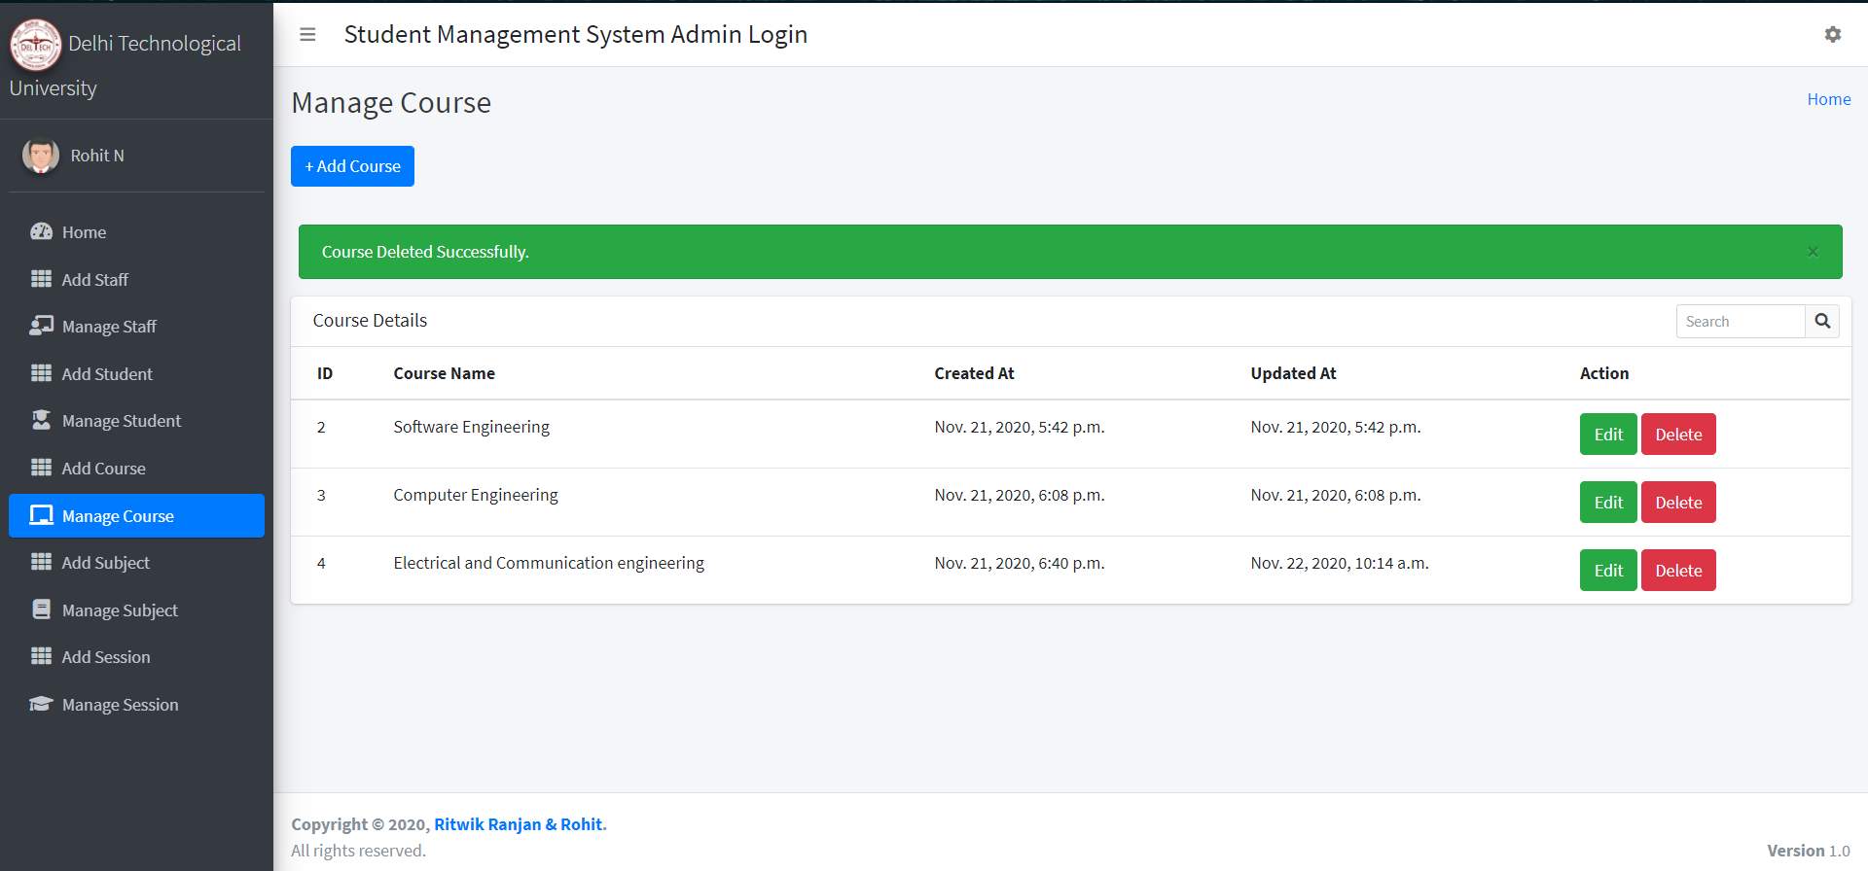

4. Test Case of Manage Subject Offering Use Case

*4.1* *The User create a new subject offering*

|  |  |
| --- | --- |
| Name | Test case: The user creates a new subject offering |
| Requirement | The new subject offering is created and distributed to the students |
| Preconditions | The user must log in as the Academic Affair Staff |
| Steps | 1. Click on the Add Subject Button 2. Enter a valid Subject Name and Assign a faculty 3. Click on add Subject button |
| Expected Results | The new subject offering is created in the system |

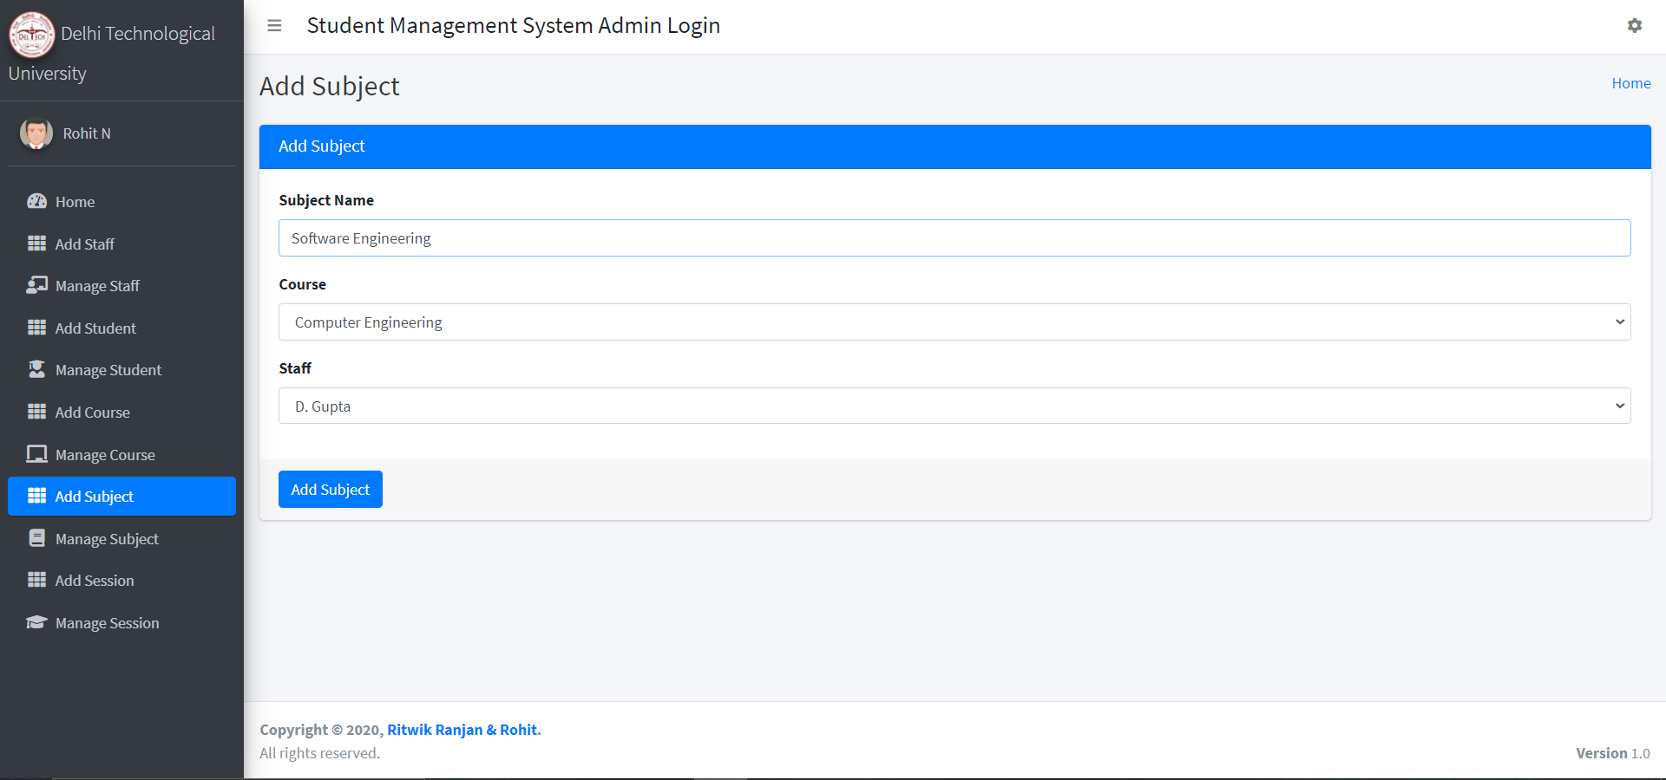

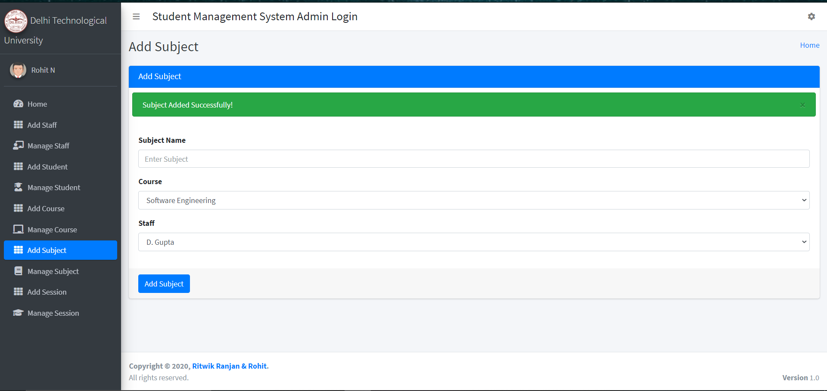

*4.2* *Update the list of subject offering*

|  |  |
| --- | --- |
| Name | Test case: Update the list of subject offering |
| Requirement | The list of subject offering is updated |
| Preconditions | The user must log in as the Academic Affair Staff |
| Steps | 1. Click on the manage subject section 2. All the academic subjects will be displayed 3. Select the Edit button and change it to desired subject you want to offer or you can also change the assigned faculty to the other one |
| Expected Results | The Subject is updated successfully into the system |

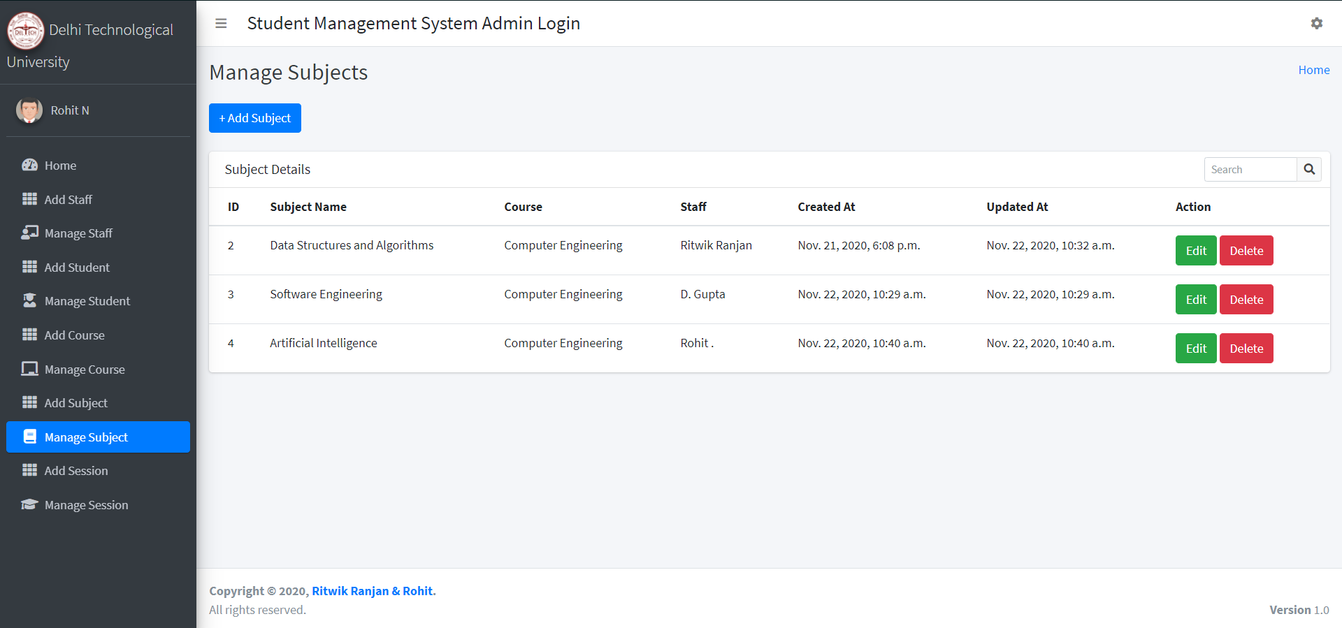

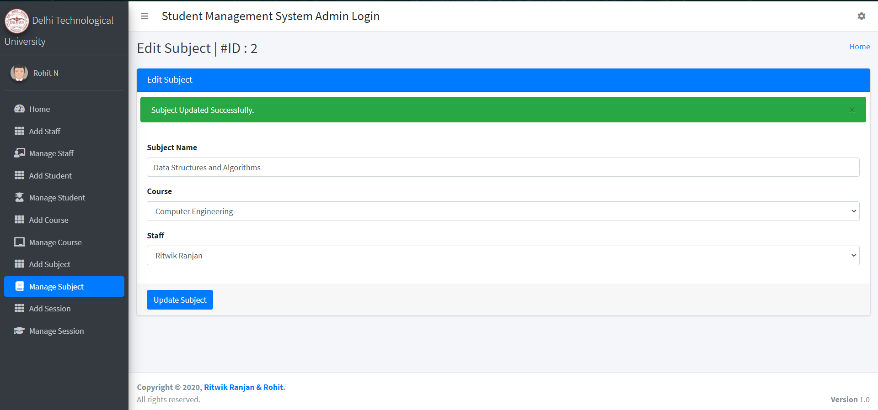

*4.3* Delete *the Subject offering*

|  |  |
| --- | --- |
| Name | Test case: Delete a subject offering |
| Requirement | When admin decides to delete the selected subject, the system removes that course from the system |
| Preconditions | The webpage that allows the admin to delete the subject offering |
| Steps | Click On the delete button of any subject to remove it from the database |
| Expected results | 1. The system deletes the selected subject from the database 2. User is redirected to his/her main page |

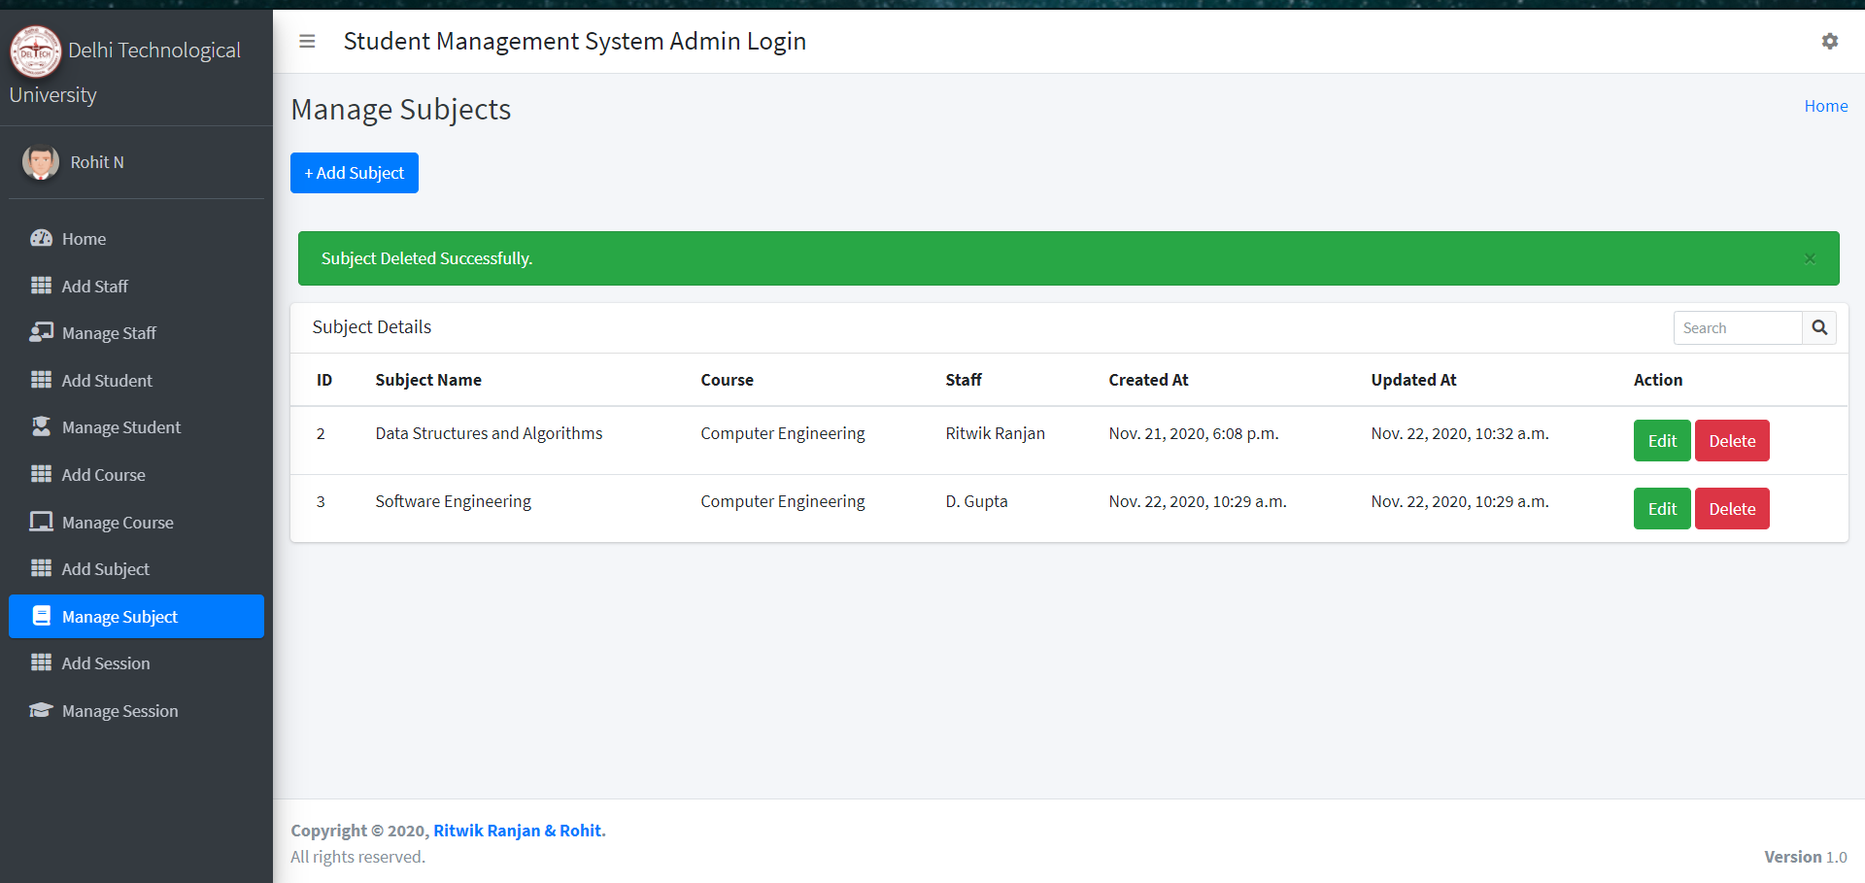

5. Test Case of Manage Session Use Case

*5.1* *The User create a new session*

|  |  |
| --- | --- |
| Name | Test case: The user creates a new session |
| Requirement | The new session for particular semester is created |
| Preconditions | The user must log in as the Academic Affair Staff |
| Steps | 1. Click on the Add Session Button 2. Enter a valid dd-mm-yyyy for start and end 3. Click on add Session button |
| Expected Results | The new session is created in the system |

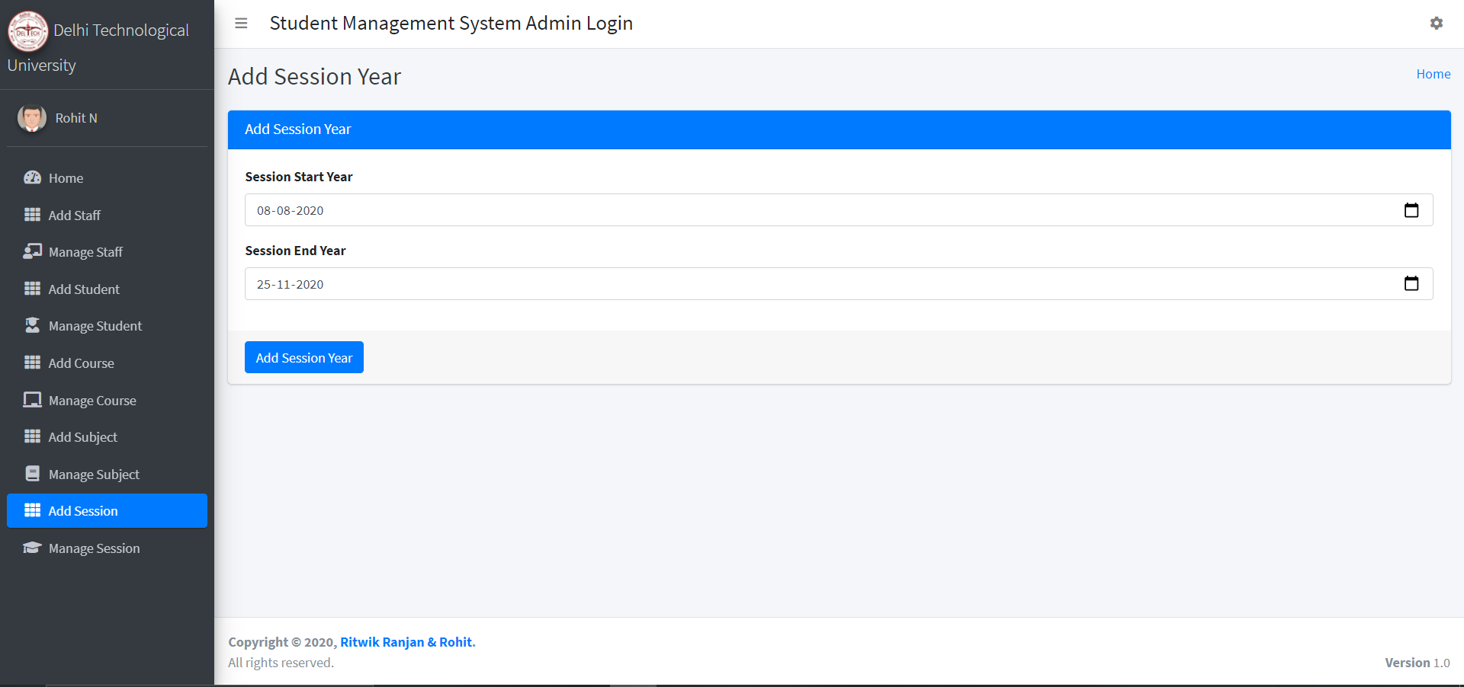

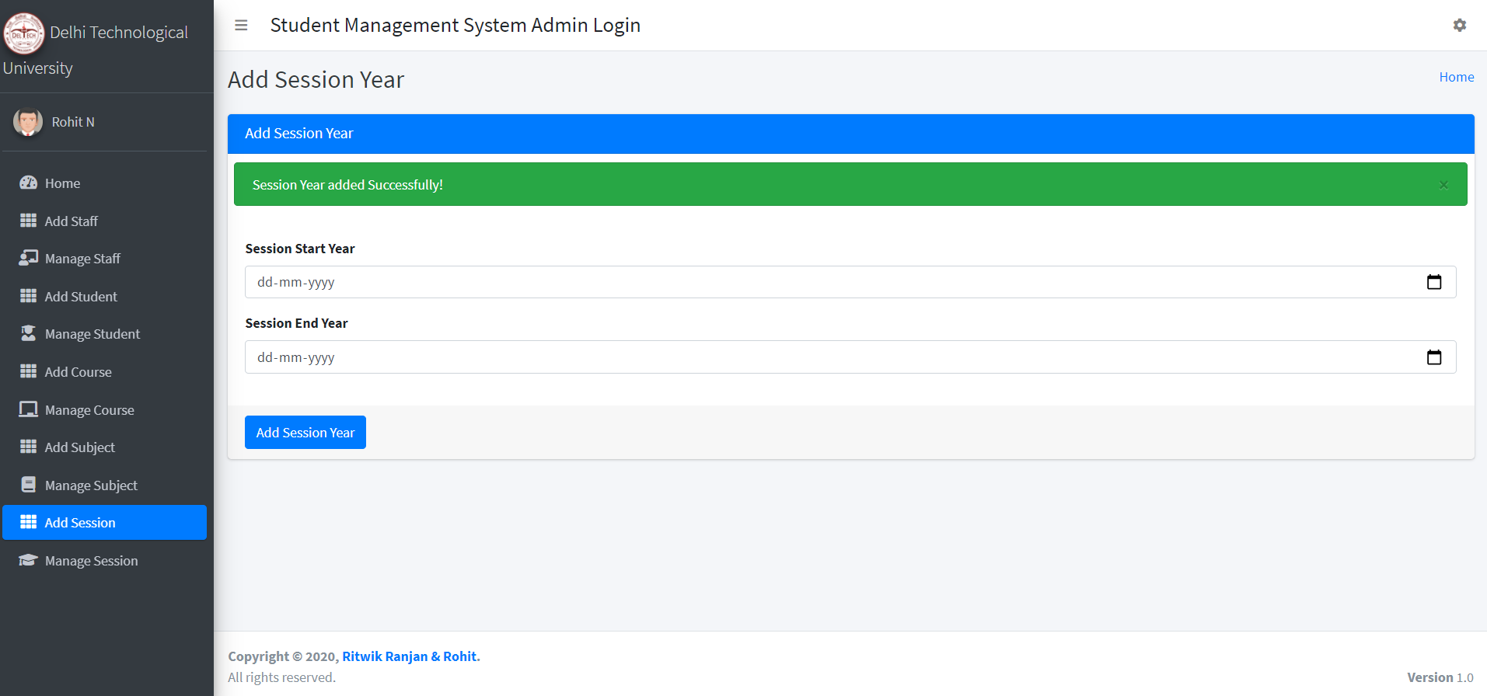

*5.2* *Update the list of sessions*

|  |  |
| --- | --- |
| Name | Test case: Update the list of sessions |
| Requirement | The list of sessions is updated |
| Preconditions | The user must log in as the Academic Affair Staff |
| Steps | 1. Click on the manage session section 2. All the sessions will be displayed 3. Select the Edit button and change it to desired dd-mm-yyyy you want to start and end with |
| Expected Results | The Session is updated successfully into the system |

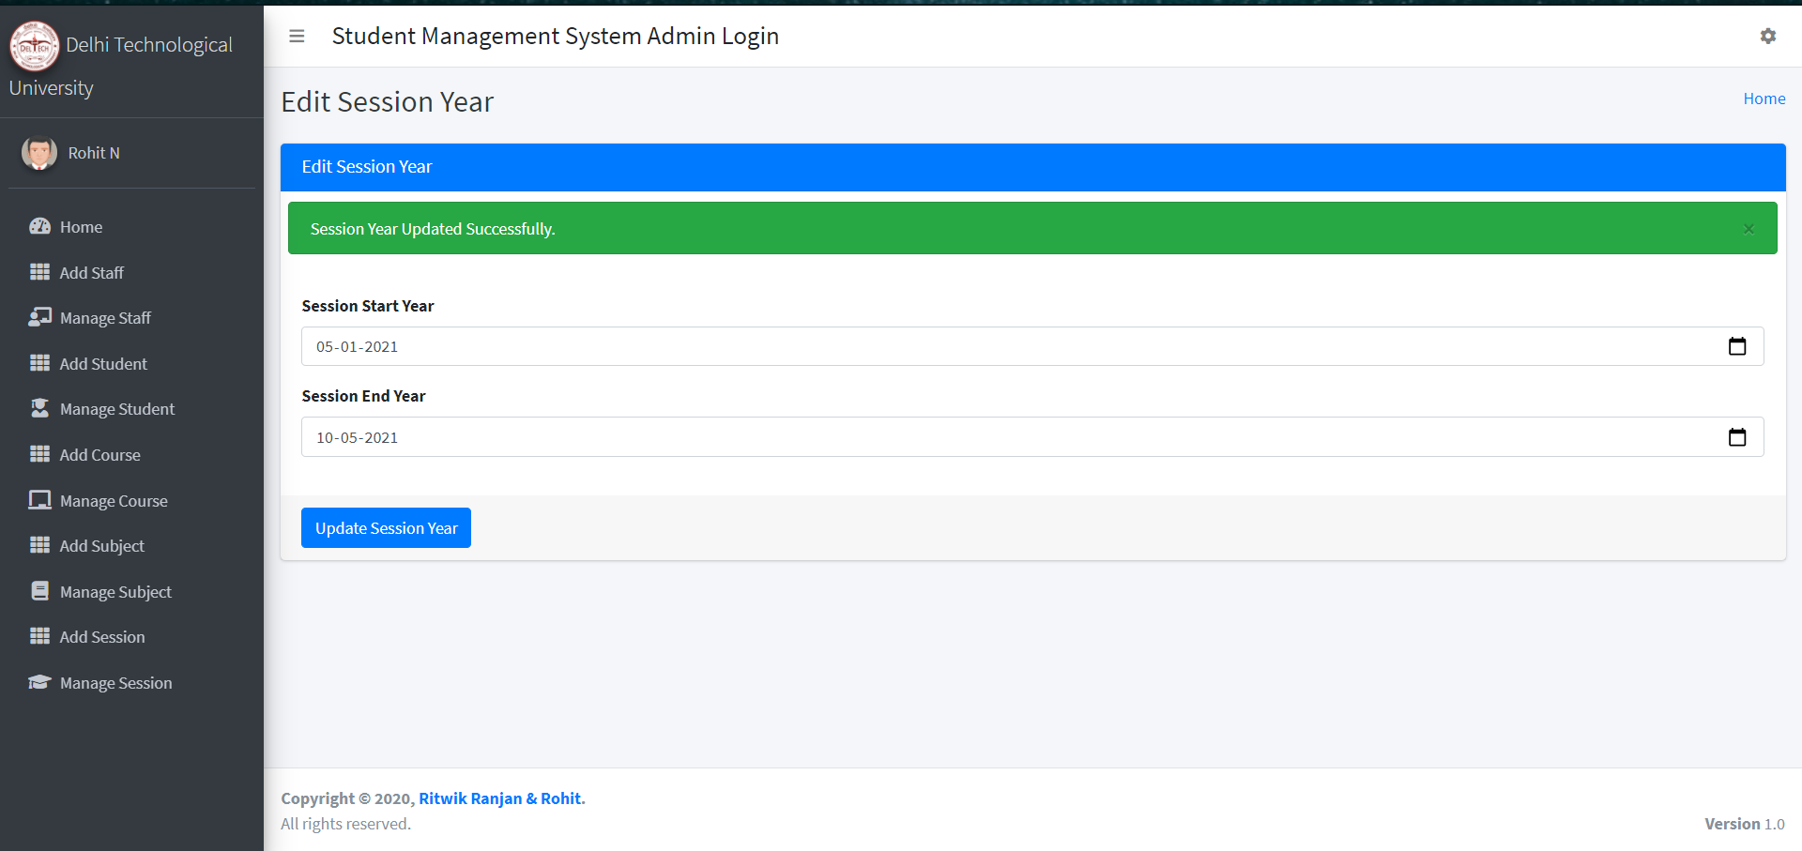

*5.3* Delete *the Session*

|  |  |
| --- | --- |
| Name | Test case: Delete a session |
| Requirement | When admin decides to delete the selected session, the system removes that session from the system |
| Preconditions | The webpage that allows the admin to delete the session offering |
| Steps | Click On the delete button of any session to remove it from the database |
| Expected results | 1. The system deletes the selected session from the database 2. User is redirected to his/her main page |

