**DOCKER ASSIGNMENT:**

**TASK 1:**

1. docker – check if docker has been installed

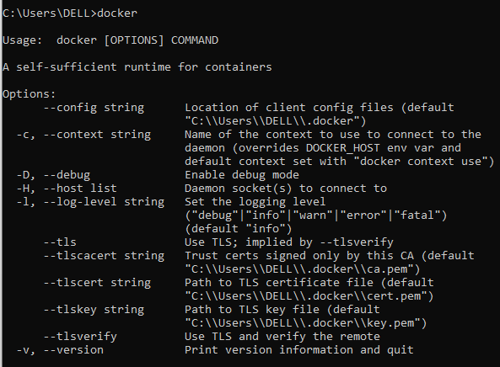

1. docker <command name> --help – get help wrt specific command

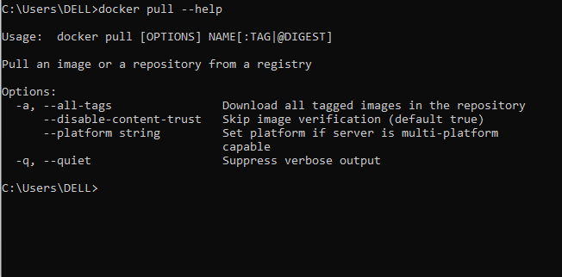

1. docker –version - check version of your docker installation

C:\Users\DELL\Desktop\Industry Projects\Day4_docker\3_docker_version.PNG

1. docker pull <imagename> - pulling the required image

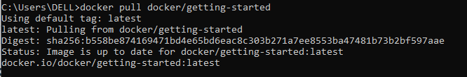

1. docker images - list of all the pulled images

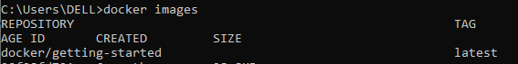

1. docker run <image name> - run the pulled image

C:\Users\DELL\Desktop\Industry Projects\Day4_docker\6_docker_run.PNG

1. docker ps – check all running containers



1. docker ps –a - check all running exited containers



1. docker stop <container id> - stop the specified container

C:\Users\DELL\Desktop\Industry Projects\Day4_docker\9_docker_stop_container.PNG

1. docker kill

C:\Users\DELL\Desktop\Industry Projects\Day4_docker\10_docker_kill.PNG

1. docker rmi <image id> --force - forcefully remove image



1. docker logs <container id> -f - check logs of specified container

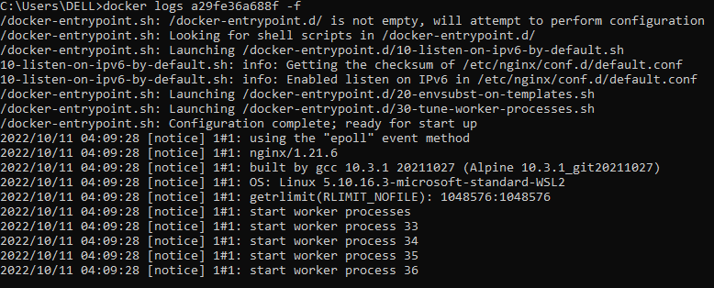

1. docker info – check info regarding our docker

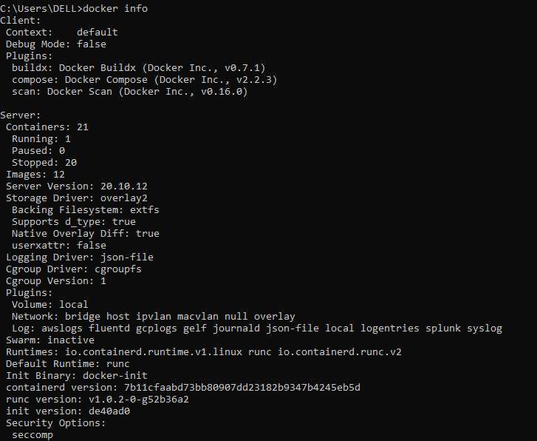

1. docker search <imagename> - check specific image



1. docker rm <continaer id> - remove specified container

C:\Users\DELL\Desktop\Industry Projects\Day4_docker\15_docker_remove_container.PNG

1. docker history <image name> - check history of docker image

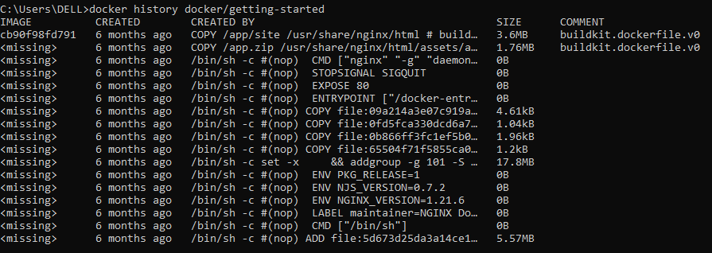

**TASK 2:**

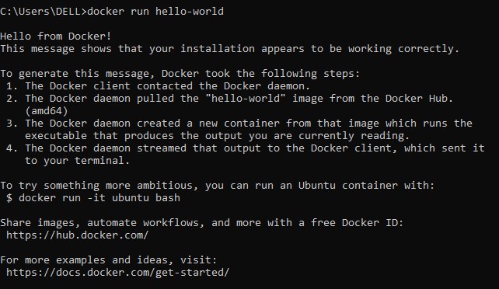

**TASK 3:**

Docker hub link:

<https://hub.docker.com/repository/docker/abhishek0303/fapi-hello-world>

Github link:

<https://github.com/therealabhishek/fastapi_helloworld_app>

**TASK 4:**