**Aldo Gonzalez**

**ASL-1511**

**Project/App Title:**

JAC Music

**Project/App Summary:**

Free music streaming application that allows you to stream music and be able to like music, create playlists, update those playlists, and even delete those playlists. We picked this application because we all enjoy listening to music and feel the free music streaming services available could have more features that are valuable to a user. You will be able to login through Facebook or Google.

**Twist:**

Our application will have a recently listened to playlist where you are able to look back at the music you have recently listened to that you may have not liked or added to your library.

**Week 1 Schedule:**

Monday-Tuesday: Research on music services and frameworks, setup, rails tutorials

Wednesday-Friday: Development

**Week 1 features:**

CRUD: Being able to add songs to your library or a playlist. You will also be able to update those playlists by adding or removing songs from them or deleting the entire playlist altogether.

MVC: Using MVC to serve the user the pages they need based on what they are trying to accomplish at any given point.

Soundcloud API: Have most of the API integrated. So being able to listen to music, search music

Responsive Design: Having the basic website responsive using Foundation

**Week 2 Schedule:**

Monday-Tuesday: Research on Facebook, Soundcloud APIs

Wednesday-Thursday: Development and Testing

Friday: Final touches, record demo, present application

**Week 2 Features:**

FB login: Being able to login to the website through the Facebook API to grab user credentials.

Styling: Having the styling completed for the website

Soundcloud API: Having all of the Soundcloud API integrated and fully functional

**Wire Diagrams:**

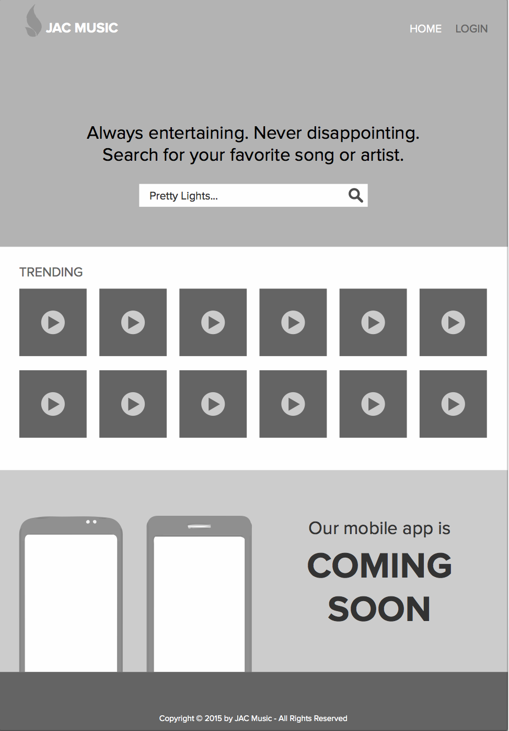

**Design Templates:**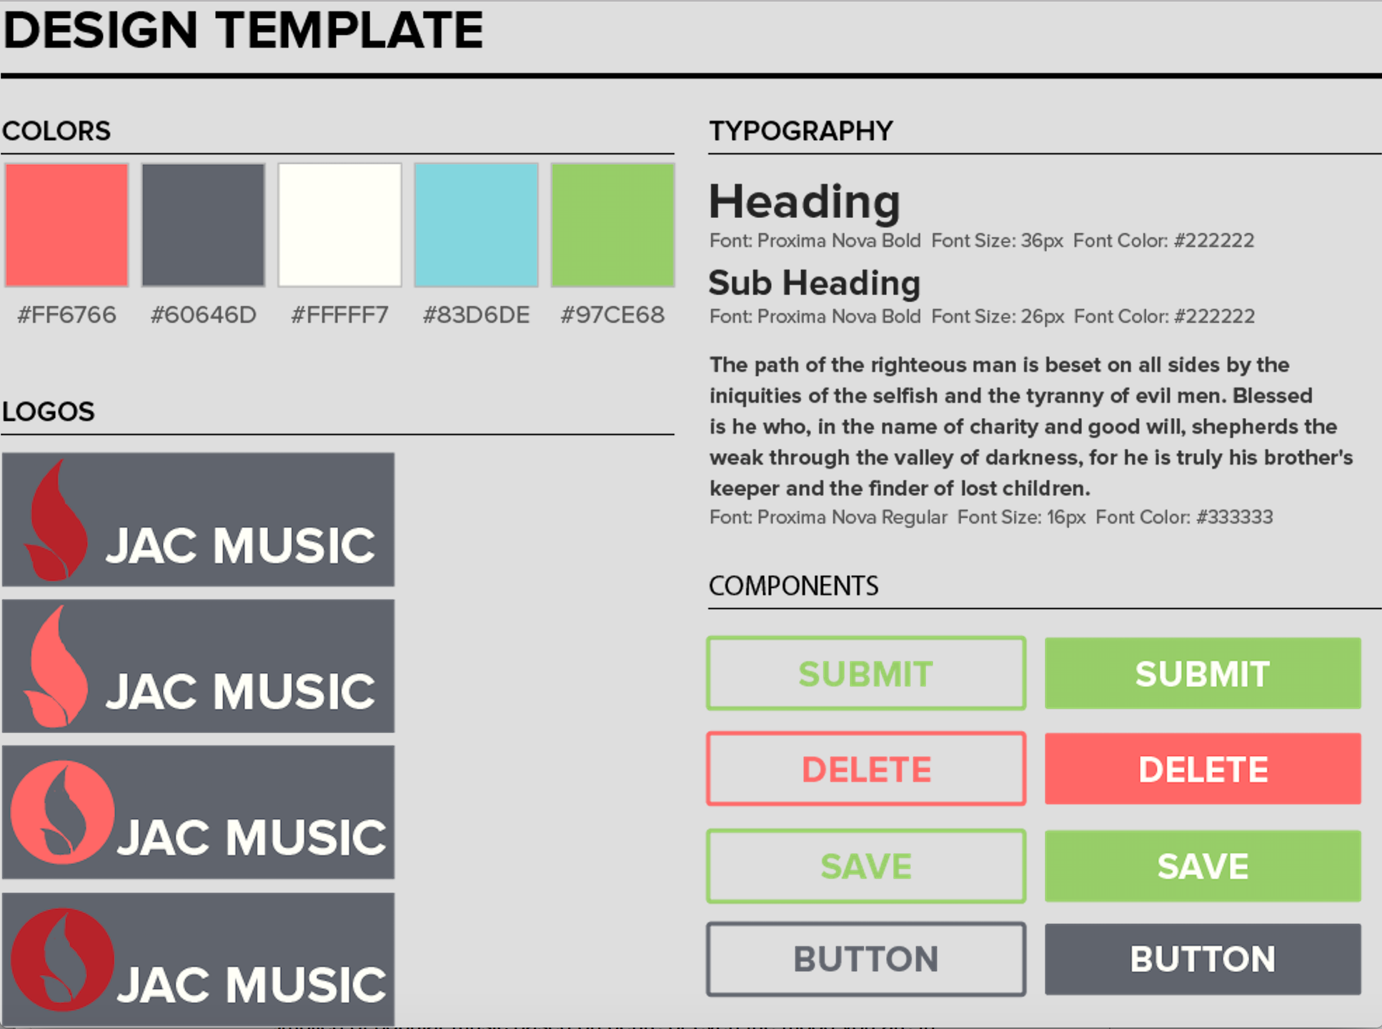

**Database Diagram:**

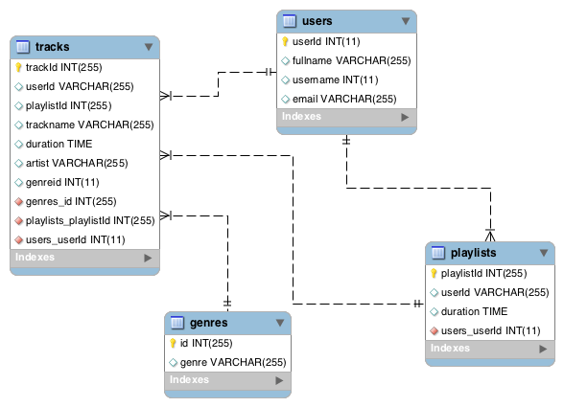

**Language and framework:**

Ruby on Rails

Foundation

MySQL

**Version one:**

Music player, FB/Google login functionality, liking music, creating playlists, recently listened to playlist

**Version two:**

Allowing the user to upload their own music using the Soundcloud API. Being able to comment on songs that you are listening to. Listening to a curated playlist that is compiled with music similar to what you listen to the most. Creating playlists compiled of popular music based on genre or even the mood you are in.