Enhancing Customer Experience and Brand Perception: Leveraging NLP and Digital Marketing for a Hotel in Porto
André Pires¹, Manuel Sampaio¹, Pedro Correia¹, Pedro Meireles¹, Miłosz Kozłuk¹
¹ IADE – Universidade Europeia, Lisboa, Portugal
Abstract. This paper presents a multi-stage NLP pipeline applied to 999 verified guest reviews collected from Booking.com for a boutique hotel in Porto, Portugal. The pipeline encompasses exploratory data analysis, supervised sentiment classification, unsupervised LDA topic modelling, K-Means customer segmentation, and rule-based Aspect-Based Sentiment Analysis (ABSA). The overall average guest score is 8.24/10 across 38 months of data. The primary operational pain point identified by ABSA is WiFi & Check-in, where 39.5% of aspect mentions are negative. A binary LinearSVC classifier achieves F1-macro of 0.6471 (5-fold CV: 0.6939) and is proposed for real-time review monitoring. XLM-RoBERTa is evaluated as a multilingual proof-of-concept but underperforms classical baselines at this dataset size. Seven evidence-backed strategic recommendations with measurable KPIs are derived.
Keywords: Hotel reviews · Sentiment analysis · Topic modelling · Customer segmentation · ABSA · NLP · Digital marketing

1 Introduction
Online guest reviews represent one of the richest, most candid sources of intelligence available to hospitality operators. Unlike internal surveys, they are unprompted, public, and directly influence future booking decisions. For a hotel experiencing declining satisfaction scores and stagnating brand perception, systematically mining this corpus offers both a diagnostic and a strategic compass.
This paper presents the end-to-end findings of a data science pipeline applied to 999 verified guest reviews collected from Booking.com between March 2023 and April 2026. The pipeline—built with LangGraph for orchestration and scikit-learn [4] for NLP modelling—covers exploratory analysis, supervised sentiment classification, unsupervised topic modelling, K-Means customer segmentation, and evidence-backed strategic recommendations. The headline finding is an overall average score of 8.24/10, masking significant variation by traveller segment and topic cluster.

2 Data Collection and Preparation

2.1 Scraping and Ingestion
Reviews were collected programmatically from Booking.com using a custom Selenium-based scraper targeting a single boutique property in Porto, Portugal. The scraper handles dynamic pagination, modal dialogs, and deduplication via content-based fingerprinting. Each record captures: reviewer name, country, room type, number of nights, date of stay, traveller type, positive and negative text, and numerical score.
Data ethics note: Reviewer names and nationalities constitute personal data under GDPR. Names were collected solely for deduplication and are not used in any analysis. All data was collected from publicly accessible pages in compliance with Booking.com's terms of service [5].

2.2 Cleaning and Feature Engineering
After automated cleaning, 999 reviews were retained from an initial 1,000 (one dropped for empty review text). Steps applied: date parsing; number-of-nights extraction; concatenation of positive and negative text into a unified full_review_text column; language detection and translation of non-English reviews; and derivation of a three-class sentiment label from numerical score (positive: ≥8; neutral: 6–7; negative: <6).

3 Exploratory Data Analysis

3.1 Score and Sentiment Distribution
Scores range from 1.0 to 10.0 with a mean of 8.24 (median 8.0, std 1.68). The distribution is left-skewed. Sentiment labels yield 779 positive (78.0%), 156 neutral (15.6%), and 64 negative (6.4%) reviews.

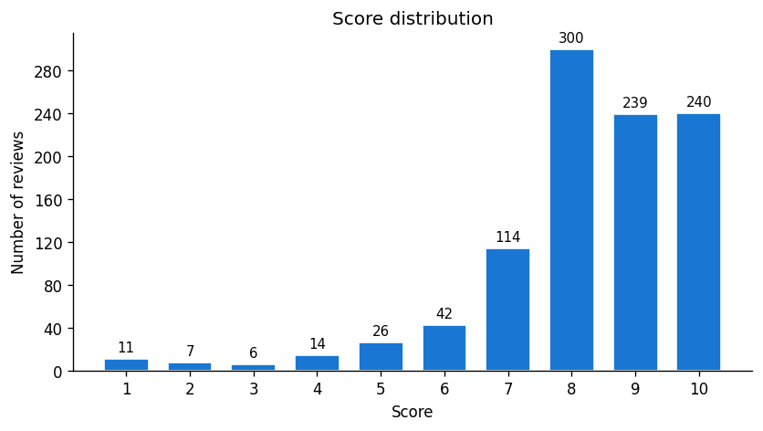
Fig. 1. Score frequency distribution across 999 reviews.

3.2 Temporal Trends
Review volume peaks in March 2026 (86 reviews). Monthly sentiment-share analysis reveals a broadly stable positive share over 38 months, indicating no systematic operational deterioration. Short-term spikes in negative share correlate with higher review volume, suggesting busy periods may strain service quality.

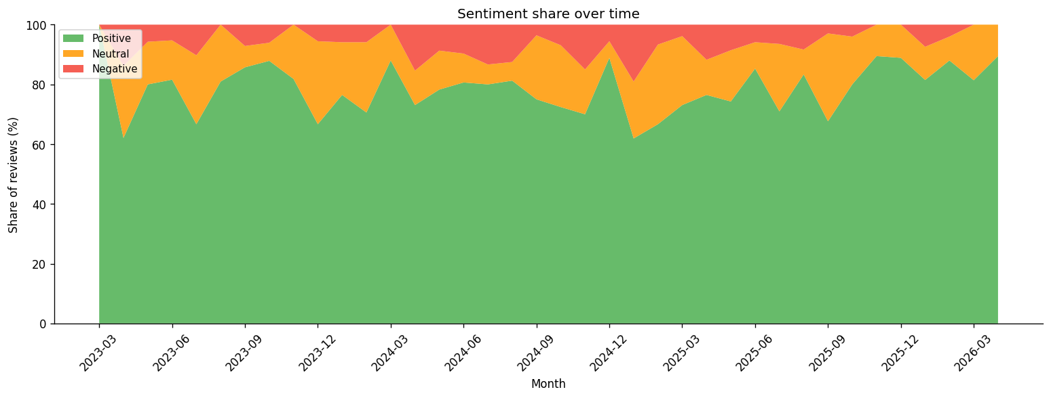
Fig. 2. Monthly sentiment share (stacked area) over 38 months.

3.3 Word Frequency
Word cloud analysis confirms that positive reviews centre on location, staff, breakfast, and friendly, while negative reviews surface noise, small, air conditioning, and WiFi as recurring pain points.

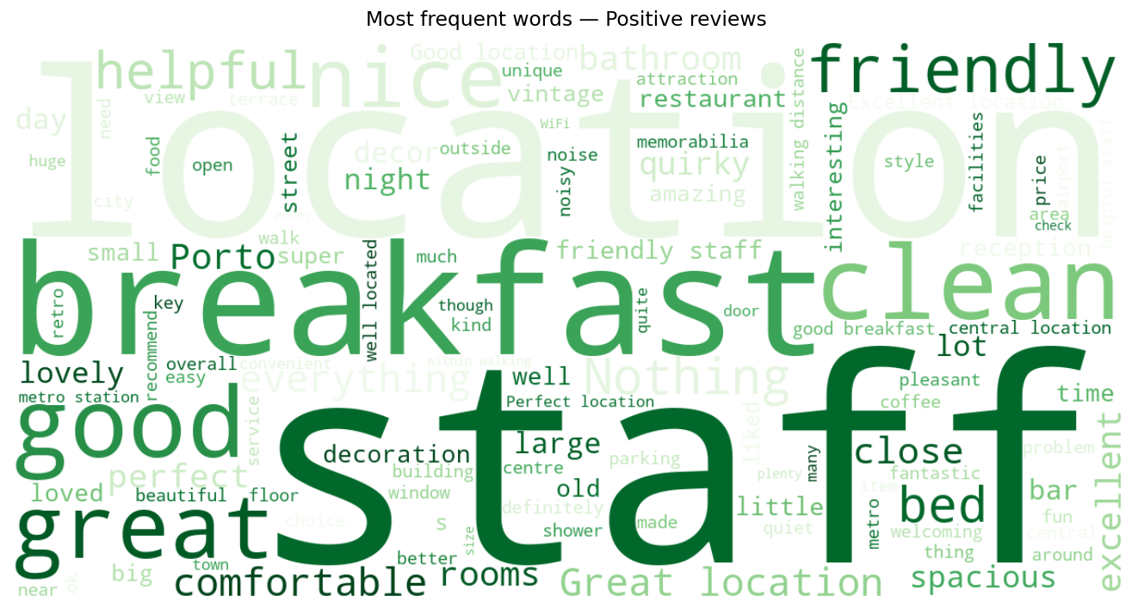 | 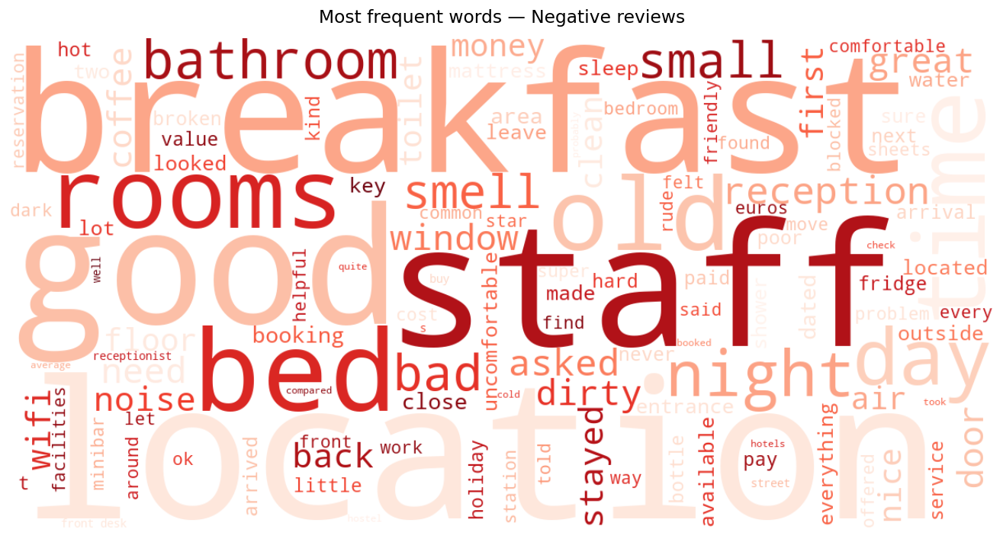
Fig. 3. Word cloud — positive reviews. | Fig. 4. Word cloud — negative reviews.

3.4 Guest Origin and Traveller Mix
The United Kingdom dominates (238 reviews, 23.8%), followed by the United States (145) and Ireland (73). Iberian markets (Spain + Portugal: 89 reviews, 8.9%) are significantly underrepresented given the hotel's Porto location.

Traveller type | Avg score | Reviews
Couple | 8.35 | 519
Group | 8.24 | 130
Solo traveller | 8.13 | 226
Family | 7.98 | 124
Table 1. Average Booking.com score by traveller type.

4 Customer Segmentation
K-Means clustering (k=4) was applied to 999 reviews using five feature dimensions: guest score, review word count, number of nights, traveller type (one-hot encoded), and sentiment (ordinal). Features were standardised with StandardScaler. k=4 was selected from elbow analysis (k=2…8) where inertia reduction flattened beyond four clusters.
Limitation: Clustering was performed at the review level, not the customer level. A single guest with multiple stays may appear across different clusters. Future work should aggregate per unique reviewer.

Segment | Size | Share | Avg score | Neg share
Romantic Couples | 518 | 51.9% | 8.35 | 5.2%
Solo Adventurers | 226 | 22.6% | 8.13 | 7.1%
Social Groups | 131 | 13.1% | 8.24 | 6.9%
Family Explorers | 124 | 12.4% | 7.98 | 9.7%
Table 2. K-Means customer segments (k=4).

5 Sentiment Analysis

5.1 Models and Approach
Three classifiers were evaluated against a VADER [2] lexicon baseline across two task formulations: 3-class (positive / neutral / negative) and binary (positive vs. non-positive). All supervised models use TF-IDF features (max 8,000 terms, 1–2 n-grams, sublinear TF scaling) with class_weight="balanced" to address the 78/15.6/6.4% class imbalance. Evaluation uses macro-averaged F1 with 5-fold stratified cross-validation. XLM-RoBERTa [3] was additionally fine-tuned for 2 epochs as a multilingual benchmark.

5.2 Results

Model | Task | Accuracy | F1-macro | CV F1-macro
VADER (baseline) | 3-class | 0.715 | 0.4511 | —
TF-IDF + LR | 3-class | 0.740 | 0.5293 | 0.4909 ± 0.039
TF-IDF + LinearSVC | 3-class | 0.800 | 0.5344 | 0.4436 ± 0.043
TF-IDF + LinearSVC | Binary | 0.750 | 0.6471 | 0.6939 ± 0.011
XLM-RoBERTa | 3-class | 0.780 | 0.2921 | —
Table 3. Sentiment model results. Best binary F1-macro highlighted.

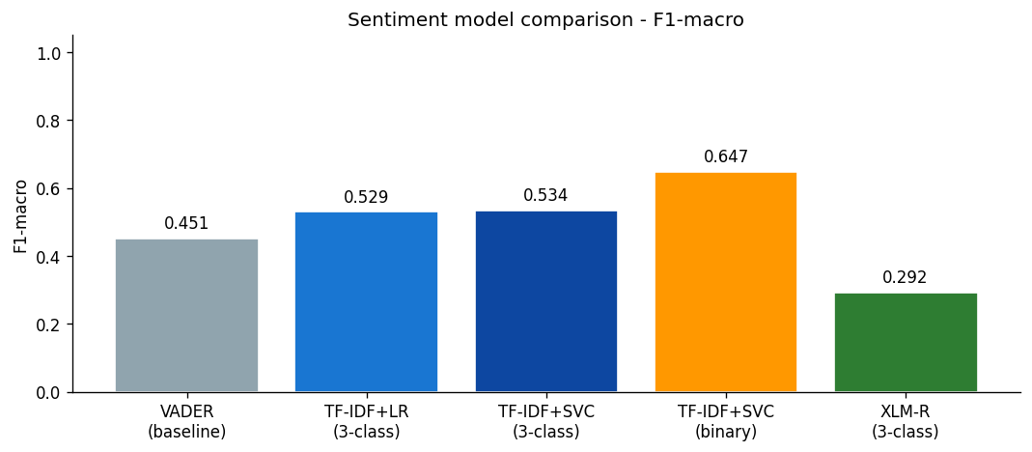
Fig. 5. F1-macro comparison across all sentiment models.

5.3 XLM-RoBERTa Discussion
XLM-RoBERTa achieved F1-macro 0.2921—below the VADER baseline (0.4511). This is expected: transformer models require substantially more labelled data than the ~800 training samples available. With only 2 fine-tuning epochs, the model has insufficient exposure to hotel-review vocabulary. This is a proof-of-concept for the multilingual upgrade path, not a performance improvement. At this dataset size, TF-IDF + LinearSVC remains the recommended production approach.

5.4 Operational Application
The binary classifier (F1-macro 0.6471, CV 0.6939) is the most deployable model. Recommended use: auto-flag incoming non-positive reviews (score < 8) within minutes of publication, triggering a 24-hour management response SLA.

6 Topic Modelling
LDA [1] was applied to all 999 review texts. The vocabulary was built with CountVectorizer (max 3,000 features, 1–2 n-grams, min_df=3, max_df=90%), yielding 1,289 unique terms after hotel-domain and multilingual stop-word filtering. Six topics were selected after comparing perplexity scores across k ∈ {4, 6, 8}; k=6 produced the most interpretable separation. Perplexity: 844.65.

Topic label | Reviews | Avg score | Top keywords
Location & Accessibility | 362 | 8.16 | location, breakfast, staff, close, bathroom
Staff & Service | 280 | 8.64 | staff, location, friendly, helpful, clean
Food & Breakfast | 219 | 8.32 | location, breakfast, staff, excellent, perfect
Room Comfort & Cleanliness | 112 | 7.36 | parking, location, check, old, bed
Rooftop Bar & Ambiance | 19 | 8.47 | pillows, design, comfort, doors, extremely
Check-in & WiFi | 7 | 7.43 | hear, people, dirty, charged, buy
Table 4. LDA topics (k=6), sorted by review count.

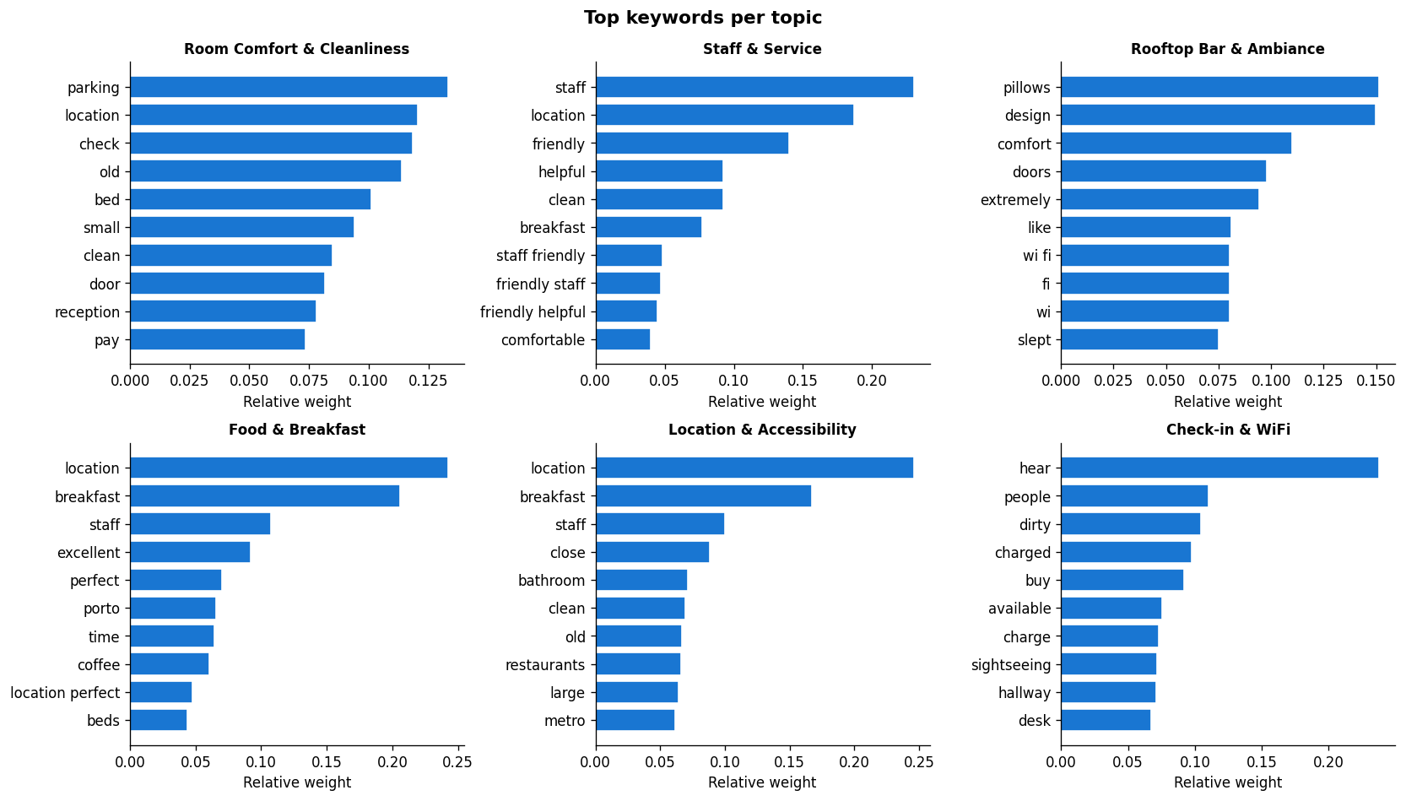
Fig. 6. Top keywords per LDA topic (relative weight).
Location & Accessibility is the dominant theme by volume (362 reviews). Staff & Service records the highest average score (8.64/10) and is the hotel's primary reputation differentiator. Room Comfort & Cleanliness records the lowest score (7.36/10). The Check-in & WiFi topic (7 reviews) is statistically thin; ABSA findings in Section 7 provide more robust evidence for this pain point.

7 Aspect-Based Sentiment Analysis
ABSA was applied using a rule-based approach: for each of eight hotel-domain aspects, keyword occurrences were located in review text and a ±12-word context window was scored with VADER. A total of 2,156 deduplicated aspect mentions were extracted across all 999 reviews.

Aspect | Mentions | Negative | Neg %
WiFi & Check-in | 114 | 45 | 39.5%
Noise | 99 | 32 | 32.3%
Room | 444 | 96 | 21.6%
Breakfast | 314 | 48 | 15.3%
Value | 74 | 10 | 13.5%
Cleanliness | 176 | 19 | 10.8%
Staff & Service | 424 | 37 | 8.7%
Location | 511 | 37 | 7.2%
Table 5. ABSA results sorted by negative mention share.

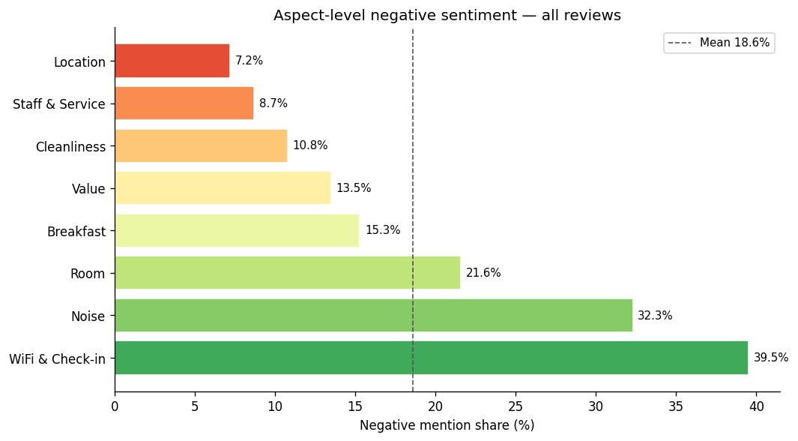
Fig. 7. Negative mention share (%) by aspect. Dashed line shows mean.
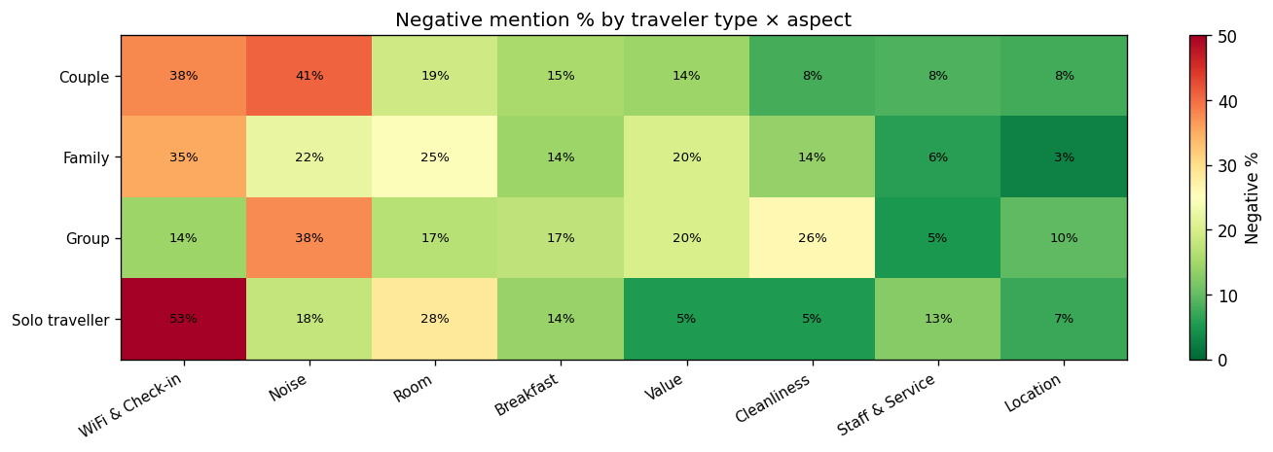
Fig. 8. Negative mention % by traveller type × aspect (heatmap).
WiFi & Check-in is the highest pain point (39.5% negative, 114 mentions). Location generates the most discussion (511 mentions) at only 7.2% negative—the hotel's clearest marketing asset. The heatmap reveals Family guests show elevated negative rates for Room and Noise aspects relative to Couples and Solo travellers.

8 Strategic Recommendations

ID | Finding | KPI | Timeline
R1 | WiFi & Check-in: 39.5% neg ABSA | Topic avg ≥8.50 | 0–6 mo
R2 | Family score 7.98 (lowest) | Family avg ≥8.20 | 0–9 mo
R4 | 6.4% negative, unresponded | Neg share ≤4% | 0–3 mo
R3 | Staff & Service avg 8.64 | +10% direct bookings | 3–12 mo
R5 | Iberian share 8.9% in Porto | Iberian share ≥15% | 6–18 mo
R6 | Room Comfort avg 7.36 | Topic avg ≥8.40 | 3–9 mo
R7 | Value aspect 13.5% neg | Value avg ≥8.60 | 3–6 mo
Table 6. Strategic decision table with KPIs and timelines.

R1 — WiFi & Check-in: Audit signal strength across all floors; install repeaters; introduce digital key/PIN access.
R2 — Family Experience: Offer interconnecting rooms and cot availability; add child-oriented breakfast items; distribute a family city guide.
R4 — Negative Review Response: Deploy the binary sentiment classifier to auto-flag non-positive reviews, triggering a 24-hour management response SLA.
R3 — Staff Marketing: Feature guest quotes about staff in OTA listings; launch a Staff Spotlight social media series; nominate praised staff for hospitality awards.
R5 — Iberian Market: Translate OTA listings into Spanish and Portuguese; partner with Iberian travel agencies; run geo-targeted social ads.
R6 — Room Comfort: Introduce a standardised room-readiness checklist; pilot a mattress upgrade in Budget Double Rooms over 90 days.
R7 — Value Perception: Offer Early Bird and Last Minute rates; bundle breakfast in promoted packages; reinforce value in post-booking emails.

9 Conclusions
This analysis of 999 guest reviews delivers a clear, data-driven picture of hotel performance. An average score of 8.24/10 and 78.0% positive sentiment confirm that the hotel's core proposition—friendly staff, unique vintage character, and central Porto location—resonates strongly with guests.
Three findings demand immediate operational attention: (1) WiFi and check-in friction anchors the highest-negative ABSA aspect (39.5%); (2) Family Explorers are the lowest-scoring segment (7.98/10); and (3) 6.4% of reviews are negative—a manageable number that the binary classifier can surface in real time.
Medium-term growth lies in Iberian market expansion (currently 8.9% of reviews), loyalty campaigns targeting Romantic Couples, and standardising room comfort. The NLP pipeline is designed to run continuously, providing ongoing operational intelligence as new reviews accumulate.

Limitations
- Label-signal mismatch: score-derived labels conflate linguistically similar positive/neutral reviews, capping 3-class F1-macro at ~0.53.
- Multilingual corpus: non-English reviews introduce noise into LDA keyword lists despite stop-word filtering.
- Single property: findings are specific to one hotel; cross-property benchmarking would strengthen confidence.
- Review-level clustering: K-Means segments reviews, not customers; future work should aggregate per unique reviewer.

References
[1] Blei, D.M., Ng, A.Y., Jordan, M.I.: Latent Dirichlet Allocation. Journal of Machine Learning Research 3, 993–1022 (2003)
[2] Hutto, C.J., Gilbert, E.: VADER: A parsimonious rule-based model for sentiment analysis of social media text. Proceedings of ICWSM 2014 (2014)
[3] Conneau, A., et al.: Unsupervised cross-lingual representation learning at scale. Proceedings of ACL 2020, pp. 8440–8451 (2020)
[4] Pedregosa, F., et al.: Scikit-learn: Machine learning in Python. Journal of Machine Learning Research 12, 2825–2830 (2011)
[5] Booking.com: Guest review data collected from publicly accessible review pages for a boutique hotel in Porto, Portugal. Retrieved 2026. https://www.booking.com

