Steps to set up Dynamic registration PoC functions

1. Create a function application and configure logging.

Login to OCI console with a user who has permissions to manage function service.

Navigate to Developer services->Functions

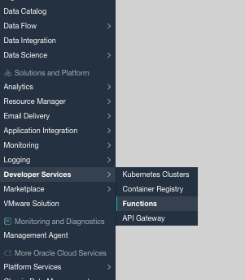

Create a new application

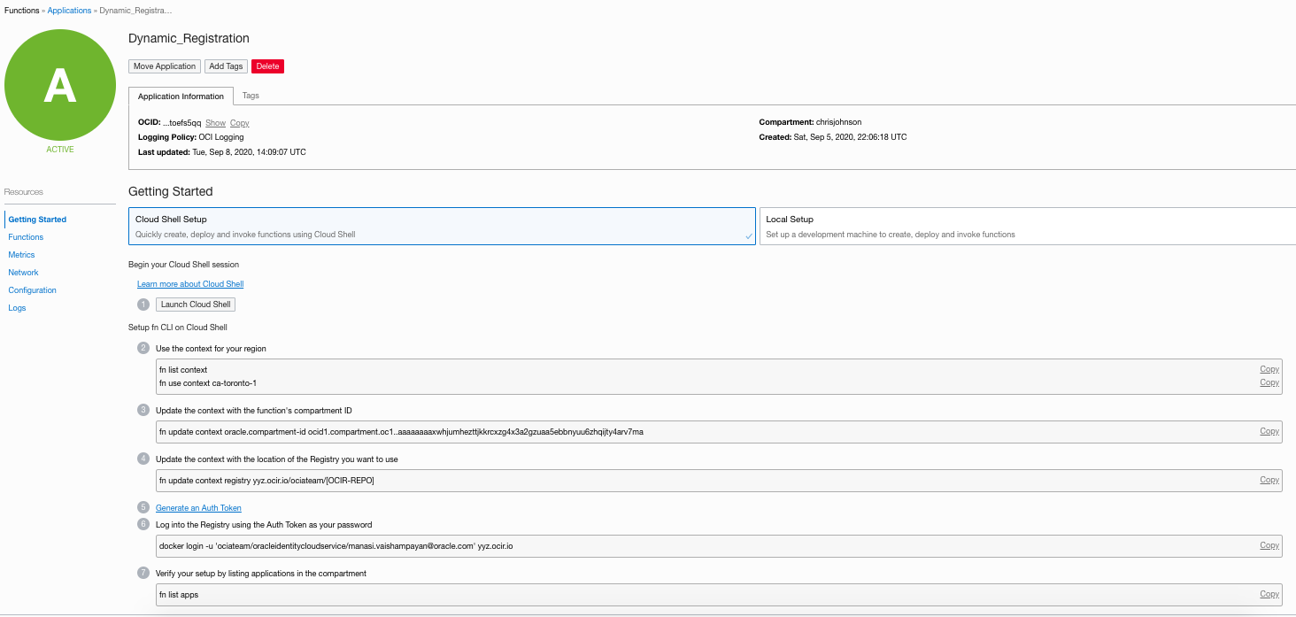

Use Instructions available in the “getting started” section for using cloud shell to create/deploy/invoke functions.



Additional reference - [<https://www.ateam-oracle.com/jumpstart-your-functions-as-a-service-journey-in-oci-with-cloud-shell>](https://www.ateam-oracle.com/jumpstart-your-functions-as-a-service-journey-in-oci-with-cloud-shell)

1. Once the cloud shell is connected and ready, get the functions code from github or unzip it

Deploy authorizer and dynamicreg functions

Change directory to each function’s code directory and run fn deploy command per function-

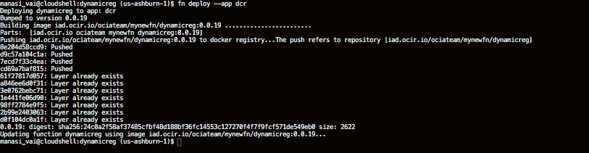

1. Setup function configuration

Ensure the functions are deployed. For each function, configure properties.

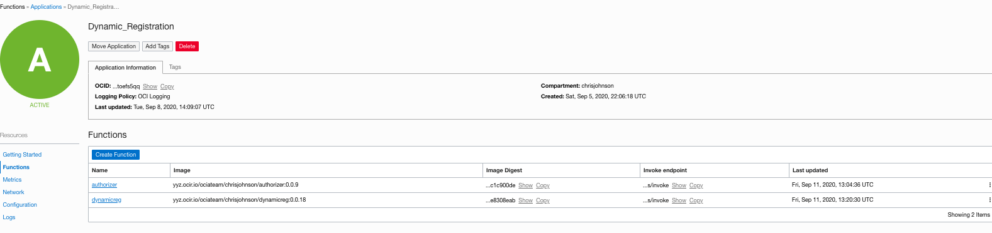

1. Authorizer function – Configure a secret password used by the client to invoke dynamic registration endpoint.

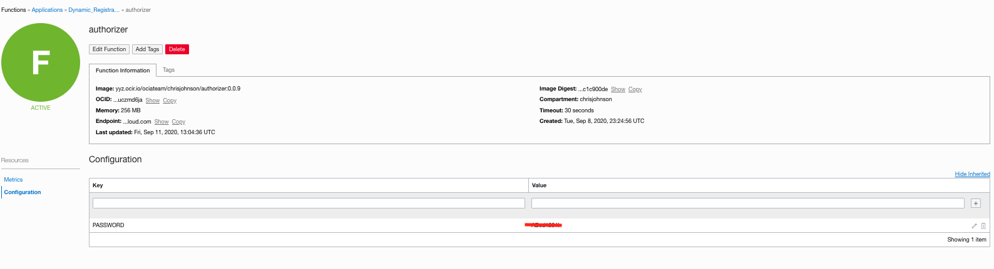

1. Dynamic Registration

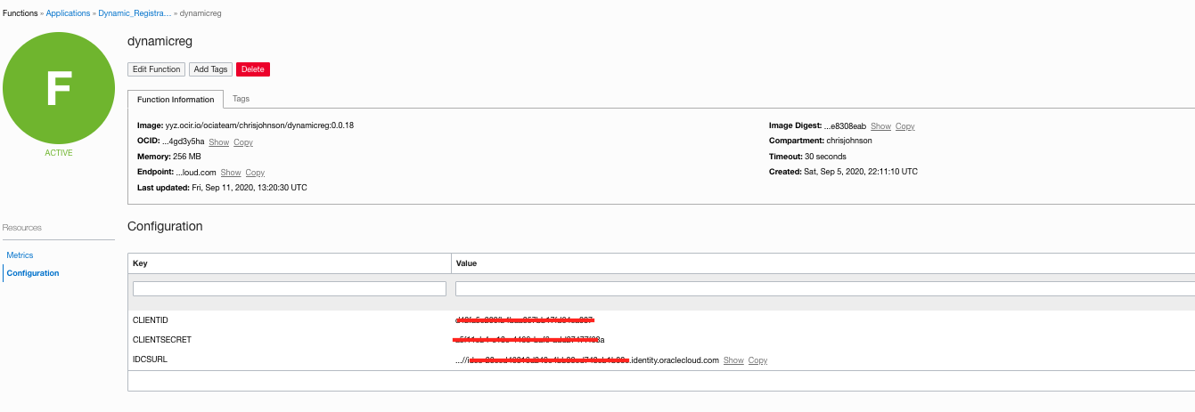

1. Create a public API Gateway

<https://docs.cloud.oracle.com/en-us/iaas/Content/APIGateway/Tasks/apigatewaycreatinggateway.htm>

* 1. Create a new deployment – Provide a name
  2. Create an authentication policy and use ‘authorizer’ fn to perform custom authentication.

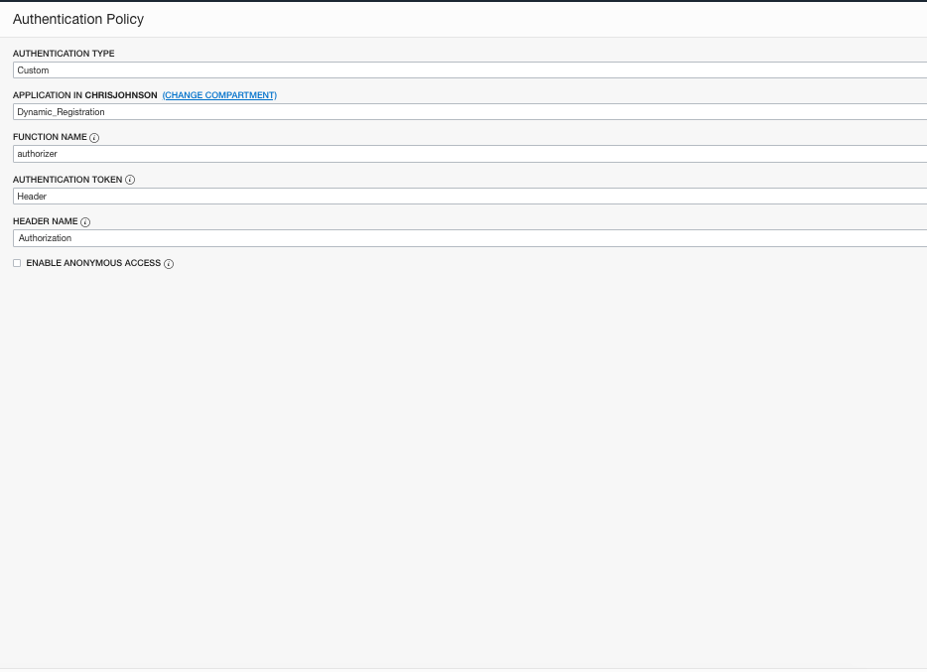

* 1. Create a route

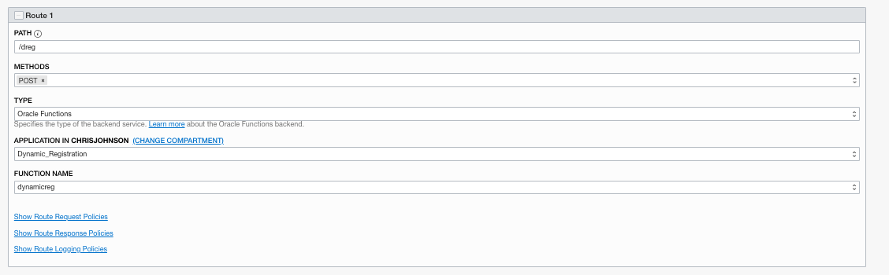

Save your API gateway configuration.

1. Test

Copy the API gateway’s deployment endpoint

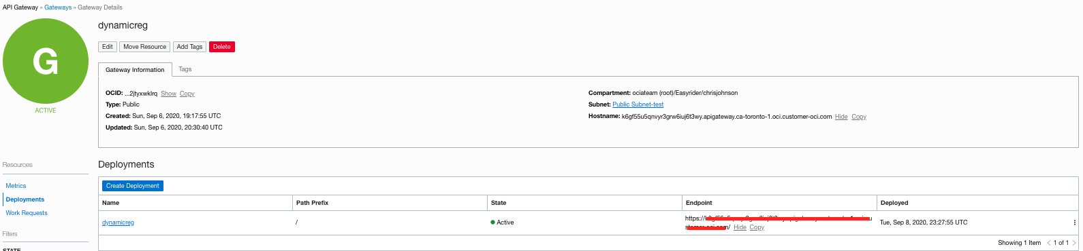

and concatenate it with the route path configured in step # 4.c

Test -

curl -v -H 'Authorization: <configured_secret>' -d @sample_requests/1_simple.json https://<api_gateway_deployment_endpoint>/<route_path>