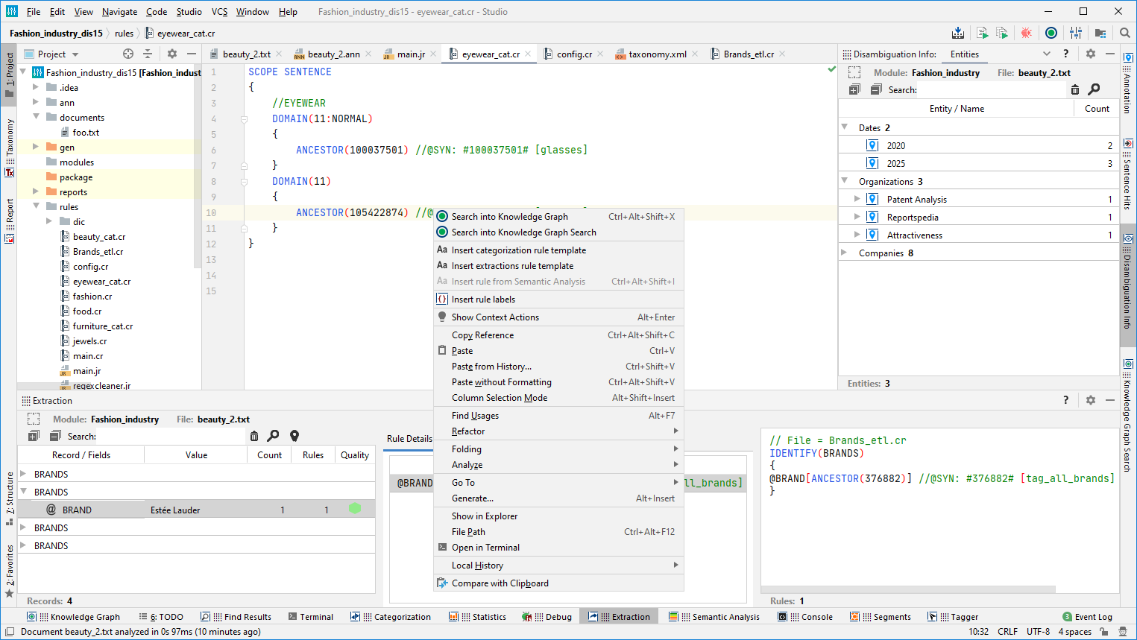

Editor

Navigation bar

Toolbar

Opened tool windows

Context menu

Tool windows

Status bar

Menu bar